**FlyAway: Airline Booking Portal**

**Introduction**

FlyAway is a comprehensive airline booking portal.This portal empowers users to easily book flights, providing a seamless and user-friendly experience. Additionally, it offers an admin backend for efficient management of airline, place, and flight data.

**Project Scope**

The FlyAway project encompasses various features for both users and administrators:

**User-Facing Features**

1. **Homepage and Search Form:** Users can enter travel details, such as the date of travel, source, destination, and the number of passengers. This information initiates the flight search process.
2. **Flight Listing:** Based on the entered travel details, FlyAway displays available flights with their respective ticket prices. These results are retrived from database
3. **Registration and Booking:** Once users select a flight, they are directed to a registration page to input their personal details. The system then shows a summary of the selected flight and initiates a dummy payment gateway. After successful payment, users receive a confirmation page with booking details.

**Admin-Facing Features**

1. **Admin Login:** Administrators have secure access to the system, allowing them to manage essential functionalities.
2. **Password Change:** Admins can change their passwords for enhanced security.
3. **Places and Airlines Management:** Admins can manage master lists of places for source and destination, as well as a list of airlines.
4. **Flight Management:** Admins have control over flight data, including source, destination, airline, and ticket price.

**Development Stack**

* **IDE:** I utilized Eclipse as our integrated development environment (IDE) to streamline the coding process.
* **Programming Language:** Java was chosen as the primary programming language for web development, database interactions, and more.
* **Database:** SQL was employed to create and manage tables for admin, airlines, places, bookings and flight specific information.
* **Version Control:** Git was used for version control and collaboration among the development team.
* **Agile Framework:** The Scrum framework was adopted to enable incremental product development and timely delivery.

**Development Process**

Our development process consisted of multiple sprints, each with its set of goals and tasks. We followed the Agile Scrum framework to ensure incremental development and early delivery of high-quality features. Here is a brief overview:

**Sprint 1: Project Setup and User Interface (Duration: 2 weeks)**

**Goals:**

* Set up the project environment, including IDE, version control.
* Create the basic project structure and database schema.
* Implement the homepage with a search form for users to input travel details.
* Develop initial flight listing functionality to display available flights.
* Begin documentation of the project.

**Tasks:**

* Configure Eclipse/IntelliJ and Git.
* Design and implement the homepage and search form.
* Create database tables for places and airlines.
* Implement basic flight listing functionality.

**Sprint 2: User Registration and Booking (Duration: 2 weeks)**

**Goals:**

* Allow users to register and provide personal details.
* Integrate payment processing via a dummy payment gateway.
* Develop booking confirmation pages.
* Enhance the flight listing with sorting and filtering options.

**Tasks:**

* Create the user registration page and integrate validation.
* Develop booking confirmation pages with booking details.
* Integrate a dummy payment gateway for payment processing.

**Sprint 3: Admin Backend and Management (Duration: 2 weeks)**

**Goals:**

* Create an admin login system with password change functionality.
* Develop the admin dashboard for managing airlines, places, and flights.
* Enhance user input validation to handle exceptions gracefully.

**Tasks:**

* Design and implement the admin login page with password change functionality.
* Develop the admin dashboard for managing master lists of places and airlines.
* Create an interface for admins to manage flights (add, display).
* Enhance user input validation to prevent exceptions.

**Sprint 4: Documentation and Finalization (Duration: 2 weeks)**

**Goals:**

* + Review and finalize the project documentation.

**Tasks:**

* + 2. Review and finalize all project documentation, including specifications and user manuals.
  + Conduct comprehensive testing and address any identified issues.
  + Prepare the project for release, including code cleanup and verification.
  + Create a GitHub release and update the GitHub repository with the final code and documentation.
  + Finalize the GitHub Portfolio with the project's screenshots and links.

**Flow charts**

**User flow**

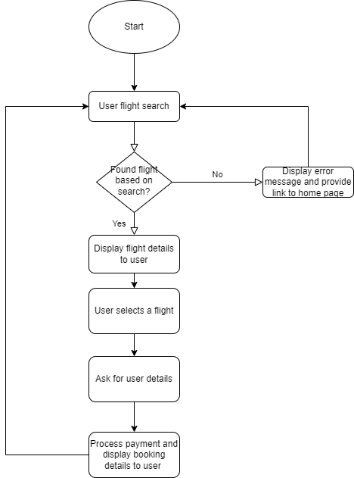

**Admin flow**

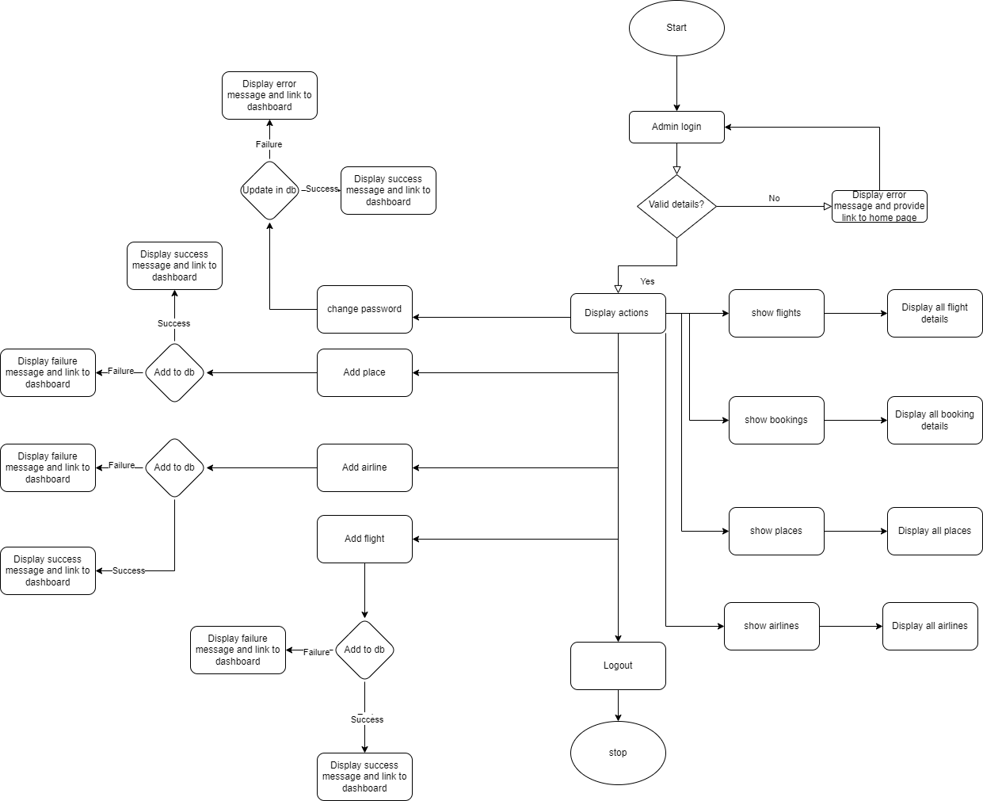

**Conclusion**

FlyAway is a robust and user-friendly airline booking portal that meets the needs of both travelers and administrators. With a focus on agile development, performance optimization, and comprehensive documentation, I have delivered a high-quality product that is ready to serve the needs of the airline industry. For more details and to verify the project's completion, please refer to below link

**GitHub Repository: https://github.com/santhoshsai4517/FlyAway**