Topics: Confidence Intervals

- For each of the following statements, indicate whether it is True/False. If false, explain why.

- The sample size of the survey should at least be a fixed percentage of the population size in order to produce representative results.
Answer:
FALSE , the sample have good confidence interval, margin of error and also variation of data’s within dataset. And also sample size are fixed percentage.

- The sampling frame is a list of every item that appears in a survey sample, including those that did not respond to questions.
Answer:
FALSE , yes it contains all the data contained in the population . and the
Survey sample are population and sampling are same.

- Larger surveys convey a more accurate impression of the population than smaller surveys.
Answer:
TRUE , yes larger survey provides near to accurate information than the
Smaller surveys.

- PC Magazine asked all of its readers to participate in a survey of their satisfaction with different brands of electronics. In the 2004 survey, which was included in an issue of the magazine that year, more than 9000 readers rated the products on a scale from 1 to 10. The magazine reported that the average rating assigned by 225 readers to a Kodak compact digital camera was 7.5. For this product, identify the following:

- The population
Answer: pc magazine of the readers

- The parameter of interest
Answer: the readers who use the Kodak compact Digital Camera. Is know as parameter of interest

- The sampling frame
Answer: All the readers of the PC Magazine. Is the sampling frame.

- The sample size
Answer: The sample size is the kodak compact digital camera specific sample is not listed then approximately 9000 for all electronic items listed in question .

- The sampling design
Answer: Census based sampling design.

- Any potential sources of bias or other problems with the survey or sample
Answer: the reader may give good rating because of his relationship with magazine…called response bias Also due to their likeliness or closeness to magazine, sometimes it there may be chance of non-response because the product he opted may not be there is called as non-response bias.

- For each of the following statements, indicate whether it is True/False. If false, explain why.

- If the 95% confidence interval for the average purchase of customers at a department store is $50 to $110, then $100 is a plausible value for the population mean at this level of confidence.
Answer: : TRUE , the value for population mean at 95% level of confidence is covers from the range of $50 to$110 then $100 is plausible is the 95% confidence interval.

- If the 95% confidence interval for the number of moviegoers who purchase concessions is 30% to 45%, this means that fewer than half of all moviegoers purchase concessions.
Answer: TRUE the case of purchase concessions of 30% to 45% as given in sample size of 95% confidence interval will suit to whole population too. Then the higher sample size .so a sample of 95% will give more reliable information.

- The 95% Confidence-Interval for μ only applies if the sample data are nearly normally distributed.

Answer: FALSE Here 95% confidence interval will definitely have large sample Size. as per the Central Limit Theorem the sampling mean of the sampling distribution becomes approximately distributed regardless of distribution of population.

- What are the chances that ?

- ¼
- ½
- ¾
- 1

Answer: B

- In January 2005, a company that monitors Internet traffic (WebSideStory) reported that its sampling revealed that the Mozilla Firefox browser launched in 2004 had grabbed a 4.6% share of the market.

- If the sample were based on 2,000 users, could Microsoft conclude that Mozilla has a less than 5% share of the market?

Answer: Hence the mozilla captures 4.6% market of internet share based on sample of 2000. Pnull is less than p value . so accept the alternate
reject null hypothesis.

- WebSideStory claims that its sample includes all the daily Internet users. If that’s the case, then can Microsoft conclude that Mozilla has a less than 5% share of the market?

Answer:
Microsoft can conclude Mozilla has a less than 5% share of population. which includes all type of internet users and this can consider as equivalent to population then If the Websidestory claims are true sample include all the daily internet users.

- A book publisher monitors the size of shipments of its textbooks to university bookstores. For a sample of texts used at various schools, the 95% confidence interval for the size of the shipment was 250 ± 45 books. Which, if any, of the following interpretations of this interval are correct?
Answer:
sample which has 95% confidence having a sample mean as 250 with its confidence intervals lower limit and higher limit are (205,295)

- All shipments are between 205 and 295 books.
Answer:
FALSE , because it is just result of sample we cannot consider all populations range between 205 and 295.

- 95% of shipments are between 205 and 295 books.
Answer:
FALSE, because sample has less data set and population has a large data set so range can be something different .

- The procedure that produced this interval generates ranges that hold the population mean for 95% of samples.
Answer:
TRUE, this statement almost reflects the real purpose of the confidence interval.

- If we get another sample, then we can be 95% sure that the mean of this second sample is between 205 and 295.
Answer:
FALSE, confident of the men lying between 205 and 295. we cant be sure by one more sample.

- We can be 95% confident that the range 160 to 340 holds the population mean.
Answer:
TRUE, because the population mean will lie in this interval
,since 160 to 340 has the interval of 205 to 295.

- Which is shorter: a 95% z-interval or a 95% t-interval for μ if we know that σ =s?

- The z-interval is shorter
- The t-interval is shorter
- Both are equal
- We cannot say

Answer : A. S tails are longer in t- interval

Questions 8 and 9 are based on the following: To prepare a report on the economy, analysts need to estimate the percentage of businesses that plan to hire additional employees in the next 60 days.

- How many randomly selected employers (minimum number) must we contact in order to guarantee a margin of error of no more than 4% (at 95% confidence)?

- 600
- 400
- 550
- 1000
Answer: A
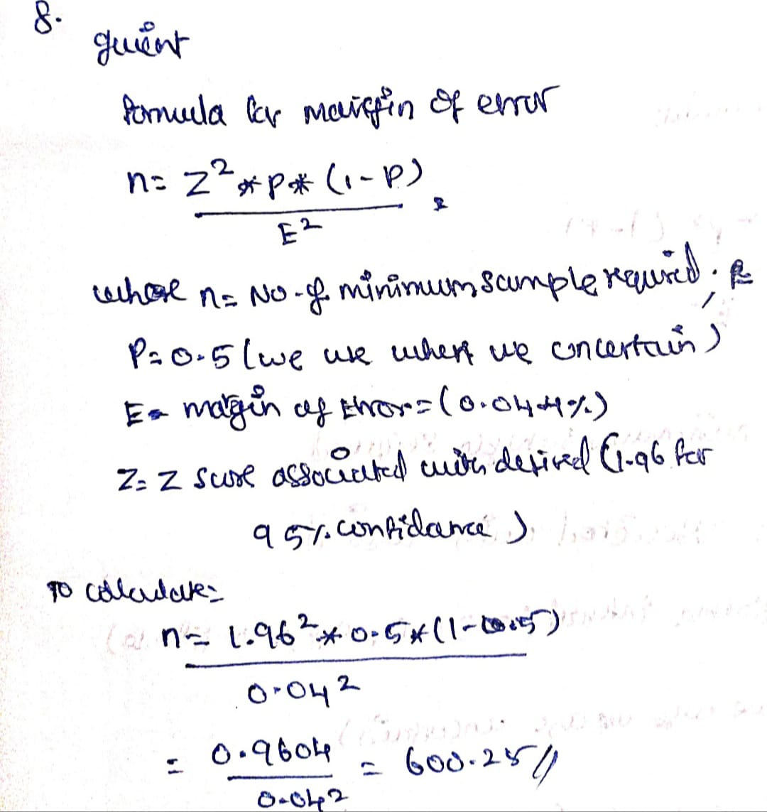

- Suppose we want the above margin of error to be based on a 98% confidence level. What sample size (minimum) must we now use?

- 1000
- 757
- 848
- 543

Answer: C
