Q1:

<html lang="en">

<head>

<title>Document

<body>

guvi

</title>

</head>

<div>

Lorem ipsum dolor sit amet consectetur adipisicing elit.

<div>

<div>

Guvi Geek Network

</div>

</body>

</html>

answer for Q1

<!DOCTYPE html>

<html lang="en">

<head>

<title>Document</title>

</head>

<body>

guvi

<div>

Lorem ipsum dolor sit amet consectetur adipisicing elit.

<div>

Guvi Geek Network

</div>

</div>

</body>

</html>

Q2:

<html lang="en">

<head>

<title>Document

<body>

guvi

</head>

<div>

Lorem ipsum dolor sit amet consectetur adipisicing elit.

<div>

<div>

Guvi Geek Network

</div>

</body>

</html>

answer for Q2

<!DOCTYPE html>

<html lang="en">

<head>

<title>Document</title>

</head>

<body>

guvi

<div>

Lorem ipsum dolor sit amet consectetur adipisicing elit.

<div>

<div>

Guvi Geek Network

</div>

</div>

</div>

</body>

</html>

Q3: Design a contact us form with all fields as required.

<!DOCTYPE html>

<html lang="en">

<head>

<meta charset="UTF-8">

<meta name="viewport" content="width=device-width, initial-scale=1.0">

<title>Contact Us</title>

</head>

<body>

<h2>Contact Us</h2>

<label for="name">Name:</label><br>

<input type="text" id="name" name="name" required><br>

<label for="email">Email:</label><br>

<input type="email" id="email" name="email" required><br>

<label for="phone">Phone:</label><br>

<input type="tel" id="phone" name="phone" required pattern="[0-9]{3}-[0-9]{3}-[0-9]{4}" title="Phone number format: 123-456-7890"><br>

<label for="message">Message:</label><br>

<textarea id="message" name="message" rows="4" required></textarea><br>

<input type="submit" value="Submit">

</form>

</body>

</html>

**Output:**

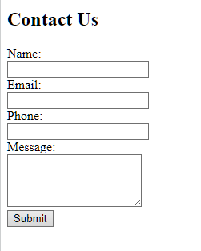

Q4:Use certain HTML elements to display the following in a HTML page.

<!DOCTYPE html>

<html lang="en">

<head>

<title>Technology List</title>

</head>

<body>

<h2>Technology Stack</h2>

<p>. Programming Language</p>

<ul>

<li>JavaScript

<ol type="a">

<li>Angular</li>

<li>React</li>

<li>Vue.js</li>

</ol>

</li>

<li>Python

<ol type="a">

<li>Django Framework</li>

<li>Flask Framework</li>

</ol>

</li>

<li>Java

<ol type="a">

<li>Spring</li>

<li>Maven</li>

<li>Hibernate</li>

</ol>

</li>

</ul>

<p>* Database</p>

<ul>

<li>MySQL</li>

<li>MongoDB</li>

<li>Cassandra</li>

</ul>

</body>

</html>

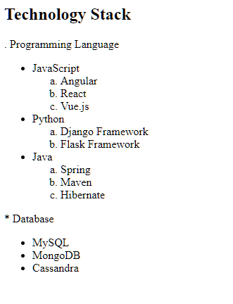

Q5: Create an element that helps you to open the https://google.com in separate new tab.

<!DOCTYPE html>

<html lang="en">

<head>

<meta charset="UTF-8">

<meta name="viewport" content="width=device-width, initial-scale=1.0">

<title>Open Google in New Tab</title>

</head>

<body>

<a href="https://google.com" target="_blank">Open Google in New Tab</a>

</body>

</html>

**Output:**



Q6: In the form, add two radio buttons with grouping them for employee type(Salaried and own business)

<!DOCTYPE html>

<html lang="en">

<head>

<title>Employee Type</title>

</head>

<body>

<h2>Employee Type</h2>

<input type="radio" id="salaried" name="employeeType" value="salaried">

<label for="salaried">Salaried</label><br>

<input type="radio" id="ownBusiness" name="employeeType" value="ownBusiness">

<label for="ownBusiness">Own Business</label><br>

<input type="submit" value="Submit">

</form>

</body>

</html>

**Output:**

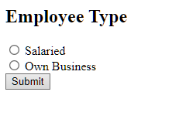

Q7: like is not working

Q8: Use the table tag to design given image

<!DOCTYPE html>

<html lang="en">

<head>

<title>Health Chat Contents</title>

<style>

table {

width: 100%;

border-collapse: collapse;

}

th, td {

border: 1px solid black;

padding: 8px;

text-align: left;

}

th {

background-color: #f2f2f2;

}

</style>

</head>

<body>

<h2>Health Chat Contents</h2>

<table>

<tr>

<th>State of Health</th>

<th>Fasting (mg/dL)</th>

<th>After Eating (mg/dL)</th>

</tr>

<tr>

<td>Healthy</td>

<td>70-99</td>

<td>&lt;140</td>

</tr>

<tr>

<td>Pre-Diabetes</td>

<td>100-125</td>

<td>140-199</td>

</tr>

<tr>

<td>Diabetes</td>

<td>&gt;126</td>

<td>&gt;200</td>

</tr>

</table>

</body>

</html>

**Output:**

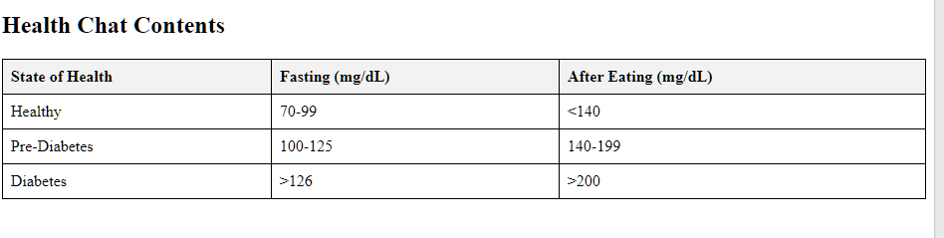

Q9:Write HTML input tags snippet to show default values for all Form elements.

<!DOCTYPE html>

<html lang="en">

<head>

<meta charset="UTF-8">

<meta name="viewport" content="width=device-width, initial-scale=1.0">

<title>Default Form Values</title>

</head>

<body>

<h2>Default Form Values</h2>

<label for="name">Name:</label>

<input type="text" id="name" name="name" value="santhosh"><br>

<label for="email">Email:</label>

<input type="email" id="email" name="email" value="santhosh@example.com"><br>

<label for="age">Age:</label>

<input type="number" id="age" name="age" value="25"><br>

<label for="gender">Gender:</label>

<select id="gender" name="gender">

<option value="male"selected>Male</option>

<option value="female">Female</option>

<option value="other">Other</option>

</select><br>

<label for="subscribe">Subscribe to newsletter:</label>

<input type="checkbox" id="subscribe" name="subscribe" checked><br>

<label for="message">Message:</label><br>

<textarea id="message" name="message">This is a default message.</textarea><br>

<input type="submit" value="Submit">

</form>

</body>

</html>

**Output:**

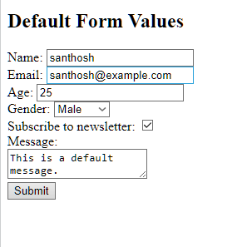

Q10:In your, HTML page add the below line and Highlight it without using any CSS.

"HTML & CSS is awesome"

<!DOCTYPE html>

<html lang="en">

<head>

<title>Highlighted Text</title>

</head>

<body>

<h2>Highlighted Text</h2>

<mark>HTML& CSS is awesome<mark>

</body>

</html>

**Output:**

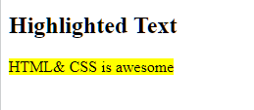

Q11: Create an HTML page, which should contain all types of input elements.

<!DOCTYPE html>

<html lang="en">

<head>

<title>All Input Types</title>

</head>

<body>

<h2>All Input Types</h2>

<label for="text">Text:</label>

<input type="text" id="text" name="text"><br>

<label for="password">Password:</label>

<input type="password" id="password" name="password"><br>

<label for="number">Number:</label>

<input type="number" id="number" name="number"><br>

<label for="email">Email:</label>

<input type="email" id="email" name="email"><br>

<label for="date">Date:</label>

<input type="date" id="date" name="date"><br>

<label for="checkbox">Checkbox:</label>

<input type="checkbox" id="checkbox" name="checkbox"><br>

<label for="radio">Radio:</label>

<input type="radio" id="radio" name="radio"><br>

<label for="file">File:</label>

<input type="file" id="file" name="file"><br>

<label for="submit">Submit:</label>

<input type="submit" id="submit" value="Submit"><br>

<label for="reset">Reset:</label>

<input type="reset" id="reset" value="Reset"><br>

<label for="button">Button:</label>

<button id="button">Button</button><br>

<label for="color">Color:</label>

<input type="color" id="color" name="color"><br>

<label for="range">Range:</label>

<input type="range" id="range" name="range"><br>

<label for="search">Search:</label>

<input type="search" id="search" name="search"><br>

<label for="tel">Tel:</label>

<input type="tel" id="tel" name="tel"><br>

<label for="url">URL:</label>

<input type="url" id="url" name="url"><br>

<label for="datetime-local">Datetime-local:</label>

<input type="datetime-local" id="datetime-local" name="datetime-local"><br>

</body>

</html>

**Output:**

