DOCKER VERSION



JENKINS CONSOLE OUTPUT

DOCKER HUB REPOSITORIES

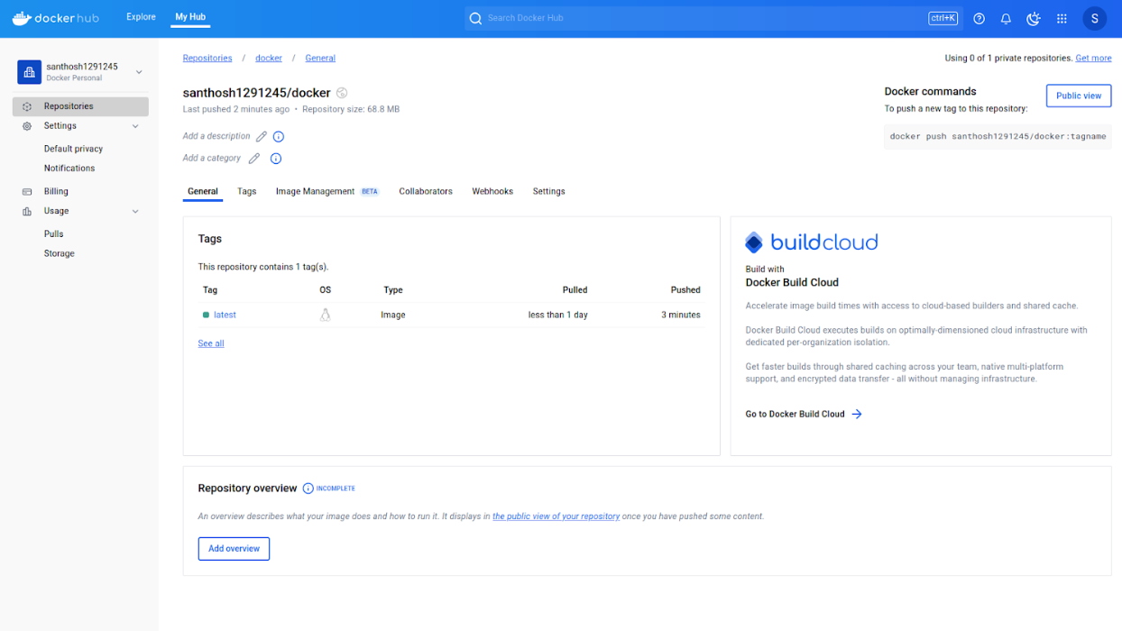

JENKINS DASHBOARD

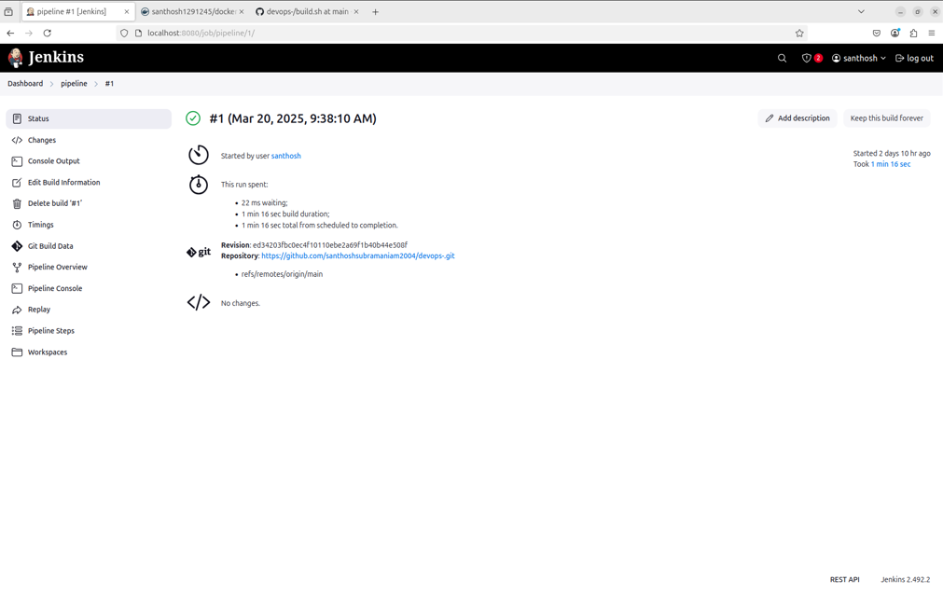

JENKINS STAGES

JENKINS OUTPUT

