MINIKUBE VERSION

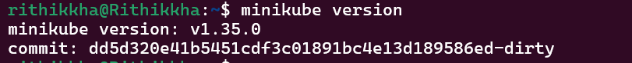

MINIKUBE DASHBOARD



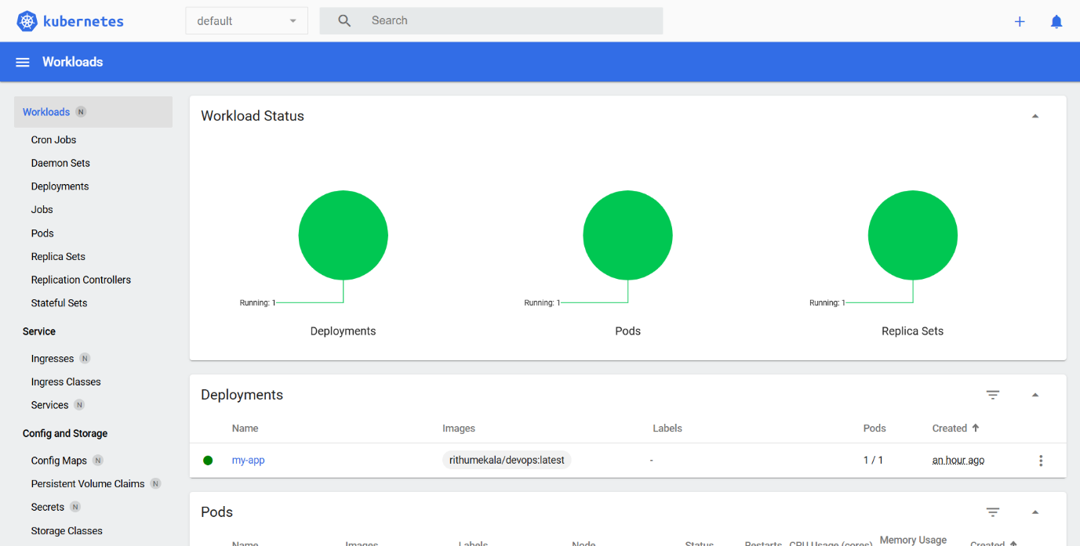

CREATED A PROJECT

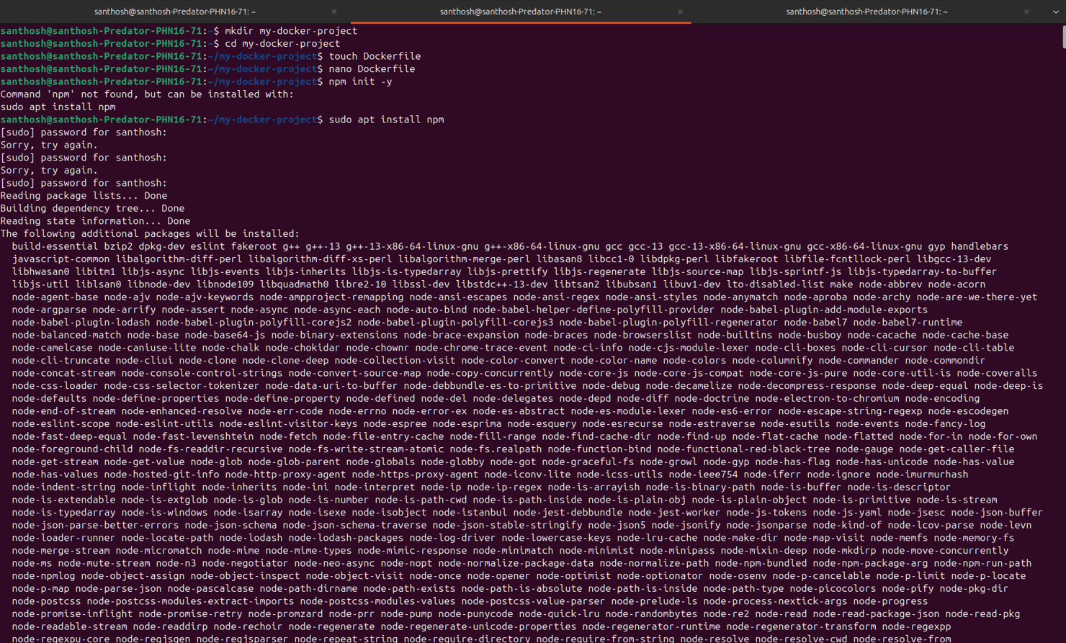

SENDING BUILD CONTEXT TO DOCKER

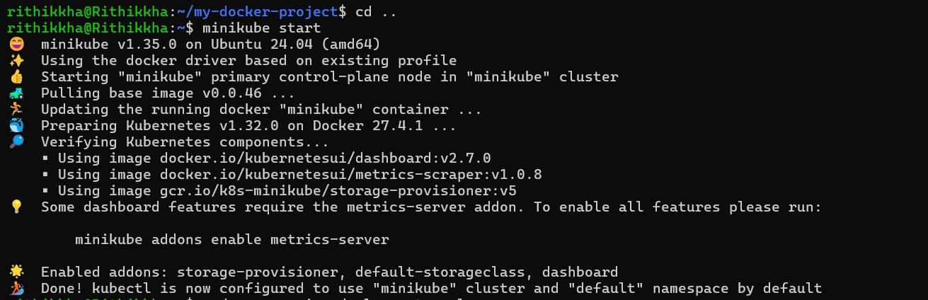MINIKUBE START

MINIKUBE SERVICE MY-APP

CURL LOCAL HOST

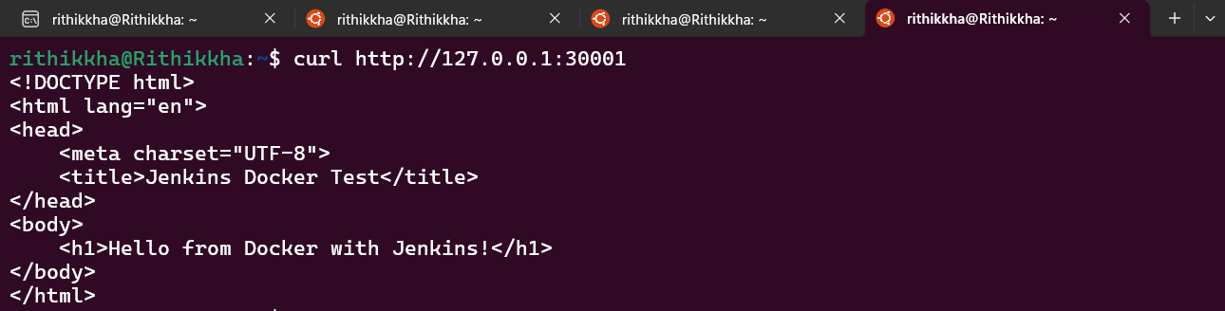

OUTPUT

