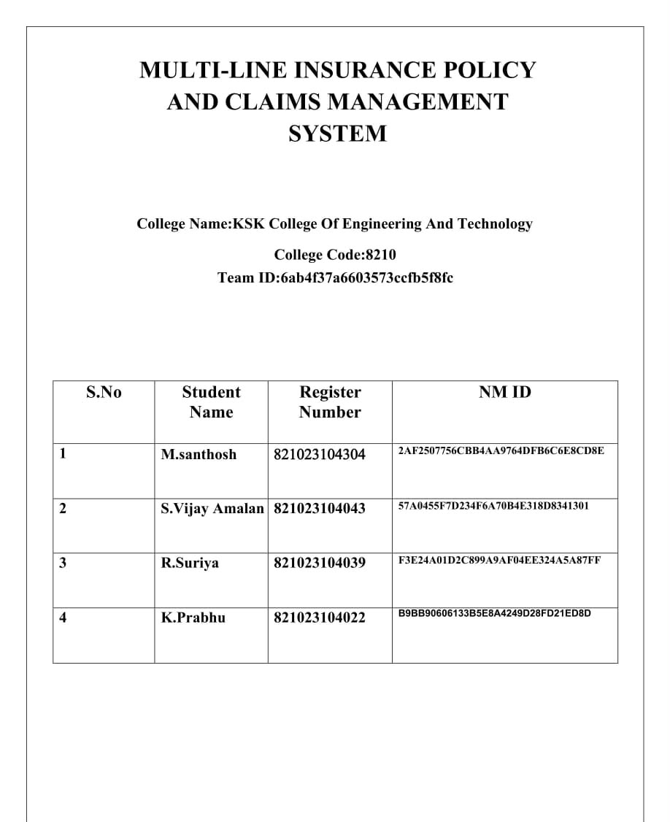

Multi-Line Insurance Policy and Claims Management System

User Story:
Multi-Line Insurance Policy and Claims Management System is designed to provide a centralized Salesforce-based solution for managing Vehicle, Property, and Life Insurance policies and claims. The system enables insurance agents to create and manage policy information using a flexible data model with policy-specific Record Types and Field Sets. Guided Screen Flows simplify policy quoting, while Apex automation calculates premiums based on policy and vehicle details. Claims are automatically routed to the appropriate queue based on policy type, and high-value claims are processed through an approval workflow involving Senior Adjusters and Claims Managers. An LWC-based Claims Dashboard provides adjusters with a focused view of their assigned claims, including claim amount, policy type, policy holder, status, and days open. This initiative improves policy processing efficiency, claim handling, data accuracy, operational visibility, and customer service.

1. INTRODUCTION

1.1 Project Overview :

The Multi-Line Insurance Policy and Claims Management System is a Salesforce-based solution designed to centralize and streamline the management of Vehicle, Property, and Life Insurance policies and claims. The system replaces fragmented and manual processes with structured Salesforce objects, Record Types, Field Sets, Flows, Apex automation, Approval Processes, and Lightning Web Components.

The solution enables insurance agents to create and manage policies through a flexible data model, while guided Screen Flows simplify the policy quoting process. The system validates policy information and uses Apex automation to calculate premiums based on factors such as state and model year. Once a claim is created, automation identifies the related policy type and routes the claim to the appropriate claims queue.

For claims adjusters, an LWC-based Claims Dashboard provides visibility into assigned claims, including claim number, policy type, policy holder, claim amount, approval status, and days open. High-value claims exceeding the defined threshold are processed through a structured approval workflow involving Senior Adjusters and Claims Managers. Security and access are managed using sharing rules and role-specific Permission Sets.

Overall, the project provides a centralized platform for improving policy processing, premium calculation, claim routing, claim approval, data accuracy, operational visibility, and customer service across multiple insurance lines.

1.2 Purpose :

The purpose of the Multi-Line Insurance Policy and Claims Management System is to provide a centralized Salesforce-based platform for managing Vehicle, Property, and Life Insurance policies and claims. The system is designed to overcome the limitations of legacy processes that result in manual, slow, and inconsistent quoting, policy issuance, and claims handling.

The solution aims to standardize and accelerate policy quoting and issuance, automate claim initiation and routing based on policy type and claim severity, and provide a 360-degree view of Customer, Policy, and Claim information. It also supports guided quoting through Screen Flows, automated premium and claim processing, data validation, and an LWC-based dashboard to improve claims adjuster efficiency.

Overall, the project focuses on improving operational efficiency, data accuracy, claims processing, and customer experience by bringing multiple insurance lines into a unified Salesforce solution.

2. IDEATION PHASE
2.1 Problem Statement (Customer Problem Statement Template)

PS | I am  (Customer) | I’m trying to | But | Because | Which makes me  feel
PS-1 | Insurance  Operations  Manager | standardize policy quoting and issuance | the process is manual, slow, and inconsistent | legacy systems and processes are fragmented | frustrated and concerned
PS-2 | Insurance  Agent | create and manage policies efficiently | different insurance lines require different information | Vehicle, Property, and Life policies have diverse data requirement  s | overwhelme  d
PS-3 | Insurance  Agent | provide accurate policy quotes | quoting requires multiple steps and manual processing | there is no unified quoting platform | frustrated and uncertain
PS-4 | Claims  Manager | manage claims efficiently | claim review and routing  are largely manual | claims processes are not centralized or automated | stressed
- Policy Information Capture
- Premium Calculation
- Policy Issuance
- Claim Initiation
- Claim Routing
- Claim Review & Approval
- Claim Resolution
- Customer Confirmation
- Reporting & Visibility

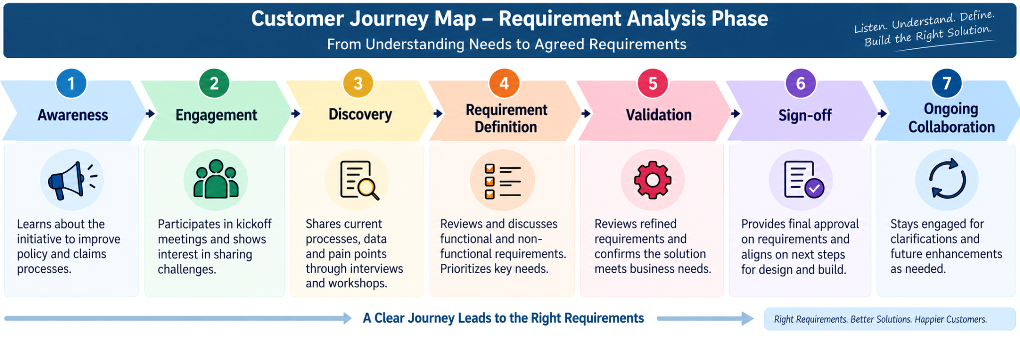

3.2 Solution Requirements

Functional Requirements

FR No | Functional Requirement
FR-01 | The system shall allow users to create and manage Insurance Policy records for Vehicle, Property, and Life Insurance.

FR-02 | The system shall support separate Record Types for Vehicle, Property, and Life policies.
FR-03 | The system shall capture product-specific policy information such as VIN for Vehicle Insurance and Square Footage/Year Built for Property Insurance.
FR-04 | The system shall provide a guided Auto Quoting Screen Flow to capture policy holder, policy start date, state, VIN, and model year.
FR-05 | The system shall create a draft policy during the quoting process.
FR-06 | The system shall calculate policy premiums using Apex-based premium calculation logic.
FR-07 | The system shall validate Vehicle Insurance VINs and ensure that the VIN contains exactly 17 characters.
FR-08 | The system shall allow users to create and manage Claim records associated with policies.
FR-09 | The system shall support different Claim Record Types for Accident, Property, and Life claims.
FR-10 | The system shall automatically route claims to the appropriate queue based on the related policy type.
FR-11 | The system shall identify high-value claims based on the configured claim amount threshold.
FR-12 | The system shall submit qualifying high-value claims through a multi-level approval process involving Senior Adjusters and Claims Managers.
FR-13 | The system shall provide an Approve/Reject Claim capability with approver comments.
FR-14 | The system shall provide Claims Adjusters with an  LWC Claims Dashboard showing assigned claims.
FR-15 | The dashboard shall display information such as Claim Number, Policy Type, Policy Holder, Claim Amount, Status, and Days Open.
FR-16 | The dashboard shall allow users to filter claims by All, Auto, Property, and Life.
FR-17 | The system shall provide automated updates to related Policy and Claim records through Record-Triggered Flows.
FR-18 | The system shall support state-based access/sharing for applicable insurance users and records.
FR-19 | The system shall provide role-specific access through Permission Sets for Insurance Agents, Claims Adjusters, and Claims Managers.
FR-20 | The system shall support reporting and visibility of Customer, Policy, and Claim information from the centralized Salesforce platform.

Non-Functional Requirements

The following requirements describe the expected quality, usability, security, scalability, and maintainability of the solution. Some are derived requirements based on the project's stated objectives and challenges rather than explicitly documented as formal NFRs.
ID | Non-Functional  Requirement | Description
NFR-01 | Usability | The system should provide simple, guided Screen Flows that minimize unnecessary clicks and make policy quoting easy for agents.
NFR-02 | Performance | Policy quoting, premium calculation, claim routing, and dashboard operations should execute efficiently to support day-to-day insurance operations.
ID | Non-Functional  Requirement | Description
NFR-03 | Scalability | The solution should support the three insurance lines—Vehicle, Property, and Life—and allow additional insurance products to be accommodated in the future.
NFR-04 | Data Integrity | Policy and claim information should be validated to maintain accurate and consistent data across insurance products.
NFR-05 | Security | Access to insurance information should be controlled according to the user's responsibility, including state-based sharing and role-specific Permission Sets.
NFR-06 | Maintainability | The solution should use modular Salesforce components such as Flows, Apex classes, LWC components, Record Types, and Field Sets so that individual components can be maintained independently.
NFR-07 | Reliability | Automated claim routing, premium calculation, and approval processes should consistently execute according to the configured business rules.
NFR-08 | Extensibility | The data model should accommodate different product-specific fields without requiring completely separate structures for each insurance line.
NFR-09 | Visibility | Users should have timely access to relevant Customer, Policy, and Claim information through centralized Salesforce records and the Claims Dashboard.
NFR-10 | User Adoption | The application should provide an intuitive experience that reduces manual effort and supports efficient adoption by agents and claims users.

3.3 Data Flow Diagram
Flow:
Customer / Agent → Screen Flow → Policy Validation → Policy__c →
PremiumCalculator → Claim__c → Claim Routing Flow → Claims Queue → Claims
Adjuster → Approval Process → Claim Update → LWC Dashboard / Reports

Main Data Flow
Step 1 – Customer / Agent Input
→ Customer and policy information is provided by the Insurance Agent.
Step 2 – Policy Data Capture
→ AutoQuoting Screen Flow captures policy holder, policy start date, state, VIN, and model year.
Step 3 – Policy Validation
→ Salesforce validates the entered information, including the 17-character VIN requirement for Auto policies.
Step 4 – Policy Creation
→ Valid information is stored in the Policy__c object with the appropriate Vehicle, Property, or Life Record Type.
Step 5 – Premium Calculation
→ Policy information is passed to PremiumCalculator Apex to calculate the applicable premium.
Step 6 – Claim Creation
→ When a claim occurs, the user creates a Claim__c record linked to the relevant Policy.
Step 7 – Claim Routing
→ A Record-Triggered Flow identifies the policy type and routes the claim to the appropriate Auto, Property, or Life Claims Queue.
Step 8 – Claim Review
→ The Claims Adjuster accesses assigned claims through the Claims Dashboard and reviews policy and claim information.
Step 9 – High-Value Claim Approval
→ Claims exceeding the configured threshold are submitted for approval to the Senior Adjuster → Claims Manager.
Step 10 – Claim Decision & Update
→ The approver selects Approve/Reject and provides comments; the claim status is updated.
Step 11 – Dashboard & Reporting
→ Claim information is displayed through the LWC Claims Dashboard, providing visibility into claim amount, policy type, policy holder, status, and days open.
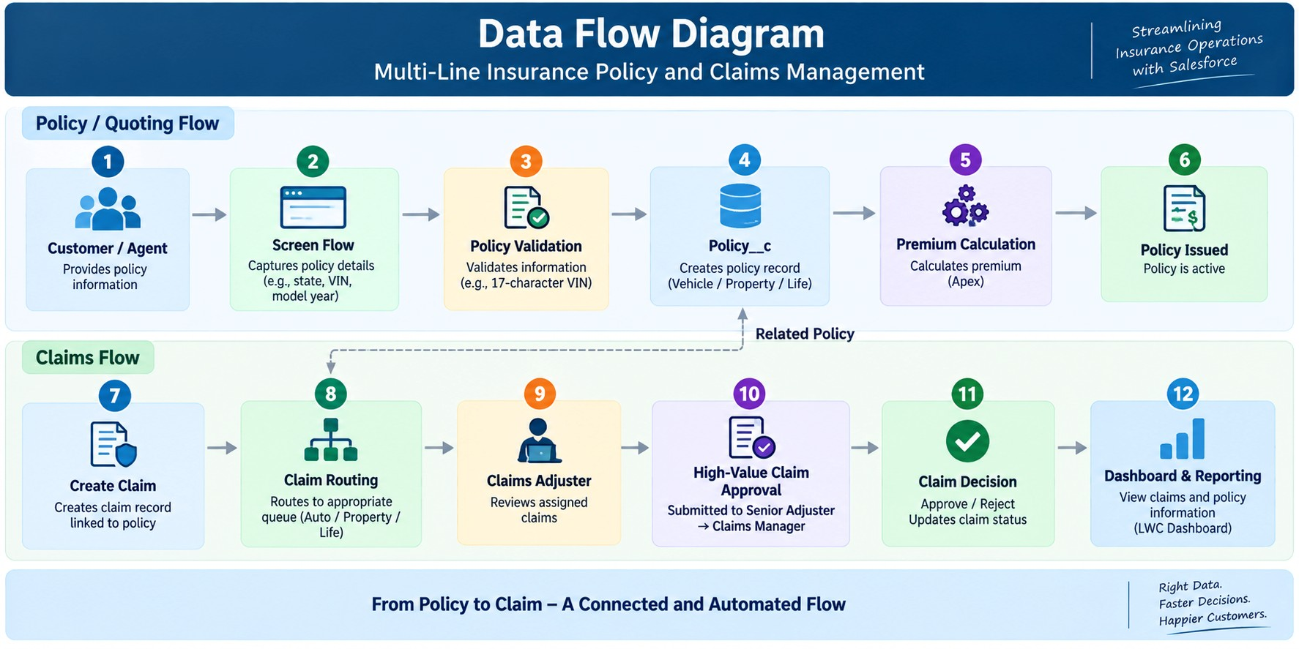

3.4 Technology Stack

Layer | Technology
UI | Salesforce Lightning, Lightning Web Components (LWC)
Logic | Salesforce Flows, Apex
Database | Salesforce Custom Objects (Policy__c, Claim__c), Contact, User
Automation | Record-Triggered Flows, Validation Rules, Approval Processes
Processing | Apex Premium Calculator, Apex Controllers
Data Configuration | Record Types, Field Sets, Custom Fields
Security | Permission Sets, State-Based Sharing Rules
Reporting | Salesforce Reports & Dashboards
Testing | Apex Test Classes

4. PROJECT DESIGN PHASE

4.1 Problem–Solution Fit
Salesforce is a strong fit for the Multi-Line Insurance Policy and Claims Management System because it directly addresses the project's key challenges through configurable automation, flexible data management, secure access, and real-time visibility. The solution combines Screen Flows, Record Types, Field Sets, Apex, Record-Triggered Flows, Approval Processes, and LWC to support policy quoting, premium calculation, claim routing, claim approval, and adjuster operations.

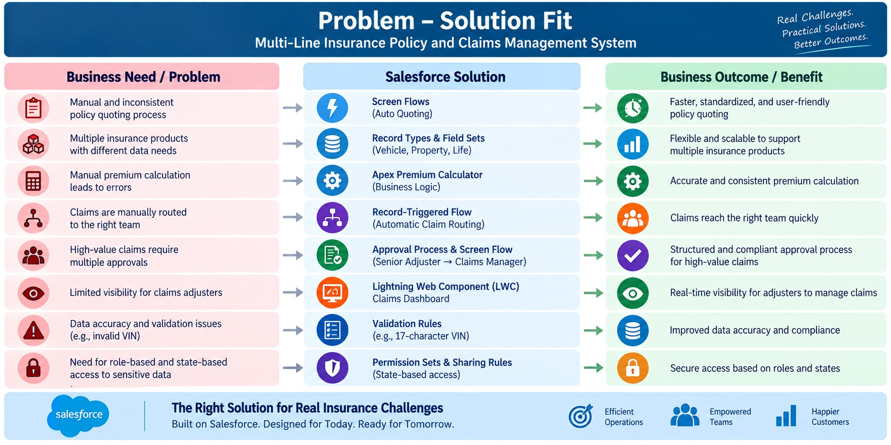

4.2 Proposed Solution

Functional Requirements
Parameter | Description
Problem | Manual and inconsistent policy quoting, issuance, and claims handling
Solution | Salesforce CRM-based Insurance Policy & Claims Management System
Innovation | Automated quoting, premium calculation, claim routing, and high-value claim approval
Impact | Faster policy processing, efficient claim handling, and improved customer service
Business Model | Centralized management of Vehicle, Property, and Life Insurance
Scalability | Flexible data model supporting multiple insurance products and future expansion
Visibility | Centralized Customer, Policy, and Claim information with  Claims Dashboard
Security | Role-based and state-based access using Permission Sets and Sharing Rules
The proposed solution is aligned with the project's documented objective of creating a single Salesforce platform to standardize policy processes, automate claims, and provide a 360-degree view of Customer, Policy, and Claim data.

4.3 Solution Architecture
The Multi-Line Insurance Policy and Claims Management System uses a layered Salesforce architecture to manage policy quoting, premium calculation, claims processing, approvals, security, and reporting.

Key Architecture Components
Layer | Project Implementation
User Layer | Insurance Agents, Claims Adjusters, Claims Managers
UI Layer | Salesforce Lightning, Screen Flows, LWC
Automation Layer | Record-Triggered Flows, Approval Processes, Validation Rules
Business Logic | Apex Premium Calculator and Claims Controller
Data Layer | Policy and Claim custom objects with Vehicle, Property, and  Life Record Types
Security Layer | Permission Sets and state-based Sharing Rules
Reporting Layer | Claims Dashboard, Reports and Salesforce Dashboards
User Story1: Creation of custom objects

- Create Policy custom object:

  - Go to setup, Click on object Manager.
  - Click on create and select custom object.
  - Fill the following details:
  - Label: Policy
  - Plural Label: Policies
  - Object Name: Auto Populated ● Record Name: Policy Number
  - Data type: Auto Number
  - Format: P - {0000} ● Starting Number: 1 ● Under optional features:
  - Allow Reports, Activities and Track field History ● Under Deployment Status:
  - Select the deployed radio button.
  - Under Search Status:
  - Check the Allow Search checkbox.
  - Click on save.

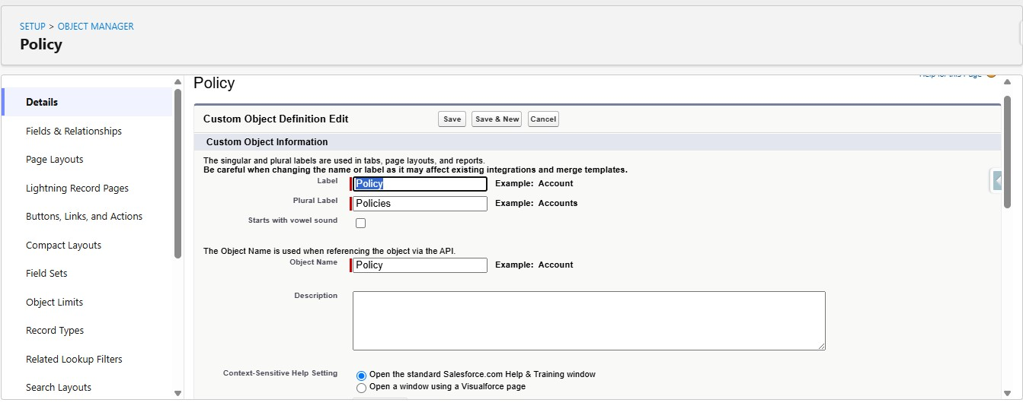

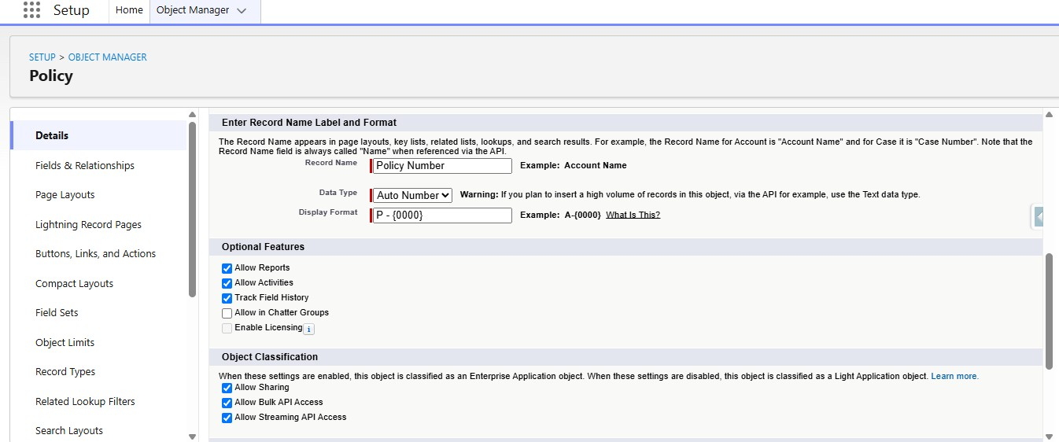

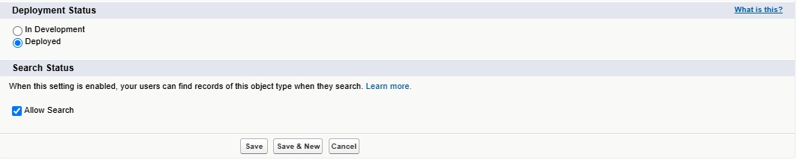

- Define Record Types on Policy Object:

○ Go to setup, Click on Object Manager.
○ Search for Policy objects and click on Policy__c.
○ In the left side panel, click on the record types.
○ Click on New.
○ Fill out the following details:
○ Select the existing record type as Master.
○ Give record type label as “Auto”
○ Record Type Name will be auto populated.
○ Give a meaningful description.
○ Check the active checkbox.
○ Check the Make Available checkbox for all the profiles. ○ Click on Next.
● It will redirect to the Assign page layouts page, Leave everything as is, and click on save.

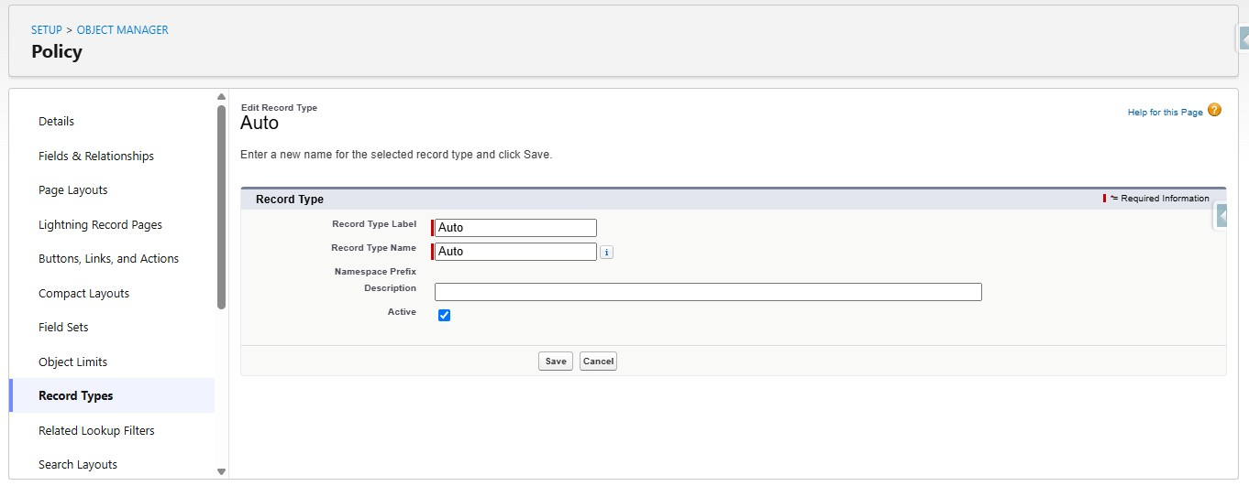

Repeat the same steps for creating the property and life record types as well.

- Create Field Sets for policy specific data:

○ Go to setup, Click on Object Manager.
○ Search for Policy object and click on Policy__c.
○ In the left side panel, click on the Field Sets.
○ Click on New.
○ Fill out the following details:
○ Field Set Label as Vehicle
○ Field Set Name will be Auto populated.
○ Where is this used: In the policy object.
○ Click on save.
○ Click on the field set you have just created and it will redirect to the page layout setup.
○ Drag VIN, and model year fields to the field set and click on save.

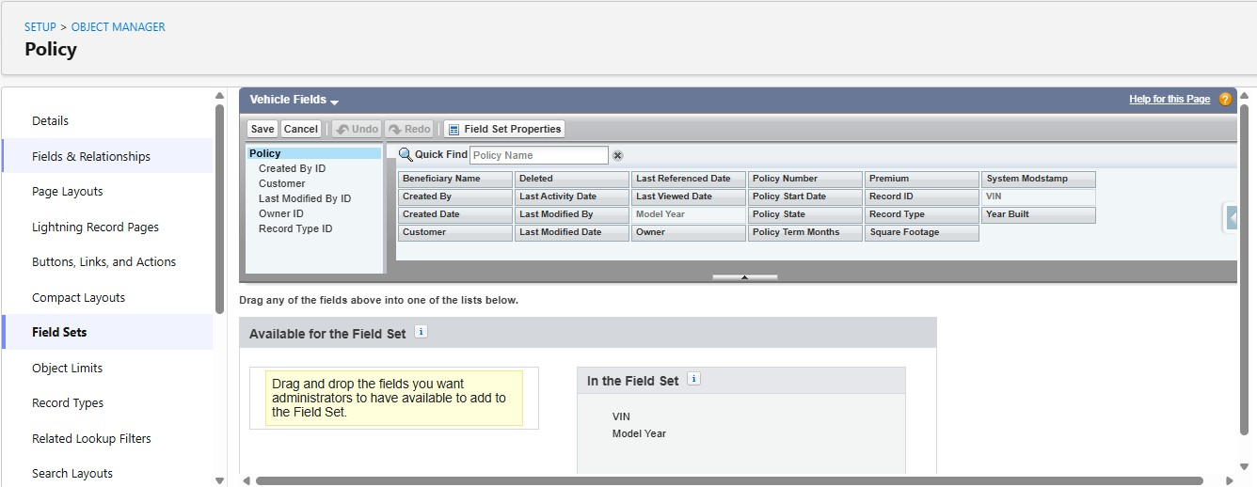

Repeat the same steps for creating the property and life Field sets as well.

3.1 Property FieldSet Requires:
- Square footage
- Year Built
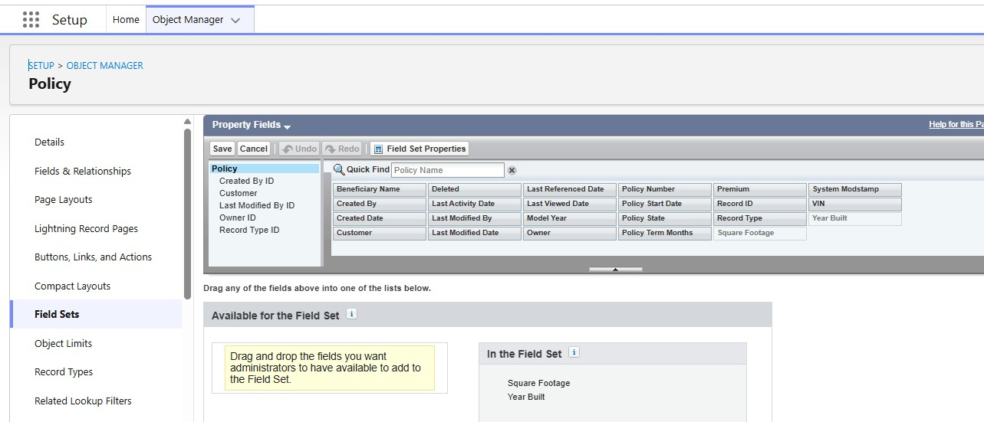

3.2 Life FieldSet Requires:
- Beneficiary Name
- Policy Term Months

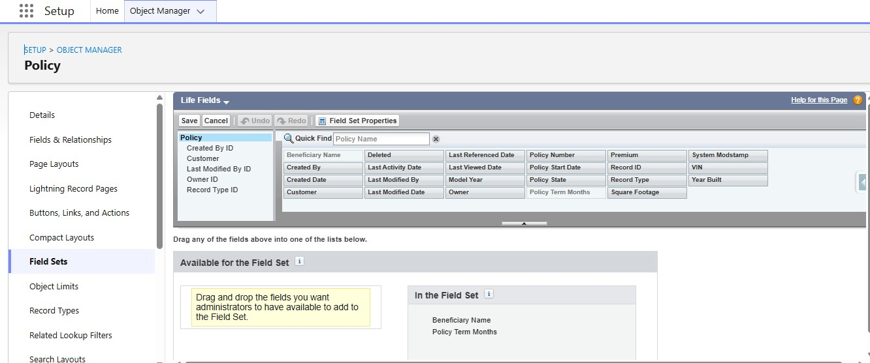

- Create Fields in the Policy Object:

S.No | Name of the Field | Data Type | Required
1 | Beneficiary Name | Text(50)
2 | Customer | Lookup(Contact)
3 | Model Year | Text(5)
4 | Policy Start Date | Date
5 | Policy Term Months | Number(18, 0)
6 | Premium | Currency(16, 2)
7 | Square Footage | Number(18, 0)
8 | VIN | Text(20)
9 | Year Built | Text(5)

- Create Claim custom object:

  - Go to setup, Click on object Manager.
  - Click on create and select custom object.
  - Fill the following details:
  - Label: Claim
  - Plural Label: Claim
  - Object Name: Auto Populated
  - Record Name: Claim Number
  - Data type: Auto Number
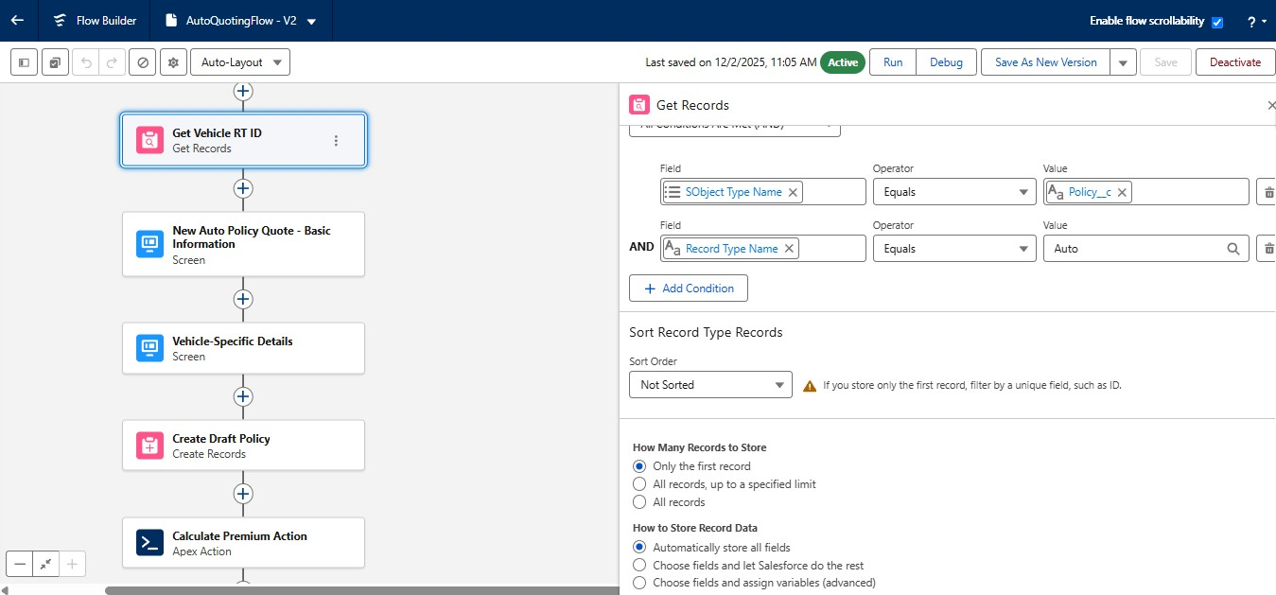
  - Add Screen Element immediately after the Get Records Element ● Give the label as New Auto Policy Quote - Basic Information ● API Name will be auto populated.
  - Drag the display text component into the flow canvas
  - Give the API Name as Screen_1_Policy_Basics
  - Drag the Lookup Component into the Canvas, Give API Name as
Customer Lookup, Field API Name as Customer__c, Label as Policy Holder, ObjectApiName as Policy__c
  - Drag Date component into the canvas, Give Label as Policy Start Date, API Name will be auto populated.
  - Drag the picklist component into the canvas, Give the label as Policy
State, API Name will be auto populated, For Choice, Create a new
Resource, Resource Type should be Picklist Choice Set, Give the API Name, Select the Policy for Object, Select Picklist as Datatype, Select Policy State as Field and Click on save
  - Click on Done
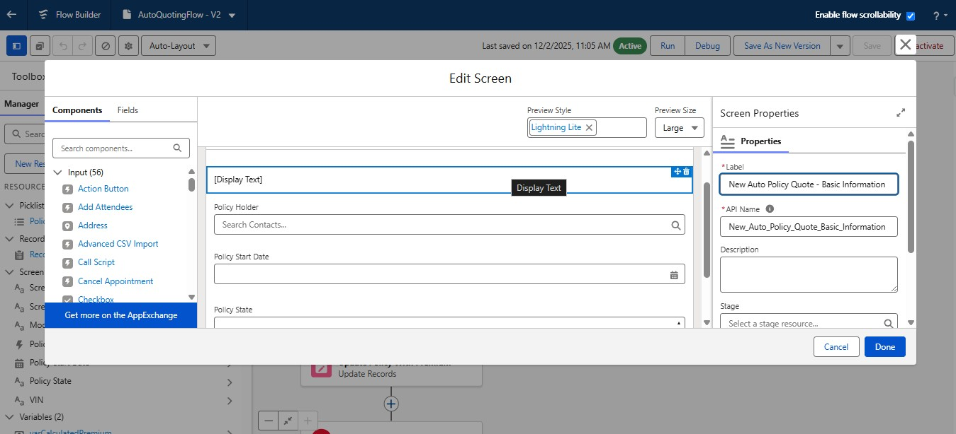
  - Add another screen element after the Auto Policy Quote - Basic Information screen
  - Give the label as Vehicle-Specific Details ● API Name will be auto populated.
  - Drag the display text component into the flow canvas
  - Give the API Name as Screen_2_Vehicle_Details
  - Drag the text component into the canvas, Give the label as VIN, API name will be auto populated
  - Again, Drag the text component into the canvas, Give the label as Model year, API name will be auto populated. ● Click on done.
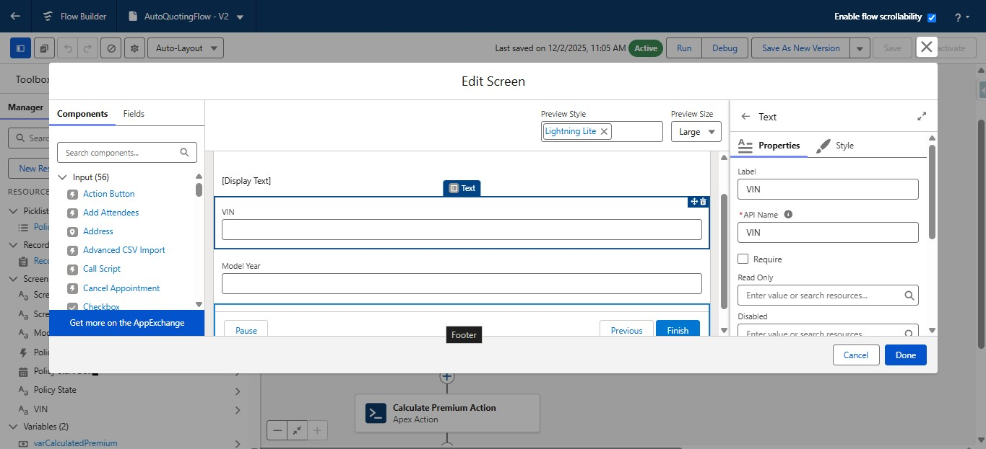
  - Add Create Records Element after the screen element.
  - Give the label as Create Draft Policy, API name will be auto populated
  - Store field values manually
  - Select the policy object
  - Set fields for the policy object as shown below:
  - Customer —> From Basic information screen-> Policy Holder -> Record ID
  - Model Year—--> Vehicle information screen -> Model Year
  - Policy Start Date —> From Basic information screen→Policy Start Date
  - Policy State —> From Basic information screen —> Policy State
  - RecordType ID —> From Get Vehicle RT Id —> RecordType ID
  - VIN —> From Vehicle Information Screen —> VIN
  - Check manually assign variables checkbox
  - In the place of variable, create a new resource, Whose resource type is variable, API Name would be varPolicyId, Datatype would be Text, Click on Done.
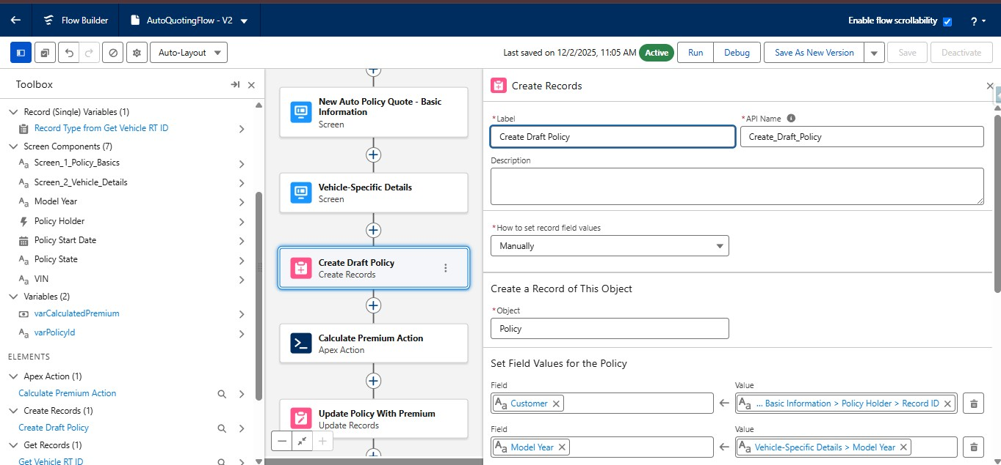
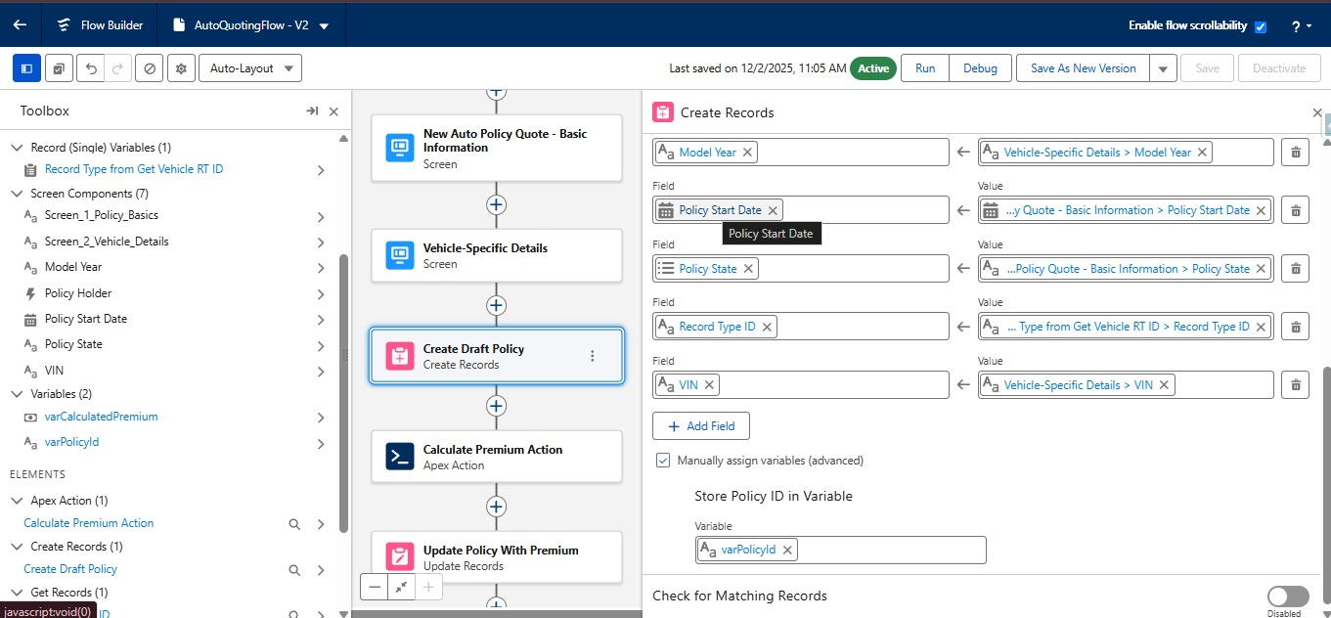
  - Save the flow with AutoQuotingFlow
  - Activate the flow

9. Create Validation Rule on Policy Object:
- Go to object manager, Search for the policy object and click on policy object
- In the left side panel, scroll down and find validation rules and click on it ● Click on New
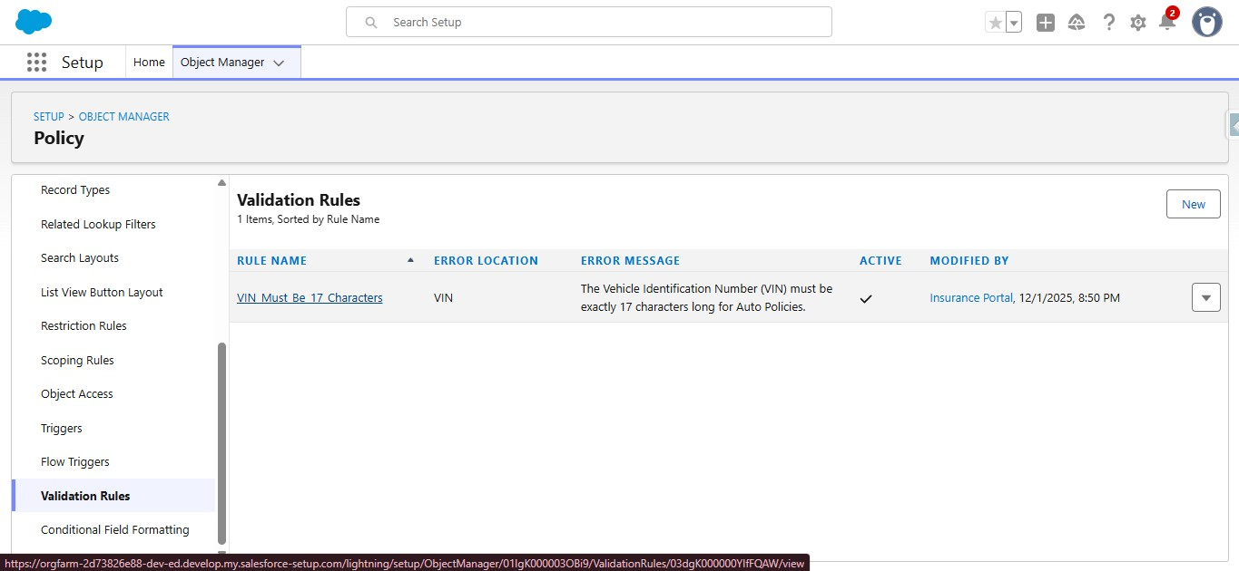
- Give the rule name as VIN_Must_Be_17_Characters
- Check the active checkbox
- Write the following formula in the formula editor
○ AND( RecordType.DeveloperName = "Auto", LEN( VIN__c )<> 17)
- For error message, The Vehicle Identification Number (VIN) must be exactly 17 characters long for Auto Policies.
- Select error location as field and select VIN field
- Click on Save
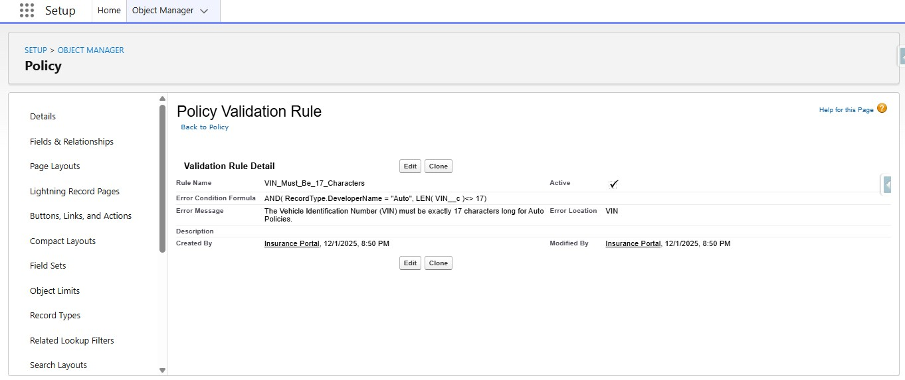

Milestone 2: Complex Policy Issuance & Claim Routing Automation

1. Create an Apex Class (PremiumCalculator) with a method that accepts policy data
- Click on setup icon, Right click on developer console, Open the link in new tab
- At the top left corner, click on the file, then click on new, and click on Apex class, Give the name as PremiumCalculator and click on create. ● Paste the following code in the apex class:
public class PremiumCalculator {
public class PremiumInputWrapper {
@InvocableVariable(required=true)
- Resource type would be variable, API Name would be varCalculatedPremium, Data type would be currency, Decimal places are ‘2’ and click Done.
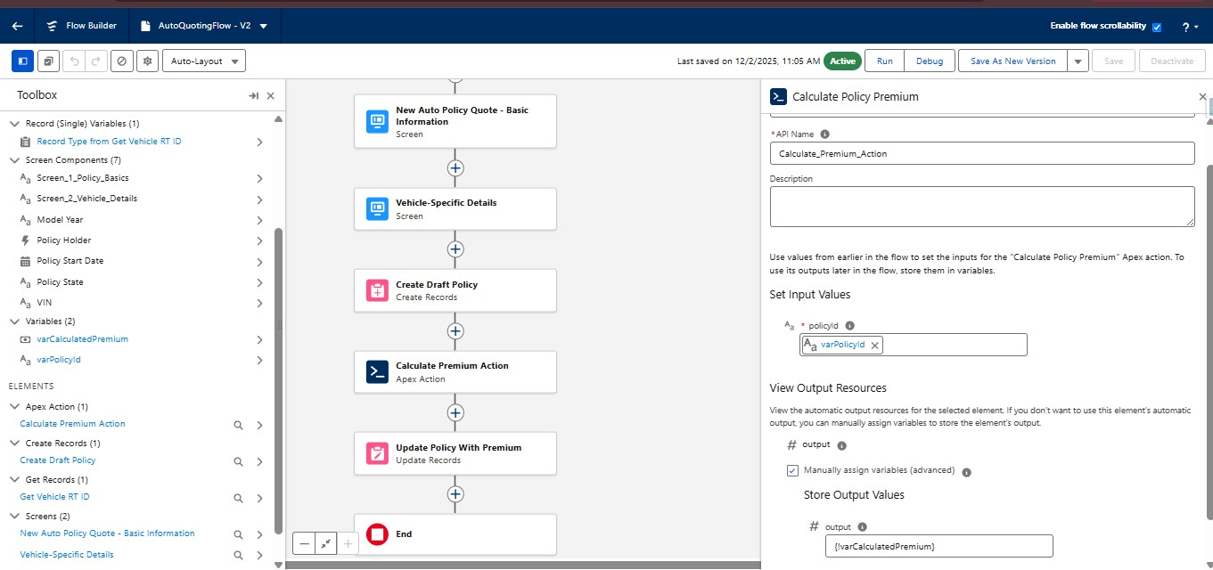
- After the action element, add the update records element, Give the label as Update Policy With Premium
- For how to find records to update and set their values, Select Specify conditions to identify records, and set fields individually
- Select object as policy
- Select all conditions are met for filter criteria ● The conditions include:
- Record Id Equals varPolicyId variable
- Under set field values for policy record
- Assign varCalculatedPremium variable to the Premium field
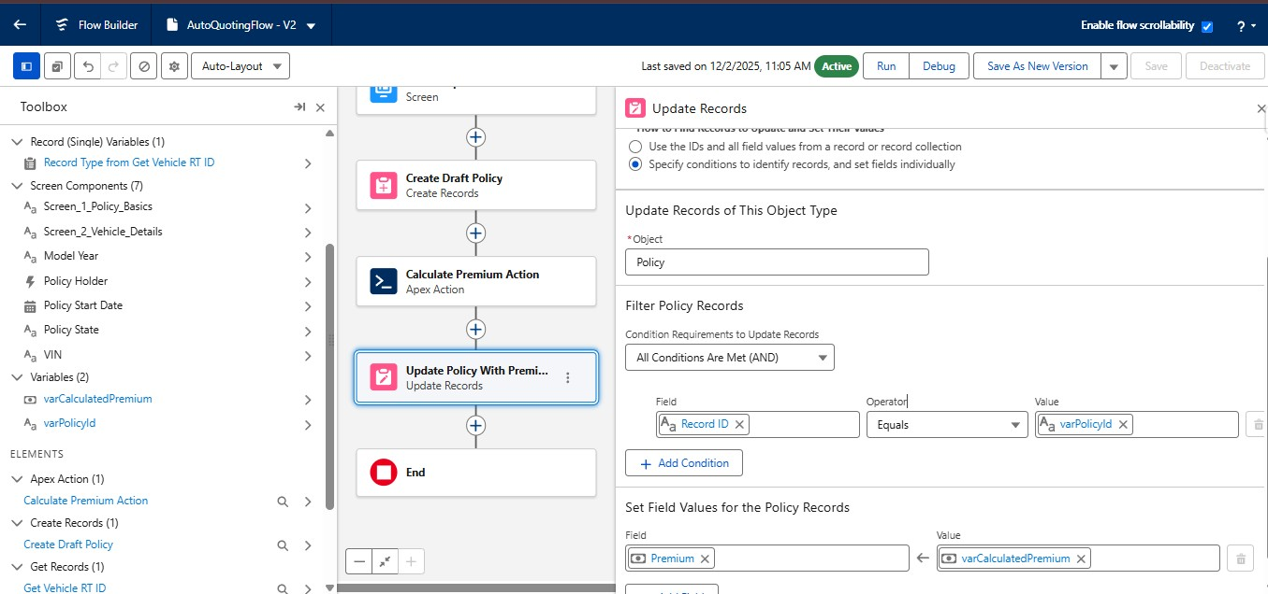
- Save the flow as a new version ● Activate the flow.

3. Create a Record-Triggered Flow (After Save) on the Claim object.
- Go to setup, In the quick find box, Search for flows and click on flows
- Click on New Flow, select Record Triggered Flow and Click on Create
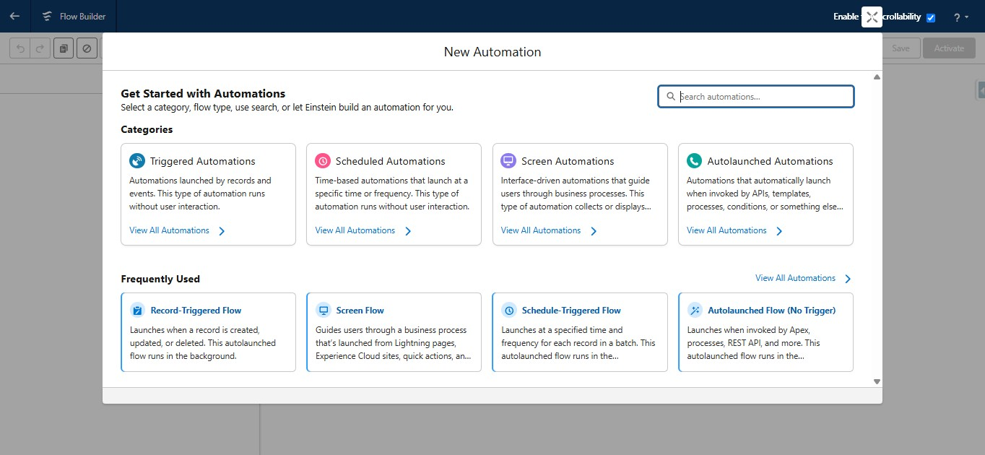
- Select Claim for an object
- Configure trigger when the record is created
- Optimize flow for action and Related Records
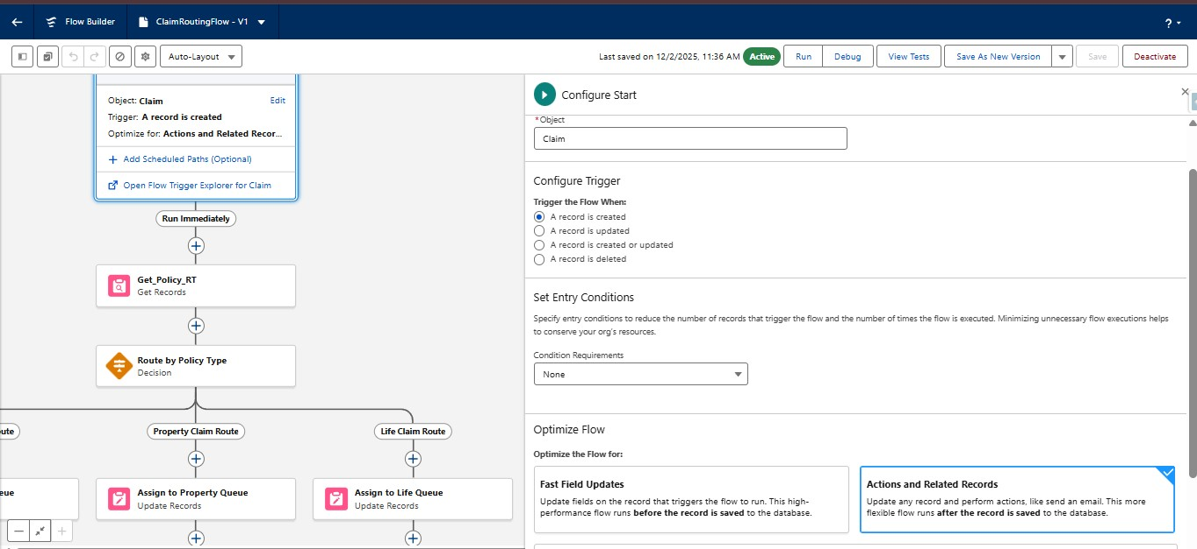
- Add Get Records element after the start and give the label as
Get_Policy_RT
- Select policy for object
- Specify all conditions are met for conditional requirements ● The conditions include:
- Record Id Equals Triggering Claim → Policy
- Store only the first record
- Choose fields and assign variables for storing record data
- Select in Separate variables for where to store field values section
- Under select variables to store policy fields
- For recordTypeID field Create a resource, Resource type would be variable, API Name would be varPolicyRTName, Data type would be Text and click on Done
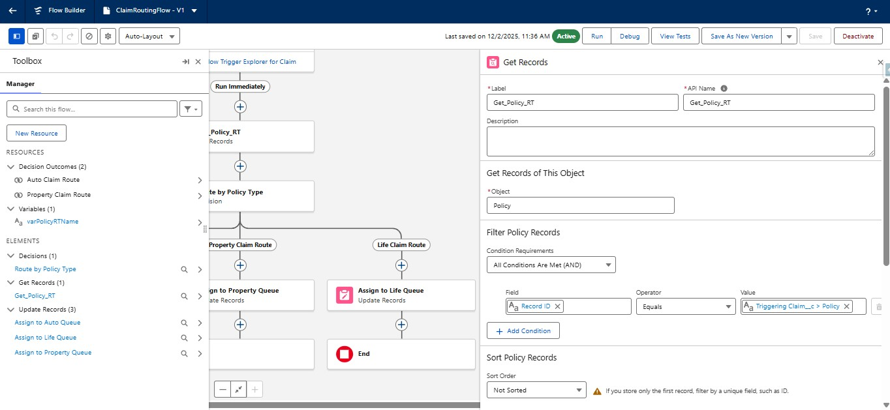
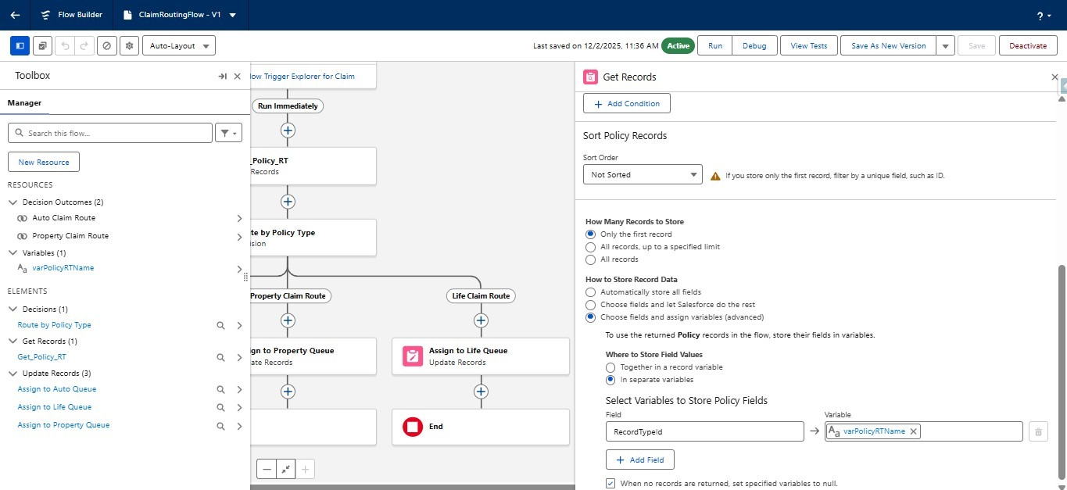
- Under Get Records Element, Add decision element
- Give the label as Route by Policy Type
- API name will be auto populated
- Select Decision Logic as Manually set conditions ● Specify the Outcomes:
- Outcome1:
○ Label as Auto Claim Route
○ API name will be auto populated
○ Select All conditions for the conditional Requirements

Milestone 3: Claims Adjuster LWC Dashboard Development

1. Create a robust Apex class (ClaimsAdjusterController) with a method using SOQL to query all Claims owned by the logged-in user, joining related Policy and Customer data. The method must return a custom Wrapper Class listing key metrics.
- Click on setup icon, Right click on developer console, Open the link in new tab
- At the top left corner, click on the file, then click on new, and click on Apex class, Give the name as ClaimsAdjusterController and click on create. ● Paste the following code in the apex class:
public class ClaimsAdjusterController {

public class ClaimWrapper {
@AuraEnabled public Id claimId;
@AuraEnabled public String claimNumber;
@AuraEnabled public Decimal claimAmount;
@AuraEnabled public String status;
@AuraEnabled public String policyType;
@AuraEnabled public String policyHolderName;
@AuraEnabled public Integer daysOpen;

<div class="slds-m-around_medium">
<lightning-combobox
name="policyFilter"
label="Filter by Policy Type"
value="All"
options={policyTypeOptions}
onchange={handleFilterChange}
class="slds-m-bottom_medium"
></lightning-combobox>
<template if:true={visibleClaims}>
<div class="slds-grid slds-wrap slds-grid_pull-padded">
<template for:each={visibleClaims} for:item="claim">
<div key={claim.claimId} class="slds-col
slds-size_1-of-1 slds-medium-size_1-of-2 slds-large-size_1-of-3
slds-p-horizontal_small">
<c-claim-tile-lwc
claim-data={claim}></c-claim-tile-lwc>

export default class ClaimsDashboardLwc extends LightningElement {
// List to hold all data retrieved from Apex
@track allClaims = [];
// List to display after filtering
@track visibleClaims = [];
error;
// Wire service to call the Apex method
@wire(getAssignedClaims)
wiredClaims({ error, data }) {
if (data) {
this.allClaims = data;
this.visibleClaims = data; // Initially display all claims
this.error = undefined;
} else if (error) {
- Open the meta-xml file and paste the following code:
<?xml version="1.0"?>
<LightningComponentBundle xmlns="http://soap.sforce.com/2006/04/metadata">
<apiVersion>63.0</apiVersion>
<isExposed>true</isExposed>
<targets>
<target>lightning__AppPage</target>
<target>lightning__HomePage</target>
</targets>
</LightningComponentBundle>

3. Create a reusable component (claimTileLwc) to display essential information for each claim
- Open the Lightning studio extension from your salesforce org ● On the Top left corner, you will find Create New
- Click on Create New and Click on Lightning Web Component
- Enter the name of the Component as claimTileLwc
- Check the isExposed checkbox
- Under target configurations, Select Lightning app page, Home page and Record page
- Click on Deploy
- Open the HTML file and paste the following code:
Milestone 4: Advanced Claim Processing, Security & Code Setup

- Modify the Claim object to include an Approval Status field.
    - Go to set up, Click on object manager, search for claim object and click on claim object.
    - In the left side panel, click on fields and relationships.
    - Click on new
    - Select Datatype as picklist
    - Label it as Approval Status
    - Select enter values radio button
    - Enter New, Submitted for Approval, Approved and Rejected line by line ● Field Name will be auto populated ● Click on Next, Next and Save.

- Configure the Approval Process to route first to the Senior Adjuster, then to the Department Manager, using two sequential steps.
  - Go to setup, In the quick find box, Search for Approval process
  - Select claim object for Manage approval process for
  - Click on create new Approval Process and select use standard setup wizard
  - Give the process name as High Value Claim Approval
  - Unique Name will be auto populated
  - Click on Next
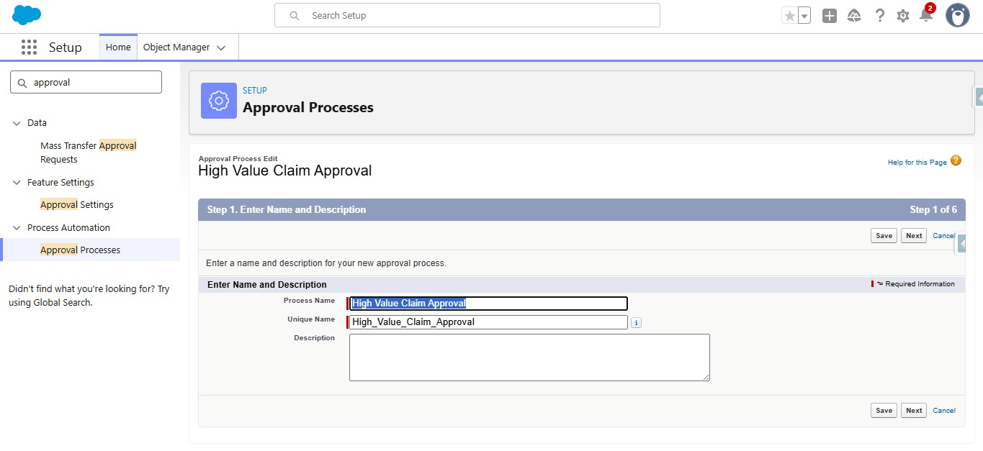
  - Under specify entry criteria, Select criteria are met for Use this approval process if
  - Criteria includes:
  - Claim amount greater than 50000
  - Click on Next
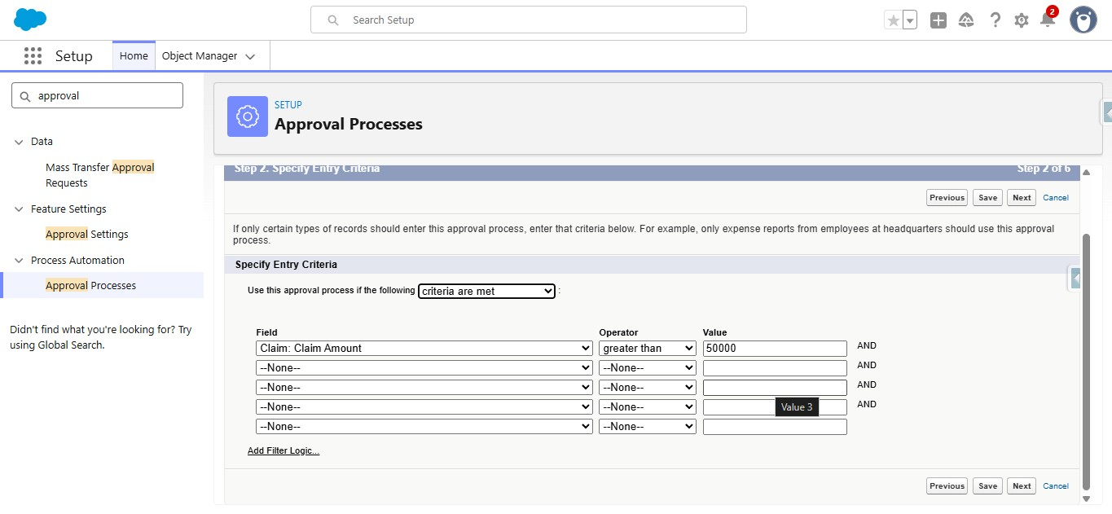
  - Under Record Editability properties, Select Administrators ONLY can edit the records during the approval process
  - Click on Next
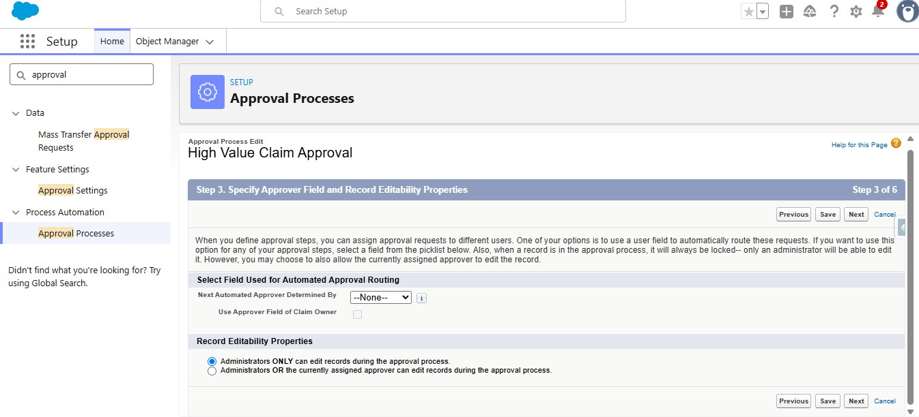
  - Click on next again
  - Under Approval Page Layout, Select Claim Number, Owner, Claim
Amount, Adjuster, Policy fields to the selected fields from available fields
  - Under security settings, Select Allow Approvers to access the page only from within the salesforce application.
  - Click on Next
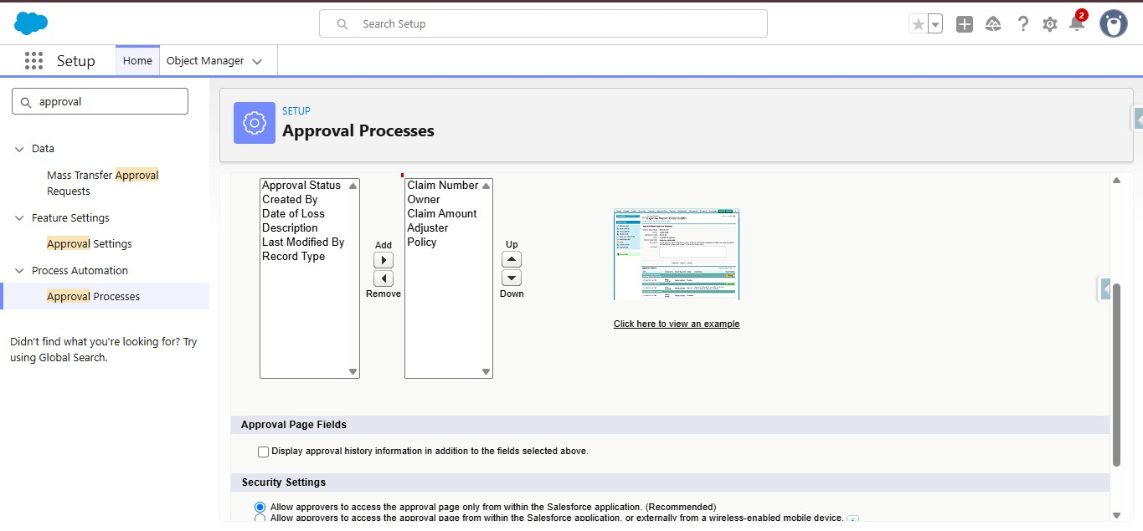
  - Under Initial Submitters, Search for owner under submitter type, and select the claim owner as allowed submitters from available submitters
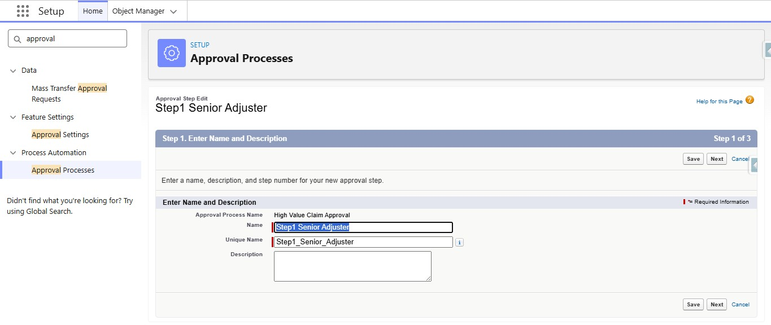
  - Under specify step criteria, Select all records should enter the step ● Click on Next
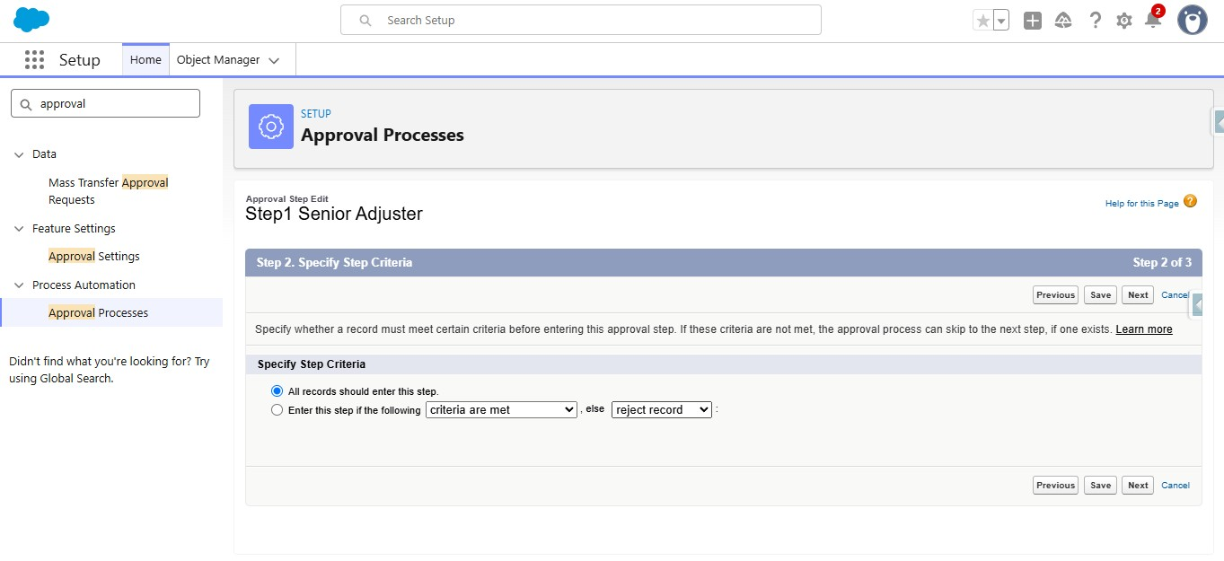
  - Under select Approver, Select Automatically assign to approver
  - Under that select the Senior Adjuster User
  - Under when multiple approvers are selected, select Approve or Reject based on the FIRST Response
  - Click on Save
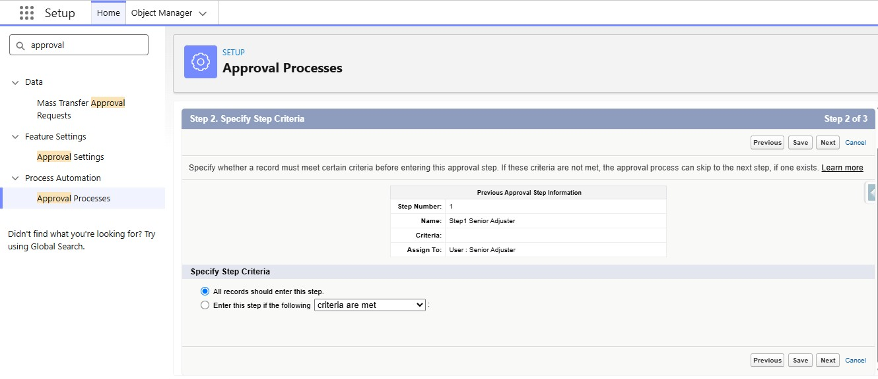
  - Under select Approver, Select Automatically assign to approver
  - Under that select the Department Manager User
  - Under when multiple approvers are selected, select Approve or Reject based on the FIRST Response
  - Under Reject behaviour, Select Perform all rejection actions for this step AND all final rejection actions
  - Click on Save
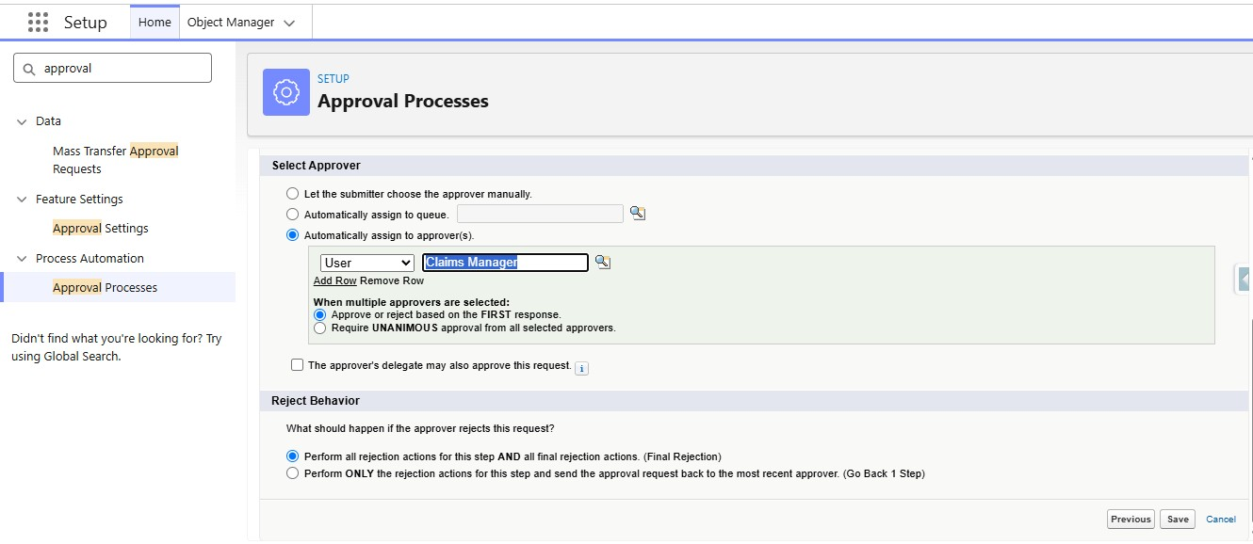
  - Under Initial Submission Actions, Click on Add New and select Field Update
  - Give the name as Update Status Submitted
  - Activate the Approval Process.

- Create a Record-Triggered Flow (After Save) that checks if the Claim
Amount is $>\$50,000$ and submits the record to an Approval Process.
      - Go to setup, In the quick find box, search for flows and click on flows.
      - Click on New Flow
      - Select Record Triggered Flow
      - Select object as Claim
      - Configure Trigger When a Record is created or updated ● Select All conditions are true for conditional requirements ● The conditions include:
○ Claim Amount Greater than 50000
○ Approval Status Equals New
      - Select Every time a record is updated and meets the conditional requirements for When to run the flow for Updated Records
      - Optimize the flow for Action and Related Records
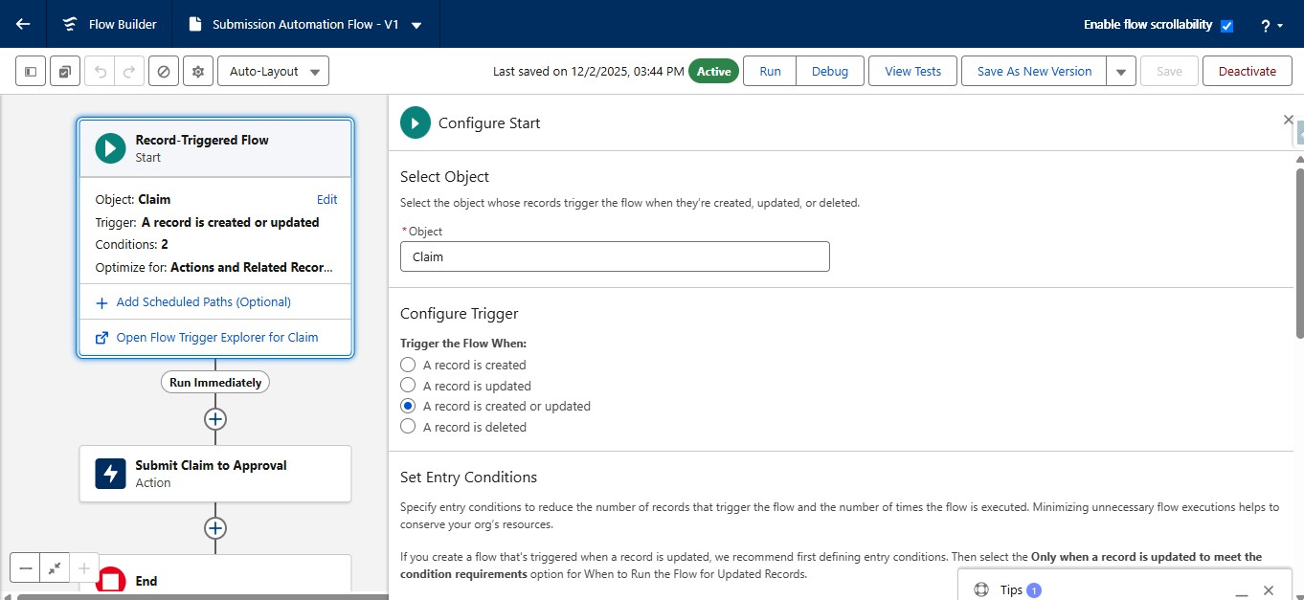
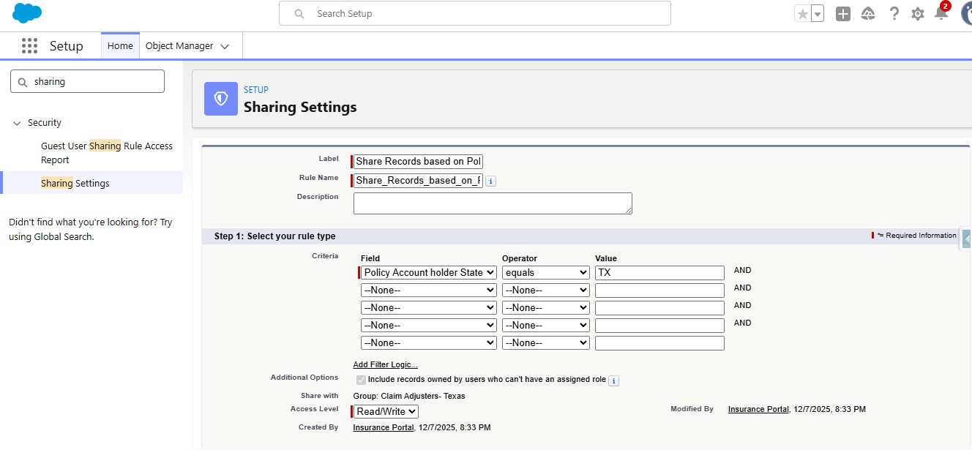

- Finalize all Permission Sets to differentiate access between Agents (Quoting only), Adjusters (Claim handling), and Managers (Reporting/Approvals).
    - Go to setup, In the quick find box, Search for Permission Sets,
Click on Permission Sets
    - Click on New
    - Give the Label as Insurance Agent Access
    - API Name will be Auto Populated
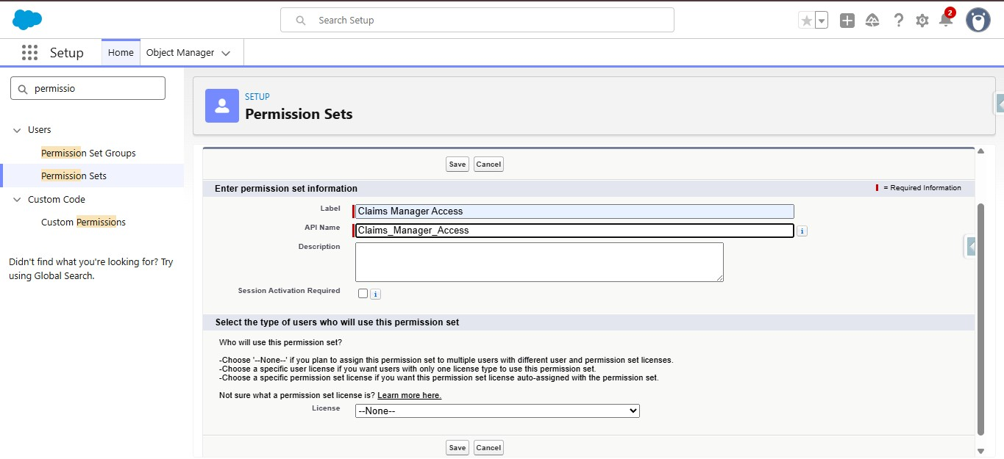
    - Give the access to objects
    - Give Read Only for Policy object
    - Give Read, Edit to contact Object
    - Give Read, Edit, Delete to Claim object
    - Make Run Reports Enabled under System permissions
    - Make Manage Approvals enabled under system permissions
7.2 Create Claims Adjuster Access Permission Set
  - Click on New
  - Give the Label as Claims Adjuster Access
  - API Name will be Auto Populated
  - Automated Claim Routing – Claims are routed to the appropriate queue based on policy type.
  - Faster Claim Processing – Approval and escalation processes reduce manual effort.
  - Better Visibility – LWC Claims Dashboard gives adjusters a focused view of assigned claims.
  - Improved Data Accuracy – Validation rules help maintain accurate policy information.
  - Flexible Data Model – Record Types and Field Sets support different insurance products.
  - Secure Access – Permission Sets and Sharing Rules support role- and state-based access.
  - Scalable Solution – The architecture can support multiple insurance lines and future enhancements.
These advantages are supported by the project's stated objectives and solution approach.

Disadvantages
- Complex Data Management – Vehicle, Property, and Life policies require different data fields.
- Approval Complexity – Claim approval must consider claim amount, policy type, and adjuster level.
- User Adoption – Agents need intuitive flows to minimize clicks and improve efficiency.
- Integration Complexity – External database callout simulation requires additional Apex and mock test classes.
- Salesforce Dependency – The solution depends on Salesforce configuration and platform capabilities.
- Implementation Effort – Multiple Flows, Apex classes, LWC components, security rules, and approval processes require careful development and maintenance.
The first four challenges are explicitly identified in the project document; the Salesforce dependency and implementation effort are reasonable project-level limitations inferred from the solution's technical scope.

- Conclusion:

The Multi-Line Insurance Policy and Claims Management System provides a centralized Salesforce-based solution for managing Vehicle, Property, and Life Insurance policies and claims. The project addresses the limitations of manual and fragmented processes by introducing guided quoting, automated premium calculation, claim routing, structured approval processes, and an LWC-based Claims Dashboard.
The solution uses a combination of Salesforce Flows, Apex, Record Types, Field Sets, Validation Rules, Approval Processes, LWC, Permission Sets, and Sharing Rules to improve policy processing, claim handling, data accuracy, security, and operational visibility.
Overall, the project demonstrates how Salesforce can bring multiple insurance processes together on a single scalable platform, helping insurance teams work more efficiently while providing better visibility and service to customers.
- FUTURE SCOPE
The Multi-Line Insurance Policy and Claims Management System can be further enhanced in the following areas:
  - External System Integration – Integrate with external vehicle and property databases for real-time quote verification.
  - Additional Insurance Products – Extend the solution to support additional insurance lines beyond Vehicle, Property, and Life.

