**Splunk server handshake application usage documentation:**

1, Create virtual env setup and run server using run_devel_server.sh, Check ***READ.md*** for more details

2, Open the ***Google chrome/Firefox***  browser

3, Enter below URL

http://localhost:8000/

4, Input pharameters (all are required) :

server_ip : <splunk server ip address with port>

user_name : <splunk server’s user name>

password : <splunk server’s password>

search_keyword : <valid search query keyword>

starting_date_time : <starting date and time>

Email : <Response receiver email>

5, Click Process

6, It’ll search the query in splunk server and send it’s response to email at background

7, The Success / Fail responses, it’ll shown message in same page (at below of process button.)

**Ref. Images:**

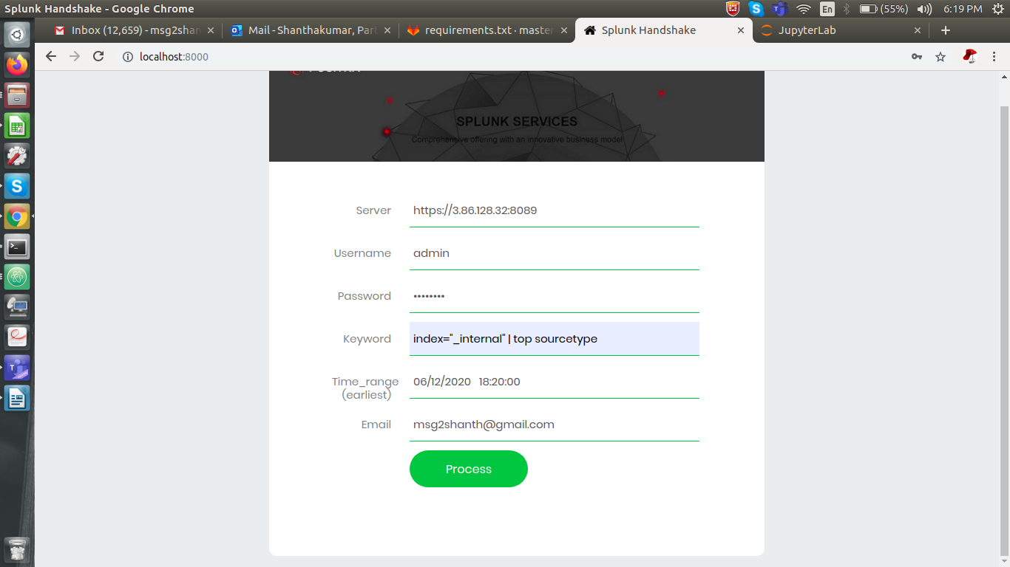

**Fig 1. Input request**

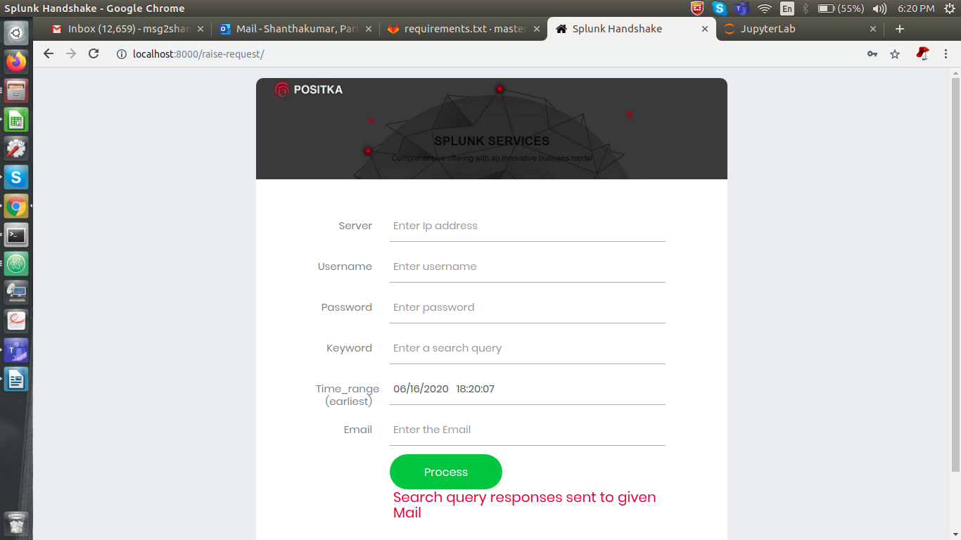

**Fig 2. Success message response**

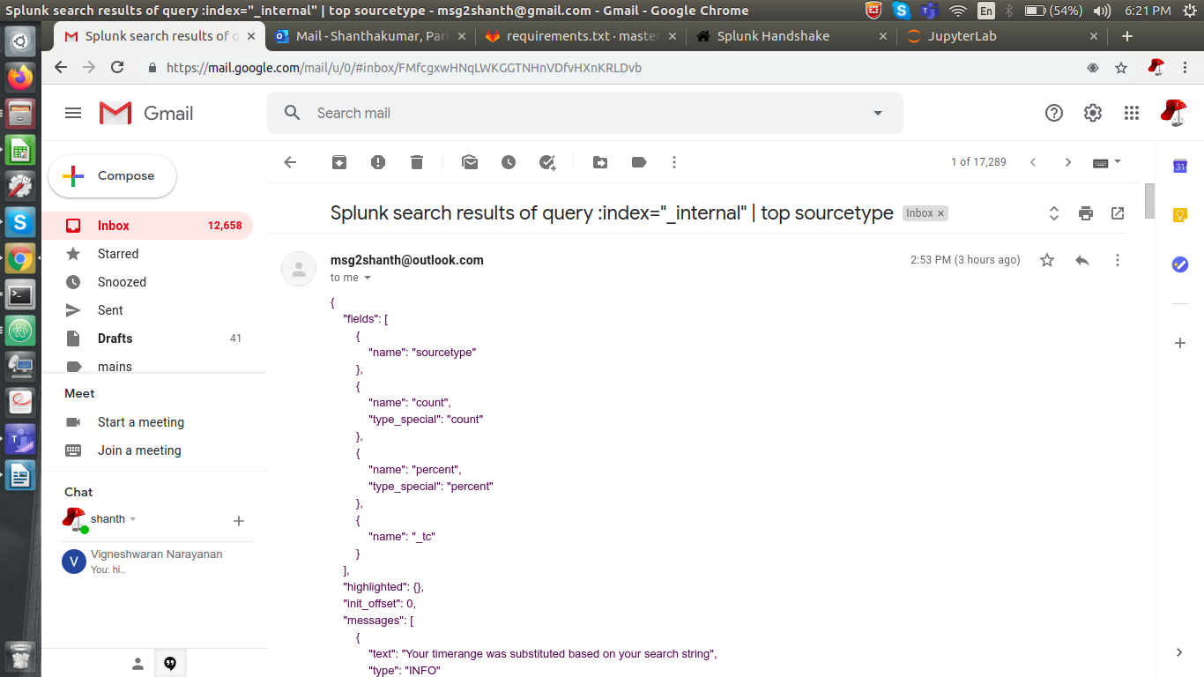

**Fig 3. Search Responses in mail**