HireSense
AI-Powered Candidate Evaluation Platform
Solution Document

Document status | Draft v1.0
Date | 22 September 2026
Prepared for | HireSense Client
Scope | Solution architecture & delivery plan (pre-implementation)
Deployment target | AWS (single-org, single-region, v1)

Table of Contents
1. Purpose & Business Context
2. Scope
3. Stakeholders & Roles
4. Functional Requirements Traceability
5. Non-Functional Requirements
6. Solution Architecture Overview
7. Component Design
8. Data Model
9. Primary Application / Process Flow
10. AWS Deployment Architecture
11. Technology Stack Summary
12. Security, Compliance & PII Handling
13. Phased Delivery Roadmap
14. Open Questions & Assumptions
15. Appendix: Glossary

1. Purpose & Business Context
HireSense is an AI-powered candidate evaluation application designed to reduce the manual effort of resume screening. It allows recruiters and hiring managers to create or upload Job Descriptions (JDs), bulk-upload candidate resumes against a JD, and have every candidate automatically scored and explained against that JD. The system is built to handle 10-100+ resumes per JD.
The core operating principle that governs every design decision in this document:
“Use AI to reduce resume-screening effort and provide structured, explainable recommendations while keeping the final hiring decision with the human recruiter or hiring manager.”
In practice this means HireSense is a decision-support system, not a decision-making system: the AI never finalizes a candidate's status, and no candidate-facing email is ever sent without an explicit human approval action.

2. Scope

2.1 In scope — Phase 1 (this document)
- JD creation (manual, upload, AI-generate/improve) and management of multiple active JDs.
- Bulk candidate resume upload and parsing, associated to a JD.
- Configurable, weighted AI evaluation producing an overall score, category scores, and explainable insights per candidate.
- Candidate ranking, Top-10 identification, filtering and sorting.
- Human-in-the-loop decisioning (Shortlisted / Hold / Rejected) with full decision history.
- Re-evaluation / rescoring with version history when JD, criteria, weights, or candidate data changes.
- AI-drafted candidate email communication, sent only after explicit human approval.
- Role-based access control: Admin, Recruiter/Evaluator, Viewer/Hiring Manager.
- Single organization (no multi-tenancy) deployment on AWS.

2.2 Explicitly out of scope for Phase 1
- Multi-tenant / multi-organization support (single-org for v1; data model leaves room to add an Organization entity later without a rewrite).
- SSO / enterprise identity provider integration (email/password auth for v1).
- Applicant-facing self-service portal (candidates do not log in; they are only recipients of outbound email).
- Interview scheduling, offer management, or downstream HRIS/ATS integrations.

3. Stakeholders & Roles
Role | Can do
Admin | Manage users and entitlements; configure application-level settings (default evaluation weights, templates).
Recruiter / Evaluator | Create JDs; upload candidates; trigger evaluation and rescoring; update candidate status; initiate and send candidate communication.
Viewer / Hiring Manager | Read-only: review JDs, candidate evaluations, recommendations, and status. Cannot change status, weights, or send email.

4. Functional Requirements Traceability
Every functional requirement in the Business Requirements Document maps to a named service in this architecture (see Section 7):
BRD Section | Requirement | Owning Component
1 | Create/manage JDs using AI | JD Service
2 (Step 1) | Create/upload/AI-generate JD; multiple active JDs | JD Service
2 (Step 2) | Bulk resume upload; extract info; associate to JD; handle 100+/JD | Resume Ingestion Service
2 (Step 3) | Overall + category scores; configurable weightage | Evaluation Orchestrator
2 (Step 4) | Explainable insights (strengths, gaps, recommendation, ranking rationale) | Evaluation Orchestrator
3 | Rank candidates; Top 10; filter/sort | Ranking & Shortlisting Service
4 | Human sets Shortlisted/Hold/Rejected; decision history | Decision & Audit Service
5 | Rescoring on JD/criteria/weight/data change; version history | Evaluation Orchestrator
6 | AI-drafted email; human-approved send only | Communication Service
7 | RBAC: Admin / Recruiter / Viewer | API Gateway / Auth layer, all services

5. Non-Functional Requirements
Category | Requirement | Design response
Scale | 10-100+ resumes per JD | Bulk upload + async job queue (SQS) + horizontally scalable worker service; nothing resume-related runs synchronously in the request path.
Explainability | Every score must come with a reason | LLM evaluation calls always return structured insights (strengths, gaps, recommendation) alongside the numeric score — never a bare number.
Governance | AI never finalizes a decision | Status transitions are a separate, human-only write path (Decision & Audit Service); no code path lets an evaluation job set candidate status.
Auditability | Decision and score history must be retained | CandidateDecision is an append-only log; Evaluation rows are versioned (is_latest flag) rather than overwritten.
Control | Email must require explicit human approval | EmailDraft has a draft/sent state machine; the send action is a distinct, logged, human-triggered API call.
Configurability | Evaluation weights must be adjustable | EvaluationCriteria is a versioned, editable table per JD, not a hardcoded prompt constant.
Security | Resumes contain PII | Resumes stored in a private S3 bucket (SSE encryption), access scoped by JD/role, secrets never in code.

6. Solution Architecture Overview
The system is a modular monolith at the application layer (FastAPI, Python) fronted by a Next.js web client, backed by PostgreSQL for structured data, S3 for resume files, and an SQS-backed job queue for asynchronous AI evaluation work. Services are organized as clean internal modules for v1; the boundaries are drawn so any module can be split into an independent deployable later without a data-model rewrite.
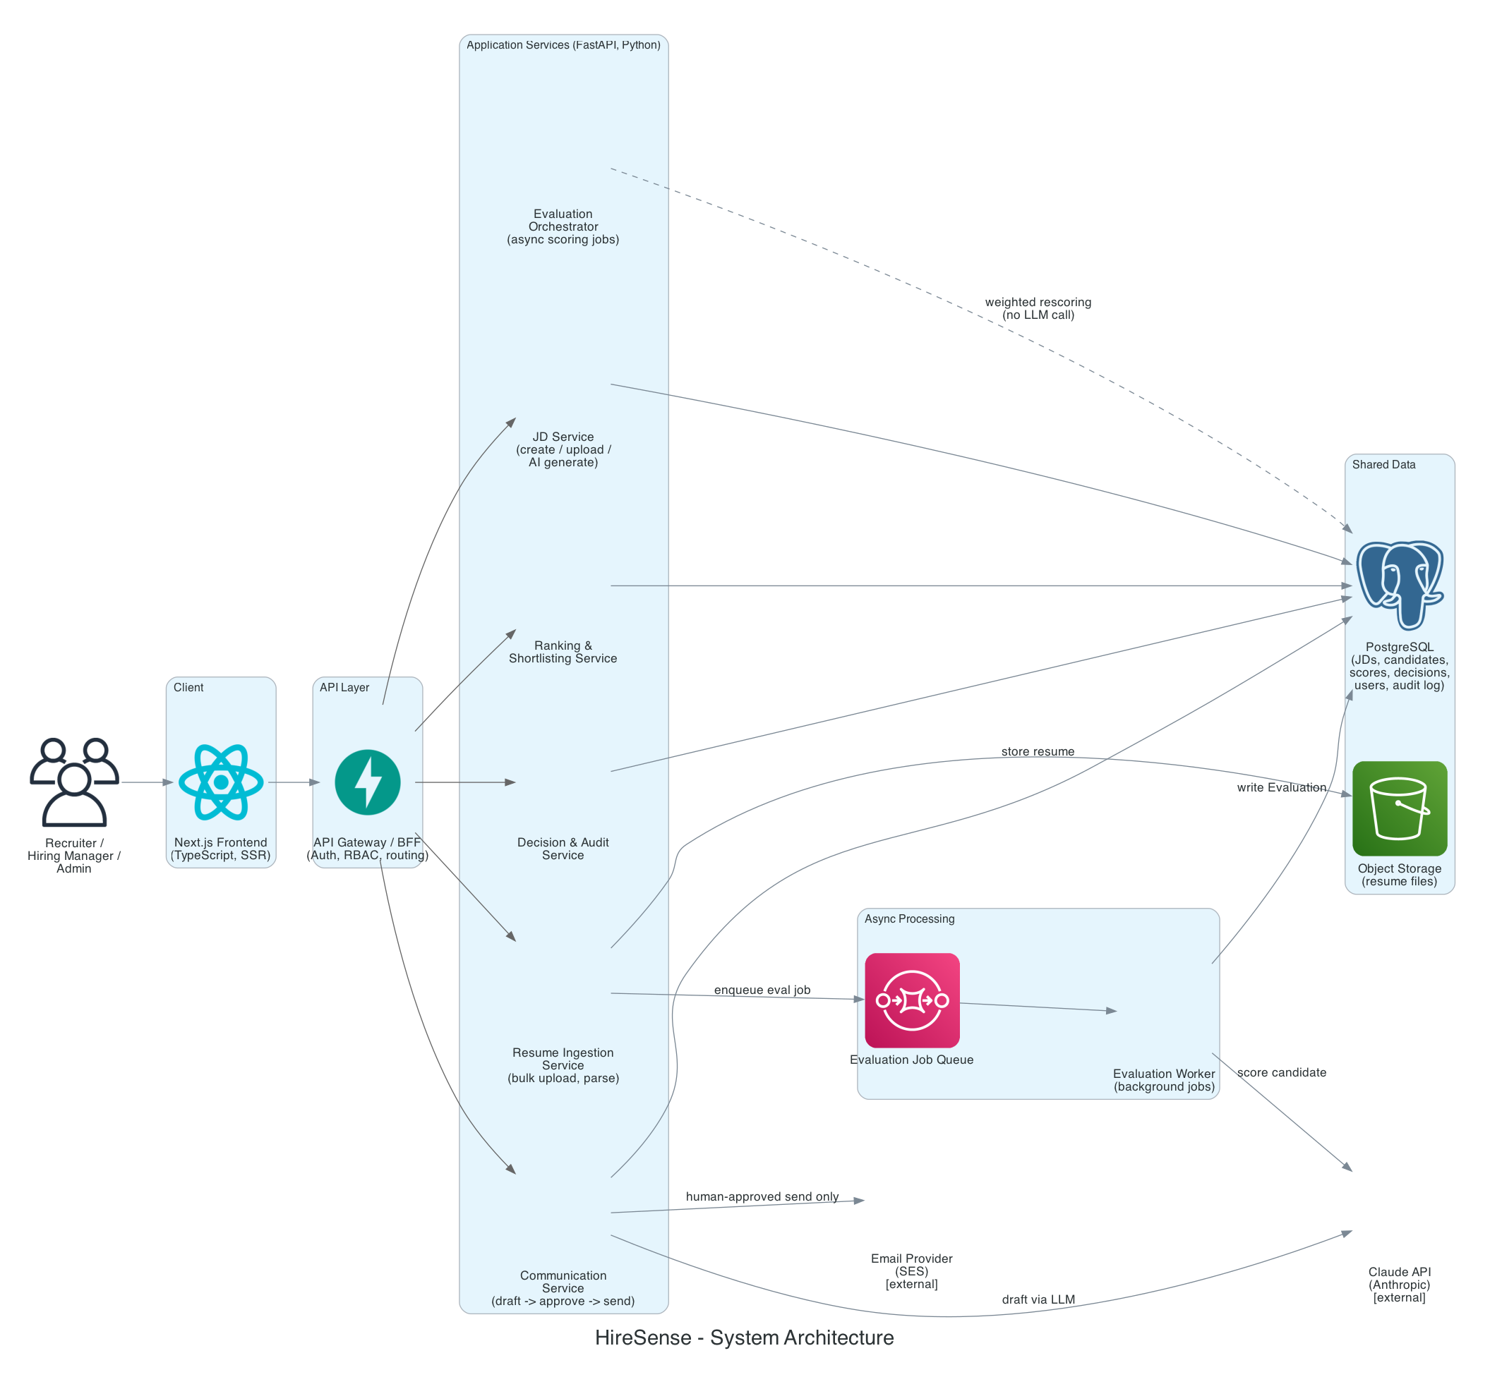
Figure 1 — HireSense logical system architecture.

7. Component Design

7.1 JD Service
- CRUD for Job Descriptions; each JD is an independent evaluation workspace.
- AI actions: generate a JD from a title/bullet list, or improve/rewrite an uploaded JD — returns structured requirements (must-have skills, nice-to-have, experience range, responsibilities), not just free text, so it can be diffed and edited.

7.2 Resume Ingestion Service
- Bulk upload endpoint accepts PDF/DOCX; raw files land in S3; a parse job is enqueued per file — never parsed synchronously in the request.
- Text extraction + LLM-based structured extraction (name, contact, skills, experience timeline, education, certifications) stored as a candidate profile.

7.3 Evaluation Orchestrator (core AI engine)
- Runs as background jobs (SQS-triggered) so 100+ resumes never block the API.
- Per-candidate LLM call uses structured output (JSON schema / tool-use), not free text, returning category scores and an insights object (summary, strengths, matching skills, gaps, differentiators, concerns, recommendation).
- The final weighted overall score is computed deterministically in application code from category scores × configured weights — the LLM never computes the weighted total, which keeps re-weighting cheap (no LLM re-call needed for a weight-only change).
- ‘Why ranked above/below’ is generated by comparing category scores/insights between neighboring-ranked candidates.

7.4 Ranking & Shortlisting Service
- Pure query logic over Evaluation rows — sort/filter by score, category, experience, skills, status. No AI call on the read path.
- ‘Top 10’ is simply the top-N by overall_score, surfaced prominently in the UI.

7.5 Decision & Audit Service
- Owns the Shortlisted / Hold / Rejected transitions — always human-initiated.
- CandidateDecision is append-only; current status is the latest row. This table is the system's audit trail for hiring decisions.

7.6 Re-Evaluation / Rescoring
- Triggered by JD edits, weight changes, criteria changes, or new candidate information.
- Evaluation rows are never overwritten — a new version is inserted and is_latest is flipped, so history is preserved and the UI always shows the latest score.
- Weight-only changes recompute the weighted sum without a new LLM call; JD/criteria definition changes trigger a full re-evaluation.

7.7 Communication Service
- LLM drafts email content (subject/body) for shortlist, hold, rejection, or interview-next-step — saved as an EmailDraft in draft state.
- No code path calls the email provider without a human-approval record attached to the request; the UI requires an explicit Send action.

7.8 RBAC / Auth
- Email/password authentication; JWT access/refresh tokens.
- Role stored on the User record; permission checks enforced at the API route/action level (e.g., only Recruiter/Admin can change status or send email; Viewer is read-only).

8. Data Model
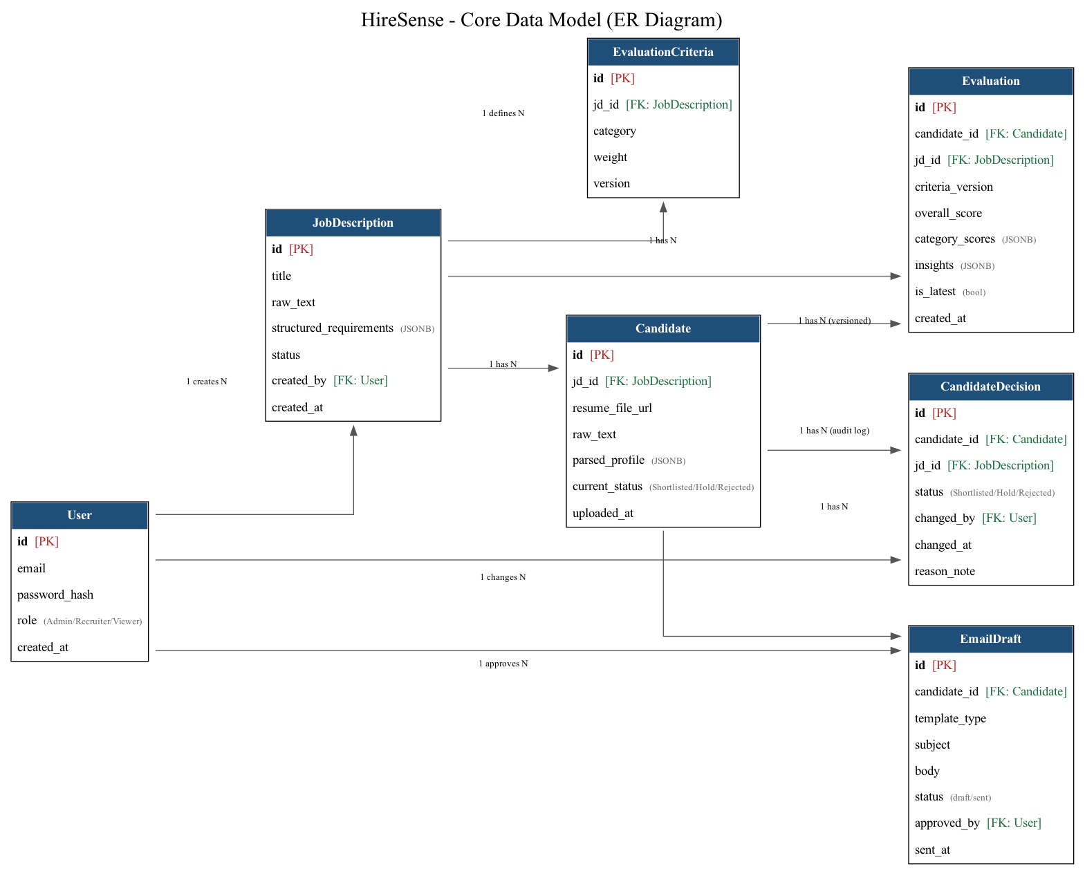
Figure 2 — HireSense core entity-relationship model.

Notes: Evaluation and CandidateDecision are intentionally append-only/versioned tables (not update-in-place) to satisfy the BRD's history requirements for rescoring and decisions. JSONB columns (structured_requirements, parsed_profile, category_scores, insights) hold semi-structured AI output so the schema doesn't need to change every time a new evaluation category is added — only EvaluationCriteria (a normal relational table) needs a new row.

9. Primary Application / Process Flow
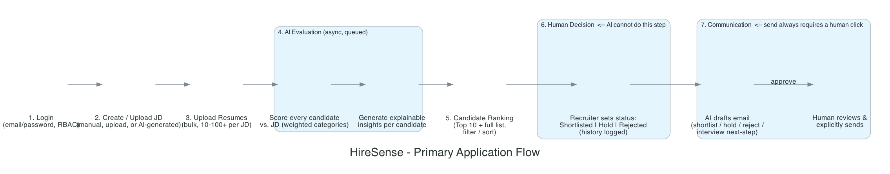
Figure 3 — Primary application flow with the two human-in-the-loop gates.

The two boxed gates in Figure 3 are hard product requirements, not defaults that can be configured away: a candidate's status can only be set by an authenticated human action, and an email can only leave the system after an explicit human send click on a specific draft.

10. AWS Deployment Architecture
Single-region, single-org deployment. Frontend and backend are independently deployable containers on ECS Fargate behind one Application Load Balancer (path-based routing); evaluation jobs run in a separate Fargate worker service so a burst of 100+ resume uploads cannot starve interactive API traffic.
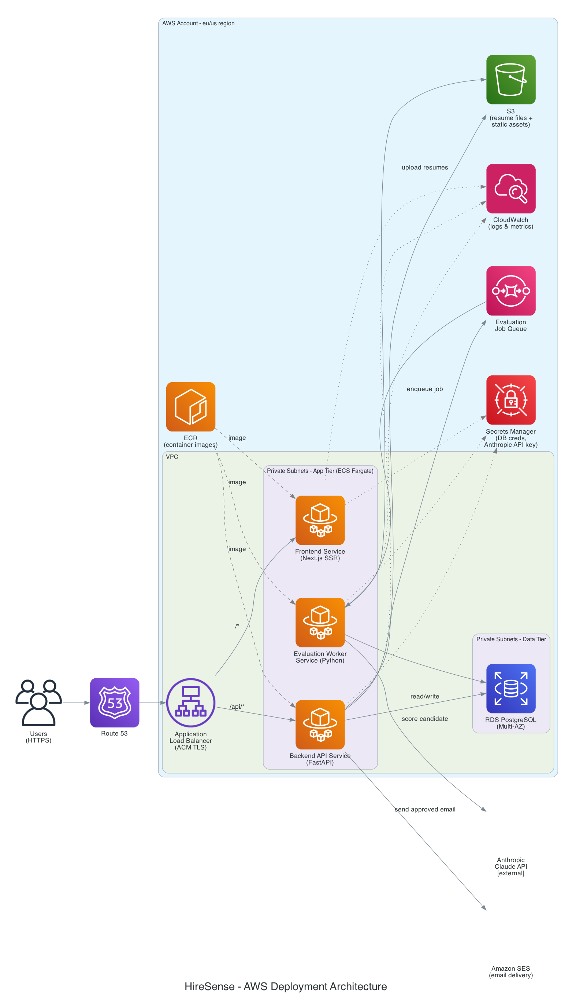
Figure 4 — HireSense AWS deployment topology.

10.1 Service-by-service rationale
AWS Service | Why
Route 53 + ACM + ALB | DNS + managed TLS termination + path-based routing to frontend vs. backend target groups.
ECS Fargate (frontend) | Runs `next start` (SSR) as a container; no server management, scales on request load.
ECS Fargate (backend API) | FastAPI app; stateless, horizontally scalable behind the ALB.
ECS Fargate (evaluation worker) | Consumes the SQS queue; scales independently of API traffic based on queue depth.
RDS PostgreSQL (Multi-AZ) | Primary datastore for JDs, candidates, evaluations, decisions, users — Multi-AZ for availability.
S3 | Private bucket for resume files and (optionally) static frontend assets; server-side encryption.
SQS | Decouples resume upload/JD-change events from the evaluation workers; absorbs bulk-upload bursts.
Secrets Manager | Anthropic API key, DB credentials, JWT signing key — never stored in code or images.
CloudWatch | Centralized logs/metrics for all three Fargate services; basis for cost and latency dashboards on LLM calls.
ECR | Private container registry; source for all three Fargate task definitions.
SES | Outbound candidate email delivery, only invoked after human approval.

11. Technology Stack Summary
Layer | Choice
Frontend | Next.js (TypeScript), Tailwind CSS, TanStack Table for the ranking grid
Backend | Python, FastAPI, SQLAlchemy + Alembic migrations
Auth | Email/password, bcrypt password hashing, JWT access/refresh tokens
Database | PostgreSQL (AWS RDS, Multi-AZ)
Object storage | AWS S3 (resume files)
Async jobs | AWS SQS + a dedicated Python worker service (boto3)
AI / LLM | Anthropic Claude API, structured/tool-use output for scoring and extraction
Email delivery | AWS SES
Compute / hosting | AWS ECS Fargate (frontend, backend API, worker — 3 services)
Secrets | AWS Secrets Manager
Observability | AWS CloudWatch (logs, metrics)
CI/CD | GitHub Actions → build & push to ECR → deploy to ECS (future work)

12. Security, Compliance & PII Handling
- Resumes and parsed candidate profiles are PII — stored in a private S3 bucket and a PostgreSQL database that are not publicly reachable; access is scoped by role and JD.
- All data in transit uses TLS (ACM-terminated at the ALB); S3 and RDS use server-side encryption at rest.
- Secrets (LLM API key, DB credentials, JWT signing key) live in Secrets Manager, never in source control or container images.
- Every status change and every sent email is attributable to a specific authenticated user and timestamped — satisfies basic audit/compliance evidence needs.
- Data retention period for resumes/PII is an open question for the client (Section 14) — recommend a configurable retention/purge policy once confirmed.

13. Phased Delivery Roadmap
Phase | Scope | Outcome
0. Discovery | Finalize data model, confirm open questions, environment setup | Signed-off architecture (this document)
1. Core loop (MVP) | Auth, manual JD create, single resume upload, AI evaluation (fixed weights), ranked list, manual status change | Provable end-to-end value
2. Scale ingestion | Bulk upload, async job queue, progress UI, 100+ resume handling | Meets stated scale requirement
3. Configurability & history | Configurable weights, versioned rescoring, decision audit trail | Meets governance requirements
4. RBAC | Full 3-role model, permission enforcement | Meets access control requirement
5. Communication | AI email drafting + human-approved send, all four templates | Closes the loop end-to-end
6. Polish / AI JD tools | AI JD generation/improvement, candidate comparison rationale | Full BRD coverage

14. Open Questions & Assumptions

14.1 Confirmed with client
- Single organization / single-tenant deployment (no multi-tenancy in v1).
- Authentication: email/password (no SSO in v1).
- Frontend: Next.js. Backend: Python (FastAPI). Deployment: AWS.

14.2 Still open — to confirm before Phase 1 build starts
- Data retention period for resumes/PII — how long is data kept, is there an obligation to purge (e.g., GDPR/CCPA-style)?
- Expected turnaround SLA for evaluating a 100-resume batch (seconds vs. minutes acceptable)?
- Email sending identity — does the client have an existing domain to verify in SES, or should HireSense provide a shared sending domain initially?
- Any compliance constraint on which region/vendor may process candidate PII through an LLM API?

15. Appendix: Glossary
Term | Meaning
JD | Job Description — an independent candidate-evaluation workspace in HireSense.
RBAC | Role-Based Access Control.
Overall score | The single 0-100 score for a candidate against a JD, computed as a weighted sum of category scores.
Category score | A sub-score for one evaluation dimension, e.g. Skills Match, Domain Experience.
Human-in-the-loop | A workflow step that requires an explicit action by an authenticated human user before it takes effect.
is_latest | Flag on the Evaluation table marking the current version of a candidate's score after rescoring.

