- Can't go wrong with Ceylon Tea, it's not the most complex or fancy tea (even tho you got the luxurious blend), but it's always a solid black tea. - Urgash - 6mo ago
(https://www.reddit.com/r/tea/comments/1nmk4wf/comment/nfdo5zd/?utm_source=share&utm_medium=web3x&utm_name=web3xcss&utm_term=1&utm_content=share_button)


- Loose leaf Ceylon has been my daily tea for as long as I can remember, but ooooh boy is it getting harder and harder for me to get it at a reasonable price. My local "Mediterranean" store frequently has this exact tin but I have yet to try it, I think perhaps now I will, so thanks OP! :) - Sazapahiel- 6mo ago

(https://www.reddit.com/r/tea/comments/1nmk4wf/comment/nfdzl63/?utm_source=share&utm_medium=web3x&utm_name=web3xcss&utm_term=1&utm_content=share_button)



- I've noticed that arabs usually either drink Lipton, or Ceylon tea (tea from Sri Lanka). Lipton makes sense because it's common and relatively cheap. But Ceylon tea isn't super mainstream or particularly well known. Why do arabs seem to prefer it? So many arab tea brands are Ceylon (Cherry brand, Layalina, Horse Head, Swan brand, etc.) Is it just the best tea that we kept as our secret? - r/AskMiddleEast - 2mo ago
(https://www.reddit.com/r/AskMiddleEast/comments/1q0ln19/why_do_a_lot_of_arabs_drink_ceylon_tea/?utm_source=share&utm_medium=web3x&utm_name=web3xcssutm_term=1&utm_content=share_button
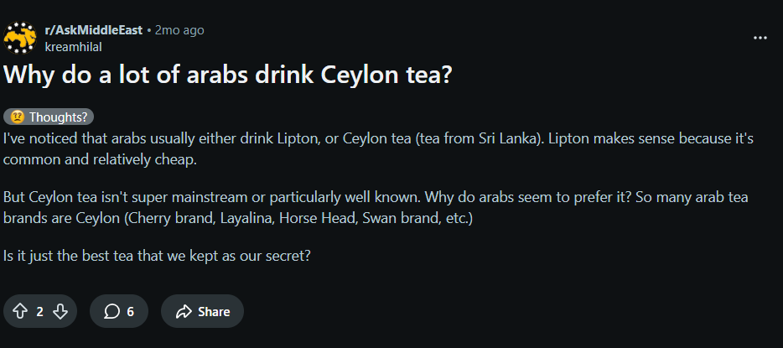

- Ceylon black tea comes from Sri Lanka. Good Ceylon tea is bold but smooth and has a characteristic fruity flavor. It is generally stronger tasting than Darjeeling, but not as strong as Assam. It is often found in English Breakfast blends.
Darjeeling comes from the mountains of Northeastern India, East of Nepal. It is generally processed with a low oxidation (especially first flush, the spring picking) for black tea, and is described as being "brisk" and having a "muscatel" flavor. - redpandaflying93 -8y ago.

(https://www.reddit.com/r/tea/comments/7xva8w/comment/dubgsze/?utm_source=share&utm_medium=web3x&utm_name=web3xcss&utm_term=1&utm_content=share_button)
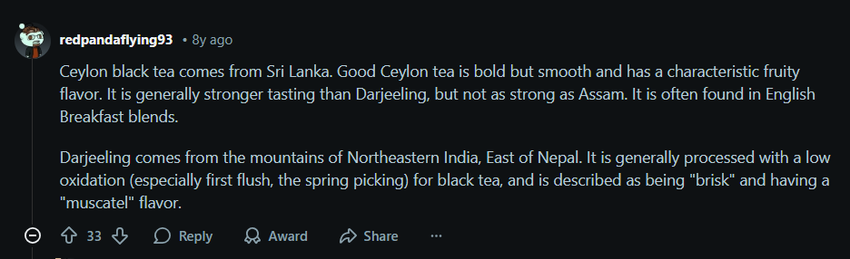

- The name of each refers to where it's grown. Darjeeling tea is from Darjeeling, India. Ceylon tea is from Sri Lanka (formerly known as Ceylon). You'll get different flavor nuances due to the different climates of the growing regions. - _Bluejay_ - 8y ago

(https://www.reddit.com/r/tea/comments/7xva8w/comment/dufa7uk/?utm_source=share&utm_medium=web3x&utm_name=web3xcss&utm_term=1&utm_content=share_button)

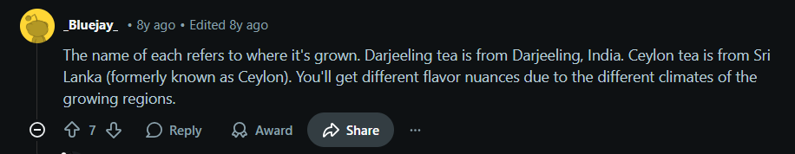

- Ceylon tea is very strong I think. The taste is unique. Does it also have relaxing properties? Are there any Ceylon drinkers who belive it calmes them down? - r/tea - 7y
(https://www.reddit.com/r/tea/comments/akbs9d/ceylon_tea/?utm_source=share&utm_medium=web3x&utm_name=web3xcss&utm_term=1&utm_content=share_button)


- Ceylon tea, like every tea, differs very widely depending on where it was grown and how it was processed. What brand and type are you drinking and do you know where it was grown (other than 'Sri Lanka')?
I recently did a tea tasting of different terroirs in Ceylon. They were all broken orange pekoe black (fully oxidised) teas but the seven terroirs tasted quite different.
They don't relax me any more than any other tea but I was impressed by the variety and complexity. - teashirtsau – 7y ago

(https://www.reddit.com/r/tea/comments/akbs9d/comment/ef5elss/?utm_source=share&utm_medium=web3x&utm_name=web3xcss&utm_term=1&utm_content=share_button)
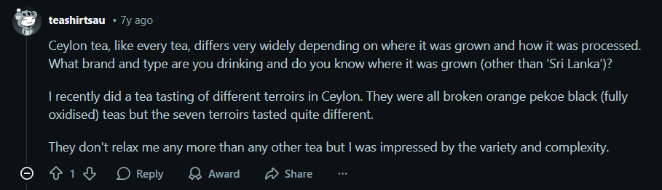

- I am trying to find the best quality Ceylon tea but all the good quality stuff like dilmah and those from Sri lankain vendors are all sell tea dust with recommend high brew times and the "low quality stuff" is whole leaf I am really confused and am looking for the best quality Ceylon tea to splurge on lol anyone know what are the best brands for the best Ceylon by typical tea standerds - r/tea - 3y ago
(https://www.reddit.com/r/tea/comments/10z1eiz/i_am_looking_for_the_best_quality_ceylon_tea_and/?utm_source=share&utm_medium=web3x&utm_name=web3xcss&utm_term=1&utm_content=share_button)

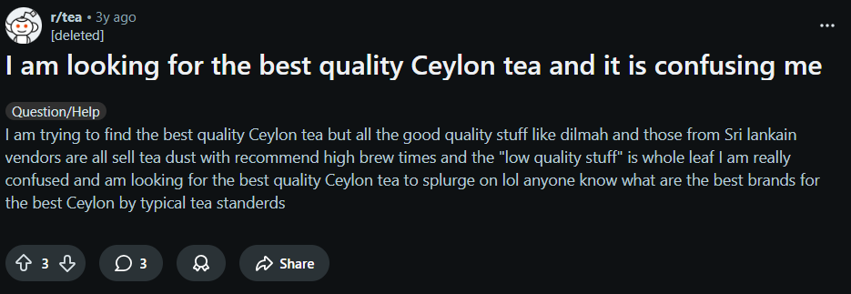

- I'm new to tea and I have been spending the last few weeks trying all sorts of teas trying to find the ones I like best. I started with teabags and moved to loose leaf and I've noticed a problem: I can't tell the difference between the types of tea!Black teas with flavors or fruits added and the Pu ehr that I've tried are the only times I've noticed a distinct difference in flavor.The Darjeeling, Ceylon Lover's Leap, Vietnamese Imperial Oolong, Nepal Plum Tree Oolong, and Fancy Assam all seem to taste the same; rather mellow but without any distinguishing markers. The descriptions of what I should expect all sound great but I just don't taste any of it!Today, I've made 3 cups of my Fancy Assam. It's described as malty with a citral finish. Maybe I don't know what malty is like and that's why I'm not picking it up, but I am definitely not getting a citral finish. And I never picked up on the peach/apricot tones in my Nepal Plum Tree Oolong.So...my question is, what am I doing wrong? I use filtered water, brewed to about 195-200 degrees and steep for 3-4 minutes. I hear people rave about their favorite teas but to me they all taste the same. Help me, please!
- r/tea - 11y ago
(https://www.reddit.com/r/tea/comments/2ukkgf/oolong_vs_assam_vs_ceylon_vs_black_its_all_the/?utm_source=share&utm_medium=web3x&utm_name=web3xcss&utm_term=1&utm_content=share_button)

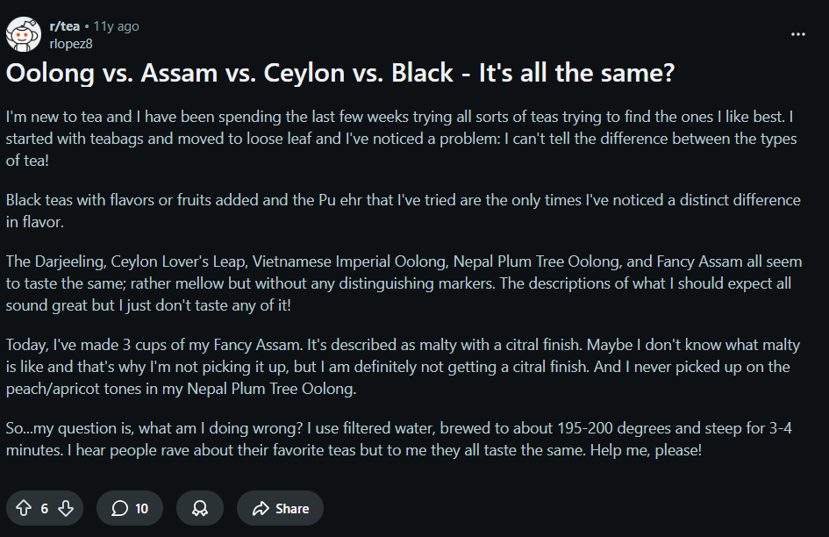

- We are in a price war for tea with India who is producing at mass. Do we try to be low cost but with old plants yeilds decline and workers I guess move on to better paying work.Basically lack of R&D and capex has finally come home to roost. Now they'll cry for government subsidy or something - TheRedhood49- 1y ago
(https://www.reddit.com/r/srilanka/comments/1k3jd8q/comment/mo2o912/?utm_source=share&utm_medium=web3x&utm_name=web3xcss&utm_term=1&utm_content=share_button)

