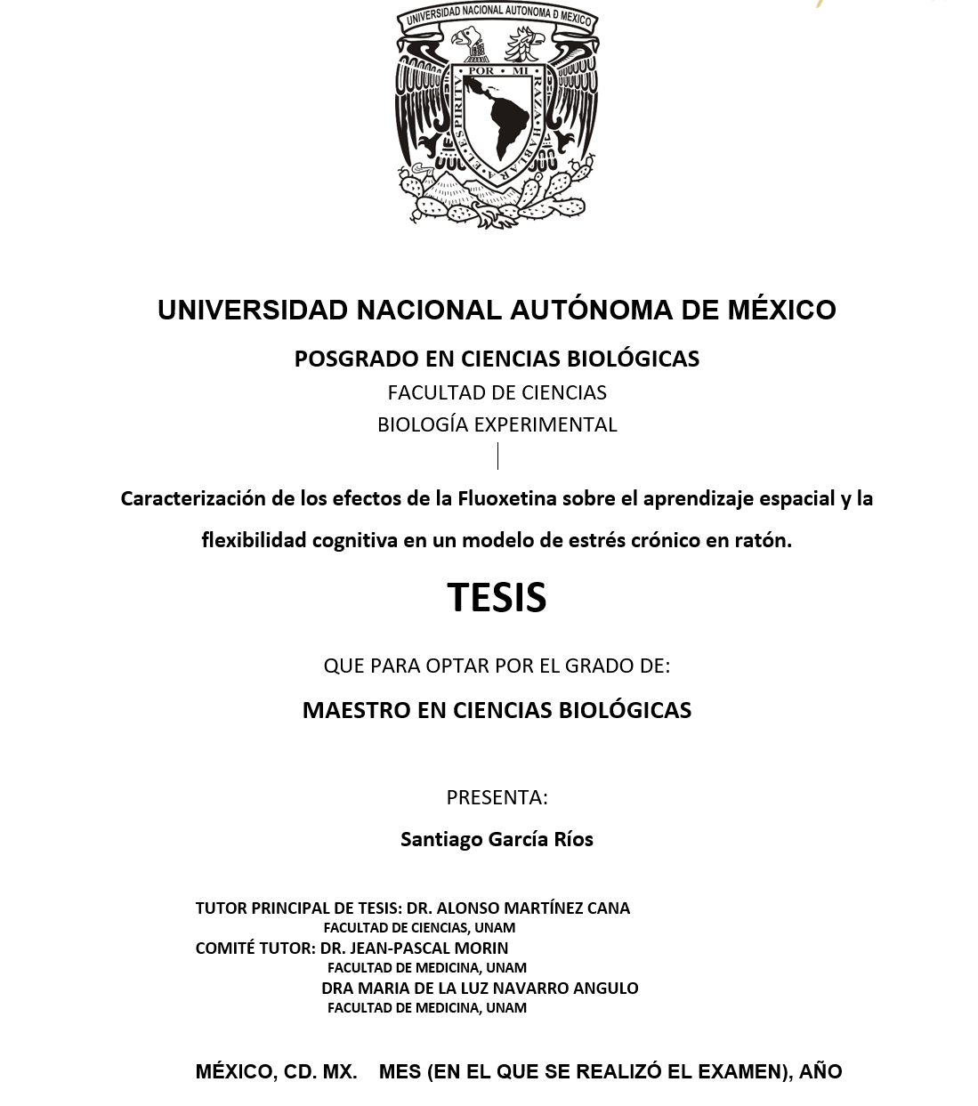

Example Dallas PD Standardized Report

Andrew P. Wheeler, PhD

2024-02-10

Table of Contents

Intro 3

Year to Date Statistics 4

Temporal Crime Breakdown 5

Burglary 5

Robbery 6

Motor Vehicle Theft 7

Repeat Harm Addresses 9

Meta 10

Intro

This is an example standard report, based on Dallas Open Crime Data, that [CRIME De-Coder](https://crimede-coder.com/) can help build for your agency.

Table default

|  |  |  |  |  |
| --- | --- | --- | --- | --- |
| Yeah | C1 | C2 | C3 | C4 |
| g | yoyo | 908 | abc | 123 |
|  |  |  |  |  |
|  |  |  |  |  |
|  |  |  |  |  |