HTML Tasks

Tasks 6, 8, 10, 16, 19 and 20 give 10 points.

Other tasks give 5 points. Maximum is 130 points.

You have to gather min. task 70 points! It gives 6 real points.

110 task points give 10 real points.

Create a folder for this task. Add all solutions to that folder. Zip the folder and return it to Return Box

This task’s solutions can be updated even later (there are 2 extra weeks for that purpose after the real deadline).

1. Create this kind of table using pure html.

|  |  |  |
| --- | --- | --- |
| Sweden | Norway | FInland |
| 9000000 | 5000000 | 5500000 |

2.

Create this kind of list.

* Helsinki
* Stockholm
* Oslo

3.

Create this kind of list.

1. Beatles
2. Eagles
3. Rolling Stones
4. Queen

4.

Create a hyperlink that opens the website of White House.

5.

How can you be sure that White House site opens to a new window or tab?  
Test it!

6.

Create these kinds of own pictures by yourself and add them to your page.  
  
Graph (With Excel it is easy to do)

Organisation chart (You can use Word or PowerPoint)

Visit card (You can use whatever tool, Paint is good,too)



7.

Add an Internet picture to your page.

(Remember to mention the source, check permission)

8.

Add 3 images to your page so that image text is on the right side of each image.

Example

|  |  |
| --- | --- |
|  | My star image on the left. |

9.

Create your own animation and add it to your page.  
You have first to create a set of images and then use some online tool to make a gif.

Try e.g  
<https://gifmaker.me/>

10.

Create an interactive image (imagemap). Use e.g. a picture of some band and create links to each band members page.

Try some online tool, e.g.  
<https://www.image-map.net/>

11.

Choose 3 different colours and show their values using a) rgb and b) hexadecimal format.

E.g colour red is a) 255, 0, 0 and b) FF0000

12.  
Explain metacodes.

13.

Give examples of using tags for bold, italic and underline.

14.

Divide your page to 3 parts using line tags.

15.

How can you create white spaces using entities?

16.

Create a video and add it to you page: introduce yourself in that video.

You can e.g mobile phone or, web cam or other kinds of resources here.

If you want to edit your video, e.g **VSDC Free Video Editor** is good tool.

17.

How do you embedd a youtube video to your page?  
Test it on a page.

18.

Record a short sample where you tell your name and add that piece  
to you web page. For recording there are several tools, e.g.   
<https://online-voice-recorder.com/>)

19.

Create this kind of form

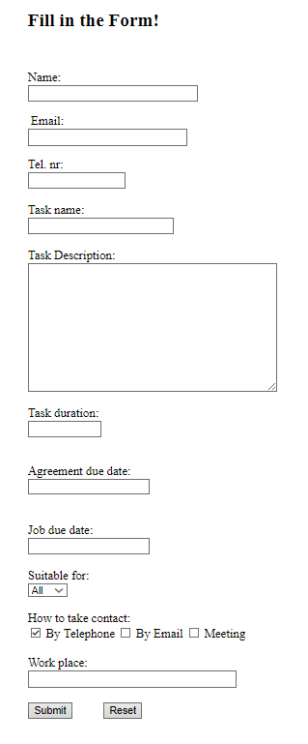

20.

Create a set of pages named home.html, page1.html and page2.html.

Add links.

Put there some contents.

Pages (layout of them) look like this:

