ER Voting Schema
Alejandro Pérez, Santiago Alcérreca, Karen Hernández
Instituto Tecnológico De Estudios Superiores De Monterrey
Chihuahua, México
Abstract
This short note shows the ER schema for keeping track of information about votes taken in the U.S. House of Representatives during the current-year congressional session.
Keywords: ER-schema, vote, elections, database, SQL-Server

Introduction
The U.S. House of representatives are getting into the elections of the current two-year congressional session. The database needs to keep track of every State, person in the House of representatives, bill and sponsor the congress person sponsored. Also, the database saves the information of how each person in the congress voted on each bill.

Design

ER Model
The model in figure 1 consists in 3 strong entities with the next key attributes that identify each instance, along other attributes:
- State: Name (key attribute) and Region.
- Congress Person: Name (key attribute), District, Start Date, and Party.
- Bill: Bill Name (key attribute), Date of Vote, Passed.
The relation types that the model uses to connect the entities are the following:
- Sponsors: The Congress Person “sponsors” more than one Bill. While Bill only has one sponsor (1 to N cardinality).
- Represents: A Congress Person “represents” only a state and State can be represent for more than one Congress Person (1 to N cardinality).
- Votes: A Congress Person can vote for as many Bill as the Congress Person wants, also the Bill can be voted for many Congress Persons. Votes has an attribute called Types, that can be Yes, No, Abstain, Absent (M to N cardinality).

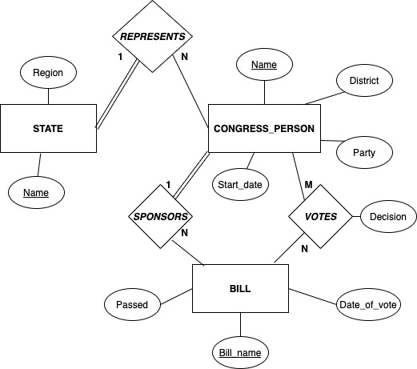
Figure 1: ER Model for the election in the U.S. House of Representatives.

Relationship Map
The relationship map shown in table 1 is based on the ER model illustrated in the table 1, putting the entities “State”, “Congress Person”, “Bill” and a new entity called “Votes”.
this entity is created because “Votes” Relationship type has an M to N cardinality, this entity is necessary to link the Congress Person and Bill entities.

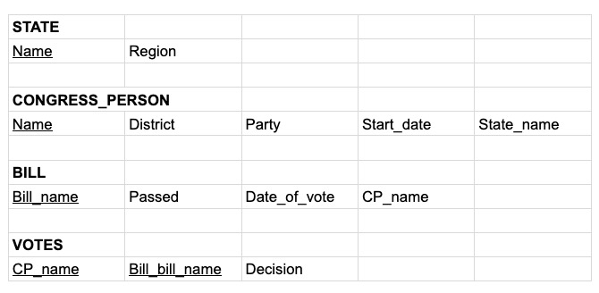
Table 1: Relationship Map for the election in the U.S. House of representatives.

Implementation
The implementation used for the election is Microsoft SQL Server.

SQL Server
With the previous design made, the database was created with the following specifications:
The database, illustrated in figure 2 has 4 different tables with the following attributes:
- State: Name (key attribute) and Region
- Congress Person: Name (key attribute), District, Start Date, Party and State Name (this is another key attribute passed by State Entity).
- Bill: Name (key attribute), Date of Vote, Passed Or Failed and Congress Person Name (this is another key attribute passed by Congress Person Entity).
- Votes: Congress Person Name, Bill Name (both attributes are the key attribute passed by Congress person and Bill entity) and Decision.
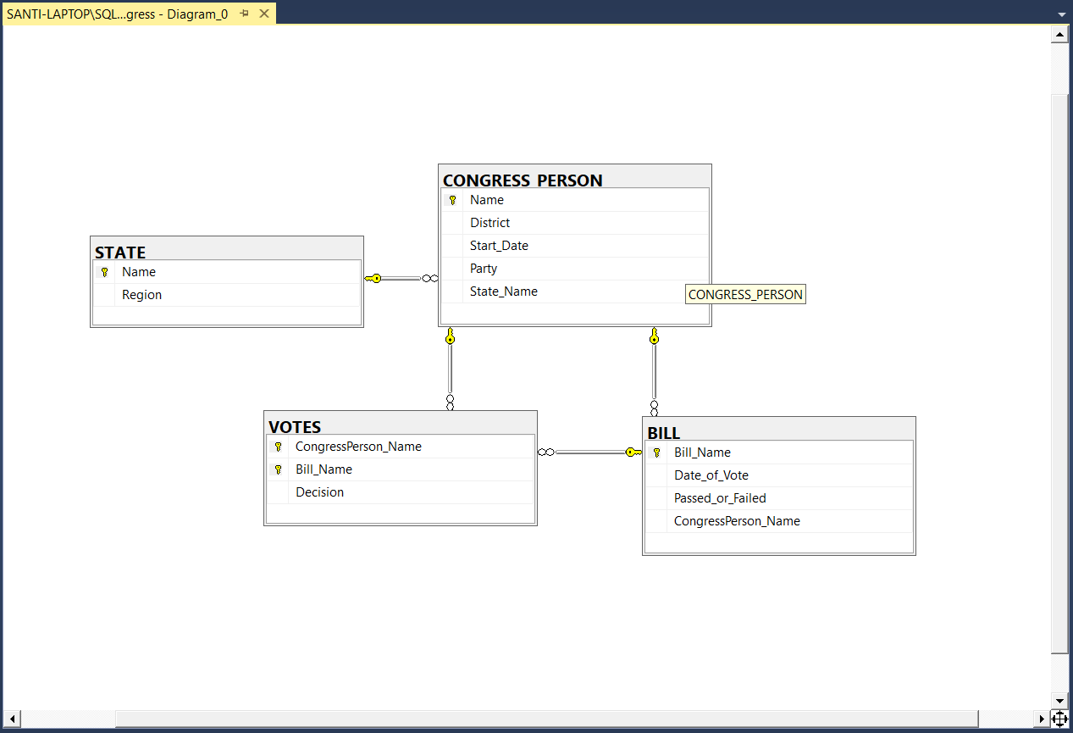
Figure 2: SQL database design diagram

Acknowledgements
Using all the fundamentals of database design the project was completed successfully and with no further design complications.
The databases course classes make a huge support for the creation of the activity, also, the teamwork was crucial for this task to be finished.

References
[1] Entity Relationship Diagram. (n.d.). Retrieved from https://www.smartdraw.com/entity-relationship-diagram/.
[2] How to Draw an ER Diagram. (n.d.). Retrieved from https://www.lucidchart.com/pages/how-to-draw-ERD.
[3] SQL Server Tutorial. (n.d.). Retrieved from https://www.sqlservertutorial.net/

