- Name of Use Case
Name of the Use Case | Smart shelter
Version No. | V0.1
Submission Date
Team Members (with student ids) | Lucia Roccaro 289423  Santiago Caro Zapata 293724  Seyedeh Sadaf Ekram 301178  Giorgio Chiesa 289629
- Scope and Objectives of Function
Scope and Objectives of Use Case
Scope | The proposed ioT platform aims at providing services for a Smart Pet House and a Smart Pet Collar
Objective(s) | The expected result consists on providing to a pet owner a smart monitoring platform for the pet health, comfort and location while he is away from home. This will aloud the owner to constantly know the condition of his pet and to remotely take action, if needed.
Domain(s) | Smart Home, Smart Collar
Stakeholder(s) | Household residents that own a pet
Short description | The proposed ioT platform aims at making a Smart Home and a Smart Health System (Smart Collar) specifically thoughts and designed for pets’ needs. It integrates different ioT devices that interact both with the environment and with the pet. The ioT devices placed on the environment will check the inside and outside temperature and the quantity of food (and water) that is available for the pet. The ioT devices placed on the collar will monitor the pet temperature, pressure, heart rate and breath rate. The Smart Collar will also include a gps. The monitoring services are available on user interfaces (Telegram BOT and Thingspeak) through REST web services and MQTT protocol. The platform, indeed, let acting remotely in real time, through the above-mentioned user interfaces, on heating/cooling of the rooms, food and water delivery and send live alerts to the user when something doesn’t fit normal parameters.  Summarizing, the main platform features are:  - Control strategies for health, comfort and location of the pet  - Remote monitoring by user interfaces (Telegram, Thingspeak)  - Communication protocol provided by REST Web services/MQTT Publisher/Subscriber
- Diagram of Use Case

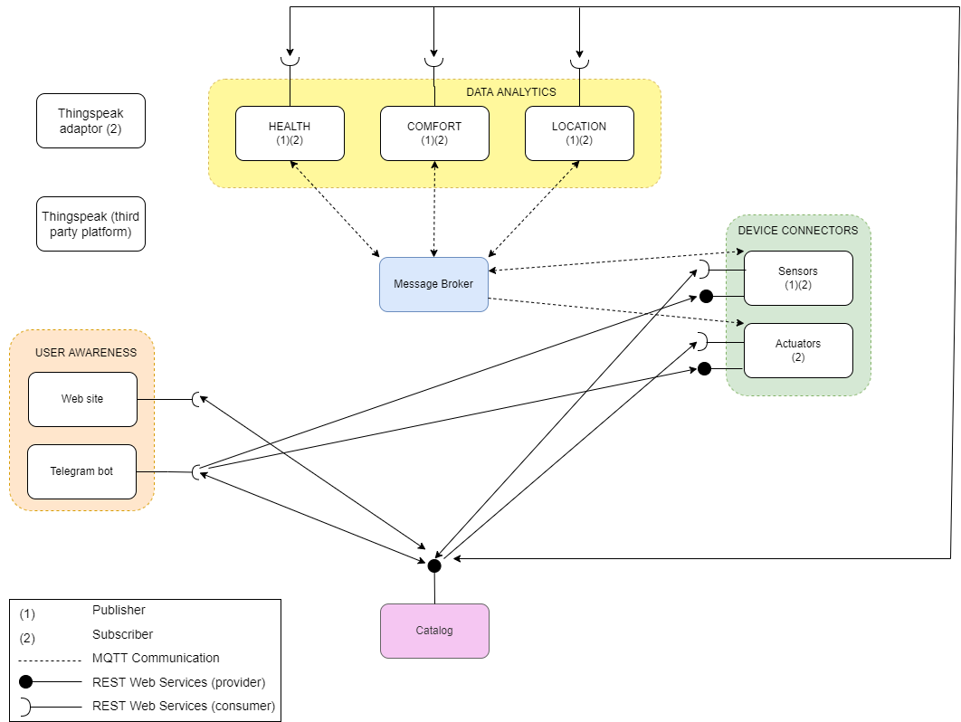
- Complete description of the system

The proposed project concerning an IoT platform for a a Smart Home and a Smart Health System based on the microservices designing pattern. Monitoring and actuation exploit two communication paradigms:

❖ Publisher/Subscriber based on MQTT protocol;
❖ Request/response based on REST Web Services.

This ioT platform put in communication different actors that we will introduce below:
- The message Broker provides an asynchronous communication based on the publish/subscribe approach. It exploits the MQTT protocol.
- The Catalog contains the services and devices registry in which all the microservices in the system are listed. It contains information about interfacing to different actors’ endpoints (e.g. RESTful Web Services and MQTT topics). Also, it provides configuration settings for control strategies, devices, and user awareness interfaces. The Catalog, through its interface based on REST services, provides a way for different actors to retrieve data.
- The Actuators microservice is a device connector which integrates into the platform the actuators connected to Raspberry Pi board. The Raspberry is connected to 3 actuators that provide food, water and switch on and off the heating/cooling of the rooms. The microservice makes the actuators available to the system by means of REST interface in order to take actions promptly from Telegram bot interface and by acting as an MQTT subscriber for actuation due to control strategies outputs.
- The Sensors microservice is a device connector running on RaspberryPi which integrates into the platform digital sensors. This sensors send to the data analytics the measures like MQTT pusblisher.
- Telegram Bot is a service to integrate the proposed infrastructure into Telegram, which is cloud-based instant messaging infrastructure. It provides measurements and alerts from IoT devices through the REST Web Services communication protocol. It also allows the user to send actuation commands to IoT devices (food, water and heating) using as before the REST web services.
- The Web Site provides to the users the possibility to see long term trends about health monitoring data, allowing them to detect important changes in pets over time.
- The comfort data analytics monitors the mass of the available food and water and the temperature of the rooms. When it is time for the pet to eat and the mass sensor detects 0 kg, the food mechanical actuator activates to provide food. Water, instead, is continuously provided when the mass sensor detects 0 kg. If the temperature sensors of the rooms detect an average temperature that is out of range, the heating actuator switch on the air conditioning and set the right temperature.
- The health data analytics monitors the body temperature, the heart rate and the respiration rate. A processing of the data is processed in python and an alert is sent to the user via telegram bot if the parameters are out of range.
- The location data analytics monitor the position of the pet via GPS and sends an alert via telegram bot when the detected position is out of the safe zone. It is also possible to ask via del telegram bot the live position of the pet.

