Category Representation in Neural Networks with Dynamic Learning Rates
matches Human Learning Performance

A Connectionist View of Common Coding in Category Learning

Abstract (262 words)
Agents associate world features that have never been presented together but share a predictive value with respect an outcome. This common coding phenomena was examined through category learning. We conducted two experiments, where participants classified exemplars in two categories. Each participant completed two tasks. In the total reversal task, all exemplars' outcomes were reversed, while in the partial reversal task, only half of the outcomes were reversed. We predicted that participants would learn faster in the total reversal tasks. Experiment 1a involved a simpler version with fewer exemplars, while Experiment 1b was more challenging with additional exemplars. In a third experiment, we evaluated whether the categories were perceptually distinct. We employed Multidimensional Scaling and Euclidean distance measures to analyse perceived similarities within and between categories in a 'psychological' space. Altogether results showed that participants learned faster the total reversal task; also, there was no significant differences in perceived similarity within or between categories, suggesting that the learning effects was not due perceptual similarities. To explain the results, we used a standard neural network with backpropagation to model the process. In these models the categories are represented in the hidden layer, and to preserve the category as in the total reversal case the networks must have an additional mechanism that allows for slower weight changes in the hidden layer and faster weight change in the output layer. We incorporate dynamic learning rates inspired by Mackintosh and Pearce-Hall to account for the different speed of learning in each layer. Overall, these findings underscore the significance of associative mechanisms in category formation and reversal learning.

Andy’s Talk CO3 2024
An Associative Analysis of Category Learning
Andrew Delamater, Santiago Castiello
Brooklyn College – CUNY, Yale University
Category learning poses interesting challenges to associative theories, in part, because they suggest that organisms encode exemplars in terms of their category membership rather than in terms of the individual binary exemplar-category associations established during training. Evidence supporting the claim of increased generalization, for example, among within-category exemplars, relative to between-category exemplars, suggests that category learning goes beyond the learning of individual binary exemplar-category response associations. One example of this enhanced within-category generalization comes from the “total-partial” reversal task, in which following an initial training phase where organisms learn that several exemplars of one type comprise category A and several exemplars of another type comprise category B, either all members of each category undergo a total reversal together or half of the exemplars of each are reversed with the others maintained. In this sort of task, non-humans and humans, alike, acquire the total reversal task more rapidly than the partial reversal task. Furthermore, performance is degraded during the partial reversal task on those exemplars that do not reverse. I will illustrate how a multi-layered connectionist network model that allows for category representations to be learned at a hidden layer can learn the basic category learning task and readily account for greater within-category than between-category generalization. However, I also point out how such a model will suffer from catastrophic interference during a total reversal phase, unless some mechanism is implemented to produce more stability of the category representations that develop at the hidden layer. One solution follows Mackintosh (1975) and Pearce and Hall (1980) by allowing for learning rates governing associative changes between different layers of the network to change as a function of prediction error. In this way, a purely associative theory can explain some of the important characteristics of category learning.

Andy’s Talk Gregynog 2024
Title: Different Perspectives on the Idea of a “Reward Prediction Error”
Abstract: The reward prediction error (RPE) concept has been influential in both associative learning and reinforcement learning theories, with new learning depending upon such errors. For years, we have assumed that the difference between obtained and expected rewards (e.g., l – SV) drive new learning (although our theories have sometimes expanded this idea to include events other than rewards, as well-imagined, e.g., in MKM). Since the connectionist movement in the 1980s, it was made clear that some mechanism is needed to propagate RPE signals throughout a complex neural network that consists of more than two layers. Since the brain consists of a complex neural network of interacting structures and is the primary organ through which learning takes place, it is time for associative learning theory to acknowledge and address this fundamental problem. One solution, apparently used widely today in AI, was to back-propagate the RPE signal (computed at an output layer) throughout the entire network. While that solution works at an engineering level, it is far from biologically plausible. An alternative framework has been to consider that some neurobiological process, e.g., dopamine, computes the RPE and then broadcasts this signal widely throughout the brain enabling new plasticity at any given synapse that receives the signal. Yet another approach, not widely recognized but is more in the spirit of Konorski (1948), is referred to as “Contrastive Hebbian Learning.” This algorithm plausibly reconceptualizes how RPEs might arise in complex networks by contrasting the activity levels of any two conceptual units (e.g., neurons) before and after reward is presented. This, effectively, means that connection strengths will increase (or decrease) when a sending unit is paired with a rise (or fall) in the activation level of a receiving unit. Thus, each conceptual “synapse” within a complex network has its own locally computable RPE term, but whose individual elements (l and SV) may very well change throughout the course of learning. While it is the goal of the system to decrease error discrepancies, the approach emphasizes the distributed nature of the reward representation and does not so much focus on whether a particular event representation (like reward) is anticipated to match reality. Instead, this algorithm ensures that the entire activity pattern of a complex interacting network produced by reward is, itself, reproduced by presentation of the predicting stimuli. In this sense, the RPE signal is not so much about predicting an “event” as it is the impact that such an event will have on an entire network. This strikes us as an insightful way of conceptualizing the RPE concept. I will review some of our efforts to examine this more biologically plausible learning algorithm applied to multi-layer networks and show that it produces results consistent with many of the associative learning phenomena our field takes to be important.

Santiago’s Poster Gregynog 2024
Title: Neurocomputational plausibility in Categorical Reversal Learning: Contrastive Hebbian Learning with Dynamic learning rates
Abstract: Backpropagation (BP) is one of the most famous and widely used artificial neural network (ANN) algorithms. However, BP has been criticized for its lack of neurobiological plausibility, where the brain cannot compute backward error signals (e.g., Lillicrap, et al, 2020 – Nature Review Neuroscience). There is a distinct family of ANN algorithms based on the Hebbian learning rule (“fire together wire together”), these ANNs can also solve most of learning problems as BP. This family is known as Contrastive Hebbian Learning (CHL) and instead of sending a discrepancy (or prediction error) learning signal backwards, it computes learning signals locally at every neurocomputational unit. Thus, CHL is a more biologically plausible algorithm. Although, neither CHL nor BP have an adequate prediction for category formation, nor have an explanation for it. Category formation can be studied with a Categorical Reversal Learning (CRL) task. In total-reversal condition, living agents learn that half exemplars belong to category A and the other half belong to category B. Then in a second phase, the exemplars from category A change to category B, and vice versa. Agents learn total-reversal categories faster than a comparison partial-reversal condition, where not all the exemplars change from one category the other in phase two. Interestingly, ANN learn faster partial-reversals than total-reversals, opposite as living agents. Delamater (2023 – Gregynog) proposed an improvement to BP that incorporates two ‘opposed’ attentional mechanisms based on adaptive/dynamic learning rates – Pearce & Hall (1980) and Mackintosh (1975). In this work we (1) present data corroborating that humans are better at learning total-reversals than partial-reversals, and (2) we incorporate the adaptive/dynamic learning rates to CHL to create a biologically plausible model that learns categories as humans may do it. Finally, we present our ongoing project ALANN (Associative Learning with Artificial Neural Networks), an open-source initiative to study learning theories with connectionist models: https://github.com/santiagocdo/ALANN.

Lillicrap, T. P., Santoro, A., Marris, L., Akerman, C. J., & Hinton, G. (2020). Backpropagation and the brain. Nature Reviews Neuroscience, 21(6), 335-346. https://www.nature.com/articles/s41583-020-0277-3

Shervani-Tabar, N., & Rosenbaum, R. (2023). Meta-learning biologically plausible plasticity rules with random feedback pathways. Nature Communications, 14(1), 1805. https://www.nature.com/articles/s41467-023-37562-1

Liu, Y. H., Smith, S., Mihalas, S., Shea-Brown, E., & Sümbül, U. (2022). Biologically-plausible backpropagation through arbitrary timespans via local neuromodulators. Advances in Neural Information Processing Systems, 35, 17528-17542. https://arxiv.org/abs/2206.01338

Song, Y., Lukasiewicz, T., Xu, Z., & Bogacz, R. (2020). Can the brain do backpropagation?---exact implementation of backpropagation in predictive coding networks. Advances in neural information processing systems, 33, 22566-22579. https://www.ncbi.nlm.nih.gov/pmc/articles/PMC7610561/

Shen, G., Zhao, D., & Zeng, Y. (2022). Backpropagation with biologically plausible spatiotemporal adjustment for training deep spiking neural networks. Patterns, 3(6). https://www.sciencedirect.com/science/article/pii/S2666389922001192

Jeong, H., Taylor, A., Floeder, J. R., Lohmann, M., Mihalas, S., Wu, B., ... & Namboodiri, V. M. K. (2022). Mesolimbic dopamine release conveys causal associations. Science, 378(6626), eabq6740. https://www.science.org/doi/10.1126/science.abq6740

This is The Manuscript

Introduction

Common Coding
The Red Sox have several skilled hitters. When a player hits a home run in a different game than another player, humans can easily label both players as 'good hitters.' This exemplifies common coding, where two cues (players) share the same outcome (home run), thus relating the players are related through a shared feature or code.
More broadly, common coding is a cognitive phenomenon in which an agent learns that one stimulus generalizes to another because they have previously been associated with similar outcomes (Delamater & Joseph, 2000). Common coding, also known as acquired equivalence, is considered the associative mechanism for category formation. In this paper, we replicate the results from a category reversal learning experiment and also offer a mechanistic explanation of category learning using an artificial neural network model of associative learning (Castiello et al., 2021; Delamater, 2012).
Common coding is a general phenomenon observed across various settings and species. It appears in instrumental conditioning with conditional discrimination in pigeons (Urcuioli et al., 1995), in Pavlovian conditioning with first-order tasks in rats (Johns & Williams, 1998), and in humans, even when the paradigm requires common consequences and common antecedents (Delamater & Joseph, 2000). Regardless of species or conditioning type, common coding may share similar underlying mechanisms.
Delamater & Joseph (2000) used two versions of a common coding paradigm: Many-To-One (MTO) and One-To-Many (OTM). MTO, as in the baseball example, occurs when different stimuli are paired with the same outcomes (e.g., A→W, B→W, C→X, and D→X), creating associations between the stimuli paired with the same outcomes (A-B and C-D), which is similar to recognizing players who hit home runs as 'good' hitters. Conversely, the OTM procedure pairs the same stimuli with different outcomes (A→W, A→X, B→Y, and B→Z), producing associations between the outcomes (W-X and Y-Z). An experimental approach to test whether common coding developed between stimuli is to reverse the associations after agents learn in an initial phase. In the second phase, if agents developed common coding, they should learn faster a condition where all the pairings are reversed (total reversal; e.g., A→X, B→X, C→W, and D→W for the MTO case) compared to when only half of the pairings are reversed (partial reversal; A→W, B→X, C→W, and D→X; Table 1).
In the total reversal condition, the common coding associations remain but with different outcomes. In contrast, the partial reversal condition requires remapping the within-stimulus associations by common coding. Faster learning in total reversal has been observed in MTO tasks compared to OTM (Delamater & Joseph, 2000; Urcuioli et al., 1995), likely because OTM does not explicitly present the two sample stimuli together, whereas MTO does, facilitating common coding. In the next section, we highlight the computational model we used and explain how it can achieve faster total reversal.

Table 1.
Categorical Reversal Learning Experimental Design (easy)
Category Total Reversal |  |  |  |  | Category Partial Reversal
Phase 1 |  | Phase 2 |  |  | Phase 1 |  | Phase 2
Learning |  | Reversal |  |  | Learning |  | Reversal
Cues | Cat. | Cues | Cat. |  | Cues | Cat. | Cues | Cat. | Condition
A | N← | A | →S |  | A | N← | A | →S | reversal
B | N← | B | →S |  | B | N← | B | N← | non-reversal
C | →S | C | N← |  | C | →S | C | N← | reversal
D | →S | D | N← |  | D | →S | D | →S | non-reversal
Note: A, B, C, and D are cues in form of fractals; S← and →N are two distinct response categories (Cat.).

Modelling
Living organisms showed a faster learning for total reversals (Delamater & Joseph, 2000), but artificial neural network (ANN) irrespectively of their learning algorithm—backpropagation (BP; Rumelhart et al., 1986), Contrastive Hebian Learning (CHL; Detorakis et al., 2019; Xie & Seung, 2003), or CHL with random feedback weights (rCHL; Detorakis et al., 2019; Shervani-Tabar & Rosenbaum, 2023)—learn faster in the partial reversal (Figure 1 with Simulations). Although, learning algorithms such as BP has been criticized for its lack of biological plausibility (Lillicrap et al., 2020), we used this model not for its learning algorithm but for its simplicity and elegance so our new implementations can be tested in a wide used algorithm.
Backpropagation does not account for the faster learning of total reversal in a category reversal learning shown in the designs in both Table 1 and Table 2. However, these models can certainly represent categories in the weights between input to hidden (Figure 2 with Weights). Although these ‘categories’ are completely remapped after the reversals (Figure 2 with Weights). One reason is that learning rates are the same for every layer within the network. Thus, when a category is already formed in first layer weights, it is easier to remap the weights in the first layer than only changing the hidden to output layer.
To solve this issue in neural networks and being able to model more adequately living organisms, we modify the algorithms and incorporated two new rules in different layers. One rule Mackintosh-like controlled by $μ$ and the second Pearce-Hall-like controlled by $ρ$ (Figure 3B). These parameters operate on $δ_{t}$, which is the average of absolutes prediction errors from the output layer (i.e., Output-Target, see models). Both parameters ($ρ$ and $μ$) control how the learning rate ($α$) change each trial (Kaye & Pearce, 1984; Pearce et al., 1984). For the case of the first layer (input to hidden) $α$ changes:
$α_{t,i}=ρδ_{t}+(1-ρ)α_{t-1,i}$ (Eq. 1)
Thus, if $ρ=1$, the higher the prediction error $δ$ the higher $α$. Thus, this rule implicitly encodes the Pearce-Hall intuition, where $α$ is larger when surprise is larger. In the case of the second layer (hidden to output), $α$ changes in the following way:
$α_{t,i}=μ(1-δ_{t})+(1-μ)α_{t-1,i}$ (Eq. 2)
where $1-δ_{t}$ incorporates the Mackintoshian intuition (Mackintosh, 1975), where higher $α$ should be given to predictive cues, i.e., when the world is quite predictive no surprise or small $δ_{t}$. By adding this dynamic learning rates, our neural network (Figure 3) successfully solves category learning by slowly changing connections between Hidden-Output (H-O) relative to Input-Hidden (I-H; Figure 2 with Weights). Where categories which are encoded in the first layer were held and used in the total reversal by only changing the connections in the output layer, which strictly relates to the ‘response’.
Figure 1. Simulation of the two conditions in the current Category Learning task. A Backpropagation as is shown here cannot emulate findings with living organisms. B same algorithm but with different changing alpha rates, shows that is easier to learn a total reversal condition.

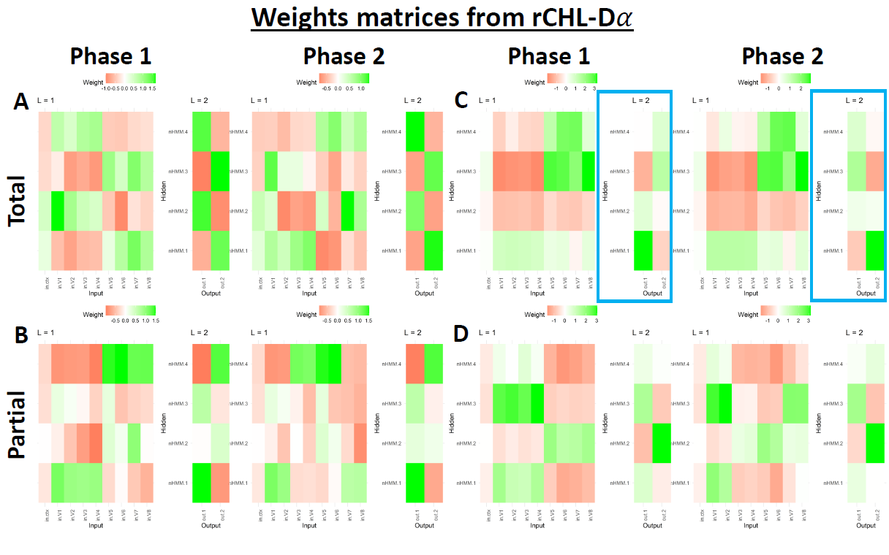
Figure 2. Weight matrices, for phase 1 vs phase 2 for both tasks (total: A and C; partial: B and D) and both sets of learning rates smoothing parameters (rho and mu). A and B rho = mu. C and D rho > mu.

Experiment 1a – Easy Version

Methods

Participants
Thirty-two participants were recruited through Prolific (www.prolific.com). The age ranged between 20 and 63 with a mean of 36.29 and standard deviation (SD) of 10.86. Twenty participants were male, 7 female, one non-binary, and 4 did not respond.
We exclude participants that did not show adequate learning in the first 96 trials of the learning phase (before reversal, see below). We define adequate learning when the probability of correct categorical classification rejects the null under a binomial test where the probability of correct is higher than correct by chance, i.e., 0.5. Thus, participants must have at least 57 correct trials over 96 trials in phase 1. Two participants were excluded.

Task and Procedures
The experiment consisted in two tasks: total- and partial-reversal. Every participant performed the two tasks. The order of the tasks was counterbalanced. Each task consisted in two phases: learning and reversal. The tasks had 6 blocks by phase. Each block consisted in 8 trials, 2 for each one of the trial types or fractals. Within each block the trials were fully randomized. Then, 6 (blocks) * 8 (trials) * 2 (phase) = 96 trials for each task.
Participants were asked to classify four fractals into two categories “North Hemisphere” (N) and “South Hemisphere” (S; see instructions in the Appendix). In every trial, participants saw one fractal exemplar and selected which category it belonged by pressing the left or the right keys (Figure 3A). Left was linked with the N (i.e., N←; see Table 1) and right with S (i.e., →S). Between trials there was an Inter-Trial Interval (ITI) with a white fixation cross and grey background. The ITI was a random variable distributed uniformly between .5 and 1.5 seconds rounded to the first decimal place. The exact instructions are provided in the Appendix.

Software and Open Science
The task was programmed in PsychoPy® (Peirce et al., 2019) and the experiment was run online via Pavlovia in Amazon Mechanical Turk®. All the statistical analysis were conducted in R (R Core Team, 2021). The PsychoPy code and R scripts are available in GitHub, along with the analysis scripts and previous drafts of the paper: https://github.com/santiagocdo/categoricalReversalLerning
All the fractals used as stimuli in these experiments were kindly provided by: https://www.enchgallery.com/index.htm

Analysis
To test the hypothesis, we used only the experimental data for the second phase, i.e., post-reversal. We modelled correct category classification (correct=1, incorrect=0) with a Logistic Mixed Model (LogMM):
$Correct=β_{0}+β_{1}Condition\left[total\right]+β_{2}*Blocks+β_{3}interaction$, (eq. 1)
The model displayed in eq. 1 had Blocks as random slope and participants as random intercept. To confirm whether the effect is due to the reversal, we ran another LogMM with only data from the first block in the second phase.
$Correct=β_{0}+β_{1}Condition\left[total\right]$, (eq. 2)
No random slope was used, and participants were random intercept. Lastly, we modelled Reaction Time (RT) with a Linear Mixed Model (LinMM), equivalent to eq. 1. Although the model residuals from the raw data were not normally distributed, nor with log nor square root transformations, we decided to run the model with that limitation—we also conducted a sensitivity analysis with the log transformation, see Supplementary Results—. The model had the following form:
$RT=β_{0}+β_{1}Condition\left[total\right]+β_{2}*Blocks+β_{3}interaction$, (eq. 3)
Same random structure as eq. 1. The significance alpha for all models’ parameters was set to 0.05.

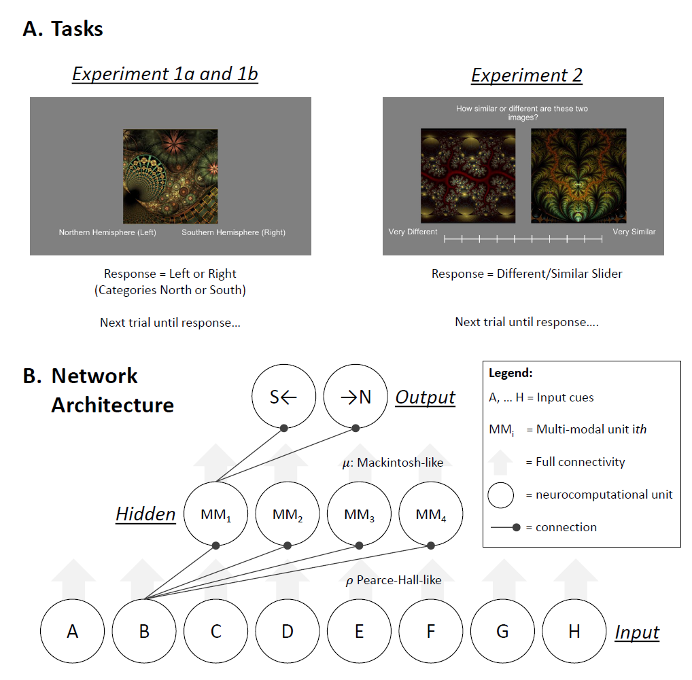
Figure 3. A. present one trial for both tasks used in Experiments 1a and 1b, and 2. B. Architecture used with all models: BP (Castiello et al., 2021; Delamater, 2012). 𝜌 control 𝛼 changes from Input-Hidden, and 𝜇 controls 𝛼 changes between Hidden-Outputs. Hidden layer always consisted in four multimodal units (i.e., fully connected).

Results

Better Learning After the Total Reversal
The mean of the probabilities of correct category classification for all blocks in both tasks are presented in Figure 4A. On one hand, the total task is represented by one line (red) given all examples from both categories experienced the same reversal condition in phase 2. On the other hand, the partial task has two conditions: reversed (blue) and nonreversed (green). The critical comparison is to compare in phase 2 the reversed exemplars between the total and the partial task (Figure 4C).
The LogMM reveal a positive main effect for total vs partial [$β_{1}=.74, p<.001, Std. Coef.=.35 (.14, .56)$], suggesting that in phase 2, in average participants had higher correct scores in the total task. There is also a positive main effect in blocks [$β_{2}=.47, p<.001, Std. Coef.=.77 (.58, .97)$], which suggest that that participants are improving their correct scores across trials. However, the interaction between task and blocks was not significant [$β_{3}=-.11, p=.08, Std. Coef.=-.20 (-.41, .02)$]. Just to corroborate that partial reversal impaired reacquisition of the categories, we tested the first block between total vs partial, and we found a significant and large effect [$β_{1}=.94, p<.001, Std. Coef.=.94 (.49, 1.39)$].

No Differences in Reaction Time After Reversal
We also tested the RT for the second phase with an LMM. We found that the RT was not distinct between tasks (total versus partial) [$β_{1}=.02, p=.528, Std. Coef.=-.01 (-.08, .06)$], nor an effect on Block [$β_{2}=-.01, p=.137, Std. Coef.=-.06 (-.13, .02)$], nor the interaction [$β_{3}=-.01, p=.399, Std. Coef.=-.03 (-.10, .04)$]. We also ran the same model but transforming the RT with the natural logarithm and the root squared. The results are similar (see Supplementary Information).

No Differences in Phase 1 Acquisition
As a control measure, we corroborated that learning in Phase 1 was not distinct between tasks (total versus partial). We fit another LMM with only data from the Phase 1. We found a positive significant effect of blocks [$β_{2}=.39, p<.001, Std. Coef.=.66 (.42, .90)$] and main tasks effect [$β_{1}=.19, p=.419, Std. Coef.=.06 (-.16, .29)$] nor the interaction [$β_{3}=-.04, p=.593, Std. Coef.=-.06 (-.28, .16)$]. This is evidence that participants similarly learn both tasks and conditions in Phase 1.

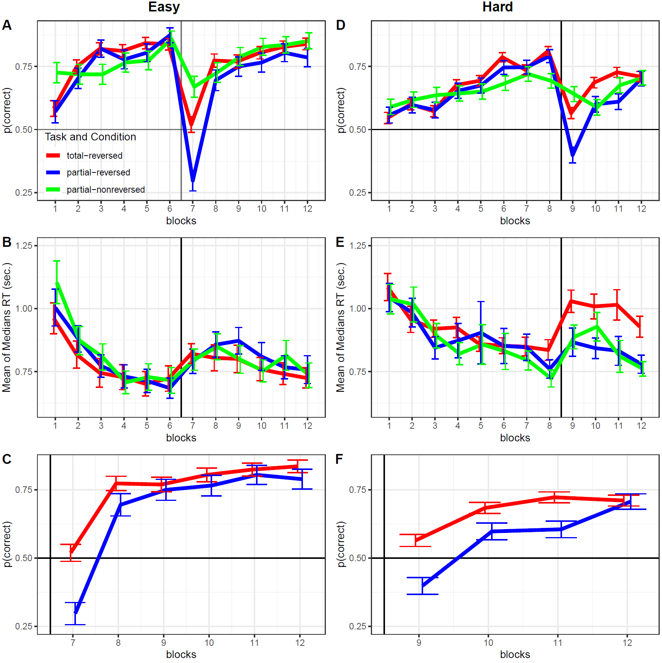
Figure 4. Left panels Experiment 1a, right panels Experiment 1b. A and D probability of correct as a function of blocks. B and E mean of median reaction times as a function of blocks. C and F same as A and D but only plotted for the reversal part of the task, after the vertical line between bocks 6th (easy task) and 8th (hard task). We also removed the partial-nonreversed (green colour) conditions. Error bars are standard errors of the means.

Experiment 1b – Hard Version

Methods

Participants
Thirty-two participants were recruited through Prolific (www.prolific.com). The age ranged between 22 and 65 with a mean of 40.16 and standard deviation of 13.80. Eleven participants were male, 15 female, one non-binary, and 5 did not replied.
We exclude participants using the same criteria as Experiment 1a. Thus, participants’ inclusion is based on a binomial test in which the probability of correct should be higher than random correct 0.5. This implies at least 142 correct trials over 256 trials in phase 1. Six participants were excluded.

Task and Procedures
The task structure is the same as Experiment 1a. The only difference in this experiment is the difficulty which was manipulated by adding more stimuli (fractals; Table 2). Also, the number of blocks per phase varied, where Phase 1 had 8 blocks and 4 blocks in Phase 2. Each block had 16 trials 2 presentations of each exemplar. And within each block the trials were fully randomized. Then in 8 (phase1: blocks) * 16 (trials) + 4 (phase 2: blocks) * 16 (trials) = 192 for each task.

Table 2.

Categorical Reversal Learning Experimental Design (hard)
Category Total Reversal |  |  |  |  | Category Partial Reversal
Phase 1 |  | Phase 2 |  |  | Phase 1 |  | Phase 2
Learning |  | Reversal |  |  | Learning |  | Reversal
Cues | Cat. | Cues | Cat. |  | Cues | Cat. | Cues | Cat. | Condition
A | S← | A | →N |  | A | S← | A | →N | reversal
B | S← | B | →N |  | B | S← | B | →N | reversal
C | S← | C | →N |  | C | S← | C | S← | non-reversal
D | S← | D | →N |  | D | S← | D | S← | non-reversal
E | →N | E | S← |  | E | →N | E | S← | reversal
F | →N | F | S← |  | F | →N | F | S← | reversal
G | →N | G | S← |  | G | →N | G | →N | non-reversal
H | →N | H | S← |  | H | →N | H | →N | non-reversal
Note: A, B, C, D, E, F, G, and H are cues in form of fractals; S← and →N are two distinct correct response categories (Cat.).

Analysis
Same analysis plan as Experiment 1a.

Results

Faster and Better Learning After the Total Reversal
Figure 4D shows the probability of correct category classification average for all blocks in both tasks. Same tasks were used as in the previous experiment but with more exemplars and more training blocks for Phase 1. The total task is represented by one line (red), here all exemplars were revered in phase 2. In contrast of the partial task where only half of exemplars were revered (blue line) and not the other half (green). The critical comparison is to compare in phase 2 the reversed exemplars between the total and the partial task (Figure 4F).
We fit a LogMM to the reversed exemplars in Phase 2, and the model revealed two significant main effects total vs partial [$β_{1}=.87, p<.001, Std. Coef.=.43 (.26, .59)$] and in blocks [$β_{2}=.47, p<.001, Std. Coef.=.53 (.34, .72)$]. The former suggests that, in Phase 2, participants were more accurate in the total than in the partial task; the latter effect suggests that overall participants improved over time. In contrast of the previous experiment, the interaction between task and blocks was significant [$β_{3}=-.18, p=.021, Std. Coef.=-.20 (-.36, -.03)$], this suggests that the rate of readjusting to the new phase (i.e., difference in block slopes between reversed tasks) was different. We also tested the first block between total vs partial, and we found a significant and large effect [$β_{1}=.70, p<.001, Std. Coef.=.70 (.39, 1.01)$]. This suggests that total reversal was acquired quickly than partial reversal.

Larger Reaction Time in the Total Reversal
In contrast to the previous experiment, we found RT differences between tasks in the second phase. Overall the RTs in the total task were higher than in the partial task [$β_{1}=.14, p<.001, Std. Coef.=.22 (.16, .29)$], but there was not a negative main effect in block [$β_{2}=-.03, p=.072, Std. Coef.=-.06 (-.13, .01)$] suggesting people did not reduce significatively their RT as when they re-learn the associations. No significant interaction was found [$β_{3}=-.01, p=.441, Std. Coef.=-.03 (-.09, .04)$]. The results are similar when we used the log-transformed and root-squared RT (see Supplementary Information).

No Differences in Phase 1 Acquisition
As in the previous experiment, it is important to test that the learning trajectories in Phase 1 were not different between the two tasks. We ran a similar model with block, task, and its interaction. We only found a significant block effect suggesting adequate learning in Phase 1[$β_{2}=.20, p<.001, Std. Coef.=.46 (.32, .60)$], but no task main effect [$β_{1}=-.04, p=.742, Std. Coef.=.06 (-.06, .18)$] nor the interaction [$β_{3}=.02, p=.399, Std. Coef.=.05 (-.07, .17)$]. This is evidence in favour of similar learning in Phase 1.

Experiment 2 – Stimuli Control
It was important to test the how dissimilar where the fractal categories. Even if we ran counterbalancing order, is well understood that the mammal brain represent visual objects in two dimensions: animacy (animate–inanimate) and aspect ratio (stubby–spiky; Bracci & De Beeck, 2023). When we visually inspect the categories we used, we suspected the aspect ratio, or other intervening variables could have played a small role in the results from Experiments 1a and 1b. Thus, we decided to experimentally test that possibility and reject it. Thus, we conducted this Experiment 2 to test there is no perceptual systematic bias in the categories we used for Experiments 1a and 1b.

Methods

Participants
Sixteen participants were recruited through Prolific (www.prolific.com). The age ranged between 28 and 61 with a mean of 42.69 and standard deviation of 9.91. Six participants were male and 7 were female.

Task and Procedures
Participants rated each pair of exemplars (Table 3) from 'very similar' to 'very different'. Each trial consisted of a fixation cross followed by the rating screen. The fixation duration, serving as the inter-trial interval (ITI), was sampled from a uniform distribution ranging between 0.5 and 1.5 seconds. After the ITI, participants saw the rating screen (see Figure 3A), which remained until they provided their similarity or difference rating. The slider appeared 1 second after participants viewed the two exemplars. This delay ensured that participants had adequate visual exposure to both exemplars before responding automatically.
In Experiments 1a and 1b, each task included 8 different exemplars. This ensured that the exemplars used in each task were tested among themselves. In each trial, participants rated one of 56 possible comparisons within each task set (Table 3). Each task had 8 exemplars, leading to 64 (8 x 8) potential comparisons. By subtracting the diagonal (comparing an exemplar with itself), we arrive at 56 unique comparisons per task. This number of trials ensured that each comparison was made twice, with left and right positions counterbalanced. Consequently, participants were expected to rate a total of 112 trials (56 trials per task * 2 tasks). However, due to a programming error, the final comparison for each task (left H versus right G) was omitted (see Table 3). Thus, participants completed a total of 110 trials.
Table 3.
Categories Perceptual Similarity: exemplar comparisons
 |  | Right
 |  | A | B | C | D | E | F | G | H
Left | A |  | x | x | x | x | x | x | x
Left | B | x |  | x | x | x | x | x | x
Left | C | x | x |  | x | x | x | x | x
Left | D | x | x | x |  | x | x | x | x
Left | E | x | x | x | x |  | x | x | x
Left | F | x | x | x | x | x |  | x | x
Left | G | x | x | x | x | x | x |  | x
Left | H | x | x | x | x | x | x
Note: 56 fractals similarity trials and ratings. 8 x 8 = 64, but 64 - 8 = 56, given the 8 stimuli diagonal, where it does not make sense to compare the same stimulus against itself. However, the comparison Left H and Right G was not tested due to a programming mistake.

Analysis
The intuition behind the analysis is that the perceived similarity between exemplars within one category should not differ from the perceived similarity within the other category. Similarly, perceived similarity within categories should not differ from the perceived similarity between categories. The perceived similarity was obtained by the distance between each pair of exemplars in in a 'psychological' space (describe below).
We first averaged the similarity ratings for each exemplar comparison. For example, we combined the similarity ratings for Left A vs. Right B with those for Left B vs. Right A. For each participant and each task, we used the 56 averaged similarity ratings between pairs of exemplars and implemented Multidimensional Scaling with 2 dimensions (k). This provided us with 2 coordinates in “psychological” space for each exemplar. This procedure was repeated for each task and each participant. We then used the Euclidean distance to compare each exemplar against the others in the same space. For each participant, this yielded 28 distances, resulting from the combination of 2 elements in a set of 8.
We conducted two relevant comparisons: (1) two categories, comparing exemplars A to D versus exemplars E to H; and (2) between-category versus within-category distances. As the distance distributions did not pass the Shapiro-Wilk test for normality, we used the Wilcoxon rank-sum test with continuity correction for the comparisons. The Type I error rate, alpha, was set to 0.05."

Results & Discussion
The distances between exemplars are shown in Figure 5. We did not find any differences between category that used exemplars A to D and the category that used exemplars E to H for task 1, $W=4089, p=.178$ (Figure 5A), nor for task 2, $W=5351, p=.0538$ (Figure 5B). In addition, we found no differences between distances within categories versus exemplars distances between categories for task 1, $W=25659, p=.425$ (Figure 5C), nor for task 2, $W=24934, p=.792$ (Figure 5D).
These results suggest that participants did not perceive one category more alike than the other. This provides evidence that the effects observed in Experiment 1b are not due to perceptual resemblance of the exemplars but due to the underlying learning of those categories.

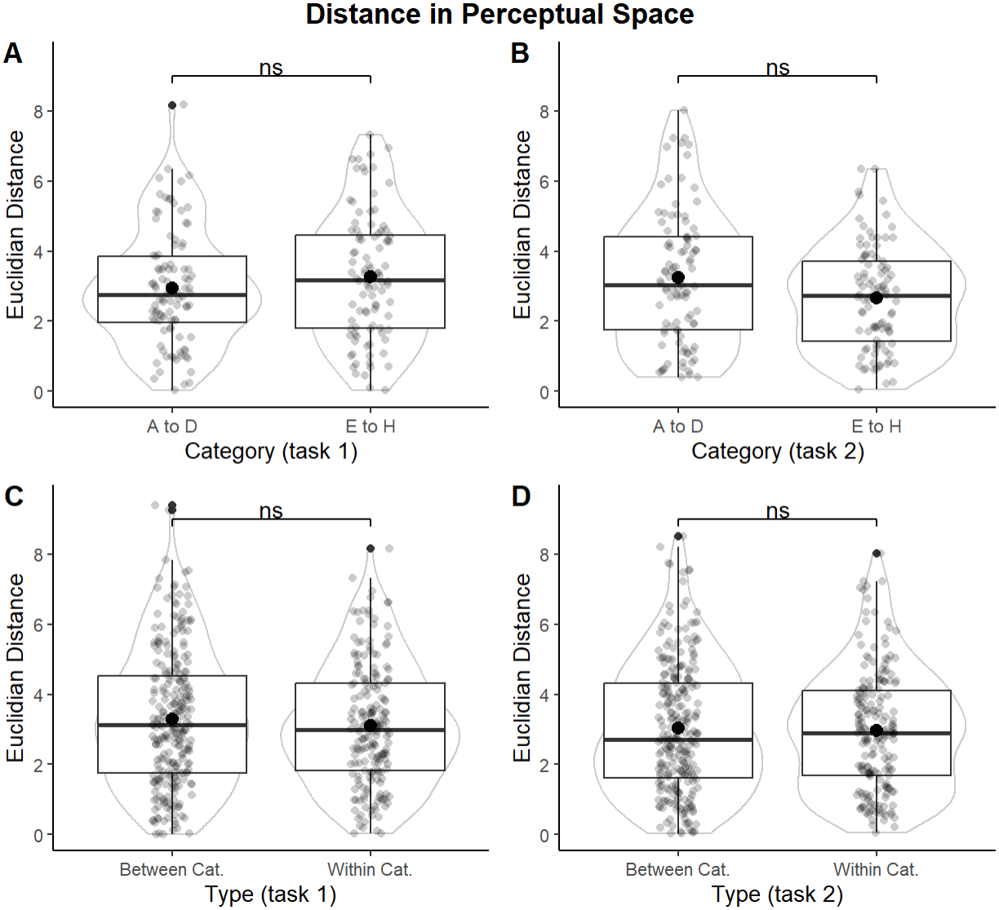
Figure 5. Category Similarity Analysis. Left panels (A and C) represent Experiment 1a results for the exemplars used in Task 1 (could be either total or partial, they were counterbalanced), and the right panels (B and D) Experiment 1b.

General Discussion
Our study also contributes to the broader understanding of common coding as a general phenomenon in humans and neural networks. The findings from our experiments provide compelling evidence for a common coding phenomenon that emerges in category learning. This was evident given that participants learnt faster the task where all outcomes were inverted persevering the same mapping, in comparison the partial reversal task where half of the outcomes were reversed in a second phase forcing participant to remap the underlying mapping of the learnt categories. Across both the easy (Experiment 1a) and hard (Experiment 1b) version of our tasks, participants consistently showed better learning and faster reacquisition in total reversal conditions compared to partial reversals.
Our analysis through Multidimensional Scaling and psychological space measures revealed no significant differences in perceived similarities within and between categories used in experiments 1a and 1b. This suggests that the learning effects observed in experiments 1a and 1b were rooted in the associative mechanisms such as common coding rather than perceptual resemblances of the exemplars. The multidimensional space approach allowed us to map out and quantify the 'psychological' distances between exemplars, providing a robust framework to understand the cognitive processes underlying category learning.
The computational model we employed further supports our experimental findings. By incorporating dynamic learning rates inspired by the Macintosh (Mackintosh, 1975) and Pearce-Hall (Pearce et al., 1984) models, our artificial neural network was able to mimic the total reversal advantage seen in living organisms.
In conclusion, the research presented here advances our knowledge of category learning and common coding. By integrating behavioural experiments with computational modelling, we provide a comprehensive perspective on how associative mechanisms drive cognitive processes such as formation of categories. Future research could build on these findings by exploring the neural correlates of common coding.

References
Bracci, S., & De Beeck, H. P. O. (2023). Understanding Human Object Vision: A Picture Is Worth a Thousand Representations. Annual Review of Psychology, 74(Volume 74, 2023), 113–135. https://doi.org/10.1146/ANNUREV-PSYCH-032720-041031/CITE/REFWORKS
Castiello, S., Zhang, W., & Delamater, A. R. (2021). The retrosplenial cortex as a possible “sensory integration” area: A neural network modeling approach of the differential outcomes effect in negative patterning. Neurobiology of Learning and Memory, 185, 107527. https://doi.org/10.1016/J.NLM.2021.107527
Delamater, A. R. (2012). On the nature of CS and US representations in Pavlovian learning. Learning & Behavior, 40(1), 1–23. https://doi.org/10.3758/s13420-011-0036-4
Delamater, A. R., & Joseph, P. (2000). Common coding in symbolic matching tasks with humans: Training with a common consequence or antecedent. Quarterly Journal of Experimental Psychology Section B: Comparative and Physiological Psychology, 53(3), 255–273. https://doi.org/10.1080/027249900411182,
Detorakis, G., Bartley, T., & Neftci, E. (2019). Contrastive Hebbian learning with random feedback weights. Neural Networks, 114, 1–14. https://doi.org/10.1016/J.NEUNET.2019.01.008
Johns, K. W., & Williams, D. A. (1998). Acquired equivalence learning with antecedent and consequent unconditioned stimuli. Journal of Experimental Psychology: Animal Behavior Processes, 24(1), 3–14. https://doi.org/10.1037/0097-7403.24.1.292
Kaye, H., & Pearce, J. M. (1984). The strength of the orienting response during Pavlovian conditioning. Journal of Experimental Psychology: Animal Behavior Processes, 10(1), 90–109. https://doi.org/10.1037/0097-7403.10.1.90
Lillicrap, T. P., Santoro, A., Marris, L., Akerman, C. J., & Hinton, G. (2020). Backpropagation and the brain. Nature Reviews Neuroscience 2020 21:6, 21(6), 335–346. https://doi.org/10.1038/s41583-020-0277-3
Mackintosh, N. J. (1975). A theory of attention: Variations in the associability of stimuli with reinforcement. Psychological Review, 82(4), 276–298. https://doi.org/10.1037/h0076778
Pearce, J. M., Kaye, H., & Hall, G. (1984). Predictive accuracy and stimulus associability: Development of a model for Pavlovian learning. In M. Commons, R. Herrnstein, & A. R. Wagner (Eds.), Quantitative analysis of behavior (Vol. 3). Ballinger.
Peirce, J., Gray, J. R., Simpson, S., MacAskill, M., Höchenberger, R., Sogo, H., Kastman, E., & Lindeløv, J. K. (2019). PsychoPy2: Experiments in behavior made easy. Behavior Research Methods, 51(1), 195–203. https://doi.org/10.3758/S13428-018-01193-Y/FIGURES/3
R Core Team. (2021). R A Language and Environment for Statistical Computing. R Foundation for Statistical Computing. httpswww.R-project.org
Rumelhart, D. E., Hinton, G. E., & Williams, R. J. (1986). Learning internal representations by error propagation. In D. E. Rumelhart, J. L. McClelland, & the PDP Research Group (Eds.), Parallel distributed processing: Explorations in the microstructure of cognition. Vol. 1: Foundations (pp. 318–362). MIT Press.
Shervani-Tabar, N., & Rosenbaum, R. (2023). Meta-learning biologically plausible plasticity rules with random feedback pathways. Nature Communications, 14(1), 1–12. https://doi.org/10.1038/s41467-023-37562-1
Urcuioli, P. J., Zentall, T. R., & DeMarse, T. (1995). Transfer to Derived Sample-comparison Relations by Pigeons Following Many-to-one versus One-to-many Matching with Identical Training Relations. The Quarterly Journal of Experimental Psychology Section B, 48(2), 158–178. https://doi.org/10.1080/14640749508401445
Xie, X., & Seung, H. S. (2003). Equivalence of Backpropagation and Contrastive Hebbian Learning in a Layered Network. Neural Computation, 15(2), 441–454. https://doi.org/10.1162/089976603762552988

Appendix

Connectionist Model
The model was implemented with code written in R and is publicly available at the following website: https://github.com/santiagocdo/NLM_Bucci_Delamater-Castiello. The connectionist model consists of a three-layer feedforward neural network, where activations go bottom-up (from CS to US representations) and learning top-down. The layers are: input (L = 0), hidden (L = 1) and output (L = 2). This model can be described with two rules: the activation rule (that calculates unit activations) and the learning rule (that determines changes in weights or connections between units).
The connectivity constraint between the input and the hidden layer given the visual, multimodal, and auditory pathways (Delamater, 2012) is encoded in the C matrix (size: number of input units x number of hidden units), where 1 represents an existent connection and 0 a non-existent connection; hence, connections between visual input units to auditory hidden layer pathway units will be equal to 0, and similarly for auditory inputs and visual pathways.
The model computes weight matrices $W$ for layers 1 and 2, i.e., between input and hidden (L = 1), and between hidden and output (L = 2), at every trial t. The values of $W^{L}$ at t = 0 are random variables from a uniform distribution between -0.5 and 0.5. In order to maintain the partial connectivity between input and hidden $W^{1}$ is multiplied (via Hadamard product or elementwise multiplication) with C. On the one hand, $W^{1}$ maps the connections’ weights between input and hidden units, thereby, the matrix size is the number of inputs x number of hidden units. On the other hand, $W^{2}$ represents the weights between hidden and output units, hence, the matrix size is the number of hidden x number of outputs. At every t, the CS information is encoded in the activation of the input layer, $a\left(n^{0}\right)$, where this vector contains 0s and 1s, representing presences and absence of CSs). The USs are encoded in a vector $λ$ (size is equal to the number of USs).
Activation Rule. The first rule of this model specifies how units are activated. The activation of the hidden and output layers is given by a sigmoidal function that receives the net input (n) vector for the current layer L, i.e., $n^{L}$:
$a\left(n^{L}\right)=1/{\left(1+e^{-\left(n^{L}-2.2\right)}\right)}$ (1).
The activations are a real number between 0 and 1. We subtract 2.2. from $n^{L}$ to shift the sigmoidal curve to the right and obtain low activation levels when elements $n^{L}$ is 0. The net input for the hidden layer is:
$n^{L}={a\left(n^{L-1}\right)}^{T}∙W^{L}$ (2),
where $∙$ is a matrix multiplication between a transpose ($T$) column vector (i.e., a row vector), and the matrix.
Learning rule. The second rule of the model specifies how $W^{L}$ changes at every t. This rule is an adaptation of backpropagation (Rumelhart, Hinton, & Williams, 1986). In general terms, the weights are the sum of the current weights and the change of those weights at t. Hence:
$W^{L}=\left\{\begin{aligned}W^{L}+∆W^{L}⊙C, L=1 \\ W^{L}+∆W^{L}, L=2 (output layer)\end{aligned}\right.$ (3),
Where $⊙$ is the Hadamard product or elementwise multiplication, and the partial connectivity only applies to input layer (L = 0) to hidden layer (L = 1) connections within the weight matrix $W^{1}$. This ensures that weights between units with impermissible connections (e.g., auditory inputs to visual pathway hidden units) are fixed at 0. Changes in weights $∆W^{L}$ are determined by:
$∆W^{L}=αδ^{L}∙{a\left(n^{L-1}\right)}^{T}+β∆W^{L}$ (4),
where $α$ and $β$ are free parameters, representing the learning rate (assumed to be 0.3) and the momentum decay (assumed to be 0.9), respectively. Finally, $δ^{L}$ is a vector of delta values, and encodes the prediction errors that are back-propagated throughout the network, following the next equation:
$δ^{L}=\left\{\begin{aligned}\left(λ-a\left(n^{L}\right)\right)a\left(n^{L}\right)\left(1-a\left(n^{L}\right)\right), L=2 (output layer) \\ \left(W^{L+1}∙δ^{L+1}\right)a\left(n^{L}\right)\left(1-a\left(n^{L}\right)\right), L=1 (hidden layer)\end{aligned}\right.$ (5),
where $λ$ is a vector which encodes with 0s (absent) and 1s (present) the USs at every t.

Instructions

Experiment 1a and 1b
In this experiment, you will be presented with a series of abstract images that represent the molecular structure of various natural objects. Your task will be to learn from which of two regions in the world these objects come (Northern Hemisphere or Southern Hemisphere).
More specifically, you will see 1 of 8 different abstract images at a time and be asked to indicate whether you think that image reflects an object taken from the Northern or Southern Hemisphere. Choose the Left Arrow Key for Northern or the Right Arrow Key for Southern Hemisphere. At first, you will need to guess, but you will be provided with feedback after your answer to help you learn which objects come from Northern or Southern Hemispheres.
Your response times are also important. Please make your response choices as quickly, but also as accurately, as you can. Your feedback will display the time (in sec) that it took for you to reach your decision, and also if your choice was correct (with a high pitch sound) or not (low pitch sound).
There will be a break halfway through.
Press the space bar when you are ready to begin.

Experiment 2
[categorySimilarity]
In this experiment, you will be shown pairs of abstract images. Your task is to rate how similar or different the two images appear to you.
The experiment consists of two parts. In the first part, you will see and rate 56 pairs of images, and in the second part, another 56 pairs. Below each pair, there will be a slider ranging from "very different" to "very similar." Use your mouse to select a position on the slider that best represents how similar or different you find the two images are relative to one another.
There will be a break between both parts.
Press the space bar when you are ready to begin.

[fractal_similarity]
In this experiment, you will be shown pairs of abstract images. Your task is to rate how similar or different each pair appears to you.
The experiment consists of two parts. In the first part, you will see 56 pairs of images, and in the second part, another 56 pairs, individual images may repeat between pairs. Below each pair, there will be a slider ranging from "very different" to "very similar." Use your mouse to select a position on the slider that best represents how similar or dissimilar you find the images.
There will be a break between both parts.
Press the space bar when you are ready to begin.

Informed Consent
This research investigates the psychological processes used when people learn to identify objects in the world. You are being asked to participate in this research study because you are a normal healthy adult, and we wish to better understand basic learning processes in your population. The purpose of this research is to gain more knowledge about the cognitive processes involved in simple forms of associative learning.
If you agree to participate, we will ask you to perform in a simple computer task that will last approximately 12 minutes. In this task, you will see a series of abstract images presented individually on the screen and your task will be to learn to choose one of two response options for each image. Also, you will be asked to respond quickly and accurately on your computer keyboard when the image appears.
• Risks/Discomforts: There are no risks for participating in this study beyond those associated with normal computer use over a 15 min period.
• Benefits: This research is not designed to directly benefit you, but your help with this study will advance basic science on the cognitive processes involved in predictive learning in normal healthy individuals. Ultimately, this research could lead to a better understanding of some of the associative learning processes that are negatively impacted by various psychological conditions (such as aging, dementia, etc).
• Confidentiality: This study does not collect identifying information, and all data collected will remain anonymous. We will ask about your gender, age, and nationality, and we will record your performance in the task itself. However, this information will not be linked directly to any individual participant. The data we obtain will be stored indefinitely and may be shared publicly via online repositories for findings that are ultimately published.
Your participation in this research is completely voluntary, and you will be able to stop at any time without penalty. If you have any questions, you can contact: Andrew R. Delamater (andrewd@brooklyn.cuny.edu). If you have any questions about your rights as a research participant or if you would like to talk to someone other than the researcher, you can contact CUNY Research Compliance Administrator at 646-664-8918 or HRPP@cuny.edu.
If you wish to participate in the study, please press the spacebar for additional instructions.

Supplementary Information

Experiment 1a: Sensitivity Analysis of the Reaction Time
RT transformed with Natural Logarithm. We ran the same LMM with condition (total versus partial), block, and its interaction. We found no main effects in Total-Condition [$β_{1}<.01, p=.975, Std. Coef.>-.01 (-.02, .02)$] nor Block [$β_{2}=-.02, p=.081, Std. Coef.=-.02 (-.04, .00)$], and no Interaction [$β_{3}>-.01, p=.815, Std. Coef.>-.01 (-.03, .01)$].
RT transformed with Root Square. We ran the same LMM with condition (total versus partial), block, and its interaction. We found no main effects in Total-Condition [$β_{1}<.01, p=.681, Std. Coef.>-.01 (-.03, .02)$] nor Block [$β_{2}>-.01, p=.106, Std. Coef.=-.02 (-.04, .00)$], and no Interaction [$β_{3}>-.01, p=.529, Std. Coef.>-.01 (-.03, .02)$].

Experiment 1b: Sensitivity Analysis of the Reaction Time
RT transformed with Natural Logarithm. We ran the same LMM with condition (total versus partial), block, and its interaction. We found the same main significant effects in Total-Condition [$β_{1}=.10, p=.016, Std. Coef.=.7 (.06, .09)$] nor Block [$β_{2}=-.05, p<.001, Std. Coef.=-.02 (-.04, .-.01)$], and no Interaction [$β_{3}=.01, p=.341, Std. Coef.>-.01 (-.02, .02)$].
RT transformed with Root Square. We ran the same LMM with condition (total versus partial), block, and its interaction. We found no main effects in Total-Condition [$β_{1}<.01, p=.681, Std. Coef.>-.01 (-.03, .02)$] nor Block [$β_{2}>-.01, p=.106, Std. Coef.=-.02 (-.04, .00)$], and no Interaction [$β_{3}>-.01, p=.529, Std. Coef.>-.01 (-.03, .02)$].

All vectors are considered to be column vectors. Hence to get a row vector we transpose them, e.g. x (column vector), x^{T} (row vector).

