Auditory Perceptual Biases in Schizophrenia:
A Case-Control Study Using Sine-Wave Speech

Authors:
Castiello, S.¹, Barch, D.M.², Erickson, M.A.³, Boudewyn, M.A.⁴, Carter, C.S.⁵, Frank, M.J.⁶, Gold, J.M.⁷, MacDonald, A.W., III⁸, & Luck, S.J.⁹, Kenny, J.¹⁰, Pappu, M.K.¹⁰, & Corlett, P.R.^{10, a}

Affiliations:
¹Department of Psychiatry, Yale University, US
²Department of Psychological & Brain Sciences, Washington University in St. Louis, US
³Department of Psychiatry & Behavioral Neuroscience, University of Chicago, US
⁴Department of Psychology, University of California, Santa Cruz, US
⁵Department of Psychiatry and Human Behavior, University of California, Irvine, US
⁶Department of Cognitive and Psychological Sciences, Brown University, US
⁷Maryland Psychiatric Research Center, Department of Psychiatry, University of Maryland School of Medicine, US
⁸Department of Psychology, University of Minnesota, US
⁹Center for Mind & Brain and Department of Psychology, University of California, Davis, US
¹⁰Wu Tsai Institute, Yale University, US
ªCorresponding author

Abstract
People who hear voices may have strong prior expectations of speech, so that noisy auditory signals are resolved as speech. Data in non-clinical voice hearers suggest that voice hearing may involve sensitivity to speech in degraded stimuli. This has yet to be examined in people with schizophrenia. In this case-control study, we presented sine-wave-speech (SWS; made by replacing the formants in speech with pure tone whistles) to people with schizophrenia (SZ, n=63) and healthy controls (HC; n=27). SWS is typically unintelligible on first exposure. However, once the listener knows that it is potentially intelligible as speech (by exposure to the unaltered speech template, which thus serves as a prior expectation), relatively high levels of comprehension are achieved. Our participants first listened to intelligible and unintelligible SWS and reported whether they heard speech. They were then exposed to the speech templates, and then the first phase was repeated. Compared to HC, people with SZ reported hearing more speech before template exposure. The Reveal increased both groups’ false alarms and reporting of speech, but there was no interaction with group. Change in hit rates after the Reveal correlated with hallucinations, which is consistent with a greater influence of the priors enhancement in SZ patients who hear voices. These findings suggest that people with SZ have stronger expectations of speech. This task has validity for hallucinatory voice hearing. It is also simple and convenient to administer, and may prove useful in detecting prodromal risk, as well as acute exacerbation in voice hearing.

Introduction
Auditory verbal hallucinations (AVHs) are a frequent symptom in people diagnosed with schizophrenia (SZ). In classical psychiatric nosology, AVH have been understood as a failure to distinguish internally generated thoughts from externally produced sounds¹. Foundational perception research established that individuals with AVHs exhibit both more vivid auditory imagery² and deficits in reality testing, leading to the misattribution of internal events to an external source³. Subsequent work showed that people with AVHs are more susceptible to conditioning, more readily learning to perceive a sound that is not present after it has been paired with another stimulus⁴. This suggests that a vulnerability in basic associative learning could contribute to the formation of hallucinatory percepts⁵. While this framework identified key cognitive vulnerabilities, contemporary computational psychiatry seeks to explain the underlying mechanisms that give rise to these perceptual experiences^{6,7}.
The predictive processing framework offers one compelling candidate, positing that perception arises from the brain’s continuous effort to align incoming sensations with its internal predictions^{6–9}. According to this model, hallucinations emerge from an imbalance wherein expectations or priors dominate perception, overriding conflicting sensory evidence¹⁰. This "overweighting of priors" can lead to the experience of a percept in the absence of a corresponding stimulus^{6,10–12}. Evidence for this mechanism is extensive; psychosis severity is linked to failures in updating beliefs based on new sensory information¹³ and the tendency to rely on priors has been identified as a marker of hallucination susceptibility^{14,15}. While some nuances remain regarding how these mechanisms operate across different sensory modalities¹⁶, the evidence converges on the idea that an overreliance on prior beliefs is a critical factor in the pathophysiology of hallucinations.
Ambiguous auditory stimuli, such as sine-wave-speech (SWS), provide an ideal paradigm to test the influence of priors on auditory perception (Figure 1). SWS is derived from natural speech but sounds like noise or whistles until a listener is cued that it contains language, at which point the prior knowledge of speech dramatically alters the perceptual experience¹². Previous studies using SWS have shown that individuals prone to hallucinations, including clinical high-risk individuals, have a greater tendency to report speech in these ambiguous sounds even before being exposed to the unaltered original audio^{17,18}. This suggests that non-clinical voice hearers, perhaps on a continuum with SZ, have a pre-existing bias towards interpreting ambiguous auditory patterns input as recognizable speech.
It remains unclear how the perceptual systems of individuals with SZ respond to ambiguous SWS and benefits (or not) from priors created by template sentence exposure. The present study was designed to test this explicitly. We used an SWS paradigm to investigate whether strengthening auditory priors¹⁷ would differentially increase the rate of hallucinatory-like speech percepts in patients with SZ compared to Healthy Controls (HC). We hypothesized that (1) people with SZ would display higher speech reports before the reveal or auditory priors enhancement, and (2) after the priors enhancement phase, patients would be significantly more likely to report hearing speech in unintelligible trials (false alarms), consistent with a mechanism in which overweighted speech expectations generate false speech percepts.

Methods

Participants
A total of 90 participants were included in this multi-site study, comprising 63 individuals with a diagnosis of SZ and 27 HC. Participants were recruited from five university sites: Washington University in St. Louis, the University of Chicago, the University of Maryland, the University of Minnesota, and the University of California, Irvine, Santa Cruz, and Davis.
For all individuals in the SZ group, diagnosis was confirmed by clinician or trained staff using the Structured Clinical Interview for DSM-5 (SCID-5¹⁹). This diagnosis had been established during prior research for re-recruited participants and was determined for the purpose of the present study for all newly recruited participants. To measure the severity of symptomatology, we used the 24-item Brief Psychiatric Rating Scale (BPRS²⁰).
All participants provided written informed consent and were free from a history of neurological injury and had no current substance use disorder (past 3 months). All study procedures were approved by the Institutional Review Board (IRB). The central IRB was at Washington University.

Design and Auditory Perceptual task
In this cross-sectional study of cases and controls, the SWS stimuli were derived from 90 audio-sentences in English (Figure 1). The audios were transformed into intelligible and unintelligible version (listen Supplementary Audio 1 and 2). Intelligible SWS sentences were created using the acoustic properties (spectral and amplitude tracks) of the original sentence, while unintelligible versions were made by mixing properties from different sentences^{12,21}. The task comprised three phases: Pre-reveal, Reveal, and Post-reveal (Figure 1).
In the first phase participants listened to total 45 intelligible and 45 unintelligible SWS sentences presented in randomized order. After each trial, they were asked to report in a forced-choice question whether they heard any speech. Since participants were naïve to SWS, we expected they would have difficulty identifying speech during this initial phase. In the second phase, participants were exposed to all 90 audio stimuli in their original, unaltered form. This reveal phase aimed to strengthen the auditory priors for speech. Finally, participants were re-tested with the same discrimination task as in the first phase, evaluating the same 45 intelligible and 45 unintelligible SWS stimuli but in a different random sequence. The current task was nearly identical to the paradigm we have previously used¹⁷, with the exception that the number of trials was doubled (90 instead of 45 in the Reveal phase). This pre-post design was specifically chosen to assess changes in auditory perception after a brief enhancement of priors (Reveal).

Data Analysis
We used Signal Detection Theory (SDT) and raw behaviour to compare task performance. We first compare groups in the Pre phase to assess baseline biases towards hearing speech, then we compare the effect of enhancing auditory priors by estimating the interaction between phase (Pre and Post) and group (Figure 1D). Lastly, we estimated Spearman correlations between task performance difference (Post minus Pre) and BPRS to explore which symptoms were particularly affected by the Reveal.

Signal Detection Theory analysis
We quantified sensitivity of detection (d’), response threshold or bias (C), hit rate, and false alarm rate, with standard SDT metrics¹¹. These metrics assume that the signal and noise variances are normally distributed, however, we are not using this analysis as a theoretical framework but purely to synthesize the task behaviour, we complement this analysis with raw behaviour [p(report ‘yes’) and p(correct)]. In SWS, the intelligible audio trials correspond to a modified version of the original audio using the same acoustic properties of the audio, and the unintelligible versions were made by using acoustic properties from different audios^{12,21}. Thus, reporting hearing speech in an intelligible audio was recorded as a hit, failing to report hearing the speech in intelligible trials was a miss, and in the case of unintelligible trials, reporting hearing the speech was considered a false alarm and reporting not hearing it was a correct rejection. We calculated the hit rate [$p(h)$] as:
$p(h)=p\left(report "yes" | intelligible\right)=\frac{hit}{hit+miss}$; (Eq. 1)
And the false alarm rate [$p(fa)$] as:
$p(fa)=p\left(report "yes" | unintelligible\right)=\frac{false alarm}{false alarm+correct rejection}$; (Eq. 2)
with these rates, we calculated both:
$Sensitivity Detection =d^{'}=z\left[p\left(h\right)\right]-z\left[p(fa)\right]$; (Eq. 3)
and
$Response Threshold=C=-1*\{z\left[p\left(h\right)\right]+z\left[p\left(fa\right)\right]\}/2$; (Eq. 4)
where $z$ corresponds to the z-score value of the probabilities: $p\left(h\right)$ and $p\left(fa\right)$. In cases where rates were 0 or 1, then the z-score would be $-∞$ or $∞$; to avoid that we used the Macmillan-Kaplan method²². We calculated these four metrics for each phase (Pre and Post) and for each participant.

Statistical Analysis and Software
To compare the two samples, we used Chi-square ($Χ^{2}$) tests for categorical variables, and two-sided Welch Two Sample t-tests for continuous variables; for the latter we reported Cohen’s d and 95% confidence interval as effect sizes. To test the effect of the auditory priors’ enhancement (i.e., the interaction between group and phase), we used linear mixed models (LMM) to predict each one of the four SDT metrics, and the two raw behaviour variables: p(correct), and p(report ‘yes’). The LMM model had participant as random intercept and no random slope. Thus, Pre and Post were nested within participant. The models had the following form:
$dep.var.=β_{0}+β_{1}X_{phase}+β_{2}X_{group}+β_{3}X_{phase}X_{group}$; (Eq. 5)
where the $dep.var.$ (i.e., dependent variable) was either: p(correct), p(report ‘yes’), $p(h)$, $p(fa)$, $d'$, or $C$. $X_{phase}$ encodes phases (Pre=0, Post=1), and $X_{group}$ encodes groups (HC=0, SZ=1). $β_{0}$ represents the intercept, $β_{1}$ encodes the difference between phases when $X_{group}$ is 0 (i.e., for Post minus Pre for the HC group), $β_{2}$ encodes the difference between groups when $X_{phase}$ is 0 (i.e., for SZ minus HC for the Pre phase), and finally, $β_{3}$ represents the group differences in the trajectories between Pre and Post, or the differences between slopes.
We used Kolmogorov-Smirnoff test to test the normality of the LLM residuals. In order to deal with the unbalance samples between the group. We conducted a permutation test in Supplementary Information (Table S1), estimating the distribution of the estimates using 27 randomly selected participants in the SZ group. The type 1 error, $α$ (alpha), was set to .05. All data processing, statistics, and visualization were conducted in R²³ using the wizaRdry²⁴, reshape2²⁵, ggplot2²⁶, report²⁷, and lmerTest²⁸ packages. See all scripts and data in: https://github.com/santiagocdo/swsSchizoBull.

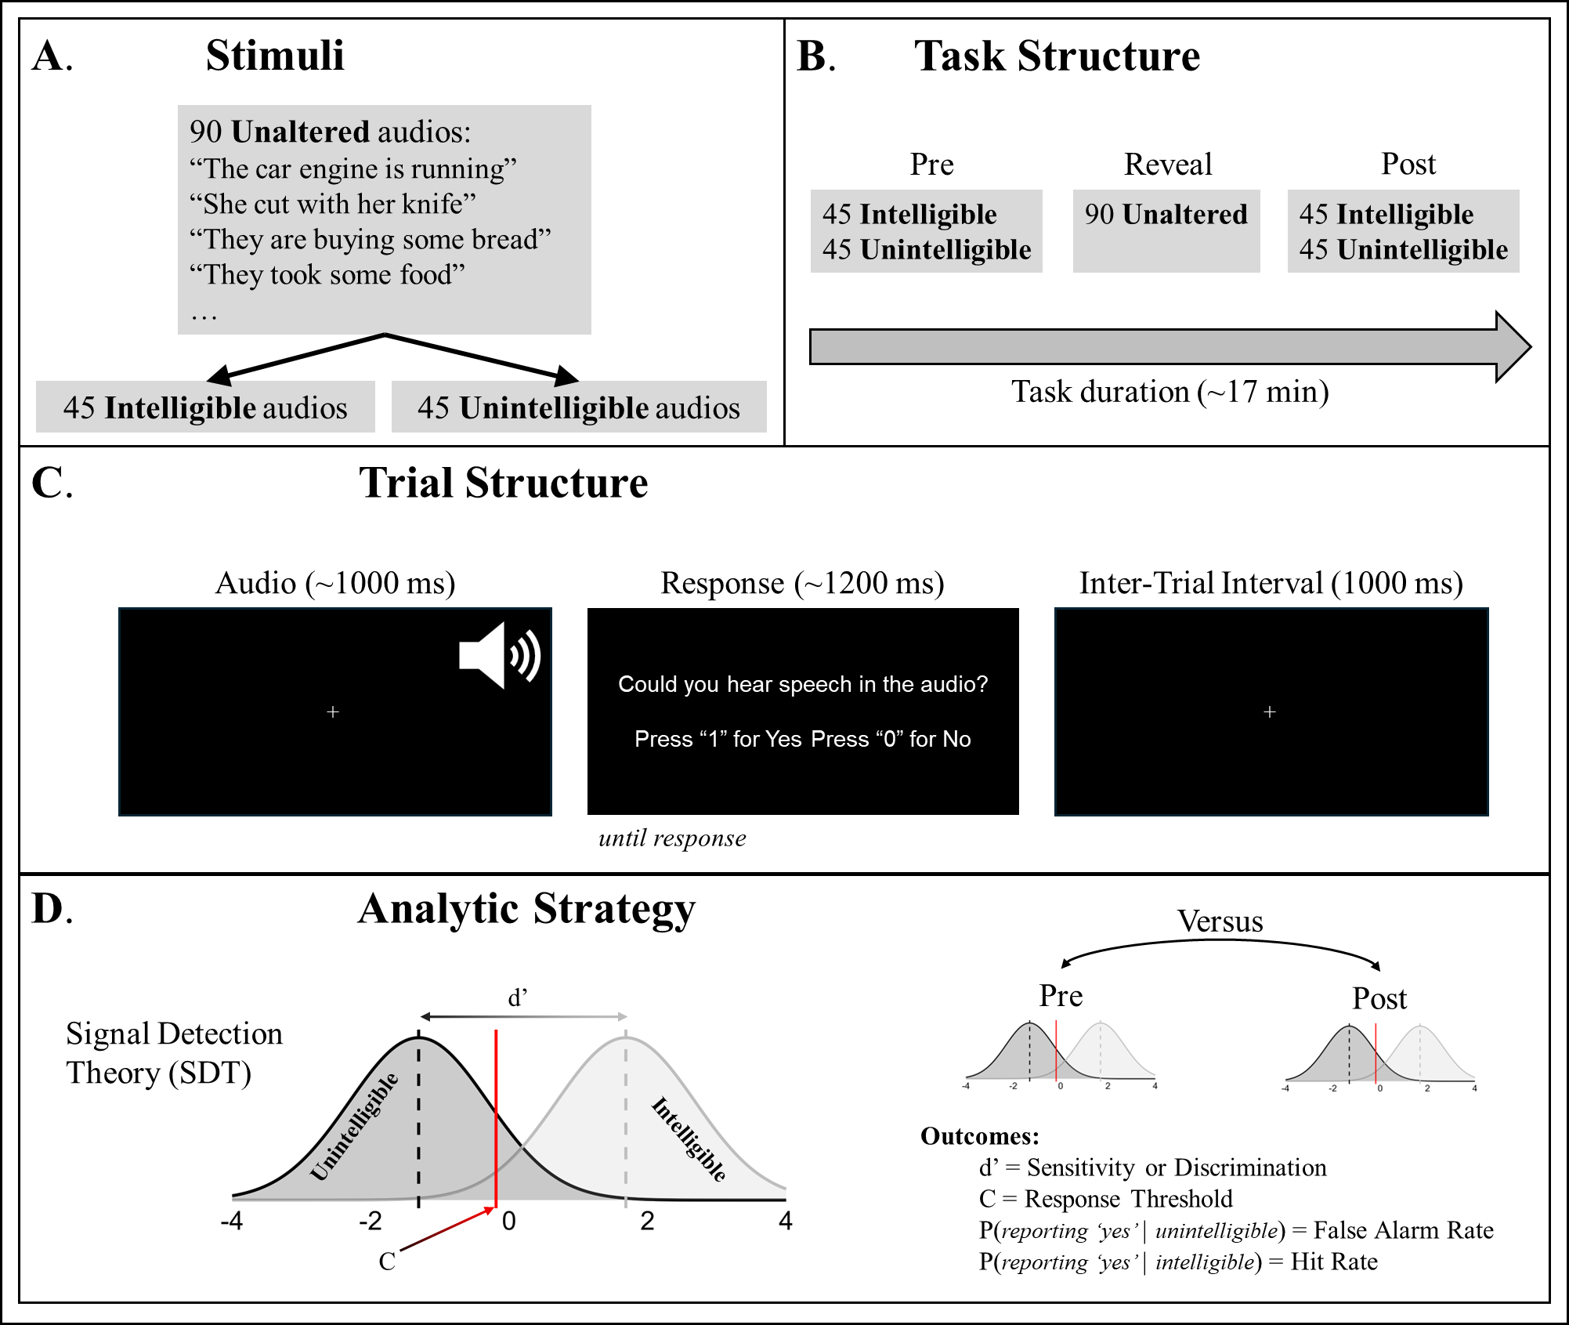
Figure 1. Sine-Wave Speech detection task and analysis. (A) Stimuli: ninety English sentences were used as stimuli, they were transformed¹² to create intelligible and unintelligible versions. (B) Task structure: the task has 3 phases, each one with 90 trials. The first and third phase (i.e., Pre and Post) consisted of the random intermixed presentation of 45 intelligible and 45 unintelligible trials. The second phase (Reveal, auditory priors’ enhancement) was the presentation of all 90 unaltered trials, and no responses were recorded. (C) Trial structure: each trial consisted in three moments, listening to the audio, reporting whether they heard speech, and finally an Inter-Trial Interval (ITI). The audio icon (in white) was not displayed in the experiment. (D) Analytic strategy: We compare Pre and Post with Signal Detection Theory (SDT), which is used to measure how well a participant discriminates between intelligible and unintelligible audios (see Methods).
Table 1. General Characteristics of the Sample: Sociodemographic, Symptoms, and Task Performance
 |  | Patients with Schizophrenia (SZ) |  |  | Healthy Controls (HC) |  |  | Group Comparison
 |  | N | M / % | SD | N | M / % | SD | t / X² | P value
Age |  | 63 | 42.25 | 10.8 | 27 | 36.81 | 9.82 | 2.34 | 0.023*
Gender | Male | 31 | 49.21 |  | 15 | 55.56 |  | 0.67 | 0.716
Gender | Female | 31 | 49.21 |  | 12 | 44.44 |  | 0.67 | 0.716
Gender | Other | 1 | 1.59 |  |  |  |  | 0.67 | 0.716
Race | White | 31 | 49.21 |  | 11 | 40.74 |  | 7.44 | 0.059
Race | Black | 27 | 42.86 |  | 8 | 29.63 |  | 7.44 | 0.059
Race | Asian | 3 | 4.76 |  | 4 | 14.81 |  | 7.44 | 0.059
Race | Mixed/Other | 2 | 3.17 |  | 4 | 14.81 |  | 7.44 | 0.059
Years of Education | Parents | 61 | 14.93 | 2.69 | 26 | 15.19 | 3.86 | -0.31 | 0.758
Years of Education | Participant | 63 | 13.74 | 3.33 | 27 | 15.78 | 3.26 | -2.70 | 0.009*
BPRS | Total | 62 | 44.00 | 10.97
BPRS | Positive | 63 | 10.92 | 5.70
BPRS | Negative | 63 | 5.78 | 2.89
BPRS | Disorganized | 63 | 5.13 | 1.65
BPRS | Depression | 63 | 5.68 | 2.75
BPRS | Mania | 63 | 4.84 | 1.42
SWS: Raw Behaviour | p(correct) Pre | 63 | 0.88 | 0.13 | 27 | 0.86 | 0.12 | 0.82 | 0.416
SWS: Raw Behaviour | p(correct) Post | 63 | 0.86 | 0.14 | 27 | 0.83 | 0.12 | 0.95 | 0.348
SWS: Raw Behaviour | p(report 'yes') Pre | 63 | 0.52 | 0.15 | 27 | 0.45 | 0.15 | 2.07 | 0.044*
SWS: Raw Behaviour | p(report 'yes') Post | 63 | 0.57 | 0.15 | 27 | 0.52 | 0.16 | 1.54 | 0.131
SWS: SDT | Sensitivity Pre | 63 | 3.02 | 1.20 | 27 | 2.81 | 1.11 | 0.83 | 0.409
SWS: SDT | Sensitivity Post | 63 | 3.02 | 1.24 | 27 | 2.68 | 1.14 | 1.27 | 0.210
SWS: SDT | Response Threshold Pre | 63 | -0.14 | 0.71 | 27 | 0.22 | 0.67 | -2.30 | 0.026*
SWS: SDT | Response Threshold Post | 63 | -0.34 | 0.66 | 27 | -0.11 | 0.73 | -1.40 | 0.167
SWS: SDT | False Alarm Rate Pre | 63 | 0.14 | 0.19 | 27 | 0.10 | 0.12 | 1.39 | 0.168
SWS: SDT | False Alarm Rate Post | 63 | 0.21 | 0.25 | 27 | 0.19 | 0.19 | 0.61 | 0.546
SWS: SDT | Hit Rate Pre | 63 | 0.89 | 0.20 | 27 | 0.80 | 0.24 | 1.78 | 0.082
SWS: SDT | Hit Rate Post | 63 | 0.93 | 0.13 | 27 | 0.85 | 0.21 | 1.89 | 0.068
SWS: SDT | Miss Rate Pre | 63 | 0.11 | 0.20 | 27 | 0.20 | 0.24 | -1.78 | 0.082
SWS: SDT | Miss Rate Post | 63 | 0.07 | 0.13 | 27 | 0.15 | 0.21 | -1.89 | 0.068
Note: BPRS = Brief Psychiatric Rating Scale; SWS = Sine-Wave-Speech task; SDT = Signal Detection Theory; # = count or frequency; % percentage; N = group size; M = average or arithmetic mean; SD = standard deviation. For categorical variables we used a chi-squared (X²) and for continuous a t-tests (t). * = P value lower than .05.

Results

Characteristics of the Samples
The sample for this case-control study consisted of 90 participants: 63 patients with SZ and 27 HC (Table 1). There were a few differences between the samples. The SZ group was slightly older than the HC group [$t=2.34, p=.023, d=.64 (.09, 1.18)$], and reported fewer years of formal education [$t=2.70, p=.009, d=.76 (.19, 1.33)$]. There were no significant group differences in race [$Χ^{2}=7.438, p=.06$; Table 1].There were no group differences in gender [$Χ^{2}=.67, p=.716$] nor in years of parental education [$t=.31, p=.758, d=.10 (-.55, .76)$].

Auditory Perceptual Biases at Baseline (Pre)
We found that, compared to HCs, participants with a diagnosis of SZ reported hearing more speech before they were exposed to the Reveal of the unaltered speech stimuli (Table 1). This was evidenced in the Pre phase by a significantly higher probability of reporting hearing speech [$t=2.07, p=.044, d=.59 (.02, 1.15)$] and a significantly more negative Response Threshold toward reporting speech [$t=-2.30, p=.026, d=-.64 (-1.20, -.08)$; more negative values indicates more liberal response toward speech]. No significant differences were found between groups in terms of sensitivity (d’), false alarms, nor probability of correct. Although, hit rates are seemingly different they did not reach significance (cf. LMM in Figure 2B). No significant group differences were found in the Post phase in any of the SDT nor behavioural indicators.

Effect of Enhancing Auditory Priors
Figure 2A displays the SDT and behavioural results for both Pre and Post phases by group. The impact of the Reveal as a brief auditory priors enhancement did not significantly differ between groups, i.e., no significant interaction indicating no difference in slopes (Figure 2B). However, both groups exhibited a significant increase in false alarm rates from the Pre phase to the Post phase, evidenced by a main effect of phase [$β_{1}=.09,p=.0056,Std.Coef.=.426 (.126,.726)$]. Similarly, in all participants (i.e., as a main effect of phase) the Reveal of unaltered audios led to an increase in reports of hearing speech in the Post phase, evidenced by significant reductions of Response Threshold [$β_{1}=-.34,p=.0007,Std.Coef.=-.48 (-.75,-.203)$]; increases of hit rates [$β_{1}=.047,p=.041,Std.Coef.=.258(.01,.486)$], and increases in the probability of reporting hearing speech [$β_{1}=.07,p=.0009,Std.Coef.=.445 (.185,.704)$]. No significant difference in phase as main effect in sensitivity nor probability of correct detection.
We also found a significant main effect of group, which is consistent with the greater bias towards reporting hearing speech in the Pre phase among individuals with SZ (Figure 2). In addition, as main effects, participants with SZ showed significantly lower Response Threshold in comparison with HC [$β_{2}=-.36,p=.024,Std.Coef.=-.51 (-.95,-.068)$; middle left panels in Figure 2A and 2B], also higher hit rates [$β_{2}=.093,p=.0302,Std.Coef.=.496 (.048,.937)$; middle right panels in Figure 2A and 2B], and higher probability of reporting ‘yes’ [$β_{2}=.0713,p=.0441,Std.Coef.=.453 (.121,.894)$]. Overall, this means that even before the Reveal, participants with SZ tend to report more speech, and all participants reported hearing more speech after the auditory priors enhancement, but there was no interaction with group.

Correlations with Symptoms
Given to the theoretical link between hearing speech and hallucinations^{12,17}, we examined whether the severity of symptoms correlated with the task performance. For symptoms, we used total BPRS score, positive and negative sub-scores, and the hallucination item. The BPRS was only scored for participants in the SZ group. For task performance we used the SDT scores. We first estimated the correlations between symptoms and performance in the Pre phase, reflecting the first hypothesis. Second, we estimated correlations between change in task performance (Post–Pre) and symptoms, reflecting the second hypothesis. All Spearman correlations are shown in Table 2.
Before the Reveal, hallucinations were negatively correlated with sensitivity and hit rate. We found that positive symptoms were negatively correlated with performance pre-Reveal, and total symptoms severity negatively correlated with sensitivity. Furthermore, to investigate whether some symptoms were susceptible to change their priors with the Reveal, we correlated the performance difference (Post–Pre) with symptoms. We found that hit rate change correlated with hallucinations, indicating that more hallucinations are associated with a greater likelihood of reporting speech after the Reveal. We fit an extra LMM to corroborate whether this effect was an artifact of the correlation, that was not the case; we found a significant interaction pointing to the same conclusion (see Supplementary Information). Finally, we examined correlations between change in performance with all individual BRPS items (Figure S1 in Supplementary Information). Some potential significant items were motor retardation, elated mood and suicidality.

Table 2. Correlation with Symptoms measured by BPRS
 |  | Brief Psychiatric Rating Scale (BPRS)
 |  | Hallucinations | Negative | Positive | Total
Pre: Auditory Perceptual Biases | Sensitivity | -0.3* | -0.03 | -0.39* | -0.37*
Pre: Auditory Perceptual Biases | False Alarm Rate | 0.14 | -0.08 | 0.18 | 0.31*
Pre: Auditory Perceptual Biases | Response Threshold | 0.12 | 0.1 | 0.14 | 0
Pre: Auditory Perceptual Biases | Hit Rate | -0.3* | -0.08 | -0.36* | -0.24
Post - Pre: Enhancing Auditory Priors | Sensitivity | 0.1 | 0.06 | 0.15 | 0.08
Post - Pre: Enhancing Auditory Priors | False Alarm Rate | 0.08 | -0.04 | 0.04 | 0.07
Post - Pre: Enhancing Auditory Priors | Response Threshold | -0.21 | -0.05 | -0.13 | -0.09
Post - Pre: Enhancing Auditory Priors | Hit Rate | 0.29* | 0.04 | 0.32* | 0.2
Note: all tests are Spearman correlations, where * means a P value < .05. Correlations in bold represent the correlation survived multiple comparisons with Bonferroni (for k = 4; i.e., 4 hypothesis). We also report Bonferroni correction (.05/4), which was conducted with 4 metrics per symptom (4 symptoms) and per condition (Pre and change score).

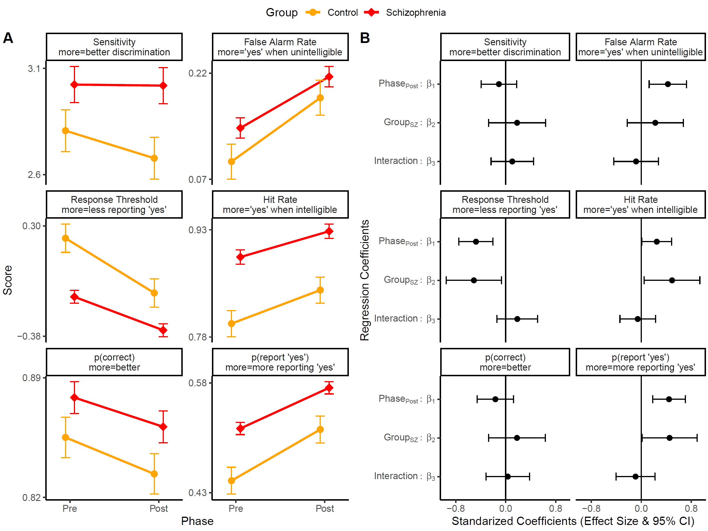
Figure 2. Main results, Pre versus Post by group. (A) Y-axis panels from top left to bottom right: Sensitivity (d’; higher values are better perceptual discrimination), false alarm rate (probability of reporting hearing a speech given there was none), Response Threshold (C; tendency towards reporting hearing a speech, negative numbers represent higher frequency of reporting “yes”), hit rate (probability of reporting hearing a speech in their presence), p(correct) is the sum of hits and correct rejections divided by the total number of trials per phase (i.e., 90), and p(report “yes) is the sum of hits and false alarms divided by the total number of trials per phase. X-axis, Pre and Post the unaltered exposure, each phase had 90 trials (see Figure 1). The error bars are within-participants standard error of the mean (SEM) using the Cousineau–Morey method²⁹. (B) Same panel order than A but y-axis represents the coefficients of a linear mixed model, and the x-axis the standardized coefficients (i.e., effect sizes). The error bars correspond to 95% of confidence intervals (CI); thus, when the vertical black line is outside the CI, the coefficient is significant.

Discussion
This is the first study investigating the role of auditory priors in Schizophrenia (SZ) using the sine-wave-speech (SWS) paradigm (an auditory perceptual task). We compared people with SZ and Healthy Controls (HC) and tested their baseline tendency to report hearing speech in distorted audios as well as the effect of enhancing auditory priors—via exposure to the unaltered speech template stimuli. Even before the reveal of the unaltered audios, we found that people with SZ have an overall greater tendency to report hearing speech more often than HC. Both groups showed an increased report of speech when it was unintelligible (i.e., false alarms) after enhancing the auditory priors. We did not observe group differences by the Reveal of unaltered audios aimed to enhanced auditory priors. However, symptoms severity was negatively correlated with task performance sensitivity at baseline; and the severity of hallucinations were associated with a greater likelihood of reporting speech in the Post phase.
Previous research with the same SWS paradigm but with different populations found comparable results^{12,17}. Participants in clinical high risk of psychosis showed a bias to report more speech in the whole task¹⁷. Similarly, non-clinical voice hearers tend to identify speech earlier than controls¹². Thus, the tendency to hear voices within noise is enhanced across the psychosis continuum, from people with a diagnosis. This is evidence for a continuous model^{30,31} where top-down perceptual effects are found in the psychosis spectrum and not only in SZ^{6,15}.
Overall, these data invite the possibility that people who experience hallucinations have speech expectation that are strong and sensitive, as observed in the neural organization of auditory cortex³². Even if we did not observe statistically significant difference in false alarms between SZ and HC, the direction of the effect points towards more false alarms in SZ. In other tasks that involve multisensory modality by pairing visual stimuli with a tone, people prone to hallucinations showed higher rates of false alarms¹⁰. Contrary to previous evidence¹⁸, our sample did not show improvement in the sensitivity (d’) between the Pre and Post phases. However, high hallucination scores were associated with poorer task performance before the Reveal. Furthermore, the increase in reporting of hearing speech is comparable across SZ and HC, as well as other voice hearing populations^{12,17,18}. The direction of the effect suggests that patients have higher sensitivity than HC. Lastly, the change in hit rates correlated with hallucinations, which is consistent with greater benefits of the new priors in hallucinators¹⁵, however this result should be taken cautiously given it did not survive multiple comparisons.

Limitations
It is unclear why our data failed to support a difference in false alarms between SZ and HC. Unlike others^{15,17}, before the Reveal, false alarms do not correlate with hallucinations; however, we did observe a positive correlation with global symptoms severity (Table 2). These results could be potentially linked to the symptoms severity in the sample or to a relatively small sample size. The severity of hallucinations may have not been high enough (BPRS hallucination item, M 3.47 and SD 2.21) and many patients were medicated, which may impact the relationship between symptoms and cognitive processes.
Reporting more speech may not imply perceiving more speech. Our data shows that participants report more speech, i.e., a decision bias. We interpreted this as perceptual bias given that previous research has shown neural and behavioural specificity for the presence of speech^{12,18}, indicating a differential processing of a meaningful signal, and not just a general reaction to the sounds. To address this, future research could ask participants to report the content of the speech, which would clarify whether they hear or just press a key.
It has been shown that after extensive exposure to SWS participants exhibit evidence for a potential perceptual learning effect¹⁸. In that case, participants may be learning to differentiate between speech and non-speech without comprehending the content¹⁸. Another alternative to why our brief auditory priors’ enhancement did not reveal a difference between groups is because patients’ expectations for speech are already at ceiling, and therefore they may perceive any noise as a voice³³. For instance, a neurocomputational theory suggests that applying a “neural Darwinist” rule (synaptic elimination) to verbal working memory system can lead to exaggerated and disordered linguistic expectations³⁴. This could cause the brain to generate word percepts in the absence of phonetic input, essentially simulating AVH.

Conclusions
Our study revealed that people with SZ have an elevated tendency to report hearing speech in ambiguous auditory stimuli. Contrary to expectations, we observed no differences between SZ and HC after a brief exposure to unaltered speech, which aimed to enhance the speech priors, although the effect on hit rate did correlate with hallucinations. Based on our study in people with SZ and previous evidence in subclinical population at risk of psychosis and active voice hearers, we conclude that the baseline enhanced report of speech in SWS extends to people with a diagnosis of SZ.
Our study provides further evidence in favour of hallucinations as ‘strong-priors’ phenomena and complement our previous evidence on animacy perception¹¹ and multimodal perception¹⁰. This task showed baseline differences between SZ and HC, but the brief protocol aimed to enhance auditory priors may be insufficient to show differential effects between the groups. Future research should explore longer or more complex prior enhancement protocols. SZ and bipolar disorder have similar usage of hospital services before the onset of the disorder³⁵, and they are not likely to be differentiate using reinforcement learning tasks³⁶. Future research should use the current perceptual auditory task to distinguish SZ from bipolar disorder.

Research Transparency Statement
- Conflicts of interest:
  - DMB has received grants from the National Institutes of Health (NIH) and the Brain & Behavior Research Foundation and consults for Janssen & Janssen and Boehringer Ingelheim.
  - MAB has received research grants from the National Institutes of Health (NIH) and the Brain and Behavior Research Foundation.
  - CSC has received research grants from the National Institutes of Health (NIH), the Brain and Behavior Foundation, the Burroughs Wellcome foundation, GlaxoSmithKline, and the Robert Wood Johnson Foundation and has been an external consultant for Lilly, Merck, Pfizer, Roche, and Servier.
  - JMG has received grants from National Institutes of Health (NIH), receives royalty payments from Brief Assessment of Cognition in Schizophrenia, and has acted as a consultant to Amgen, AstraZeneca, GlaxoSmithKline, Hoffman-LaRoche, Merck, Pfizer, and Solvay.
  - SJL has received research grants from the National Institutes of Health (NIH), the National Science Foundation (NSF), McDonnell-Pew Program in Cognitive Neuroscience, and the Human Frontier Science Program.
  - AWM has received research grants from the National Institutes of Health (NIH) and the Brain & Behavior Research Foundation.
  - PRC is cofounder of Tetricus Labs, a precision psychiatry company. They did not fund this work. All other authors report no biomedical financial interests or potential conflicts of interest.
- Funding:
  - National Institute of Mental Health (NIMH) ROI1: MH084840 (DMB), MH084826 (CSC), MH084821 (JMG), MH084861 (AWM) and MH084828 (ME).
  - Templeton Foundation to SC and PRC
- Artificial intelligence: Artificial intelligence assisted technologies were used at support for codding and helping the first author to clarify few sentences.
- Ethics: This research received approval by Washington University IRB.
- Preregistration: No preregistration.
- Materials: Task example available: https://belieflab.yale.edu/sineWaveSpeech/index.php?src_subject_id=test
- Data: For data protection reasons the data may be available upon request.
- Analysis scripts: All primary scripts are publicly available: https://github.com/santiagocdo/swsSchizoBull
- Grey literature:
Corlett, P. (2025). Speech Processing Performance Relates Expectations to Auditory Verbal Hallucinations in People With Schizophrenia. Biological Psychiatry, 97(9), S8.

CRediT
- Conceptualization: DMB, MAE, MAB, CSC, MJF, JMG, AWM, SJL, PRC
- Methodology: DMB, MAE, MAB, CSC, MJF, JMG, AWM, SJL, PRC
- Software: SC, MKP, JK
- Formal Analysis: SC, MKP, JK
- Resources: DMB, MAE, MAB, CSC, MJF, JMG, AWM, SJL, PRC
- Data Curation: SC, MKP, JK
- Writing – Original Draft: SC, PRC
- Writing – Review & Editing: SC, DMB, MAE, MAB, CSC, MJF, JMG, AWM, SJL, MKP, JK, PRC
- Visualization: SC, PRC
- Supervision: DMB, MAE, MAB, CSC, MJF, JMG, AWM, SJL, PRC
- Project Administration: DMB, MAE, MAB, CSC, MJF, JMG, AWM, SJL, PRC
- Funding Acquisition: DMB, MAE, MAB, CSC, MJF, JMG, AWM, SJL

Acknowledgements
None

References
1. Schneider K. Clinical Psychopathology. 5th ed. Grune & Stratton; 1959.
2. Mintz S, Alpert M. Imagery vividness, reality testing, and schizophrenic hallucinations. J Abnorm Psychol. 1972;79(3):310-316. doi:10.1037/H0033209
3. Bentall RP, Slade PD. Reality testing and auditory hallucinations: A signal detection analysis. British Journal of Clinical Psychology. 1985;24(3):159-169. doi:10.1111/J.2044-8260.1985.TB01331.X;REQUESTEDJOURNAL:JOURNAL:20448260;PAGEGROUP:STRING:PUBLICATION
4. Kot T, Serper M. Increased susceptibility to auditory conditioning in hallucinating schizophrenic patients: A preliminary investigation. Journal of Nervous and Mental Disease. 2002;190(5):282-288. doi:10.1097/00005053-200205000-00002,
5. Corlett PR, Schoenbaum G. Leveraging Basic Science for the Clinic—From Bench to Bedside. JAMA Psychiatry. 2021;78(3):331-334. doi:10.1001/JAMAPSYCHIATRY.2020.3656
6. Corlett PR, Horga G, Fletcher PC, Alderson-Day B, Schmack K, Powers AR. Hallucinations and Strong Priors. Trends Cogn Sci. 2019;23(2):114-127. doi:10.1016/J.TICS.2018.12.001
7. Sterzer P, Adams RA, Fletcher P, et al. The Predictive Coding Account of Psychosis. Biol Psychiatry. 2018;84(9):634-643. doi:10.1016/J.BIOPSYCH.2018.05.015
8. Benrimoh DA, Parr T, Vincent P, Adams RA, Friston K. Active Inference and Auditory Hallucinations. Computational Psychiatry. 2018;2(0):183. doi:10.1162/CPSY_A_00022
9. Adams RA, Stephan KE, Brown HR, Frith CD, Friston KJ. The computational anatomy of psychosis. Front Psychiatry. 2013;4:47. doi:10.3389/FPSYT.2013.00047/BIBTEX
10. Powers AR, Mathys C, Corlett PR. Pavlovian conditioning–induced hallucinations result from overweighting of perceptual priors. Science (1979). 2017;357(6351):596-600. doi:10.1126/SCIENCE.AAN3458/SUPPL_FILE/AAN3458-POWERS-SM.PDF
11. Castiello S, Ongchoco JDK, van Buren B, Scholl BJ, Corlett PR. Paranoid and teleological thinking give rise to distinct social hallucinations in vision. Communications Psychology. 2024;2(1):1-12. doi:10.1038/s44271-024-00163-9
12. Alderson-Day B, Lima CF, Evans S, et al. Distinct processing of ambiguous speech in people with non-clinical auditory verbal hallucinations. Brain. 2017;140(9):2475-2489. doi:10.1093/BRAIN/AWX206
13. Bansal S, Bae GY, Robinson BM, et al. Association Between Failures in Perceptual Updating and the Severity of Psychosis in Schizophrenia. JAMA Psychiatry. 2022;79(2):169-177. doi:10.1001/JAMAPSYCHIATRY.2021.3482
14. Kafadar E, Fisher VL, Quagan B, et al. Conditioned Hallucinations and Prior Overweighting Are State-Sensitive Markers of Hallucination Susceptibility. Biol Psychiatry. 2022;92(10):772-780. doi:10.1016/j.biopsych.2022.05.007
15. Teufel C, Subramaniam N, Dobler V, et al. Shift toward prior knowledge confers a perceptual advantage in early psychosis and psychosis-prone healthy individuals. Proc Natl Acad Sci U S A. 2015;112(43):13401-13406. doi:10.1073/PNAS.1503916112/SUPPL_FILE/PNAS.201503916SI.PDF
16. Valton V, Karvelis P, Richards KL, Seitz AR, Lawrie SM, Seriès P. Acquisition of visual priors and induced hallucinations in chronic schizophrenia. Brain. 2019;142(8):2523-2537. doi:10.1093/BRAIN/AWZ171
17. Kafadar E, Mittal VA, Strauss GP, et al. Modeling perception and behavior in individuals at clinical high risk for psychosis: Support for the predictive processing framework. Schizophr Res. 2020;226:167-175. doi:10.1016/J.SCHRES.2020.04.017
18. Alderson-Day B, Moffatt J, Lima CF, et al. Susceptibility to auditory hallucinations is associated with spontaneous but not directed modulation of top-down expectations for speech. Neurosci Conscious. 2022;2022(1):1-14. doi:10.1093/NC/NIAC002
19. First MB, Williams JBW, Karg RS, Spitzer RL. Structured Clinical Interview for DSM-5 Disorders, Clinician Version (SCID-5-CV). American Psychiatric Association. Published online 2016:94.
20. Lukoff D, Liberman RP, Nuechterlein KH. Symptom Monitoring in the Rehabilitation of Schizophrenic Patients. Schizophr Bull. 1986;12(4):578-603. doi:10.1093/SCHBUL/12.4.578
21. Rosen S, Wise RJS, Chadha S, Conway EJ, Scott SK. Hemispheric asymmetries in speech perception: Sense, nonsense and modulations. PLoS One. 2011;6(9). doi:10.1371/JOURNAL.PONE.0024672,
22. Macmillan NA, Kaplan HL. Detection Theory Analysis of Group Data. Estimating Sensitivity From Average Hit and False-Alarm Rates. Psychol Bull. 1985;98(1):185-199. doi:10.1037/0033-2909.98.1.185
23. R Core Team. R A Language and Environment for Statistical Computing. R Foundation for Statistical Computing. Preprint posted online 2021. httpswww.R-project.org
24. Kenney JG, Williams TF, Pappu MK, Spilka MJ. wizaRdry: A Magical Framework for Collaborative &amp; Reproducible Data Analysis. CRAN: Contributed Packages. Published online April 25, 2025. doi:10.32614/CRAN.PACKAGE.WIZARDRY
25. Wickham H. Reshaping Data with the reshape Package. J Stat Softw. 2007;21(12):1-20. http://www.jstatsoft.org/v21/i12/
26. Wickham H. Ggplot2: Elegant Graphics for Data Analysis. Springer-Verlag New York; 2016. https://ggplot2.tidyverse.org
27. Makowski D, Ben-Shachar MS, Patil I, Lüdecke D. Automated Results Reporting as a Practical Tool to Improve Reproducibility and Methodological Best Practices Adoption. CRAN. Published online 2021. https://github.com/easystats/report
28. Kuznetsova A, Brockhoff PB, Christensen RHB. lmerTest Package: Tests in Linear Mixed Effects Models. J Stat Softw. 2017;82(13):1-26. doi:10.18637/jss.v082.i13
29. Cousineau D, O’Brien F. Error bars in within-subject designs: a comment on Baguley (2012). Behav Res Methods. 2014;46(4):1149-1151. doi:10.3758/S13428-013-0441-Z/METRICS
30. Claridge G. Schizotypy: Implications for Illness and Health. Oxford University Press; 1997.
31. Grant P, Green MJ, Mason OJ. Models of Schizotypy: The Importance of Conceptual Clarity. Schizophr Bull. 2018;44(suppl_2):S556-S563. doi:10.1093/schbul/sby012
32. Doucet GE, Luber MJ, Balchandani P, Sommer IE, Frangou S. Abnormal auditory tonotopy in patients with schizophrenia. NPJ Schizophr. 2019;5(1):1-6. doi:10.1038/S41537-019-0084-X;SUBJMETA=1761,1799,476,692,699;KWRD=PSYCHOSIS,SCHIZOPHRENIA
33. Hoffman RE, Rapaport J, Mazure CM, Quinlan DM. Selective speech perception alterations in schizophrenic patients reporting hallucinated “voices.” American Journal of Psychiatry. 1999;156(3):393-399. doi:10.1176/AJP.156.3.393/ASSET/IMAGES/AK9T2.JPEG
34. Huffman RE, McGlashan TH. Synaptic elimination, neurodevelopment, and the mechanism of hallucinated “voices” in schizophrenia. American Journal of Psychiatry. 1997;154(12):1683-1689. doi:10.1176/AJP.154.12.1683/ASSET/IMAGES/A59F4.JPEG
35. Ortiz-Orendain J, Gardea-Resendez M, Castiello-de Obeso S, et al. Antecedents to first episode psychosis and mania: Comparing the initial prodromes of schizophrenia and bipolar disorder in a retrospective population cohort. J Affect Disord. 2023;340:25-32. doi:10.1016/J.JAD.2023.07.106
36. MacDonald AW, Patzelt E, Kurth-Nelson Z, et al. Computational Modeling of Reversal Learning Impairments in Schizophrenia and Bipolar Disorder Reveals Shared Failure to Exploit Rewards. Journal of Psychopathology and Clinical Science. 2025;134(3):262-271. doi:10.1037/ABN0000944

Supplementary Information

Normality Testing for Dependent Variables
We tested the distribution for the dependent variables using a Kolmogorov-Smirnoff test: Hit rates [$D=.21, p<.001$], False Alarm rates [$D=.11, p=.03$], Sensitivity or d’ [$D=.046, p=.84$], Response bias or C [$D=035, p=.98$], probability of correct [$D=.083, p=.162$], and probability of reporting ‘yes’ [$D=.05, p=.74$]. We found that models’ residuals of hit and false alarm rates models may not come from normal distributions. Thus, these results should be carefully considered.

Hallucinations and Hit Rates: Linear Mixed Model
We ran a LMM to corroborate the correlation between hit rate difference (Post minus Pre) and hallucinations score that we report in the main text. We fit a LMM in the form of Eq. 5 (see Main Text), but instead of group as a regressor we included the BRPS hallucination score. We found a significant interaction between hallucinations and phase [$β_{3}=.01,p=.028,Std.Coef.=.18 (.02,.35)$] suggesting that the effect of Reveal on hit rates depends on the severity of hallucinations. We did not find a significant Phase main effect [$β_{1}=-.01,p=.644,Std.Coef.=.22 (.06,.38)$], but a significant main effect of hallucinations [$β_{3}=-.03,p=.007,Std.Coef.=.34 (-.58,-.10)$].

Bootstrapping with Group Balanced Designs
We fitted 1000 permutation of balanced versions of the models (27 SZ vs 27 HC) shown in Figure 1. Then we calculated the proportion of estimates larger or smaller (depending on the estimate sign) than 0 (as null hypothesis; see Table S1). Our results show the group differences are still there in 95% of the cases for: False Alarm rates, Response Threshold, Hit rates, and p(report ‘yes). We also found that using balanced design and permutations there is a likely to be a significant interaction for Response Threshold.

Table S1. Proportion of estimates larger or lower than 0 (null hypothesis)
 | Phase[post] | Group[SZ] | Interaction
Sensitivity | NA | 0.887 | 0.809
False Alarm Rate | NA | 0.955 | 0.782
Response Threshold | NA | 1 | 0.977
Hit Rate | NA | 1 | 0.758
p(correct) | NA | 0.894 | 0.602
p(report 'yes') | NA | 1 | 0.862
Note: 1000 permutations of the Linear Mixed Models with a balanced design (i.e., 27 SZ vs 27 HC). Each permutation randomly selected 27 participants from the 63 participants with SZ. Do not consider Phase[post], because the group of reference was always the same for all runs, i.e., 27 HC.

BPRS Analysis for Individual Items
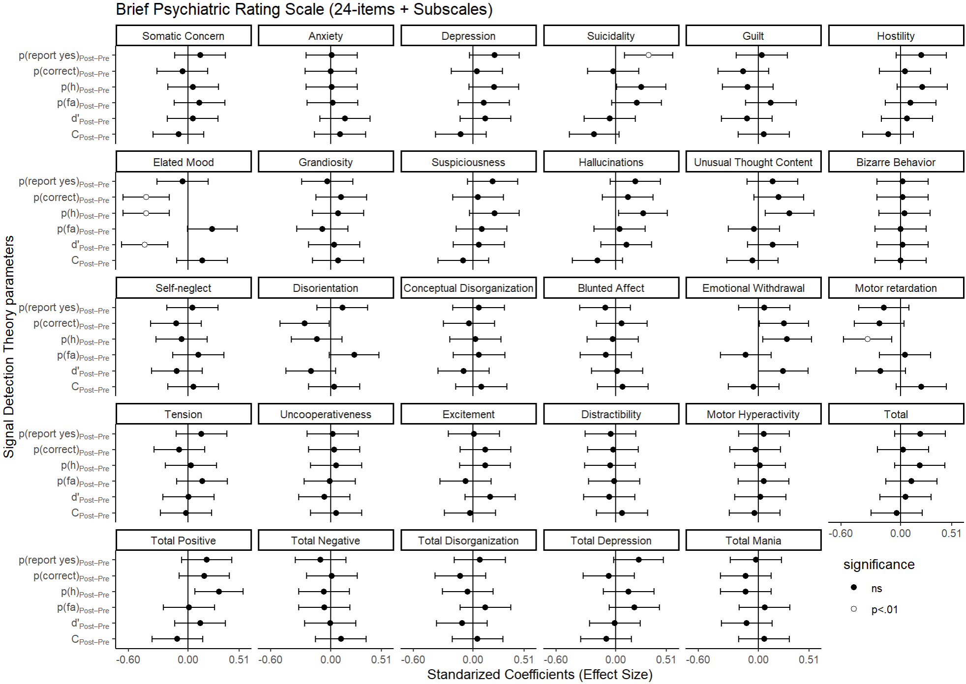
Figure S1. Exploratory analysis predicting performance change with BPRS. Y-axes represent the differences between Post and Pre of the Signal Detection Theory (SDT) scores and raw behaviour: hit rate (detecting a speech in intelligible trials), false alarm rate (reporting a speech in unintelligible trials), d’ or sensitivity (overall tendency to adequately discriminate speech from noise), and Response Threshold (overall tendency to either report or non-report hearing a speech). X-axis is the effect size with its 95% confidence interval. Each panel is one item of the Brief Psychiatric Ratings Scale (BPRS), including panels with total, positive, and negative symptoms.

