LINK: <https://github.com/santiagochango1999/pw_u1_p5_sc/tree/taller2>

FOTO:

PRIMERA PAGINA

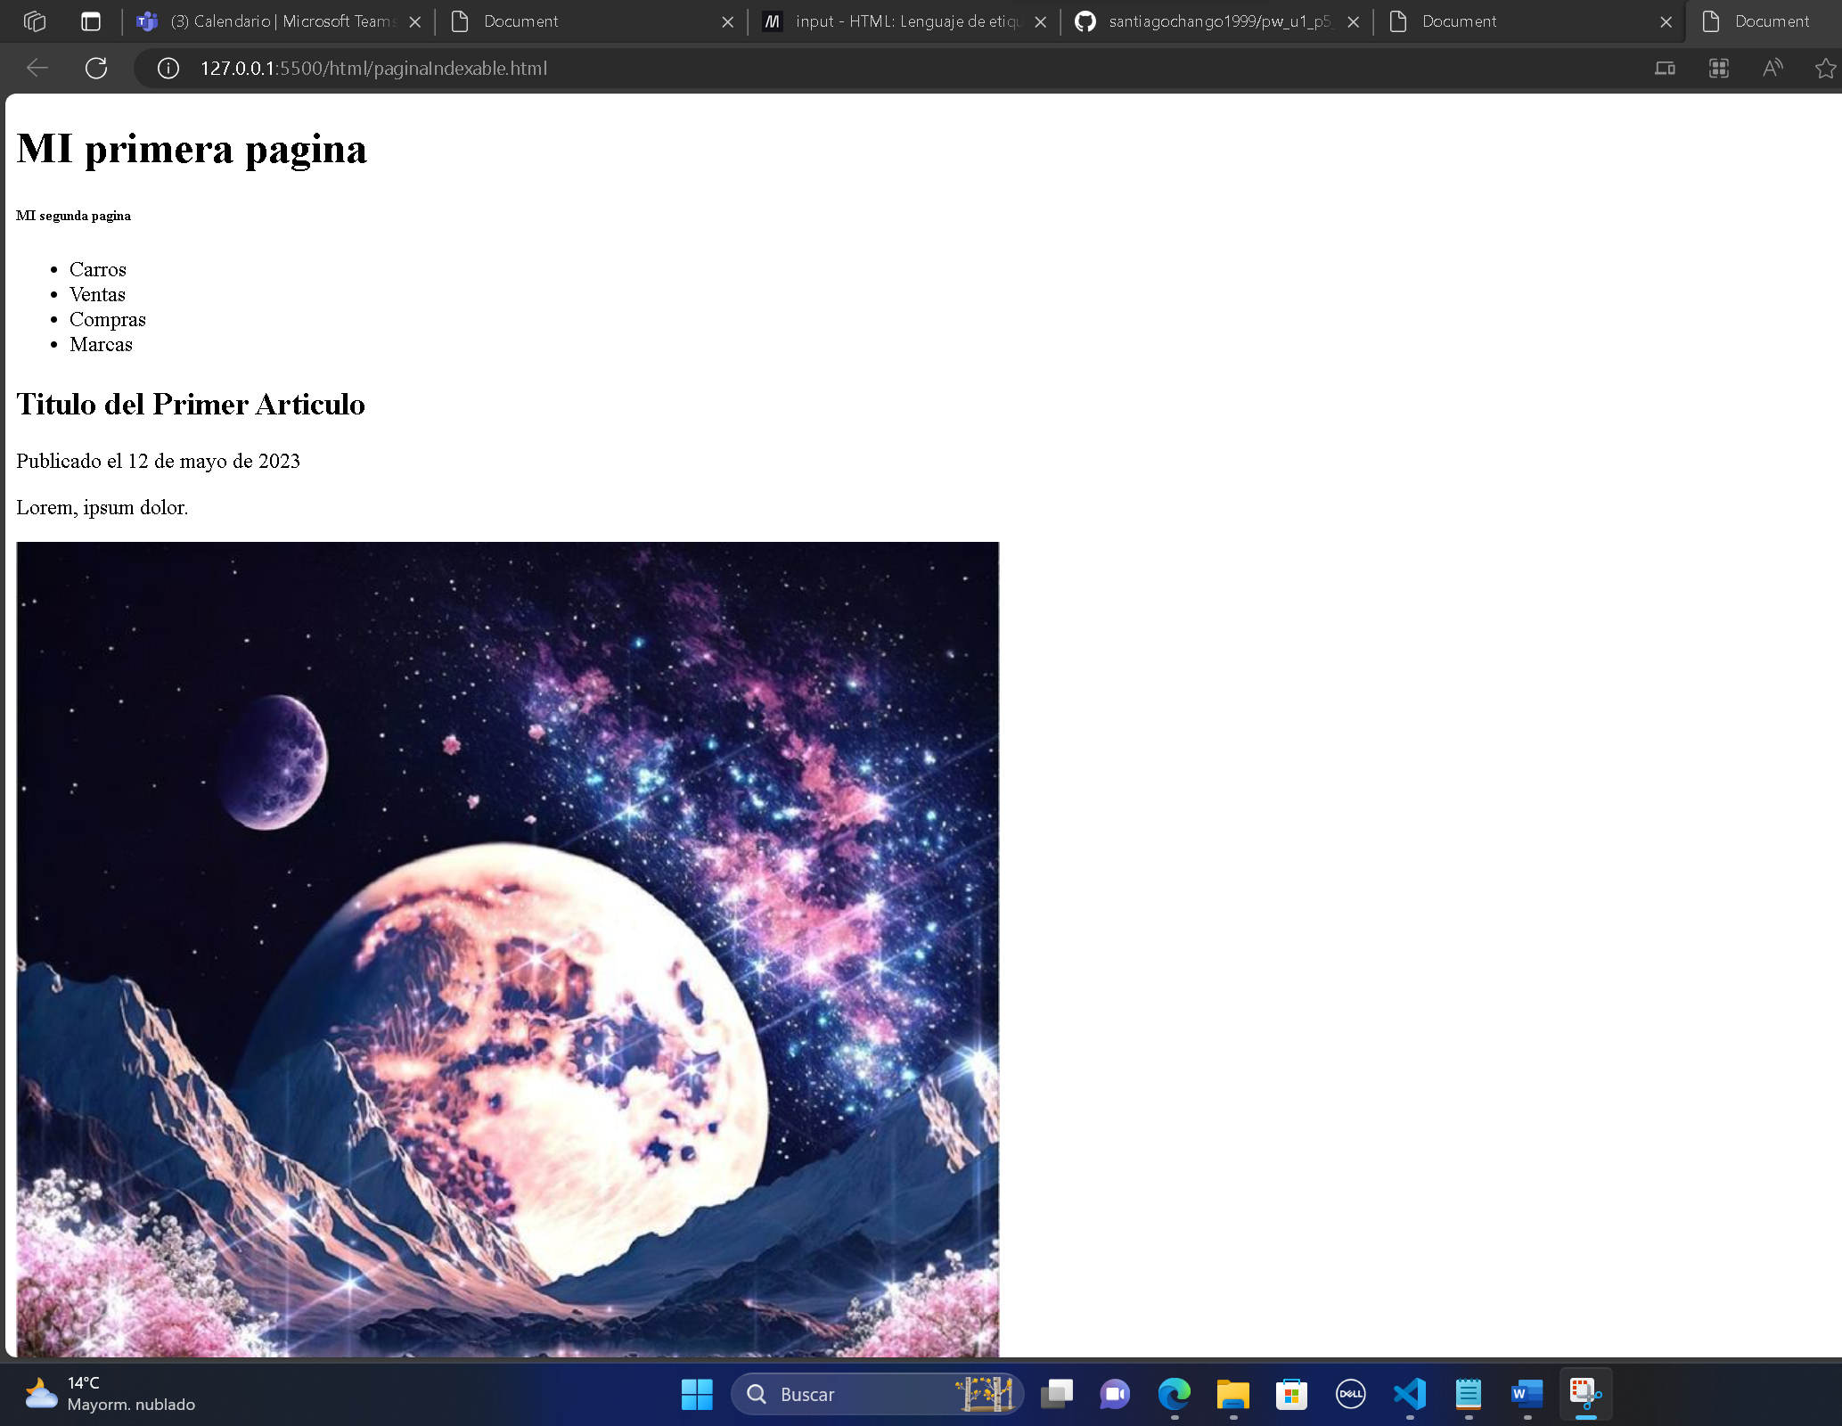

SEGUNDA PAGINA

