Game Design Documents

Concept: It’s a simple 2D old donkey kong like game, where you are Marquitos and you want to drink all the beer that it’s out there… but every time that you take a pint it’s gets harder to drink another one.
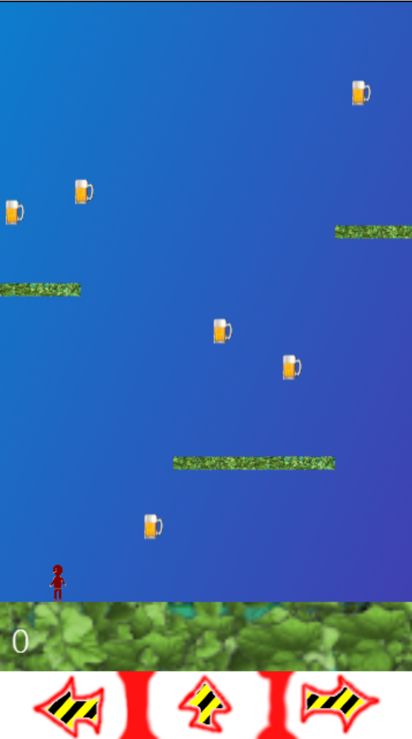
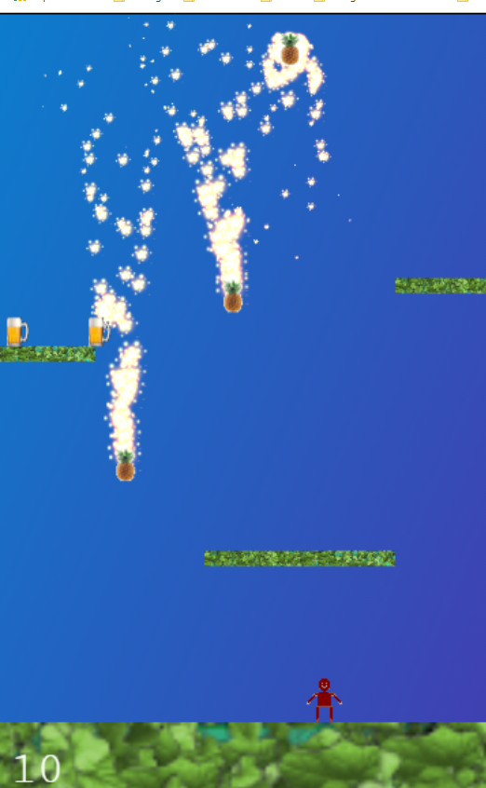

Mechanics/UI:
    - Touch on mobile
    - Arrow key on desktop
Platforms:
    - Browsers
Assets:
    - Sprites:
      - a player - Marquitos
      - Pineapple enemies with fire propultion
      - treasure/beers
      - background
      - platforms and ground.
      - Buttons for touch

