Game Design Documents

Concept:
    - It’s a casual 2D frogger style game, wher you have to get the beer at the end of the track trying to avoid the killing pineapples.
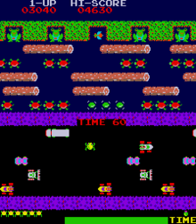
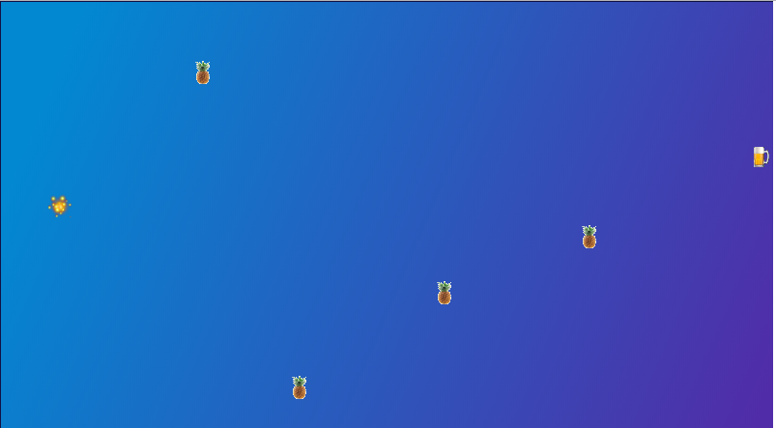

Mechanics/UI:
    - touch on mobiles
    - keyboards on desktops.

Platforms:
    - cross-platform through browser.
Assets:
    - sprites:
      - a player (?)
      - Pineapple enemies
      - treasure/beer
      - background

