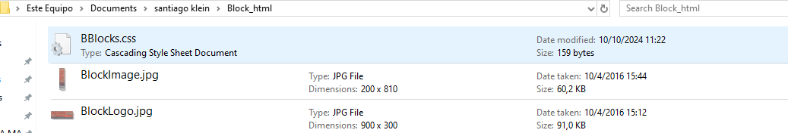

Evidence 5

The image does not mantain the aspect ratio.