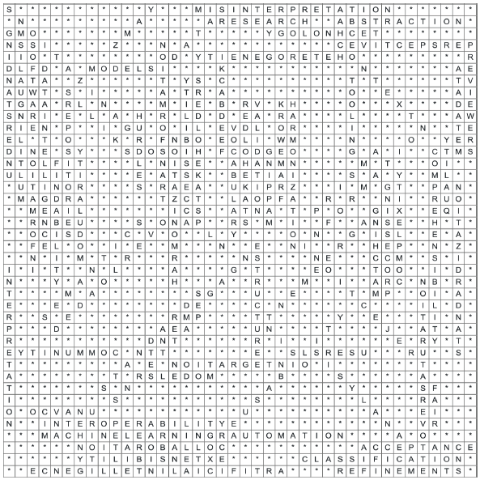

**PALABRAS**

1. NISO
2. PRISMA
3. PROCESSING
4. FINDABILITY
5. ACCESSIBILITY
6. INTEROPERABILITY
7. REUSABILITY
8. MATCHING
9. HARMONIZATION
10. OVERLOADED
11. FAIR
12. UNAVCO
13. CLASSIFICATION
14. YAMZ
15. HETEROGENEITY
16. STAKEHOLDERS
17. REPOSITORIES
18. ENGAGEMENT
19. STANDARDIZATION
20. ANALYSIS
21. PATTERNS
22. METADATA
23. CONTEXT
24. PERSPECTIVE
25. ABSTRACTION
26. STRUCTURE
27. SEMANTICS
28. STANDARDS
29. OVERSATURATION
30. REJECTION
31. COMMUNITY
32. STAKEHOLDER
33. USERS
34. ORGANIZATIONS
35. FEEDBACK
36. VOCABULARY
37. TOOLING
38. QUALITY
39. COLLABORATION
40. INTERPRETATION
41. INTEGRATION
42. AUTOMATION
43. HARMONIZATION
44. MAPPING
45. TRANSFORMATION
46. VALIDATION
47. AGREEMENT
48. REVIEWERS
49. DATA
50. INFORMATION
51. TECHNOLOGY
52. SKILLS
53. ACCEPTANCE
54. SOFTWARE
55. COMPLEXITY
56. UNDERSTANDING
57. COMPREHENSIBILITY
58. HURDLES
59. MISINTERPRETATION
60. MODELS
61. EXTENSIBILITY
62. MODULARITY
63. REFINEMENTS
64. MULTILINGUALISM
65. NLP
66. INFORMATION
67. ARTIFICIALINTELLIGENCE
68. MACHINELEARNING
69. DATAINTELLIGEN