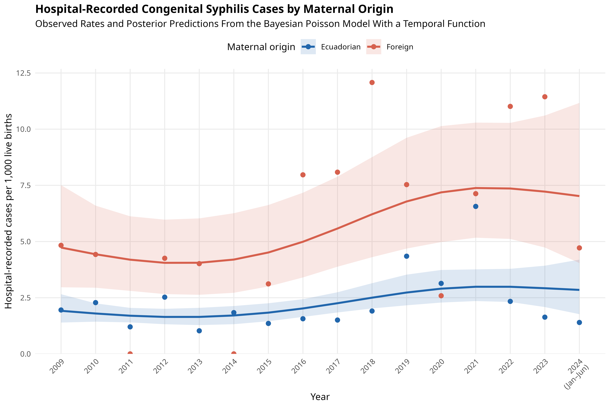
Figure 1. Observed rates and posterior predictions of hospital-recorded congenital syphilis cases by maternal origin, 2009–June 2024.
Points represent observed rates per 1,000 institutional live births. Lines represent posterior expected rates estimated using the Bayesian Poisson regression model with a spline temporal function and the logarithm of live births as an offset; shaded bands represent 95% credible intervals. The maternal-origin contrast was modeled as constant over time. Data for 2024 include January through June only.

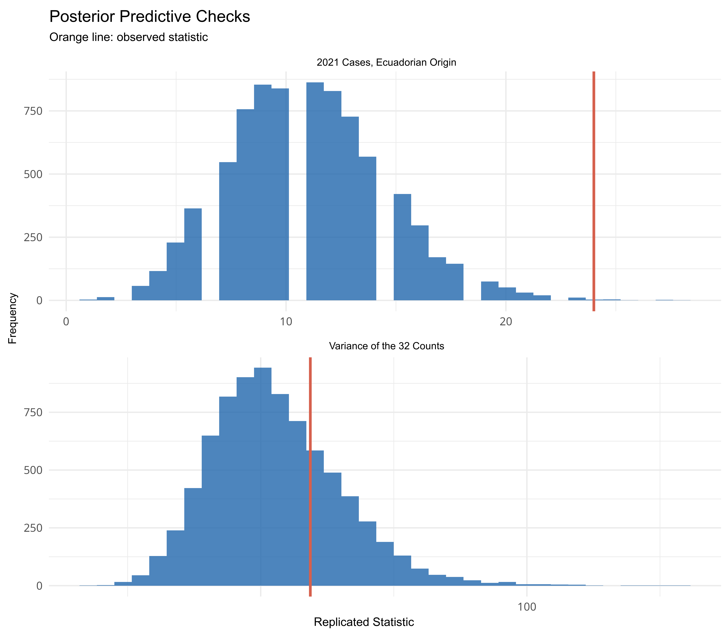
Figure S1. Posterior predictive checks of the primary Bayesian model.
Note: The orange line represents the observed value; the distribution represents values obtained from data replicated by the model using posterior_predict().

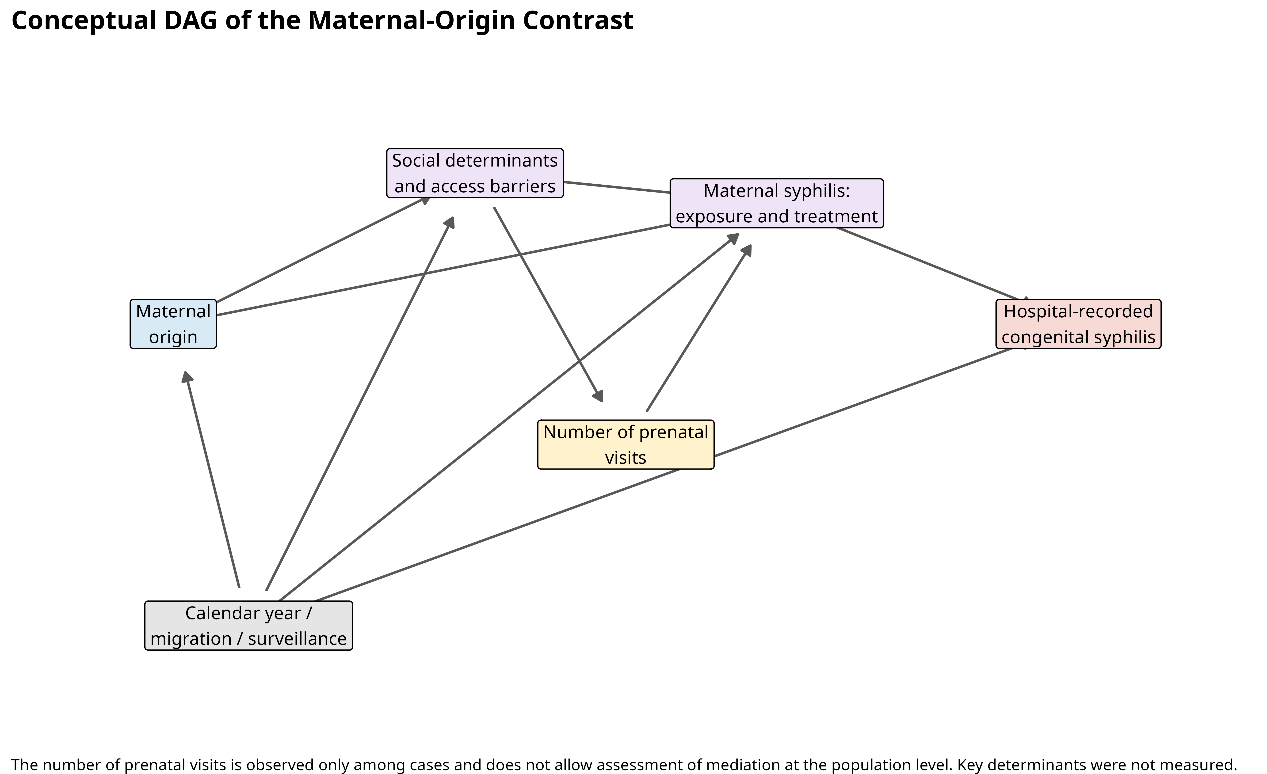
Figure S2. Conceptual DAG of the analytical restriction of the secondary analysis among cases.
Note: The number of prenatal visits was observed only among recorded congenital syphilis cases. Consequently, conditioning the analysis on the presence of the outcome allows estimation of the association between maternal origin and the number of prenatal visits within the set of cases, but does not allow assessment of mediation at the population level. DAG, directed acyclic graph.

