# Styla AEM-Plugin Config

Inhalt

Styla AEM-Plugin Config 1

1. Mastertemplate and Component 2

2. Setup Styla content 3

3. Cloudservice Configuration Page 3

4. Refernce to Cloud Service Configuration 5

4.1. Setup System User 6

5. Apache Sling Service User Mapper Service setup 6

6. Import Config 7

7. Verification of SEO Data import 8

## Mastertemplate and Component

The plugin contains a Master template for convenience. It is available in AEM at /conf/styla/settings/wcm/templates/master. This is a dynamic template, it can be adjusted to your needs. It contains initially only the „Styla Content Hub“ component to display Styla‘s magazine or landing pages.

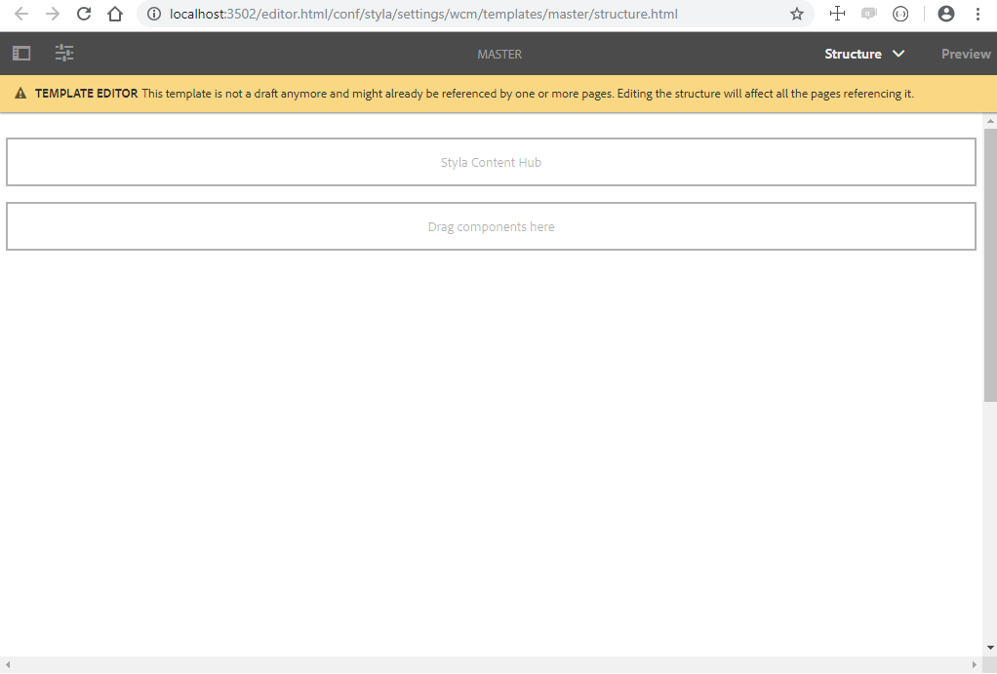

Of course, it is also possible to use the Styla Content Hub component on other pages or templates:

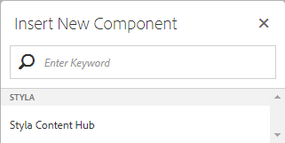

## Setup Styla content

You will use the Master template (or any other template with the Styla Content Hub component) to integrate Styla content into your website. Simply create a new page for each Styla Page you will use (Magazine Top page, Story within a Magazine, Landing Page). Choose the master Template when creating Styla pages.

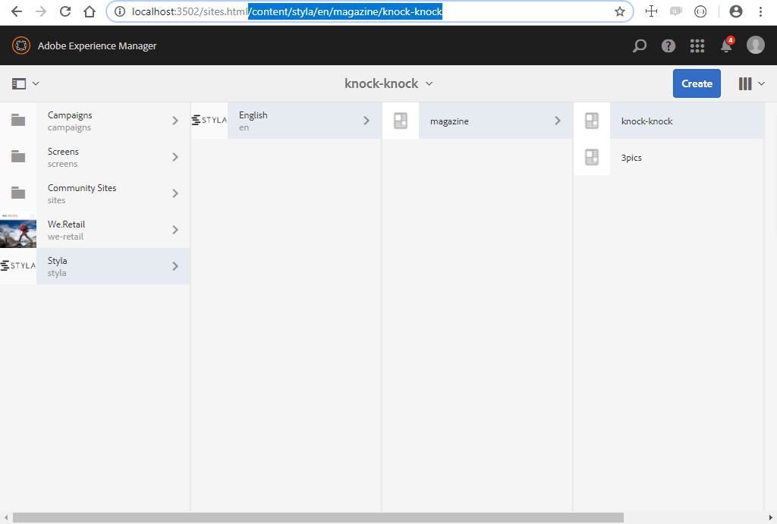

## Cloudservice Configuration Page

Go to AEM CloudServiceConfiguration, e.g. available at [http://localhost:3502/miscadmin#/etc/cloudservices](http://localhost:3502/miscadmin" \l "/etc/cloudservices) and create a new page with title **Styla** and Name **styla**:

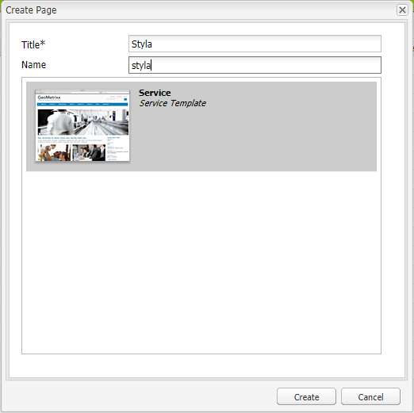

Within Cloud Services (e.g at <http://localhost:3502/etc/cloudservices.html>) search for the new **Styla** page, and setup a new Config, by clicking **Configure Now**.

The Plugin needs two pieces of information, which you get from your Styla integration manager. First SEO API URL to fetch SEO meta tags to be injected into each page. And a SCRIPT snippet, which is responsible for injecting the actual Styla content into your pages. Edit the config and enter:

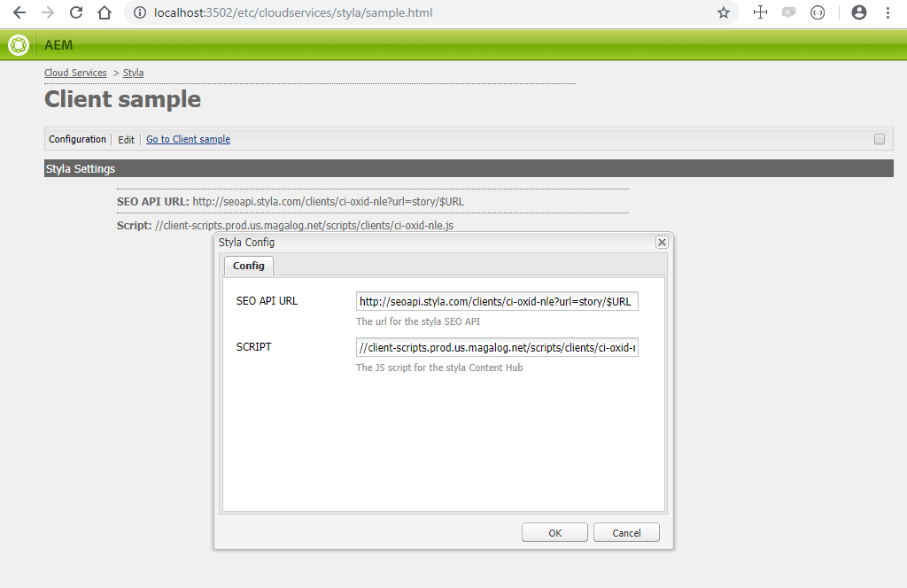

SEO API URL understands wildcards $URL and $LANG, which will be replaced with the content path url and te current language.

Example:

While importing SEO Data for AEM page/content/styla/en/magazine/knock-knock using this URL config <http://seoapi.styla.com/clients/ci-oxid-nle?url=story/$URL&lang=$LANG> will result into this request being sent to Styla <http://seoapi.styla.com/clients/ci-oxid-nle?url=story/knock-knock&lang=en>

## Refernce to Cloud Service Configuration

In the content section open from your content‘s parent page its **Page Properties** e.g. <http://localhost:3502/editor.html/content/styla/en.html> for the parent language level. Select the previously created config in Tab **CLOUD SERVICES**:

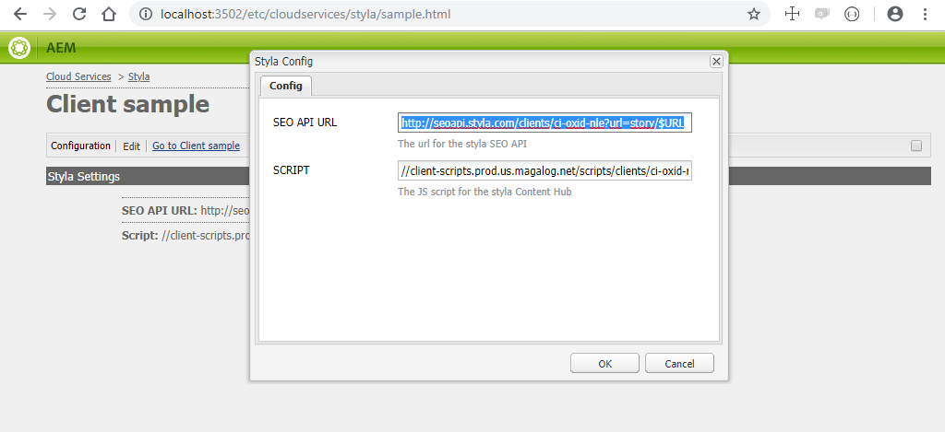

Generally, you can do CLOUD SERVICE config on each page where you have Styla content. If you do it on language level, it will be inheritet by all pages below this parent. You can choose different configs for different languages, as told you by your Styla integration manager, e.g. one for /content/styla/en and another for /content/styla/de, but also for pages below, e.g. to have a different config for /content/styla/en/magazine/knock-knock.

## Setup System User

You‘ll need to create a System User which will be responsible for SEO Metadata import.

Create a System User from User Administration interface <http://localhost:3502/crx/explorer/index.jsp> with name „seoImportUser“:

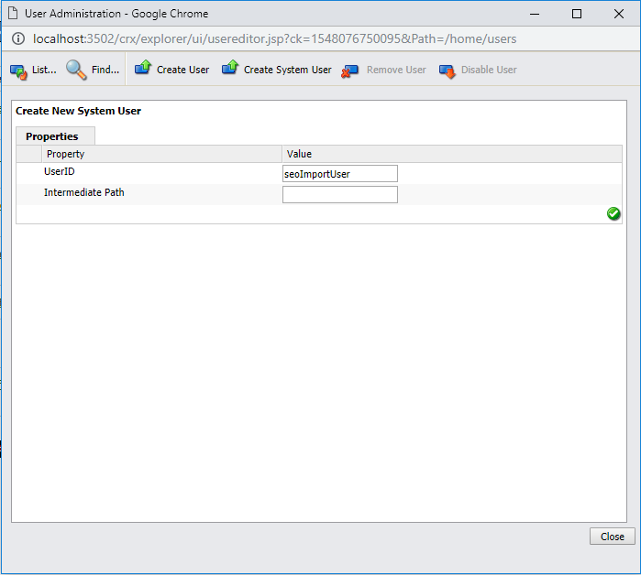

Setup the user‘s rights via <http://localhost:3502/useradmin>

Read-Only on /etc/cloudservices/  
Read/Write on /content/<brand> (e.g. /content/styla)

## Apache Sling Service User Mapper Service setup

To use this user for SEO import, you need to map this user to the Styla SEO import Service.

Create an new Config via <http://localhost:3502/system/console/configMgr> with the following mapping: **de.neofonie.styla.core:seoImportService=seoImportUser**

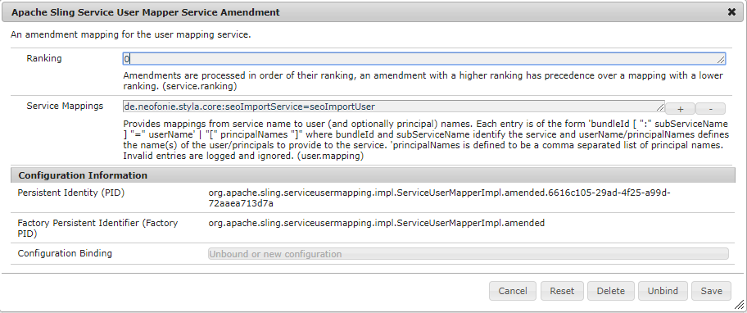

## Import Config

SEO import timing will be setup via Web Console <http://localhost:3502/system/console/>. Create an new config for „**Styla SEO job service“** and do setup import timings via Cron-job expression. Set via Template Type the template that will get SEO Data. Content Root Path is the parent page that will get SEO information.

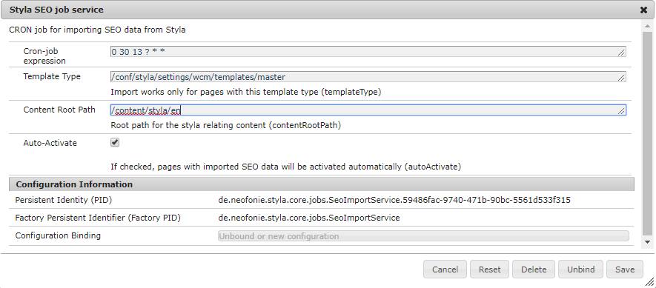

Choose if you want to AutoActivate SEO Content. If set, all pages are automatically activated after a new SEO import is done. This will also activate other changes that you might have done to pages that are not activated yet. If you deselect, you‘ll need to activate each page manually.

## Verification of SEO Data import

If everything is setup correctly, you‘ll see SEO data being filled for your content pages after the SEP data runnier is triggered from your cron expression. [http://localhost:3502/mnt/overlay/wcm/core/content/sites/properties.html?item=%2Fcontent%2Fstyla%2Fen%2Fmagazine](http://localhost:3502/mnt/overlay/wcm/core/content/sites/properties.html?item=%2Fcontent%2Fstyla%2Fen%2Fmagazineachdem) via Meta Tags Tab:

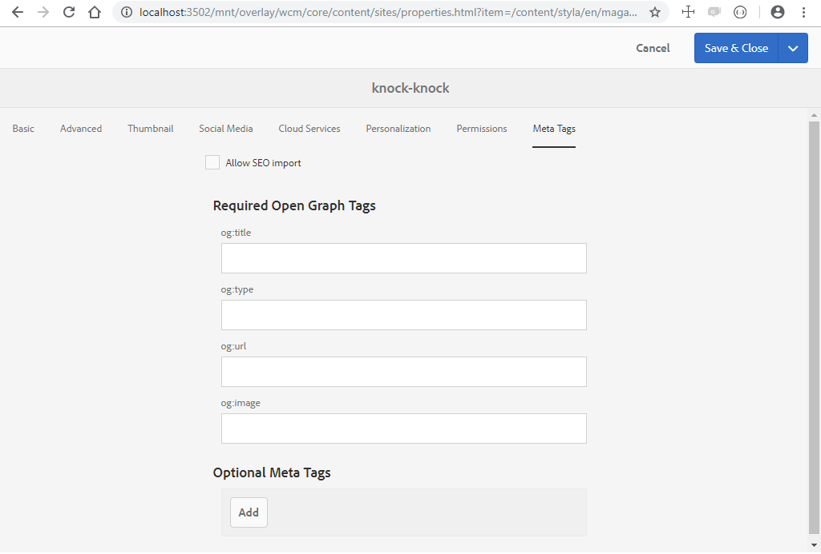

You can overwrite SEO data here manually. Please uncheck „Allow SEO Import“, otherwise your changes would be overwritten after the next SEO import run.