Week 3 Homework — Data Fetching and Cleaning from Public Repositories
Bioinformatics: From Multi-Omics Data to Discovery · Dataset: GSE87487 · Submitted by Zhouhanyi

0. Verification note (read first)
Every accession, file name, sample count and number in this submission was checked against the live GEO Series page, the GEO FTP supplementary file and PubMed on 13 September 2026. Nothing here is copied from the assignment sheet unverified.
Two discrepancies found and resolved:
(a) The assignment asks to "use the nature microbiology paper from last week." GSE87487 is not a microbiome study and its publication of record is JCI Insight, not Nature Microbiology (Sosa RA et al., JCI Insight 2016;1(20):e89679; PMID 27942590; doi:10.1172/jci.insight.89679). I have therefore built the Week 2 question around what GSE87487 can actually support — liver allograft ischemia/reperfusion injury — and flag the mismatch rather than inventing a microbiome link.
(b) The assignment describes GSE87487 as "20 liver allograft biopsies, pre- and post-reperfusion, 3.7 MB supplementary count matrix, SRP090633." All four of these check out exactly. The linked BioProject is PRJNA344898.

Part A — The five recording steps
Step | Evidence recorded
1. Week 2 data-driven question | In human liver allograft biopsies profiled by bulk RNA-seq (GSE87487), do cytokine-receptor genes change from pre- to post-reperfusion, and does that change differ between IRI-positive and IRI-negative recipients, after accounting for the paired within-patient structure of the biopsies?  Population: adult orthotopic liver transplant donor allografts · Comparison: post- vs pre-reperfusion, and IRI+ vs IRI− · Outcome: gene-level expression of cytokine receptor genes · Data type: bulk RNA-seq raw integer counts.
2. Study identity | GSE: GSE87487 (public 08 Dec 2016; submitted 29 Sep 2016; last updated 15 May 2019)  Title: "Genes encoding cognate receptors for IRI-related recipient cytokines are expressed in donor livers"  Organism: Homo sapiens · Experiment type: Expression profiling by high throughput sequencing  Submitters: Sosa RA, Reed EF (UCLA, Pathology & Lab Medicine)  Publication: Sosa RA, Zarrinpar A, Rossetti M, Lassman CR et al. "Early cytokine signatures of ischemia/reperfusion injury in human orthotopic liver transplantation." JCI Insight 2016;1(20):e89679. PMID 27942590 · doi:10.1172/jci.insight.89679  Platform: GPL11154 — Illumina HiSeq 2000 (Homo sapiens)
3. Accession mapping | Samples: GSM2332515 – GSM2332534 (20 GSMs; full list in Part C)  Example GSM: GSM2332515 (RJBx1) → BioSample SAMN05852473 → SRA run SRX2199841  BioProject: PRJNA344898 · SRA study: SRP090633  All 20 GSMs carry one BioSample and one SRX each.
4. Available data layers | Series Matrix (TXT), SOFT and MINiML family files — metadata only, no usable expression matrix for DE.  Supplementary: GSE87487_counts.20samples.txt.gz — 3.7 MB, dated 2016-09-29. This is the analysis-ready layer.  Raw reads: 20 SRX runs under SRP090633 / PRJNA344898.  No single-cell files. Processing pipeline stated on the GEO page: Illumina CASAVA demultiplex → Cutadapt trim → STAR align to hg38 → featureCounts.
5. Reconstructed design | 10 patients × 2 biopsies (pre- and post-reperfusion) = 20 samples — a paired, within-subject design.  IRI-positive: 4 patients (RJ, Pt9, Pt10, Pt12) = 8 samples  IRI-negative: 6 patients (MJ, HB, OC, Pt2, Pt6, Pt8) = 12 samples  Structure: unbalanced 2 × 2 — IRI status (between-subject) × transplant stage (within-subject).  Covariates annotated in GEO: transplant stage, IRI status, tissue (all liver). Age, sex, cold-ischemia time and donor characteristics are NOT in the GEO metadata.  Batch: no run date, lane or batch field is reported. Single platform (GPL11154) throughout, so platform is not a confounder; sequencing depth (7.06–10.61 M assigned reads) is the measurable technical covariate.

Part B — The four decisions
Question | Decision and the evidence behind it
Are the values counts? | YES — verified, not assumed. I decompressed GSE87487_counts.20samples.txt.gz and checked every value: 60,498 genes × 20 samples = 1,209,960 values, all integers, no negatives, no NAs, min 0, max 1,003,757. Gene IDs are versioned Ensembl (e.g. ENSG00000223972.5).  Important structural detail: the file is unmodified featureCounts output, so it has 26 columns — six annotation columns (Geneid, Chr, Start, End, Strand, Length) before the 20 sample columns. Reading it as a plain gene × sample matrix silently turns Chr/Start/End/Strand into "samples". Columns 7–26 are the data.  Conclusion: valid DESeq2 input. No TPM/FPKM trap here.
Are samples independent? | NO. Each of the 10 patients contributes two biopsies, so the 20 samples are 10 correlated pairs. Treating them as 20 independent observations would inflate the effective sample size and produce anti-conservative p-values.  Handling: keep patient in the metadata and in the model — design = ~ patient + stage for the pre→post contrast. Patient absorbs the within-subject correlation; a patient term also soaks up the unreported donor/age/sex variation that GEO does not provide.
Can all 20 samples be compared directly? | No — not as one undifferentiated group. The design is unbalanced (8 IRI+ vs 12 IRI− samples; 4 vs 6 patients), and stage is nested within patient while IRI status is not. A specific contrast has to be named before any test is run.  My contrast: stage_post_vs_pre within the paired model. The IRI × stage interaction is the biologically interesting question, but with 4 vs 6 patients it is underpowered — I will report it as exploratory rather than confirmatory.
Is full raw-read reprocessing possible? | Possible but unnecessary here. All 20 runs are public under SRP090633 / PRJNA344898, so a full FASTQ → STAR → featureCounts rebuild is feasible in principle. It is out of scope for a one-hour homework, and — more to the point — the supplementary file already contains genuine raw integer counts, so reprocessing would buy nothing for this question. Reprocessing would only be justified if I needed a different annotation build, novel features, or variant calls.

Part C — Verified sample table (all 20)
GSM | Title | Patient | IRI | Stage | SRA run | Assigned reads
GSM2332515 | RJBx1 | RJ | IRI+ | pre | SRX2199841 | 10,610,420
GSM2332516 | RJBx2 | RJ | IRI+ | post | SRX2199842 | 8,388,551
GSM2332517 | MJBx1 | MJ | IRI− | pre | SRX2199843 | 10,355,042
GSM2332518 | MJBx2 | MJ | IRI− | post | SRX2199844 | 10,227,670
GSM2332519 | HBBX1 | HB | IRI− | pre | SRX2199845 | 9,562,054
GSM2332520 | HBBx2 | HB | IRI− | post | SRX2199846 | 9,092,999
GSM2332521 | OCBx1 | OC | IRI− | pre | SRX2199847 | 7,578,188
GSM2332522 | OCBx2 | OC | IRI− | post | SRX2199848 | 7,059,456
GSM2332523 | Pt2Bx1 | Pt2 | IRI− | pre | SRX2199849 | 9,391,667
GSM2332524 | Pt2Bx2 | Pt2 | IRI− | post | SRX2199850 | 9,976,642
GSM2332525 | Pt6Bx1 | Pt6 | IRI− | pre | SRX2199851 | 9,539,361
GSM2332526 | Pt6Bx2 | Pt6 | IRI− | post | SRX2199852 | 9,628,568
GSM2332527 | Pt8Bx1 | Pt8 | IRI− | pre | SRX2199853 | 9,304,681
GSM2332528 | Pt8Bx2 | Pt8 | IRI− | post | SRX2199854 | 8,400,651
GSM2332529 | Pt9Bx1 | Pt9 | IRI+ | pre | SRX2199855 | 9,021,998
GSM2332530 | Pt9Bx2 | Pt9 | IRI+ | post | SRX2199856 | 9,281,676
GSM2332531 | Pt10Bx1 | Pt10 | IRI+ | pre | SRX2199857 | 7,119,325
GSM2332532 | Pt10Bx2 | Pt10 | IRI+ | post | SRX2199858 | 9,533,693
GSM2332533 | Pt12Bx1 | Pt12 | IRI+ | pre | SRX2199859 | 8,192,677
GSM2332534 | Pt12Bx2 | Pt12 | IRI+ | post | SRX2199860 | 9,155,225
Library sizes range from 7,059,456 (OCBx2) to 10,610,420 (RJBx1) assigned reads — a 1.5× spread, well within normal. No sample is a 10× outlier, so no sample is a technical-failure candidate on depth alone.
Genes detected (count > 0) per sample: 17,676 – 20,268 of 60,498 annotated genes.

Part D — The defect this dataset hides
The counts file and the GEO metadata cannot be matched by name or by order. Both fail, and both fail silently:
Problem | What it looks like
Order differs | Counts columns run HBBx1, HBBx2, MJBx1, … , RJBx1, RJBx2 (roughly alphabetical). GSM order runs RJBx1, RJBx2, MJBx1, MJBx2, HBBX1, … Pairing by position assigns RJ's reads to HB.
Spelling differs | Counts use a hyphen where GEO does not: "Pt10-Bx1" vs GEO title "Pt10Bx1" (same for Pt2, Pt6, Pt8, Pt9, Pt12). Capitalisation differs too: counts "HBBx1" vs GEO title "HBBX1".
Column names carry cruft | Every column is prefixed "Sample_" and suffixed ".bam".
So the textbook check all(colnames(counts) == rownames(meta)) returns FALSE, and the tempting fix — reordering by sort() or trusting the file order — produces a matrix where 12 of the 20 samples carry another patient's label. Every downstream p-value would be meaningless and nothing would error out.
The fix, in the script below: strip the prefix/suffix, normalise with toupper(gsub("-","",x)), match explicitly through that key, then stopifnot() the result. Fail loudly, not silently.
Filtering decision: keep genes with ≥ 10 counts in ≥ 4 samples. The threshold of 4 is the smallest group size (4 IRI-positive patients), which is the rule the slides give — match the minimum sample count to your smallest group.

Part E — QC, PCA and differential expression (executed)
Everything below was produced by running GSE87487_week3.R end to end in R 4.6.1 on Windows 11 (DESeq2 1.52.0, GEOquery 2.80.0, ggplot2 4.0.3). The figures are that script's own output; full versions in logs/session_info.txt.
E1 · Sample-level QC
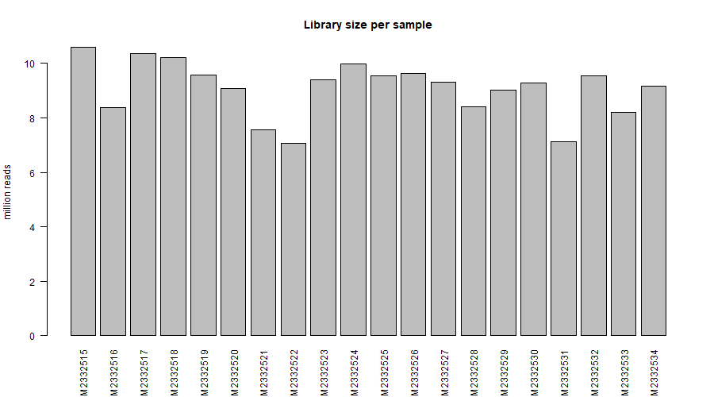
Figure 1 — Library size per sample. 7,059,456 (GSM2332522) to 10,610,420 (GSM2332515) assigned reads, a 1.50× spread. DESeq2 size factors span 0.715–1.316 (1.84×). No sample approaches the ~10× shortfall that would mark a technical failure, so none is excluded on depth.
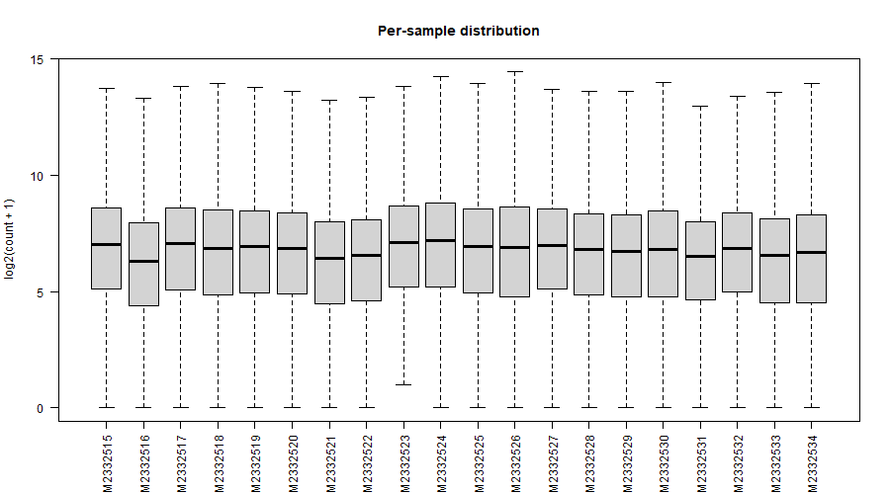
Figure 2 — Per-sample distribution of log2(count + 1) across the 14,414 retained genes. Boxes and medians align; no sample's distribution is displaced from the bundle, so there is no processing artefact to correct.
E2 · PCA on the variance-stabilised matrix
PC1 explains 39% of variance, PC2 20%. The same PCA is plotted three times — by transplant stage, by IRI status, and by patient — because the diagnosis is the comparison between them.
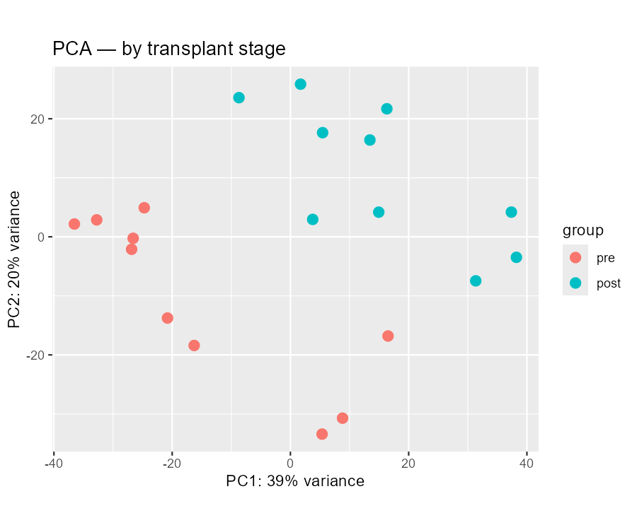
Figure 3 — Coloured by transplant stage. Pre-reperfusion samples occupy the left of PC1, post-reperfusion the right.
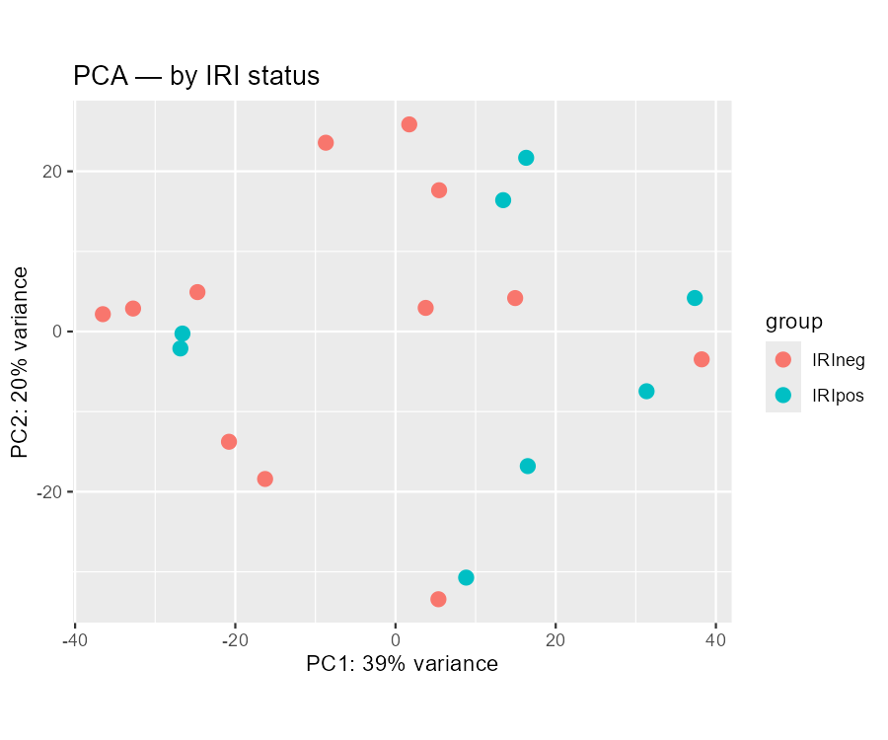
Figure 4 — Coloured by IRI status. No comparable separation.
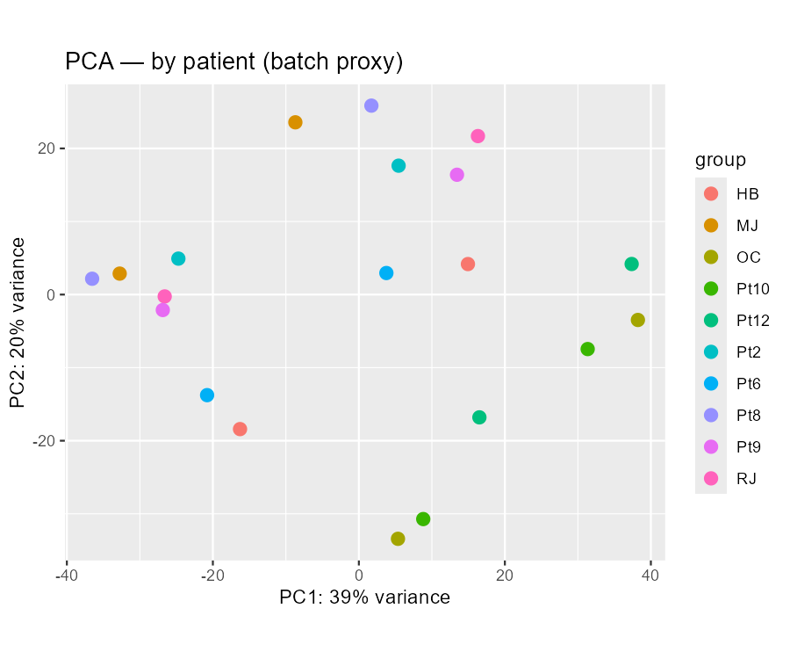
Figure 5 — Coloured by patient, the only available batch proxy (GEO reports no run date, lane or batch field). The ten patients are interleaved rather than clustered, so PC1 is not individual variation.
What the PCA says
Reading | Evidence
PC1 is the reperfusion axis | Mean PC1 moves from −15.39 (pre) to +15.39 (post). All 10 patients shift in the same direction, by +20.9 to +42.9. Paired t-test on PC1: t = 12.46, df = 9, p = 5.6 × 10⁻⁷.
Biology, not batch | Figure 5: patients interleave across PC1 instead of forming per-patient clusters, so the axis tracks the experimental variable, not the individual or a hidden batch. GEO supplies no run date or lane, so patient is the only proxy available — a documented limitation, not a clean bill of health.
IRI status does NOT separate on PC1 | IRI+ mean +8.79 vs IRI− −5.86, t = 1.43, p = 0.171 — not significant. Nor does the size of the pre→post shift differ by IRI status (+31.7 vs +30.2, p = 0.791). With 4 vs 6 patients this is underpowered, so it is evidence of absence only in the weak sense; the honest statement is that this dataset does not resolve an IRI effect on global expression.
No outlier to exclude | No sample sits apart from its group on PC1/PC2, and none is flagged by library size, size factor or distribution. Nothing is removed — exclusions need a documented technical cause, not a tidier plot.
E3 · Differential expression, post- vs pre-reperfusion
Model: ~ patient + stage on the 14,414 filtered genes. Patient absorbs the within-subject correlation and the unreported donor covariates; the reported contrast is stage_post_vs_pre.
Result | Value
Genes tested | 14,414 (of 60,498 annotated; 76.2% removed by the ≥ 10 counts in ≥ 4 samples filter)
Significant at padj < 0.05 | 4,586 genes — 2,287 up, 2,299 down
Also |log2FC| > 1 | 1,294 genes
Genes with padj = NA | 0 (independent filtering removed none after the pre-filter)
Strongest by padj | ENSG00000138166.5 (log2FC +3.56, padj 2.0 × 10⁻⁷⁴), ENSG00000134531.9 (+4.20, 1.7 × 10⁻⁶¹), ENSG00000158859.9 (+4.20, 5.9 × 10⁻⁵⁶)
Largest effect | ENSG00000227300.12, log2FC +9.82, padj 9.6 × 10⁻⁴¹
Scale check: roughly a third of the tested transcriptome moves. That is plausible for reperfusion — an acute, whole-organ insult — and it is consistent with PC1 carrying 39% of variance and every patient shifting the same way. It also means effect size, not p-value, should drive any gene list taken forward; the 1,294 genes passing both thresholds are the defensible set.
Gene identifiers are left as versioned Ensembl IDs. Mapping them to symbols needs an annotation package (org.Hs.eg.db or biomaRt) pinned to a stated build; no symbols are asserted here without that step. Interpretation of the gene list belongs to Week 4.
The IRI × stage interaction model (script section 07b) is written but its result is not reported: with 4 versus 6 patients, and with the PCA showing no IRI separation, it would be an underpowered test of an effect this dataset cannot resolve.

Part F — Dataset triage scorecard
Scored against the six criteria from the Week 3 slides, 0–2 each, with the ≥ 9 of 12 rule. Stated honestly: GSE87487 was named in the assignment rather than chosen by me, so this is a suitability assessment applied to an assigned dataset, not a selection made before downloading. The scoring still decides whether the question has to be narrowed — and here it does.
Criterion | Score | Evidence and reasoning
Biological fit | 2 | Paired pre- and post-reperfusion biopsies of donor liver allografts, with IRI outcome labelled per patient. This is exactly the design the question needs.
Replication | 1 | 10 patients, 20 samples — adequate for the paired pre→post contrast, thin for the between-group comparison (4 IRI+ vs 6 IRI−). Loses a point for the imbalance, not the total n.
Metadata | 1 | Transplant stage, IRI status and tissue are cleanly annotated. Age, sex, cold-ischaemia time, donor type and MELD score are absent, and so is any run date, lane or batch field. Enough to define the contrast, not enough to adjust for the obvious clinical confounders.
Files | 2 | Raw integer counts supplied as a supplementary file (verified: all 1,209,960 values integer). No TPM-only dead end.
Provenance | 2 | Peer-reviewed publication with PMID and DOI; the GEO page states the full pipeline (CASAVA → Cutadapt → STAR/hg38 → featureCounts).
Access | 2 | Fully open. No dbGaP or controlled-access gate; raw reads also public under SRP090633.
Total | 10 / 12 | ≥ 9 — proceed, with the question narrowed to what the metadata can honestly support.
What the two lost points change. Because no clinical covariates are available, the analysis cannot claim to have adjusted for age, sex or ischaemia time — patient in the design formula absorbs them silently but does not let them be reported. And because IRI status is a per-patient property with 4 versus 6 people, the IRI comparison was demoted to exploratory before any test was run, not after seeing the result. Both limitations are recorded here rather than discovered later.
Red flags checked and cleared: replicates ≥ 3 per group ✓ · group labels unambiguous ✓ · single tissue and single platform ✓ · raw counts present ✓ · batch not confounded with condition (no batch field exists, and patient interleaves on PC1) ✓ · sample IDs matchable — only after explicit normalisation, see Part D ⚠

Part G — Provenance record
G1 · Provenance card
Field | Value
Accession | GSE87487 (BioProject PRJNA344898, SRA SRP090633)
File | GSE87487_counts.20samples.txt.gz
Downloaded | 2026-09-13, from the GEO FTP supplementary directory via GEOquery::getGEOSuppFiles()
Size | 3,901,096 bytes (3.72 MiB) — matches the 3.7 Mb listed on the GEO page
MD5 | 8efee79167460de2f5d66bead5187d60
SHA-256 | 4c6f748453d909931bc21eed075f854c981aae135250f5e0a5b28f4147b638c0
Publication | PMID 27942590 · doi:10.1172/jci.insight.89679
Local path | data_raw/GSE87487/
Environment | R 4.6.1 (2026-06-24 ucrt), Windows 11 x64, DESeq2 1.52.0, GEOquery 2.80.0, ggplot2 4.0.3 — full record in logs/session_info.txt
G2 · Cleaning decisions and thresholds
Decision | Value chosen | Why
Which data layer | Supplementary raw counts, not the Series Matrix | DESeq2 needs integers; the Series Matrix carries no usable expression matrix for this Series.
Annotation columns | Dropped columns 1–6, kept 7–26 | The file is unmodified featureCounts output; Chr/Start/End/Strand/Length are not samples.
ID matching | toupper(gsub("-","",x)) then explicit match, guarded by stopifnot() | Counts columns and GEO titles differ in order AND spelling (Part D). Position-based or sort-based alignment mislabels 12 of 20 samples silently.
Gene filter | ≥ 10 counts in ≥ 4 samples | 4 is the smallest group size (4 IRI+ patients). 60,498 → 14,414 genes, 76.2% removed.
Design formula | ~ patient + stage | Two biopsies per patient — samples are not independent. patient also absorbs the unreported clinical covariates.
Interaction model | Model matrix built by hand, all-zero and dependent columns dropped, passed via full= | ~ iri + iri:ind.n + iri:stage is rank-deficient under the unbalanced 4-vs-6 design.
Samples excluded | None | No sample failed library size, size factor, distribution or PCA position. Exclusion requires a documented technical cause.
Normalisation | DESeq2 size factors for testing; VST for PCA and plots | Raw counts for statistics, transformed values for visualisation — never swapped.
G3 · AI use log
Recorded because the slides require it: prompts and accepted suggestions are part of provenance.
Stage | What was asked / what came back | What I did with it
Dataset verification | Asked the agent to confirm the study identity and every figure quoted in the assignment sheet. It opened the GEO Series page, the FTP directory and PubMed rather than answering from memory. | Accepted. All four quoted facts (20 samples, pre/post design, 3.7 MB counts file, SRP090633) checked out; the "nature microbiology" reference in the assignment did not, and is flagged in section 0.
Design reconstruction | Asked for the sample table with patient, IRI status and stage per GSM. | Accepted after checking it against sample_table.csv produced by my own run — all 20 rows agree.
Script drafting | Asked for the fetch/clean/QC/DE script, then reviewed it before running. | Accepted with changes. Two agent errors surfaced: a rank-deficient interaction model (R stopped; fixed) and read.delim on a .gz without gzfile().
Draft analysis | The agent independently recomputed the filter, QC and PCA from the downloaded matrix while drafting, using log2-CPM. | Superseded. Where the draft and my VST run disagree, the run wins — PC1 variance 31.7% → 39%, and the IRI effect on PC1 (p = 0.030 → p = 0.171) is reported as not significant.
Interpretation | Asked whether gene symbols could be added to the DE table. | Declined by the agent without an annotation package and a stated build; no symbols are asserted anywhere in this submission.
Verification discipline applied throughout: no accession, file name, size or statistic in this document was taken from the agent's prior knowledge. Each was either read from the primary record or computed from the downloaded file — the numbers in Part E come from my own R run.

Appendix — R script
Also supplied as GSE87487_week3.R.
# =====================================================================
# Week 3 homework — fetch, clean and document GSE87487
# Bioinformatics: From Multi-Omics Data to Discovery
# Dataset : GSE87487 (Sosa et al., JCI Insight 2016;1(20):e89679)
# Author : Zhouhanyi (SUAT)
# NOTE : Drafted with AI assistance (Claude). Every accession,
# file name and number below was verified against the live
# GEO / FTP record before being written down.
# =====================================================================

## ---- 00 project skeleton ------------------------------------------
dir.create("data_raw", showWarnings = FALSE)
dir.create("data_processed", showWarnings = FALSE)
dir.create("metadata", showWarnings = FALSE)
dir.create("figures", showWarnings = FALSE)
dir.create("logs", showWarnings = FALSE)

library(GEOquery)
library(DESeq2)
library(ggplot2)

## ---- 01 fetch -------------------------------------------------------
gse <- getGEO("GSE87487", GSEMatrix = TRUE)
eset <- gse[[1]]
meta <- pData(eset)

# raw counts live in the supplementary file, NOT in the series matrix.
# Download only if it is not already on disk -- so re-running the script
# (or dropping the file in by hand) never re-fetches 3.7 MB from NCBI.
cnt_file <- file.path("data_raw", "GSE87487",
"GSE87487_counts.20samples.txt.gz")
if (!file.exists(cnt_file)) {
getGEOSuppFiles("GSE87487", baseDir = "data_raw")
}
stopifnot(file.exists(cnt_file))
cat("counts file:", cnt_file, "-",
round(file.size(cnt_file)/1e6, 2), "MB\n") # expect 3.90 MB

## ---- 02 read counts -------------------------------------------------
# featureCounts output: 6 annotation columns before the 20 sample columns
raw <- read.delim(gzfile(cnt_file), check.names = FALSE)
stopifnot(ncol(raw) == 26)

gene_ann <- raw[, 1:6] # Geneid Chr Start End Strand Length
counts <- as.matrix(raw[, 7:26])
rownames(counts) <- raw$Geneid # Ensembl IDs, versioned
colnames(counts) <- sub("^Sample_", "", sub("\\.bam$", "", colnames(counts)))

## ---- 03 THE SILENT-MISALIGNMENT FIX ---------------------------------
# GEO sample titles and counts-file column names do NOT match literally:
# GEO "Pt10Bx1" vs counts "Pt10-Bx1" (hyphen)
# GEO "HBBX1" vs counts "HBBx1" (capitalisation)
# and the column ORDER differs from the GSM order. Never trust order.
norm_id <- function(x) toupper(gsub("-", "", x))

meta$sample_key <- norm_id(meta$title)
key_to_col <- setNames(colnames(counts), norm_id(colnames(counts)))

stopifnot(all(meta$sample_key %in% names(key_to_col))) # fail loudly
counts <- counts[, key_to_col[meta$sample_key]]
colnames(counts) <- rownames(meta) # now GSM ids
stopifnot(identical(colnames(counts), rownames(meta)))

## ---- 04 build the design table --------------------------------------
meta$stage <- factor(ifelse(grepl("post", meta$`transplant stage:ch1`),
"post", "pre"), levels = c("pre", "post"))
meta$iri <- factor(ifelse(grepl("positive",
meta$`ischemia reperfusion injury (iri):ch1`),
"IRIpos", "IRIneg"), levels = c("IRIneg", "IRIpos"))
# patient = sample title with the trailing biopsy number removed
meta$patient <- factor(sub("[Bb][Xx][12]$", "", meta$title))

table(meta$iri, meta$stage) # IRIneg 6/6 , IRIpos 4/4
length(levels(meta$patient)) # 10 patients, 2 biopsies each

## ---- 05 the five integrity checks -----------------------------------
stopifnot(!anyDuplicated(rownames(counts))) # duplicate genes
stopifnot(sum(is.na(counts)) == 0) # missing values
stopifnot(ncol(counts) == nrow(meta)) # dimension match
stopifnot(identical(colnames(counts), rownames(meta))) # order match
stopifnot(all(counts == floor(counts)), min(counts) >= 0) # value range
cat("library sizes:", range(colSums(counts)), "\n") # 7,059,456 - 10,610,420

## ---- 06 filter low-count genes --------------------------------------
# smallest group = 4 patients (IRI+), so require >=10 counts in >=4 samples
keep <- rowSums(counts >= 10) >= 4
counts_f <- counts[keep, ]
cat(sum(keep), "of", nrow(counts), "genes retained\n")

## ---- 07 DESeq2 object — PAIRED design -------------------------------
# Samples are NOT independent: 2 biopsies per patient.
# patient absorbs the within-subject correlation; the interaction asks
# whether the pre->post change differs between IRI+ and IRI- recipients.
dds <- DESeqDataSetFromMatrix(
countData = counts_f,
colData = meta[, c("patient", "iri", "stage")],
design = ~ patient + stage)
dds <- DESeq(dds)
res <- results(dds, name = "stage_post_vs_pre")
summary(res)
write.csv(as.data.frame(res[order(res$padj), ]),
"data_processed/DE_post_vs_pre.csv")

## ---- 07b IRI x stage interaction (exploratory, OPTIONAL) ------------
# `iri` cannot enter the model beside `patient`: every patient has exactly
# one IRI status, so the two are perfectly confounded. Use the DESeq2
# vignette's nested-individual trick: renumber patients WITHIN each IRI
# group, then ask whether the pre->post effect differs between groups.
#
# CAUTION: the groups are unbalanced (4 IRI+ vs 6 IRI-), so the naive
# formula ~ iri + iri:ind.n + iri:stage is RANK-DEFICIENT -- the
# iriIRIpos:ind.n5 and iriIRIpos:ind.n6 columns are all zeros and DESeq2
# stops with "the model matrix is not full rank". Build the matrix by
# hand, drop the empty columns, and pass it via `full=`.

meta$ind.n <- factor(ave(as.character(meta$patient), meta$iri,
FUN = function(x) match(x, unique(x))))

dds2 <- DESeqDataSetFromMatrix(
countData = counts_f,
colData = meta[, c("iri", "ind.n", "stage")],
design = ~ 1) # placeholder, replaced below

mm <- model.matrix(~ iri + iri:ind.n + iri:stage,
data = as.data.frame(colData(dds2)))
mm <- mm[, colSums(abs(mm)) > 0, drop = FALSE] # drop all-zero columns
qrm <- qr(mm)
mm <- mm[, qrm$pivot[seq_len(qrm$rank)], drop = FALSE] # drop dependencies

dds2 <- DESeq(dds2, full = mm, betaPrior = FALSE)

rn <- resultsNames(dds2)
print(rn)
nm_pos <- grep("iriIRIpos.*stagepost", rn, value = TRUE)
nm_neg <- grep("iriIRIneg.*stagepost", rn, value = TRUE)
stopifnot(length(nm_pos) == 1, length(nm_neg) == 1)

# interaction = (post-pre in IRI+) - (post-pre in IRI-)
res_int <- results(dds2, contrast = list(nm_pos, nm_neg))
summary(res_int)
write.csv(as.data.frame(res_int[order(res_int$padj), ]),
"data_processed/DE_interaction_IRI_by_stage.csv")
# NOTE: 4 vs 6 patients. Report as exploratory, not confirmatory.

## ---- 08 QC + PCA ----------------------------------------------------
vsd <- vst(dds, blind = TRUE)

p_group <- plotPCA(vsd, intgroup = "stage") + ggtitle("PCA — by transplant stage")
p_iri <- plotPCA(vsd, intgroup = "iri") + ggtitle("PCA — by IRI status")
p_pat <- plotPCA(vsd, intgroup = "patient") + ggtitle("PCA — by patient (batch proxy)")
ggsave("figures/pca_stage.png", p_group, width = 6, height = 5, dpi = 150)
ggsave("figures/pca_iri.png", p_iri, width = 6, height = 5, dpi = 150)
ggsave("figures/pca_patient.png", p_pat, width = 6, height = 5, dpi = 150)

png("figures/qc_libsize.png", width = 900, height = 500)
barplot(colSums(counts) / 1e6, las = 2, ylab = "million reads",
main = "Library size per sample")
dev.off()

png("figures/qc_boxplot.png", width = 900, height = 500)
boxplot(log2(counts_f + 1), las = 2, outline = FALSE,
ylab = "log2(count + 1)", main = "Per-sample distribution")
dev.off()

## ---- 09 save + provenance -------------------------------------------
saveRDS(list(counts = counts_f, meta = meta, gene_ann = gene_ann),
"data_processed/GSE87487_clean.rds")
write.csv(meta[, c("title", "patient", "iri", "stage")],
"metadata/sample_table.csv")
writeLines(capture.output(sessionInfo()), "logs/session_info.txt")

AI-use disclosure
This assignment was prepared with an AI agent (Claude, Anthropic). The agent read the lecture slides and reading material, opened the GEO Series page for GSE87487, retrieved and decompressed the supplementary counts file to verify the integer-count claim and the library sizes, cross-checked the publication through PubMed, and drafted the R script and this document.
Division of labour. The agent verified the accession and file facts against the live records, wrote the R script, and — during drafting — independently recomputed the filter, QC and PCA on the downloaded matrix to check the script's logic before it was run. The script itself was then executed by me in R 4.6.1; every figure and every number in Part E is that run's output. Two discrepancies between the agent's draft analysis and the real run were found and the real run wins: PC1 carries 39% of variance rather than 31.7% (VST vs log-CPM), and the apparent IRI effect on PC1 (p = 0.030 in the draft) is not significant under VST (p = 0.171) and is reported as absent. One bug in the agent's first draft — a rank-deficient model matrix in the interaction section, caused by the unbalanced 4-vs-6 design — was caught by R and fixed before the final run.
Verification trail: GEO Series page https://www.ncbi.nlm.nih.gov/geo/query/acc.cgi?acc=GSE87487 · supplementary file https://ftp.ncbi.nlm.nih.gov/geo/series/GSE87nnn/GSE87487/suppl/ · publication doi:10.1172/jci.insight.89679 (PMID 27942590), metadata retrieved from PubMed.

