Week 11 Homework — Short Answers (Papers 1–3)
Paper 1: A spatiotemporal proteomic map of human adipogenesis (Nature Metabolism, 2024)
Q1. How were the data generated and processed?
Tryptic peptides were measured by label-free DIA mass spectrometry as 1-hour single shots across four adipocyte models (SGBS, hAPC, TERT-hAPC, hWA) and seven-donor primary samples, n=3. Spectronaut v15.7 in directDIA mode searched the UniProt human database at 1% q-value. We got 5,979–7,061 protein groups per model and 8,268 in the merged set. QC looked good: median CV 12.3% and replicate Pearson r 0.97. In Perseus, values were log2-transformed, missing values imputed, and significant proteins called by ANOVA at permutation FDR < 0.01 (Fig. 1a).
Q2. What did the temporal analysis show?
PCA ordered the samples along the differentiation trajectory (PC1 24.7%, PC2 13.8%), with lipid-droplet proteins driving PC1 (Fig. 1c,d). Of 6,569 significant proteins, 1,979 had conserved profiles—positive correlation in every model pair. Hierarchical clustering split them into early, intermediate and late groups, and Fisher enrichment (BH FDR < 0.1) showed cell-cycle shutdown early, mitochondria and fatty-acid metabolism in the middle, and cholesterol plus lipid-droplet proteins late (Fig. 1g,h). The 1,500 unchanged proteins were the housekeeping machinery.
Q3. What did the transcriptome and spatial analysis add?
Protein–mRNA correlation was only 0.39–0.48 and 16% of profiles were negatively correlated, so mRNA cannot fully predict protein levels. For localization, PCP plus SVM prediction mapped 5,530/5,675 proteins (96%/88% accuracy) and 1,323 proteins changed compartment (Fig. 3). For C19orf12: it sits around lipid droplets and co-IPs the TOM40/TOM22/TOM5 import complex; knockdown raises LD number, halves basal lipolysis and lowers maximal respiration. Etomoxir removes the difference, while palmitate and isoprenaline tests rule out substrate and lipase problems, so it limits mitochondrial long-chain fatty-acid use (Fig. 6). Its expression also inversely correlates with body fat and HOMA in clinical cohorts.
Paper 2: A universal gut-microbiome-derived signature predicts cirrhosis (Cell Metabolism, 2020)
Q1. How were the data generated and processed?
From 163 UCSD subjects (27 NAFLD-cirrhosis, 54 controls, plus relatives), stool DNA was shotgun sequenced on MiSeq and processed through HUMAnN2—MetaPhlAn2 for taxonomy, DIAMOND/UniRef90 and MetaCyc for function—giving 310 species and 7,355 pathways. Fecal metabolites were extracted in 50% methanol, run on UPLC-qTOF, and processed in MS-DIAL/MS-Finder, yielding 435 metabolites.
Q2. How was the predictive signature built and validated?
Features were selected with DESeq2 plus a random forest (caret, Gini ranking, 10-fold CV), giving 19 species and 17 metabolites, each with training AUC 0.91. The 19 species plus age reached AUC 0.88 in relatives, 0.86 in the Chinese cohort and 0.89 in the Italian cohort. Adding albumin (22 features) lifted these to 0.91 and 0.95, and in the mixed-fibrosis cohort the model separated cirrhosis from NAFL/fibrosis at 0.85/0.84, improving to 0.94/0.91 with AST (Fig. 5).
Q3. What other analyses supported the findings?
HUMAnN2 found 39 altered pathways, concordant across cohorts by RV-coefficient analysis. The 19 species and 17 metabolites were linked by Spearman correlation in a 33-node, 338-edge network. A culture experiment added mechanistic support: R. gnavus produced more C18-sphingosine and indole-3-carboxaldehyde as chenodeoxycholic acid increased. Clinical variables (age, albumin, AST) were folded into the RF models to improve discrimination. The authors note the associations do not establish causality.
Paper 3: Shared and disease-specific host gene–microbiome associations (Nature Microbiology, 2022)
Q1. How were the data generated and processed?
208 paired mucosal samples (CRC 88, IBD 78, IBS 42) each gave one RNA-seq and one 16S profile. RNA-seq was trimmed, mapped with HISAT2 to GRCh38, counted with featureCounts and DESeq2-VST transformed (12,513/11,985/12,429 genes). 16S OTUs were clustered in USEARCH/QIIME, contaminants removed and CLR-transformed (235/121/238 taxa). Procrustes found global host–microbe correspondence only in CRC (P=0.0001; IBD 0.1, IBS 0.42), confirmed by Mantel.
Q2. How were the associations identified?
Sparse CCA (PMA, LOOCV-tuned, BH FDR < 0.1) found group-level co-variation: 7 components in CRC, 4 in IBD, 6 in IBS. Gene-wise LASSO (glmnet, LOOCV lambda) with desparsified-lasso p-values and stability selection (60% threshold) gave 755, 1,295 and 441 associations at FDR < 0.1. Fisher enrichment then identified 18 disease-specific pathways (4/9/5), including NOTCH1 in CRC, thrombin/PAR in IBD and arachidonic acid in IBS.
Q3. What was shared and what was disease-specific?
Overlap defined three shared host pathways (including oxidative phosphorylation and RAC1) and three shared taxa (Peptostreptococcaceae, Streptococcus, Staphylococcus), versus 102 disease-specific pathways. The same RAC1 pathway pairs with oral taxa in CRC, Granulicatella in IBD and Bifidobacterium/Bacteroides in IBS; other shared host genes cluster in VEGF, complement/coagulation and cytokine pathways. So a shared host immune-metabolic axis is wired to disease-specific microbes. Because everything is correlational, directionality cannot be determined, and 16S gives no microbial functional data.

Appendix: Original figures from the papers
Paper 1 — A spatiotemporal proteomic map of human adipogenesis
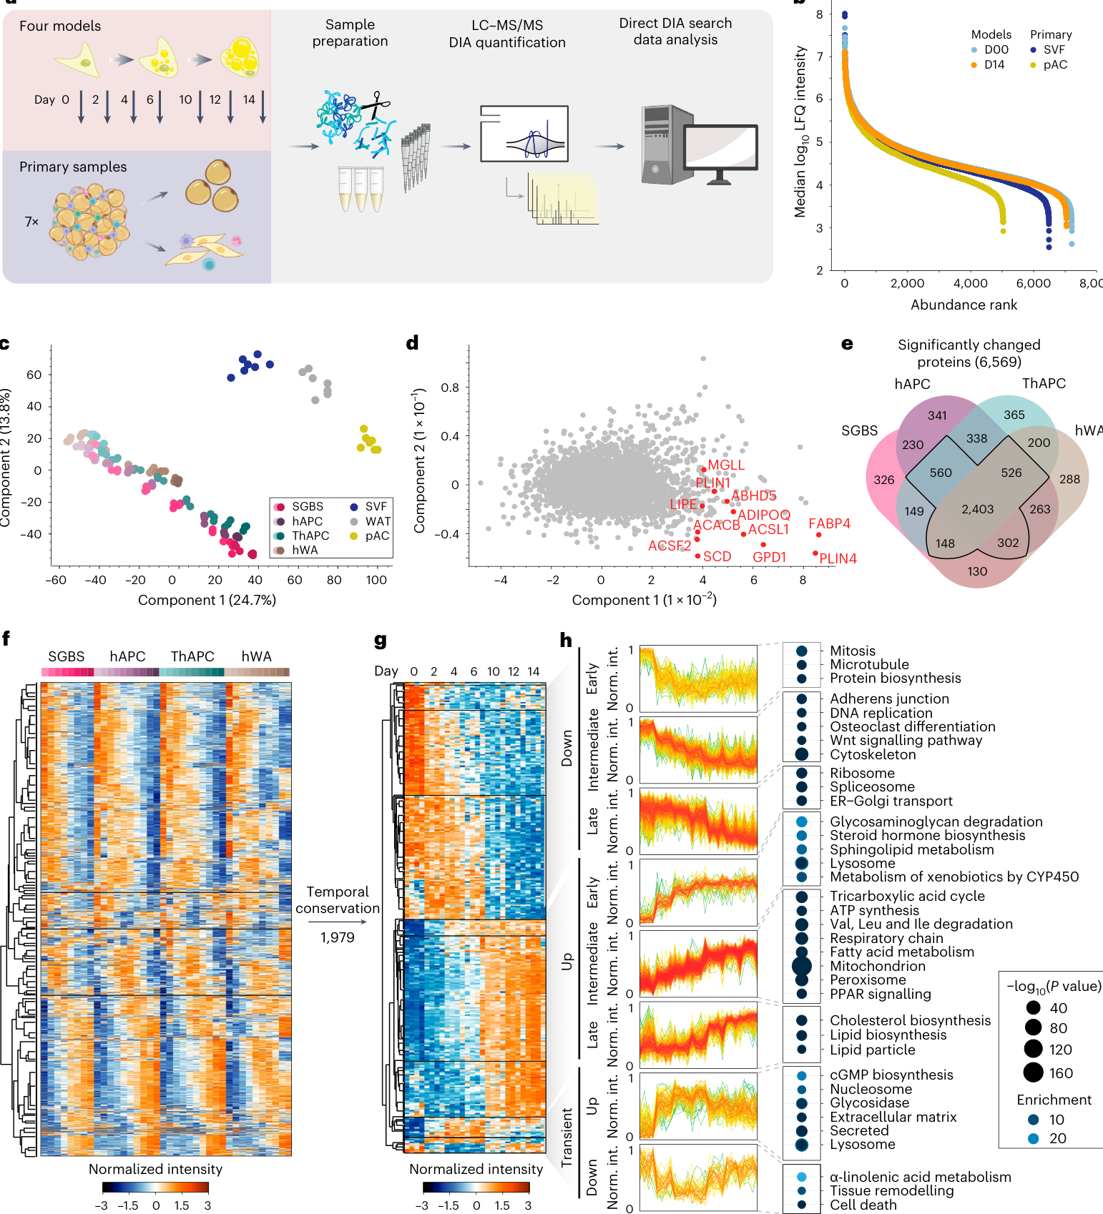
Fig. 1 | Proteomic dataset of four adipocyte models and primary samples.
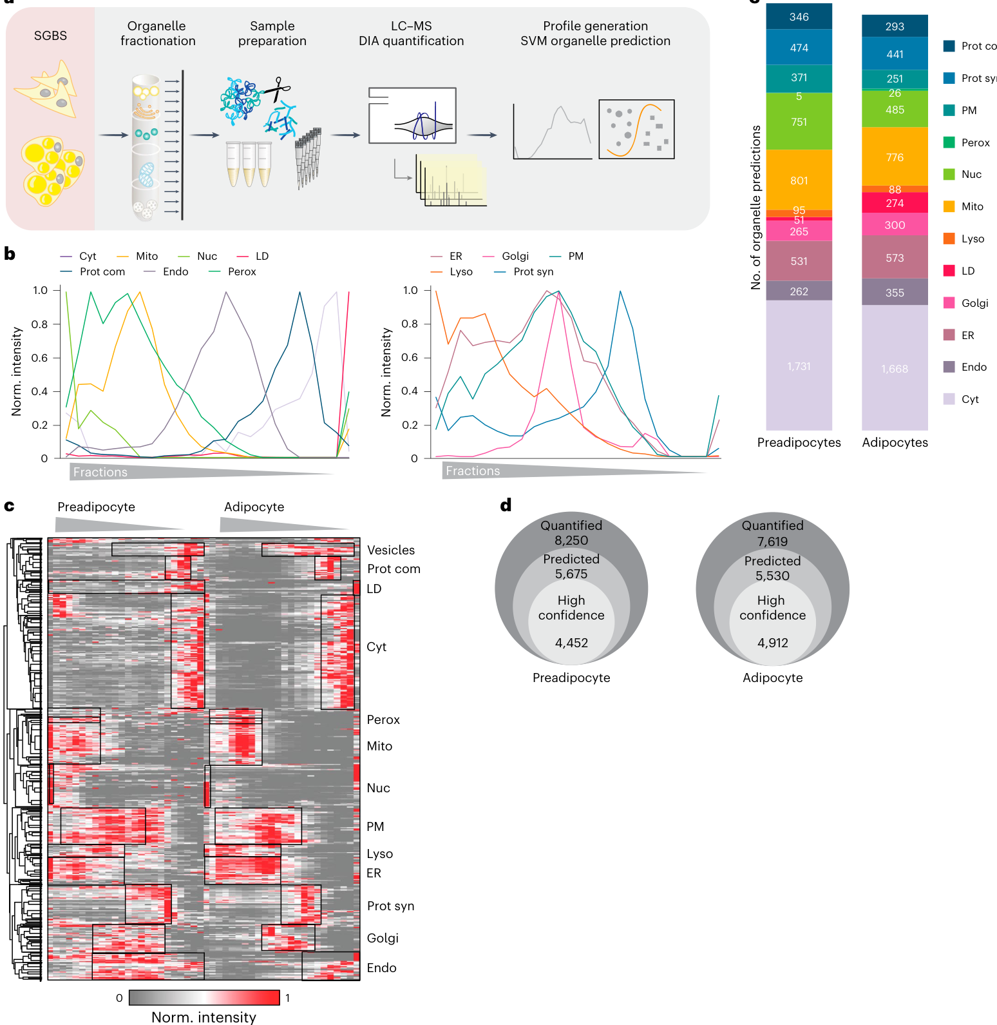
Fig. 2 | Spatial proteomics workflow and organelle prediction (PCP–SVM).
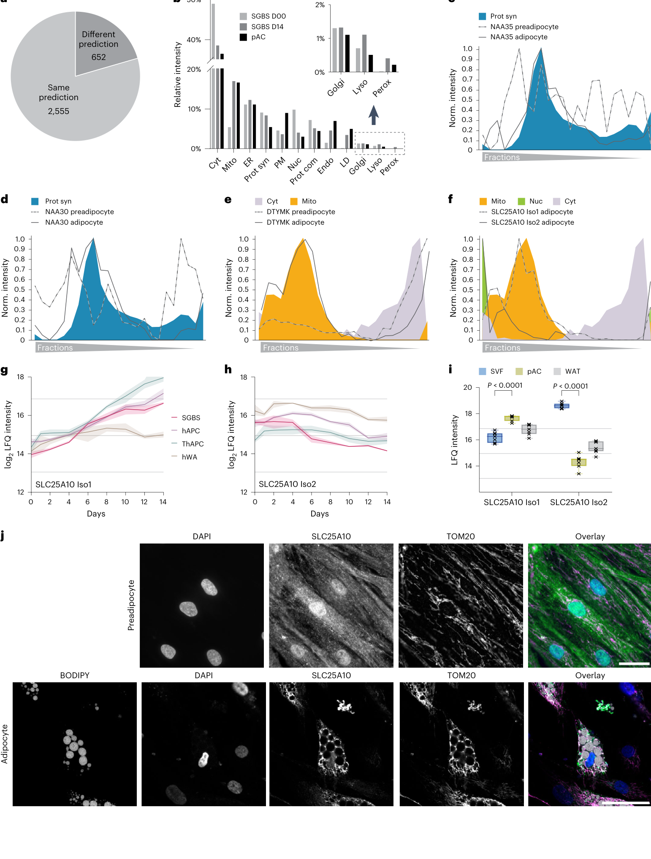
Fig. 3 | Organelle relocalization of 1,323 proteins during differentiation.
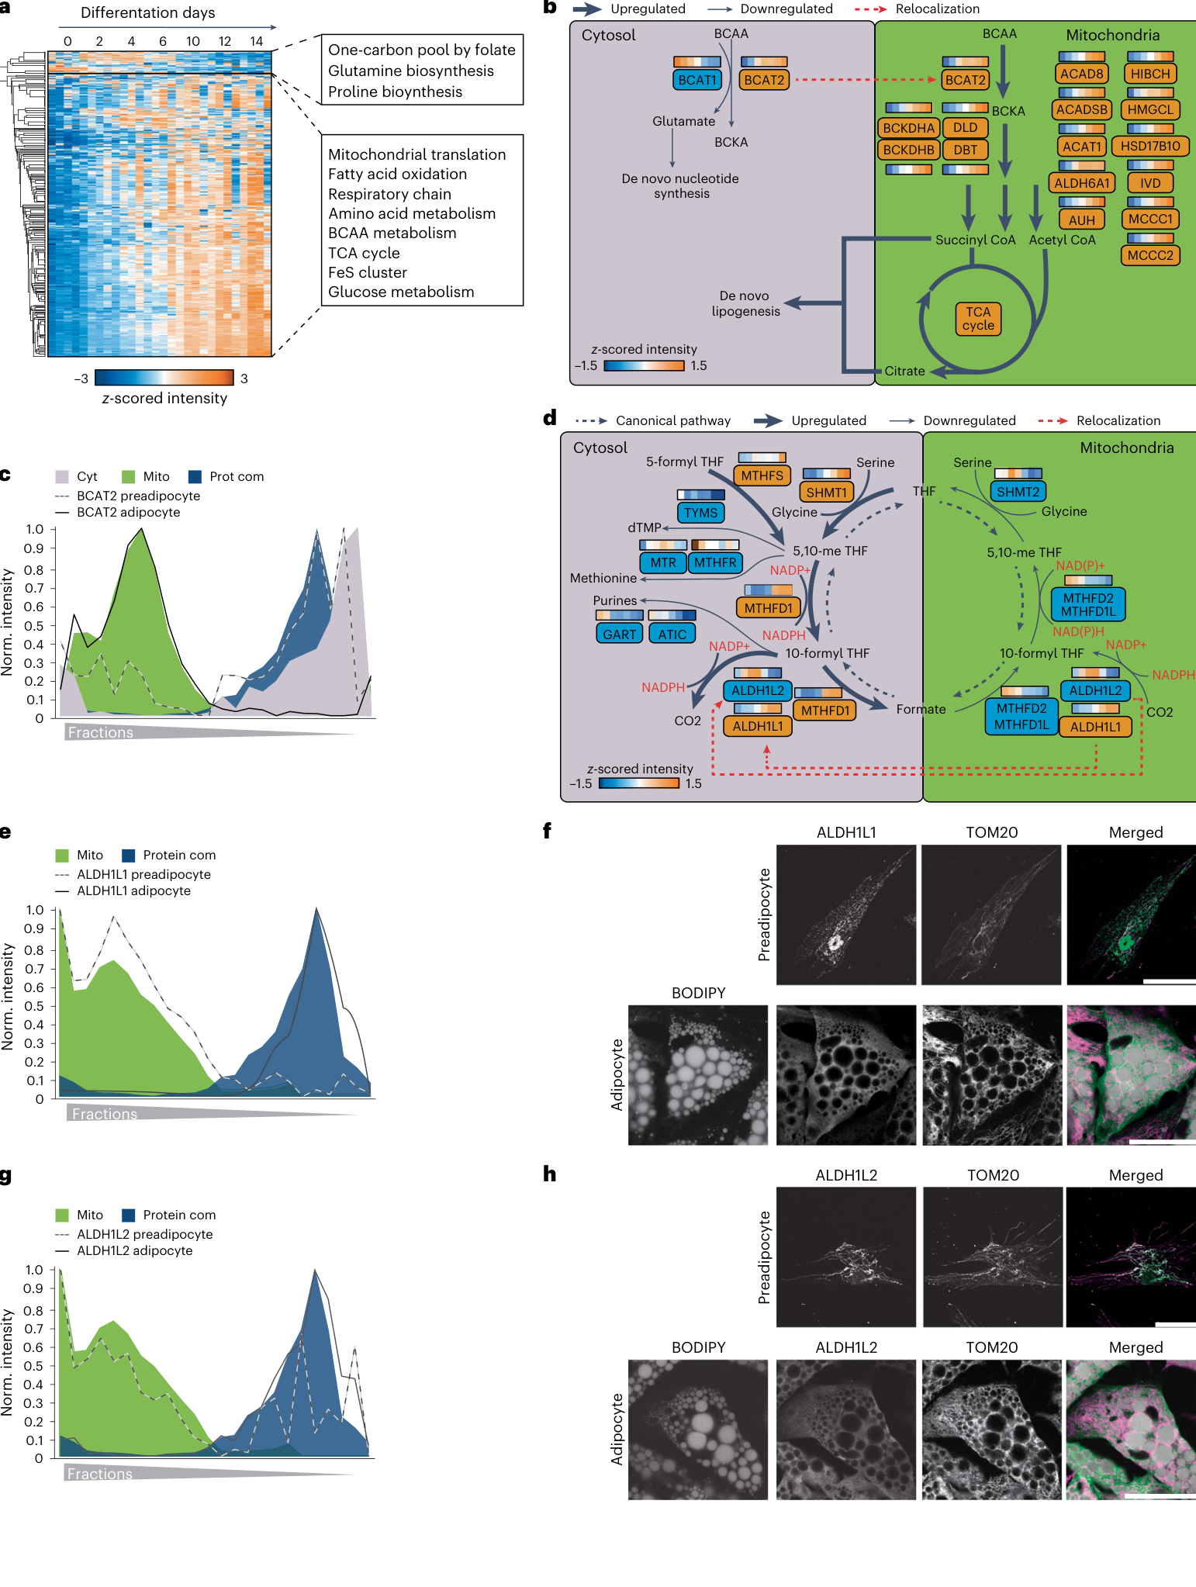
Fig. 4 | Relocalization of BCAA and one-carbon metabolism enzymes.
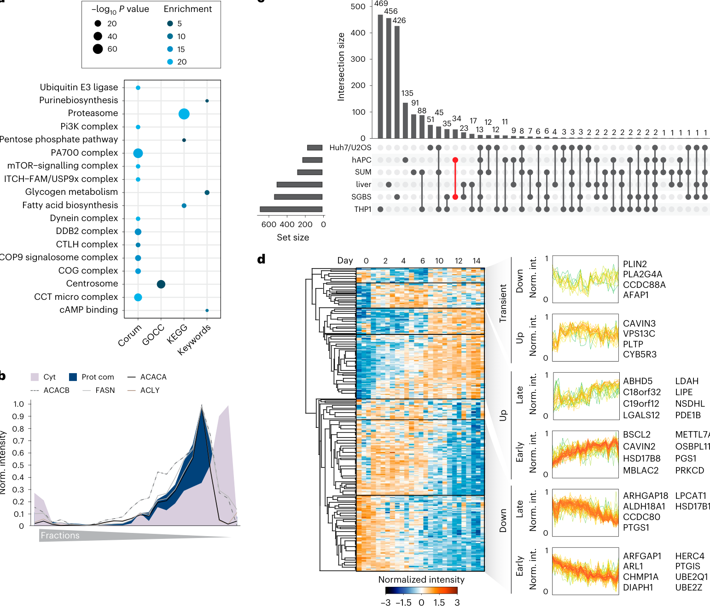
Fig. 5 | Mitochondrial contact-site proteins and lipid-droplet proteins.
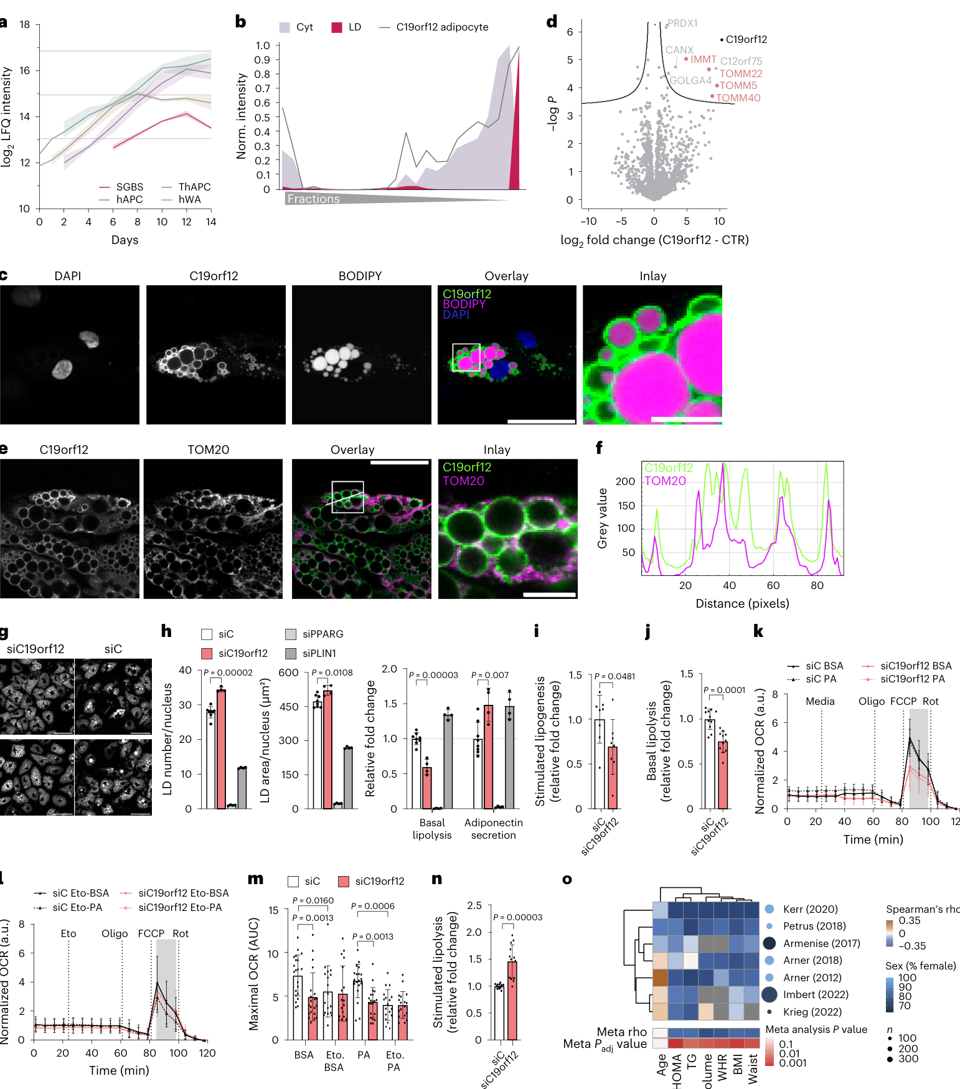
Fig. 6 | C19orf12 characterization, knockdown phenotypes and clinical cohorts.
Paper 2 — A universal gut-microbiome-derived signature predicts cirrhosis
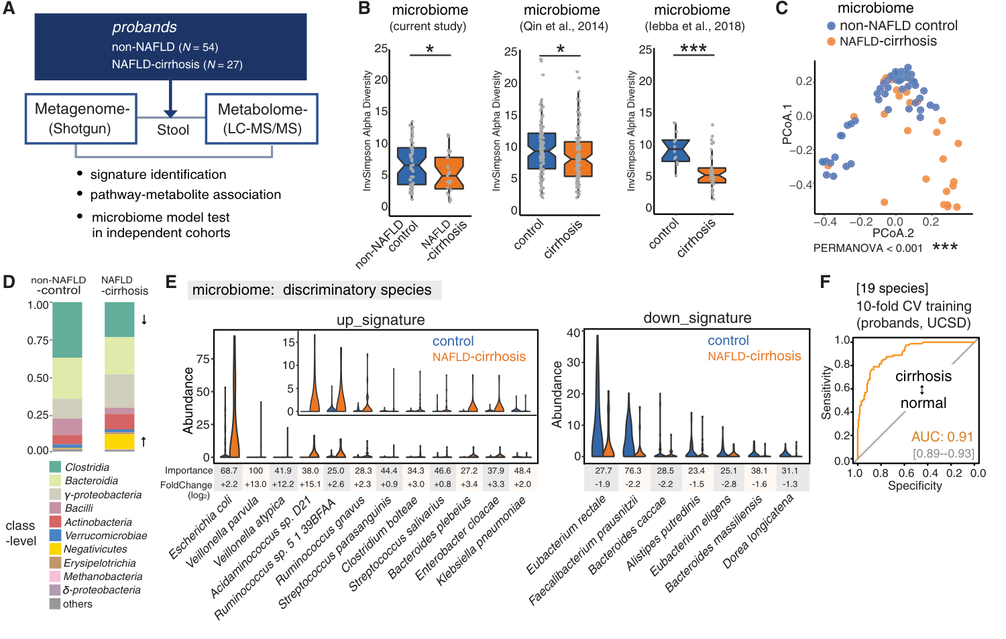
Fig. 1 | Cohort design and overall microbiome–metabolome analysis.
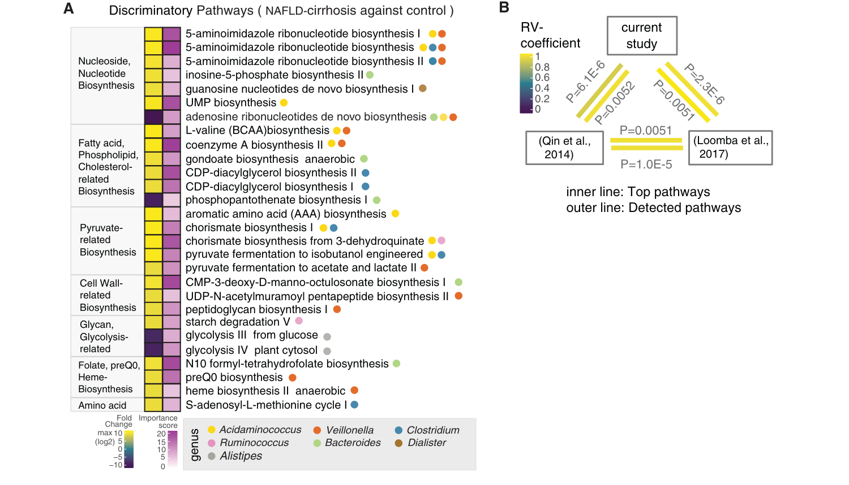
Fig. 2 | Discriminatory microbial pathways and cross-cohort concordance.
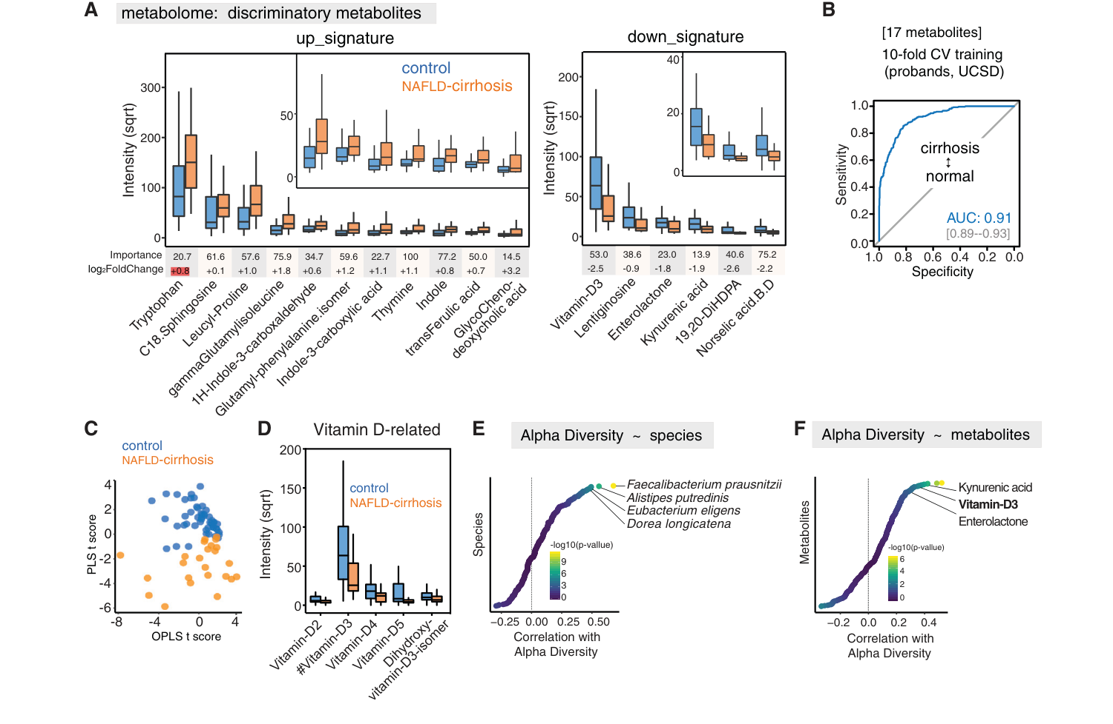
Fig. 3 | Discriminatory metabolites and diversity associations.
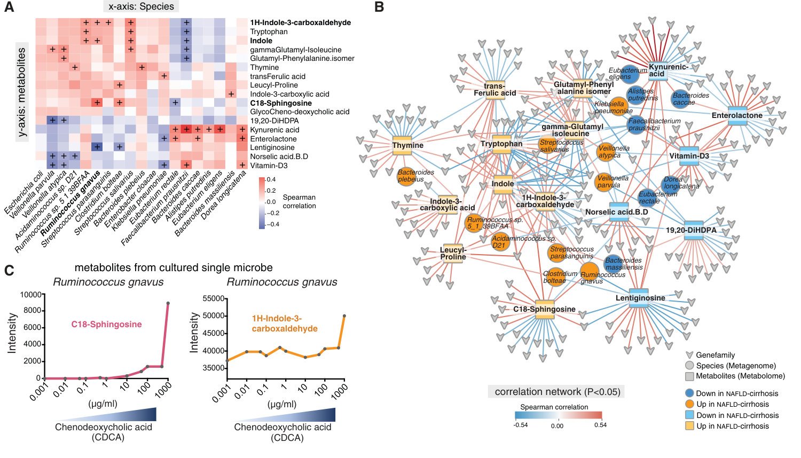
Fig. 4 | Correlation network and R. gnavus culture experiment.
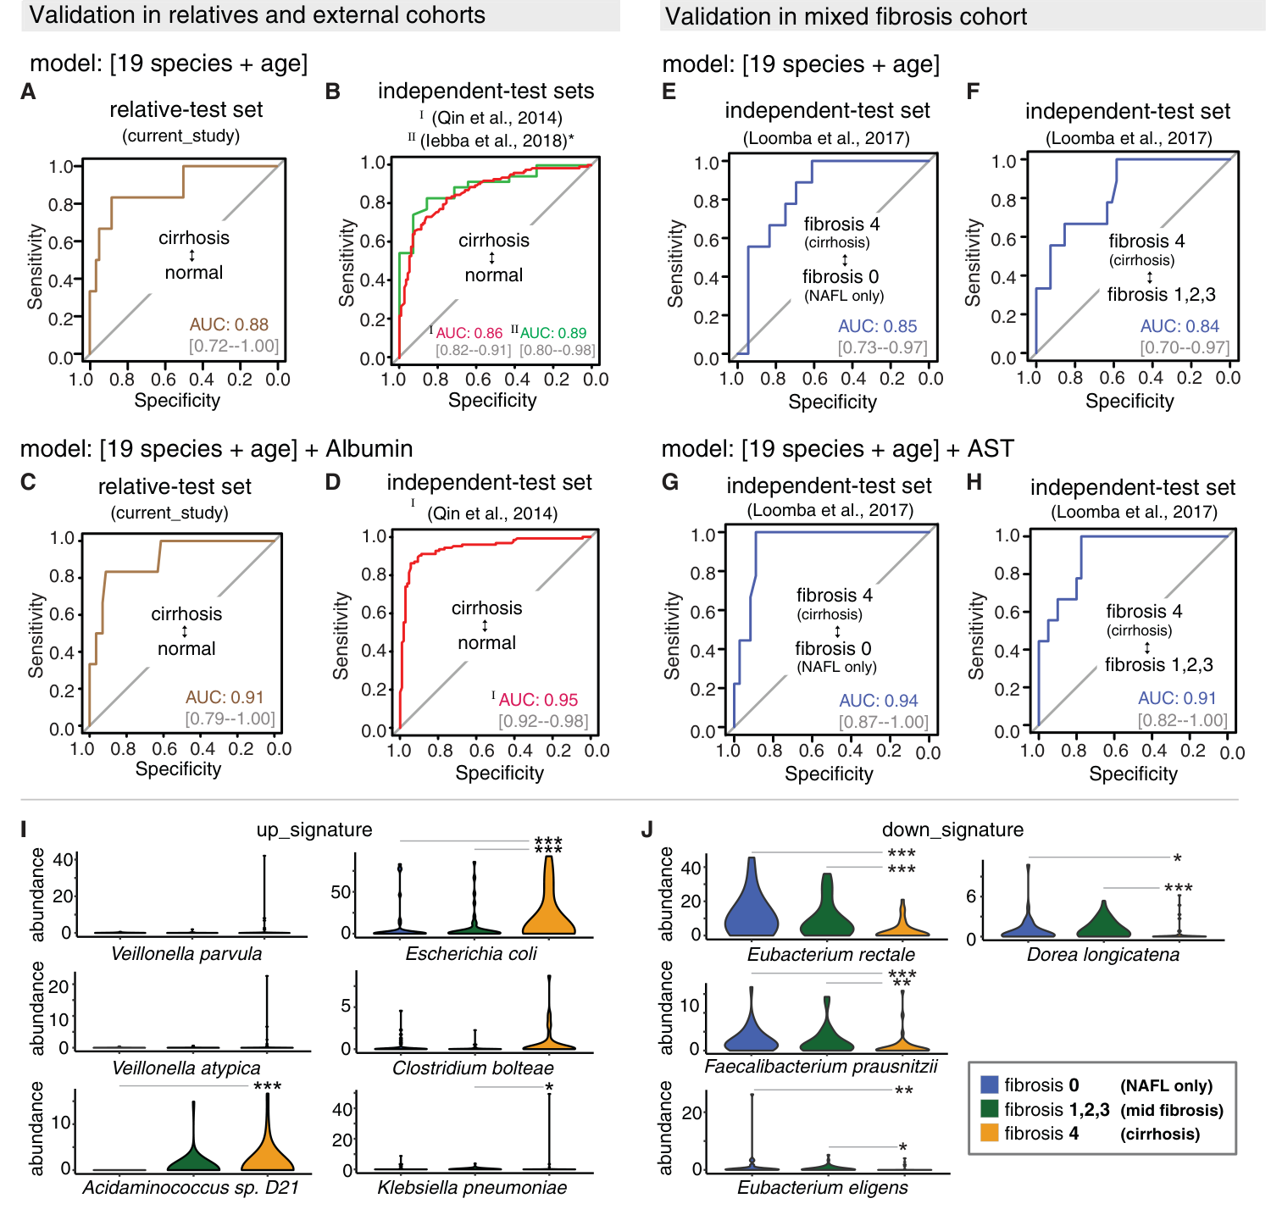
Fig. 5 | Random-forest signature and external validation (AUC).
Paper 3 — Shared and disease-specific host gene–microbiome associations
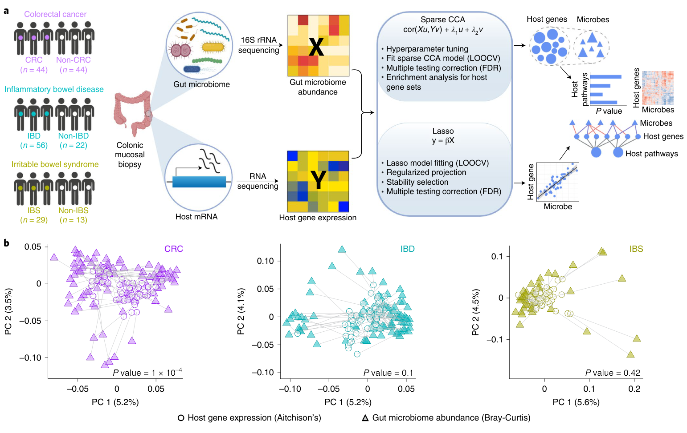
Fig. 1 | Study design and Procrustes analysis of paired samples.
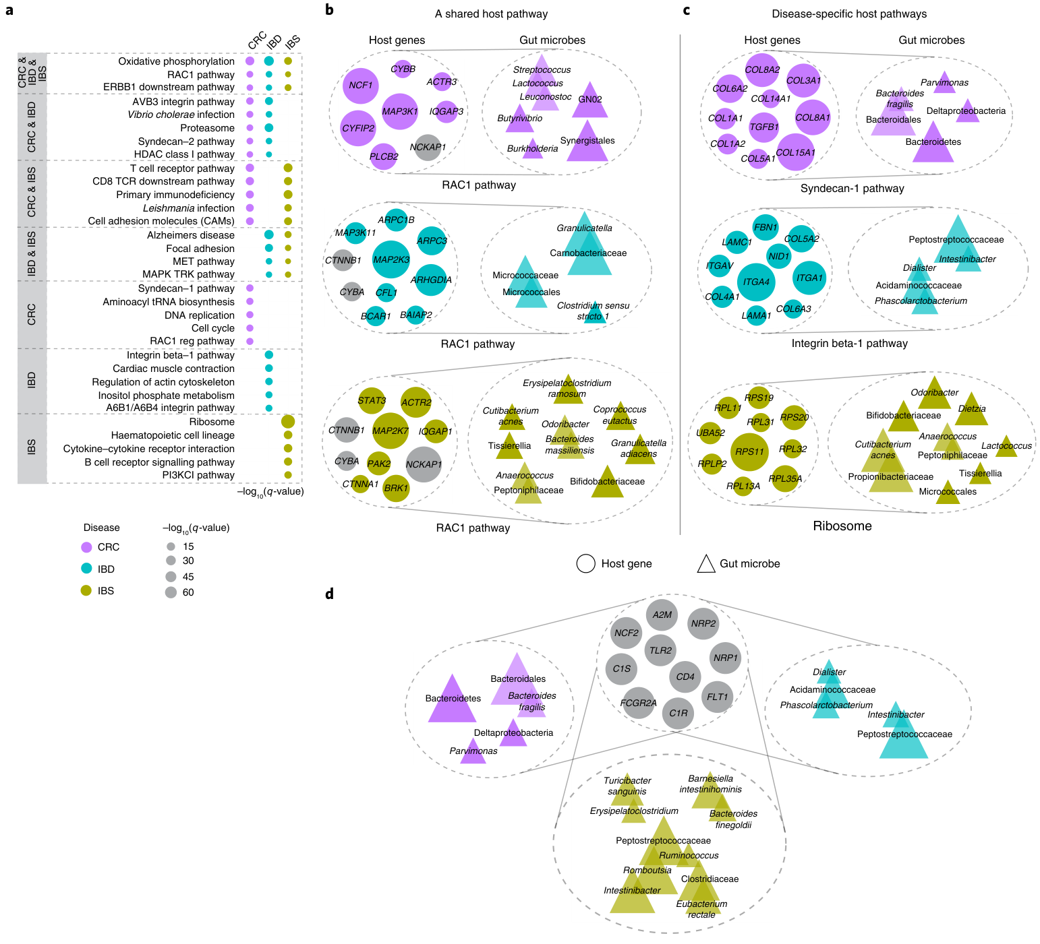
Fig. 2 | Shared RAC1 pathway and disease-specific pathways.
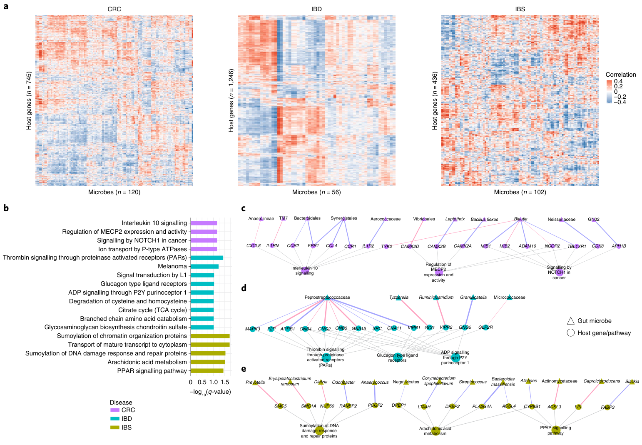
Fig. 3 | Association heatmaps and disease-specific pathway networks.
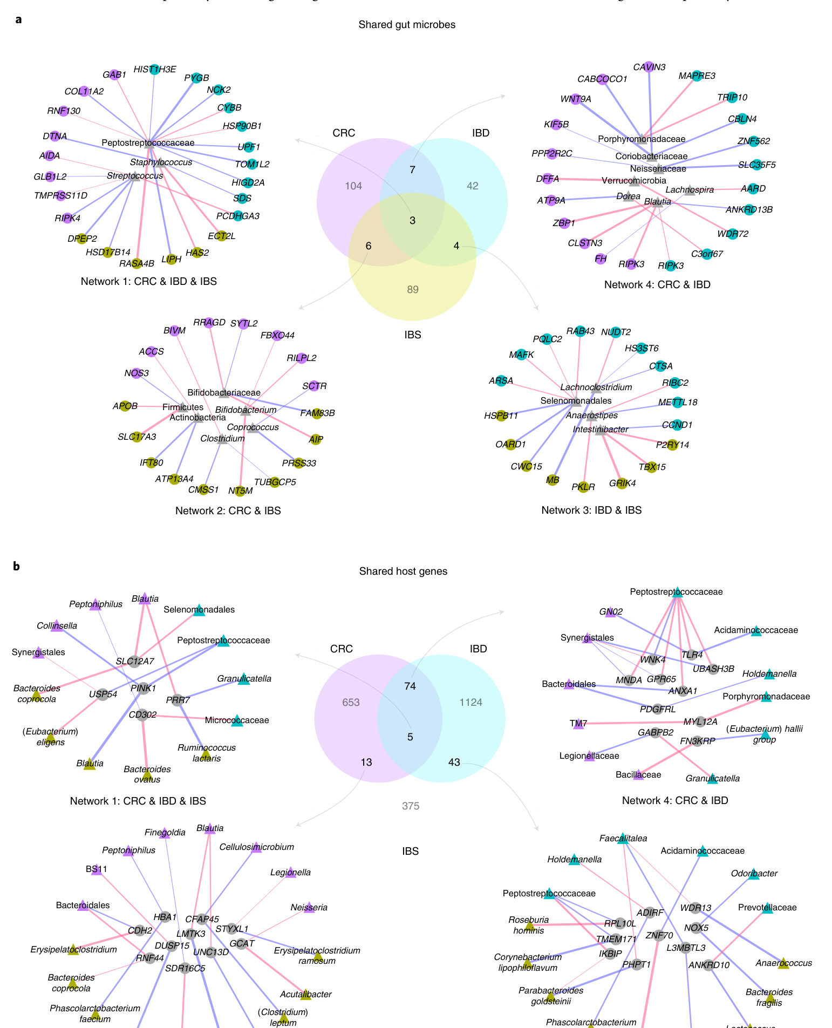
Fig. 4 | Shared microbes and shared host genes across the three diseases.

