BancaFiel — Workflow & AWS Services
Version: March 2026 · Stack: AWS Serverless · Region: us-east-1
1. How the System Works (End-to-End)
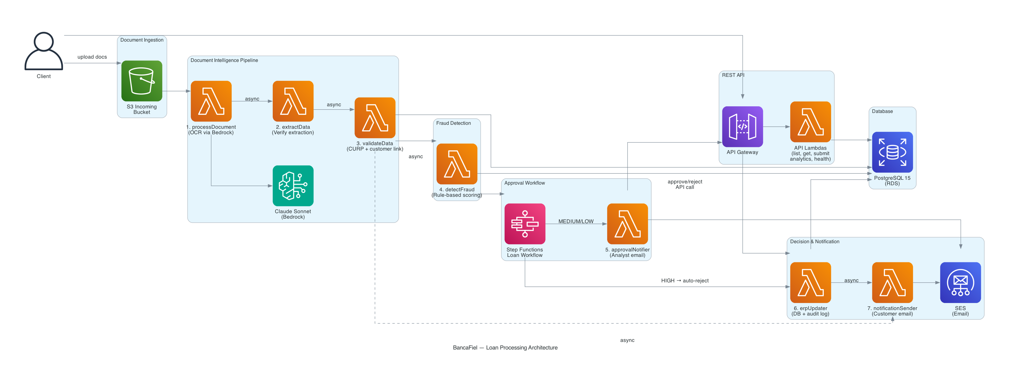
Entry Point
A client submits a loan application through www.bancafiel.com by uploading their INE (national ID) and proof of address. These files land in an S3 bucket, which automatically triggers the pipeline. Clients also use a REST API to check status, register, and log in.
Phase 1 — Document Intelligence (Lambdas 1–3)
Lambda 1 · processDocument — Triggered on S3 upload. Sends the document to Claude Sonnet via Amazon Bedrock for AI-powered OCR. Saves extracted fields to the database and asynchronously triggers Lambda 2.
Lambda 2 · extractData — Verifies the Bedrock output is complete and well-structured, organizes fields by document type (name, CURP, address, DOB), then asynchronously triggers Lambda 3.
Lambda 3 · validateData — Core validation step. Validates all fields, links the customer via their CURP, creates or finds the customer record in PostgreSQL, and sends the applicant a confirmation email. Only triggers Lambda 4 on the INE document to prevent the pipeline from running twice.
Phase 2 — Fraud Detection (Lambda 4)
Lambda 4 · detectFraud — Runs a custom rule-based fraud scoring algorithm checking: debt-to-income ratio, age from CURP, ID consistency, duplicate applications, and blacklists. Assigns a risk level — HIGH → auto-reject; MEDIUM/LOW → analyst review via Step Functions.
Phase 3 — Approval Workflow (Step Functions + Lambda 5)
Step Functions · Loan Workflow — Orchestrates the human-in-the-loop approval. Routes the case based on fraud risk and waits for the analyst's decision.
Lambda 5 · approvalNotifier — Sends an HTML email to the analyst with full application details, fraud score, and Approve/Reject buttons that call the REST API.
Phase 4 — Decision & Notification (Lambdas 6–7)
Lambda 6 · erpUpdater — Updates the application status in PostgreSQL and writes a full audit log entry. Asynchronously invokes Lambda 7.
Lambda 7 · notificationSender — Sends the applicant their result via Amazon SES using HTML email templates: received confirmation, approval, or rejection.
2. AWS Services Used
Service | Role in BancaFiel
AWS Lambda | Runs all 7 pipeline steps + REST API handlers — executes only when triggered, zero idle cost
AWS Step Functions | Orchestrates the analyst approval flow — routes HIGH/MEDIUM/LOW fraud risk to the correct path
Amazon S3 | Stores uploaded loan documents — triggers the pipeline automatically on every upload
Amazon RDS (PostgreSQL) | Single source of truth — applications, customers, fraud scores, audit history, login accounts
Amazon Bedrock (Claude) | AI-powered OCR — reads and extracts structured data from ID documents
Amazon API Gateway | Exposes the REST API to the frontend — handles all HTTP requests from both portals
Amazon CloudFront | Serves www.bancafiel.com and analyst.bancafiel.com globally with low latency
Amazon SES | Sends all transactional HTML emails — received, approved, and rejected notifications
AWS IAM | Enforces least-privilege access — each Lambda only calls the exact services it needs
AWS ACM | Manages the SSL/TLS certificate for all three domains — enforces HTTPS everywhere
CloudFront OAC | Locks S3 so files can only be served through CloudFront — raw S3 URLs are blocked
AWS SAM | Defines and deploys the entire backend from a single YAML file — one command to deploy
AWS CloudFormation | Underlying engine used by SAM — manages all resources as a single versioned stack
Total: 13 AWS services — the same stack trusted by Netflix, Airbnb, Apple, Disney, NASA, and 60% of the Fortune 500.

