**CASH DEPOSIT ENTRY UPDATED**

*If Transaction Type is Cash Sales*   
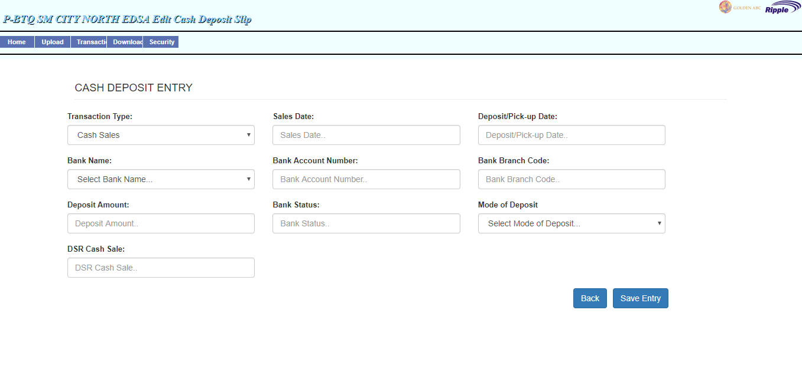

If Not

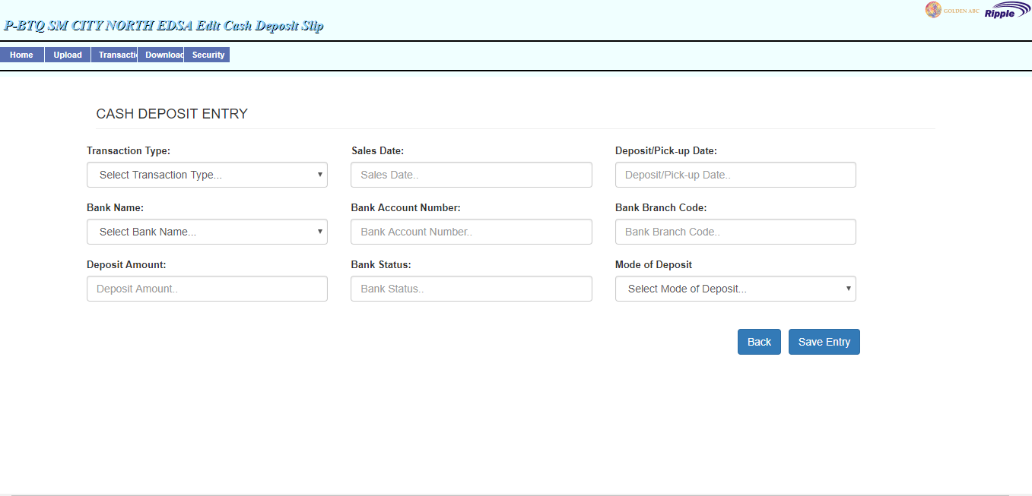

**TREASURY ENROLLMENT APPROVAL**  
  
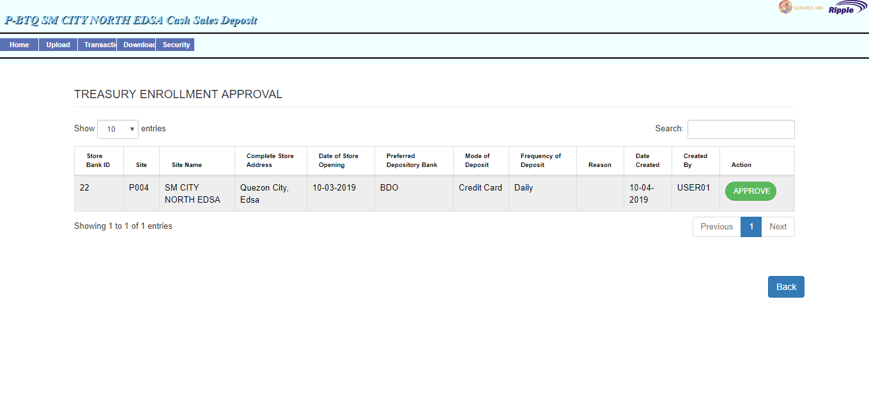

*-Button Approve Modal Validation in Treasury Enrollment Approval*

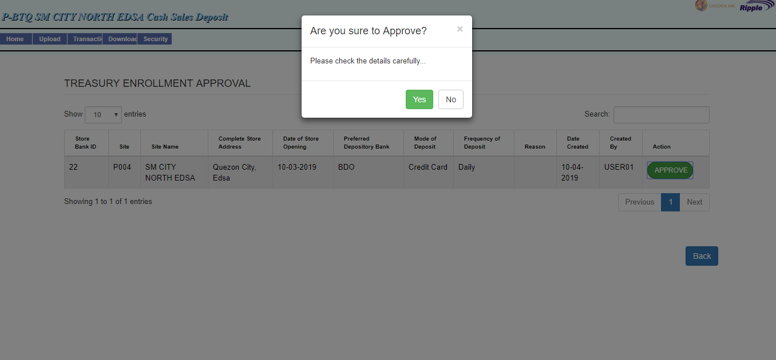

**IF ACCOUNTANT LOGIN TO SITE CASH DEPOSIT HOMEPAGE  
button (BANK,TRANSACTION_TYPE,MODE_OF_DEPOSIT, BANK_ENROLLMENT) will show**

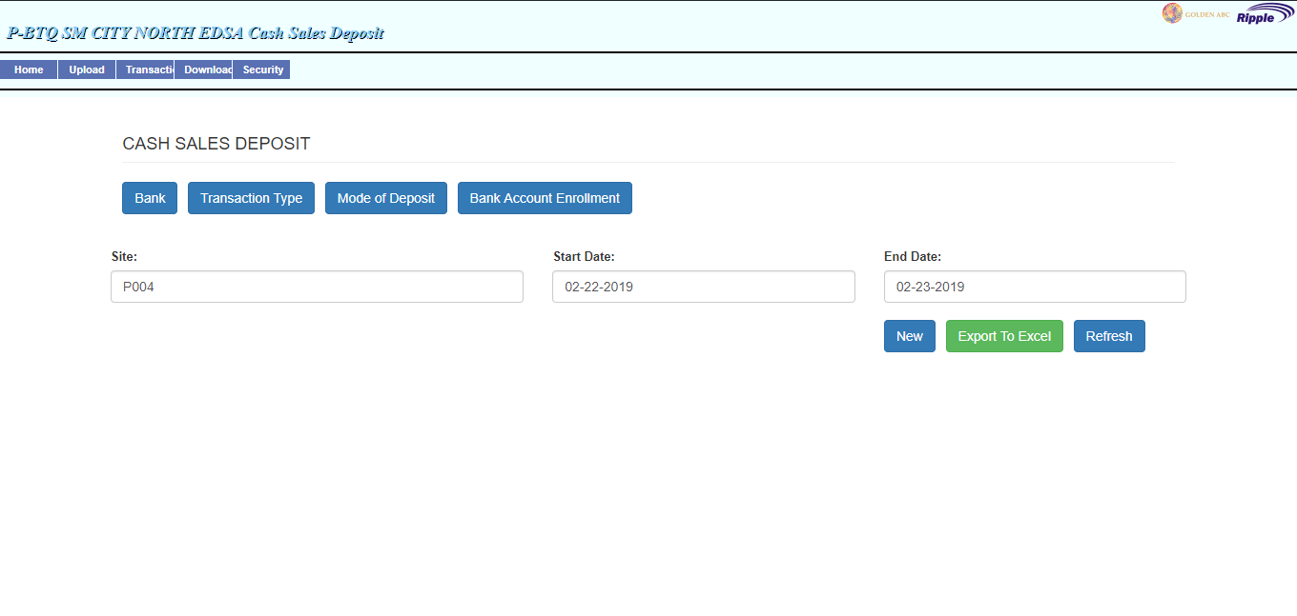

**IF CASHIER LOGIN TO SITE CASH DEPOSIT**

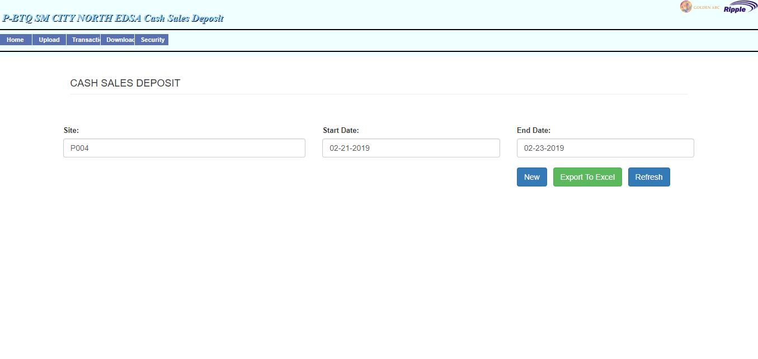

**BANK ACCOUNT ENROLLMENT UPDATED**

-Change label to Bank Account Enrolment

-Remove the Remove Button

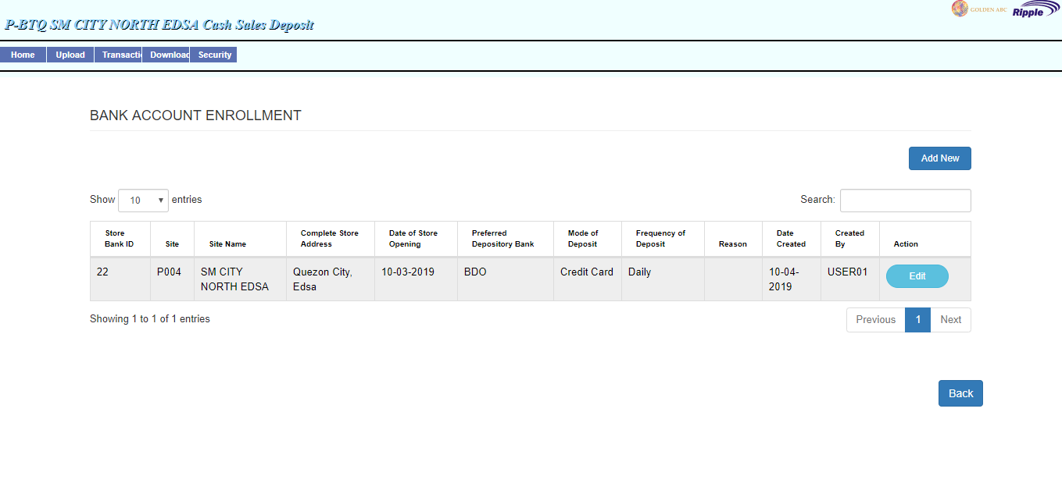

**UPDATED UI OF MASTER DATA MAINTENANCE BANK**

-Add Column Status check if bank is active or inactive  
-Change Remove button to inactive and active button

- Automatic Update column Status when button Inactive click and Active click

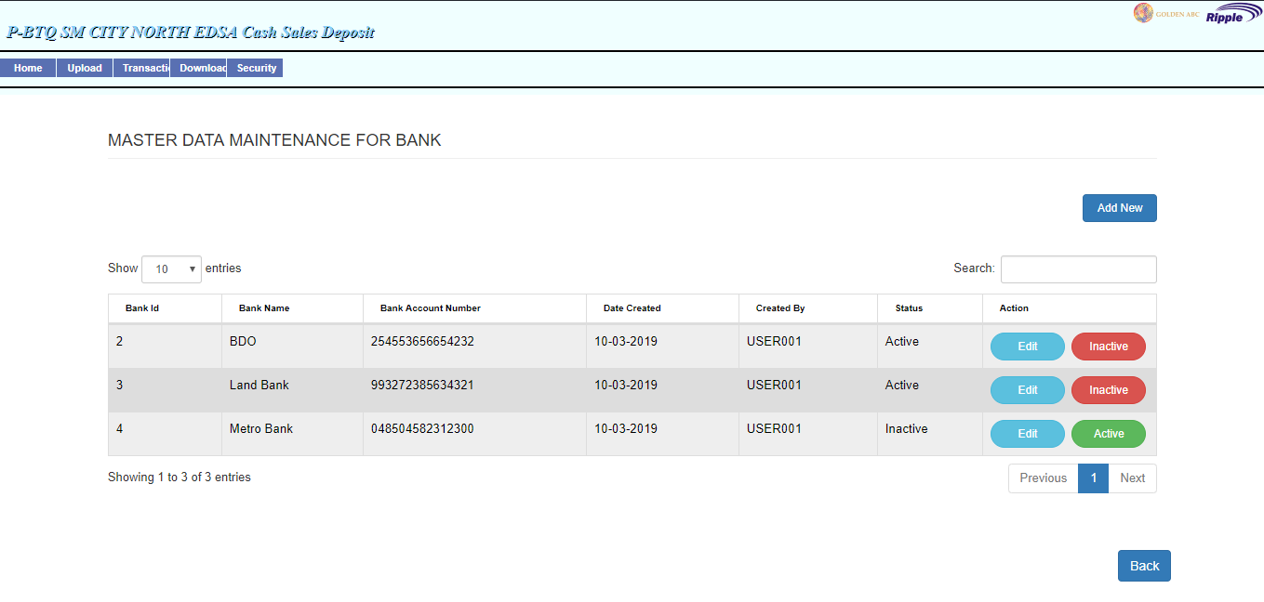

* **UPDATED UI OF MASTER DATA MAINTENANCE FOR TRANSACTION TYPE**Add Column Status check if bank is active or inactive  
  Change Remove button to inactive and active button

Automatic Update column Status when button Inactive click and Active click

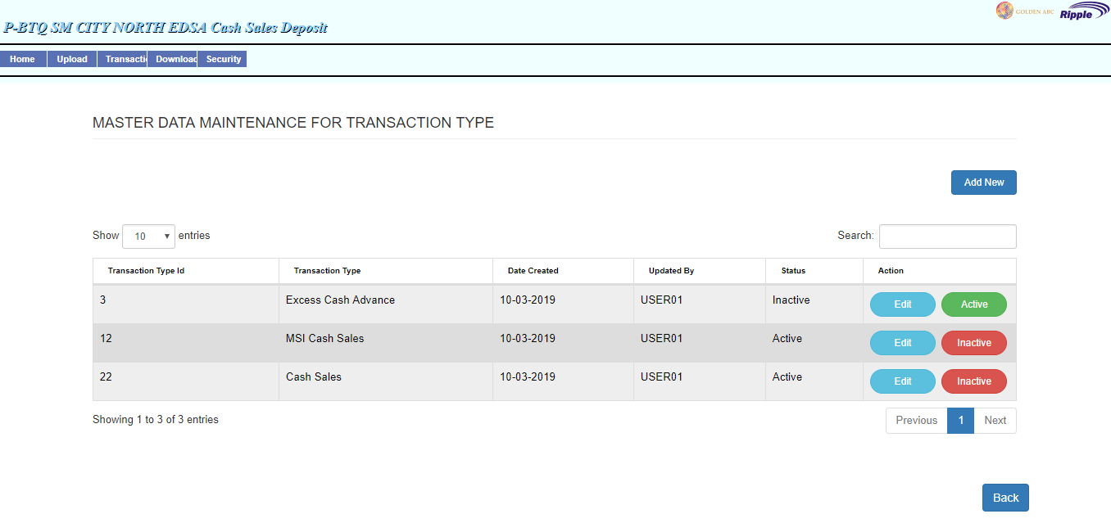

* **UPDATED UI OF MASTER DATA MAINTENANCE FOR MODE OF DEPOSIT**

Add Column Status check if bank is active or inactive  
Change Remove button to inactive and active button

Automatic Update column Status when button Inactive click and Active click

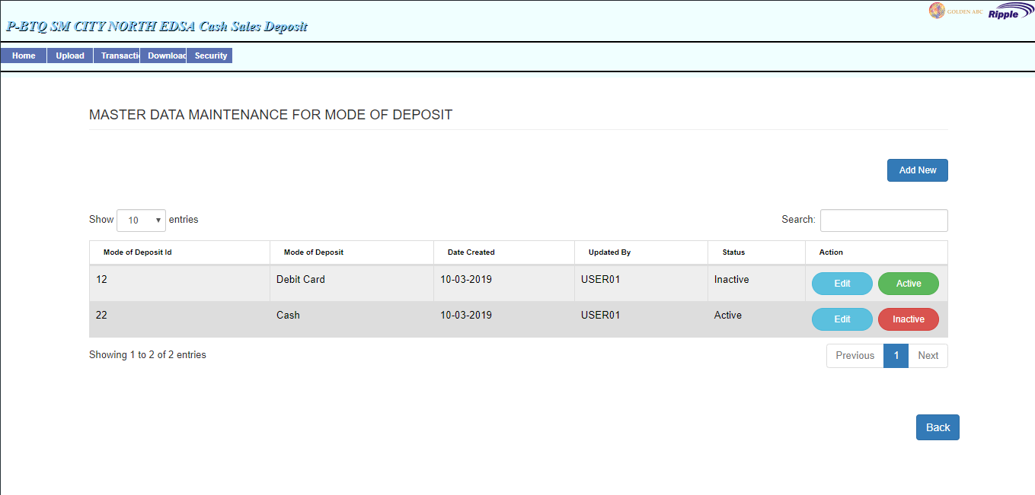

**Auto site fill up when adding a new bank account enrollment**

