Lab 4
Santiago Flores
2/24/2020
Screen shots of running code

1. Show that you cannot define more than the max number of variables, 5.


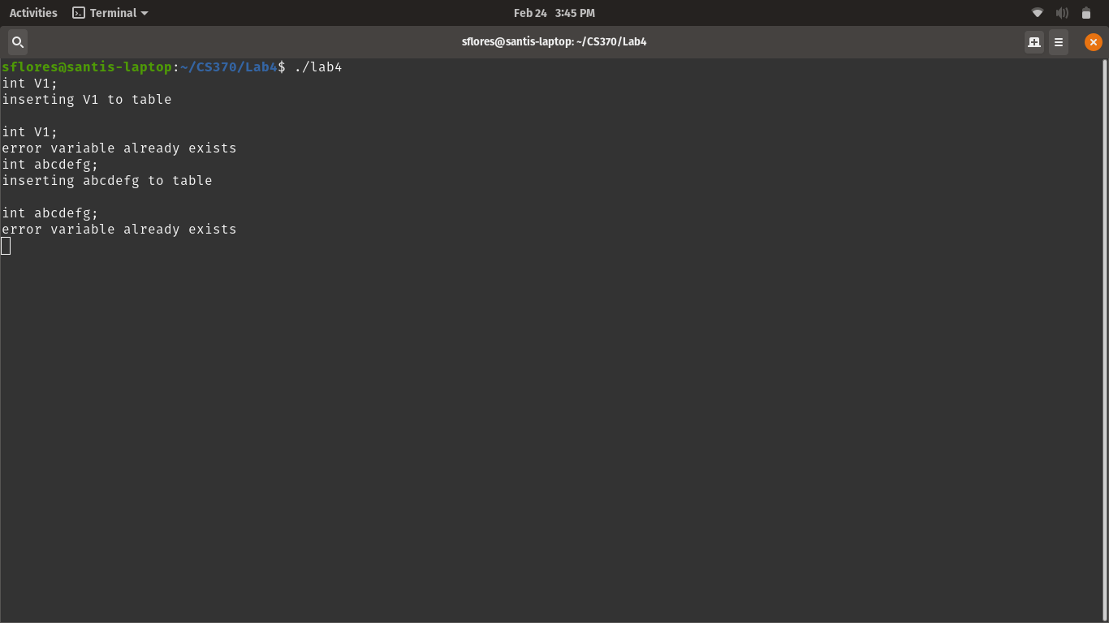
2. Cannot declare a variable more than once

3. Cannot use a variable that hasn’t been defined

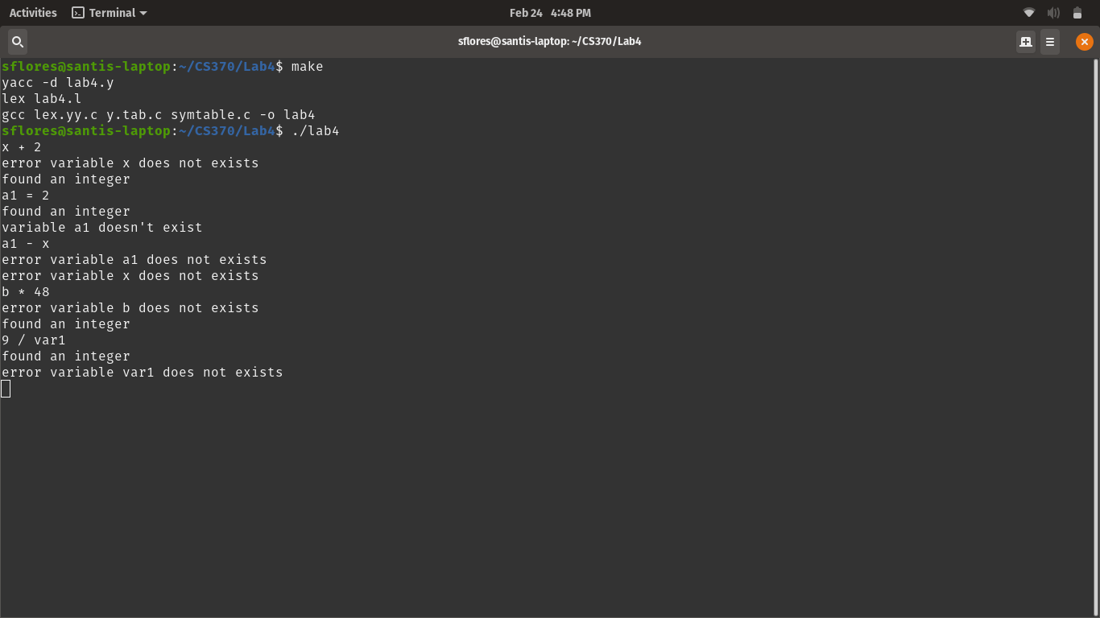

4. A declared variable can be set and used

