Assign3 writeup

Santina

Sunday, November 02, 2014

In this assignment, we examined a few different linear models that are trained based on different attributes or on data that were imputed.

The source code is loaded here.

source("Assign3_SantinaLin.R")

And here's the summary of all four models in comparison.

kable(summary)

| | accuracy| sensitivity| specificity| |:----------------|--------:|-----------:|-----------:| |MClean_goodness | 0.9360| 0.9833| 0.6951| |MBoth_goodness | 0.9300| 0.9975| 0.6495| |MIncome_goodness | 0.9300| 0.9975| 0.6495| |MAge_goodness | 0.9140| 0.9925| 0.6040| Let's look at them in graph

grid.arrange(accuracy_summary, sensitivity_summary, specificity_summary, ncol=3)

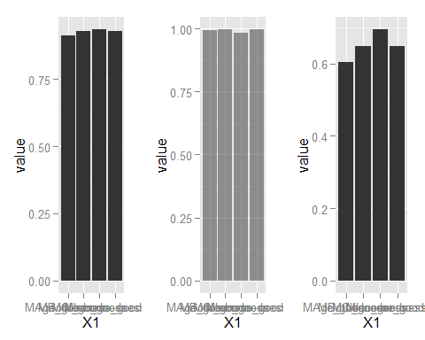

We can see that