Chapter 4 Mini Report Santino Celebre

Chapter four is the chapter about continuous variables and their probability distributions. This report will focus on the specific parts of the chapter on Normal, Beta, and Gamma Distributions. First, we should look at the definitions and theorems involved in all three distribution types. We begin with Normal Distribution and as stated in the book, this distribution is the most widely used continuous probability distribution. As definition 4.8 states, a normal variable Y is said to have a normal probability distribution if and only if the density function of Y is

For the given equation it makes sense that locates the center of the distribution and that measures the spread which more or less the range of possible values expected in the outcome. The normal density function is said to be symmetric around the value , this makes it easier to make statistical analysis of the distribution. This is important in the real world because it gives you the ability to find the probability of observations in a distribution falling above or below a given mean. The book provides the example as follows. *A* *machining operation produces bearings with diameters that are normally distributed with mean 3.0005 inches and standard deviation .0010 inch. Specifications require the bearing diameters to lie in the interval 3.000 °æ .0020 inches. Those outside the interval are considered scrap and must be* *re-machined. With the existing machine setting, what fraction of total production will be* *scrap?* With this question you can understand the importance of the normal distribution. In business, business owners will try to produce different techniques that can lower the chance of wasting material directly affecting profits. On pure interest I did a quick search online for the career fields that have been known to use Normal Distribution and jobs like sales/marketing, accounting, stock market analysis, and politics all came up. I also found an article on Indeed which explained normal distribution and its uses in business, a less math intensive way of explaining it than the book which I found to be helpful.

Next, we have the Gamma Probability Distribution that can be found in section 4.6 in the book. Some random variables are always nonnegative and for several reasons yield distributions of data that are skewed (nonsymmetric) to the right and this is where Gamma Distribution comes into play. The book gives examples of when Gamma Distribution was used to model specific situations like “The lengths of time between malfunctions for aircraft engines possess a skewed frequency distribution, as do the lengths of time between arrivals at a supermarket checkout queue (that is, the line at the checkout counter). Similarly, the lengths of time to complete a maintenance checkup for an automobile or aircraft engine possess a skewed frequency distribution.” When looking at the definition we can find that the variable Y is said to have a gamma distribution with parameters > 0 and > 0 if and only if the density function of Y is ￼ WHERE

The symbol that looks like an upside-down L (Γ) represents the gamma function. You can also see when you change the value of it changes the shape of the gamma distribution model. For this reason, the book refers to as the shape parameter. The parameter β is called the scale parameter because multiplying a gamma-distributed random variable by a positive constant also changes the model of gamma in a unique way. The gamma density function in which α = 1 is called the exponential density function. The exponential density function is often useful for modeling the length of life of electronic components. This makes sense because as machines get older the wear and tear on the machine gradually and consistently increases. The real-world problem provided in the book was as follows, *The magnitude of earthquakes recorded in a region of North America can be modeled as having an exponential distribution with mean 2.4, as measured on the Richter scale. Find the probability that an earthquake striking this region will* *exceed 3.0 on the Richter scale and the probability that an earthquake will fall between 2.0 and 3.0 on the Richter scale.* With that example you can see the importance of Gamma Distributions in proper preparations for various levels of earthquakes.

The last distribution we will talk about will be from section 4.7 which is the Beta Probability Distribution. The beta density function is a two-parameter distribution function. This distribution is often used as a model for proportions, such as the proportion of impurities in a chemical product or the proportion of time that a machine is under repair. In comparison to Gamma and Normal distribution the model of Beta Distribution resembled a wide number of different shapes that really have no pattern. As stated in definition 4.12 a random variable Y is said to have a beta probability distribution with parameters α > 0 and β > 0 if and only if the density function of Y is WHERE Similar to the gamma function when you change the values of the parameter of and you will get a different size graph. One notable example the book provides on the beta density function was as follows. *A gasoline wholesale distributor has bulk storage tanks that hold fixed supplies and are filled every Monday.* *Of interest to the wholesaler is the proportion of this supply that is sold during the week. Over many weeks of observation, the distributor found that this proportion could be modeled by a beta distribution with α = 4 and β = 2. Find the probability that the wholesaler will sell at least 90% of her stock in a given week.*

In conclusion throughout this report we went over Beta Distribution, Gamma Distribution, and Normal Distribution. Beta Distribution resembles many different shapes with no pattern. Gamma Distribution provides data that is skewed (nonsymmetric) to the right. Lastly, Normal Distribution is the most widely used continuous probability distribution and the normal density function is said to be symmetric. Below I will provide three graphs on how Normal Distribution, Gamma Distribution, and Beta Distribution all look.

NORMAL

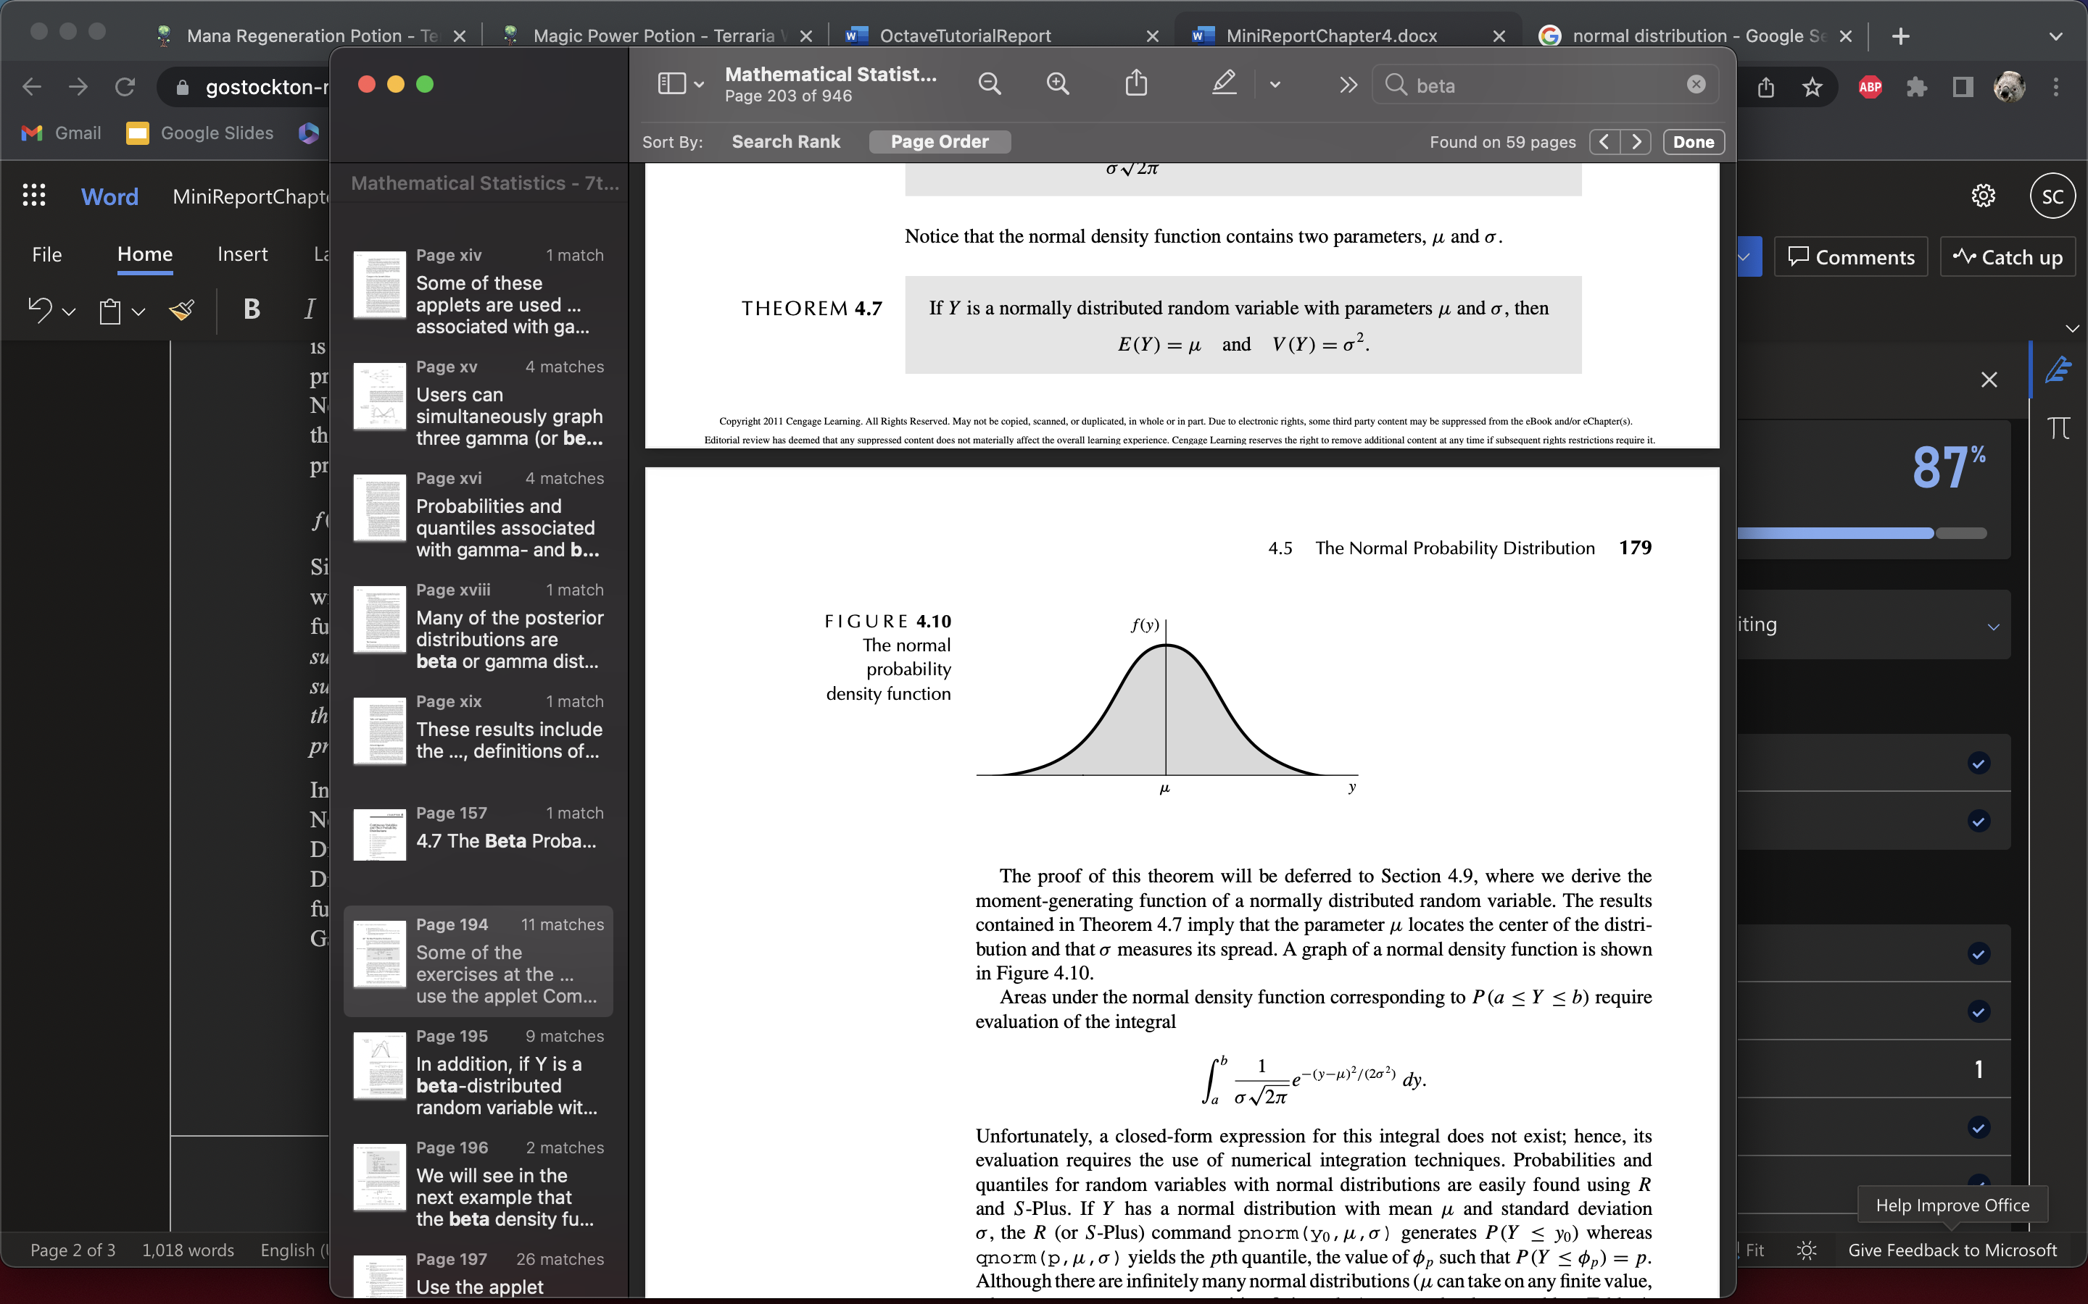

GAMMA

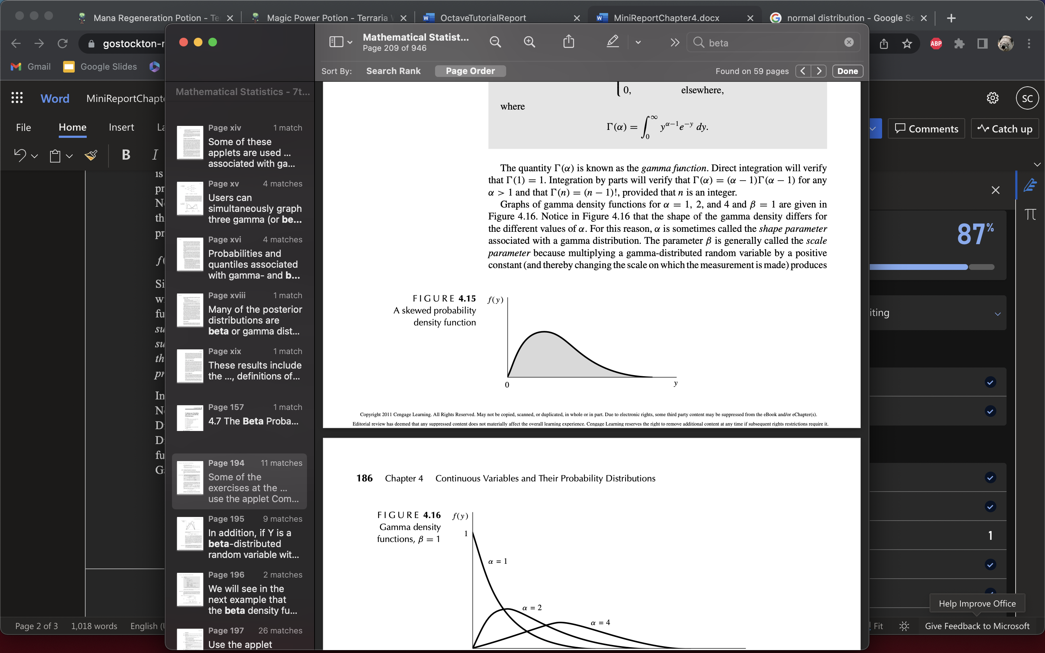

BETA

