Octave Tutorial Report Santino Celebre

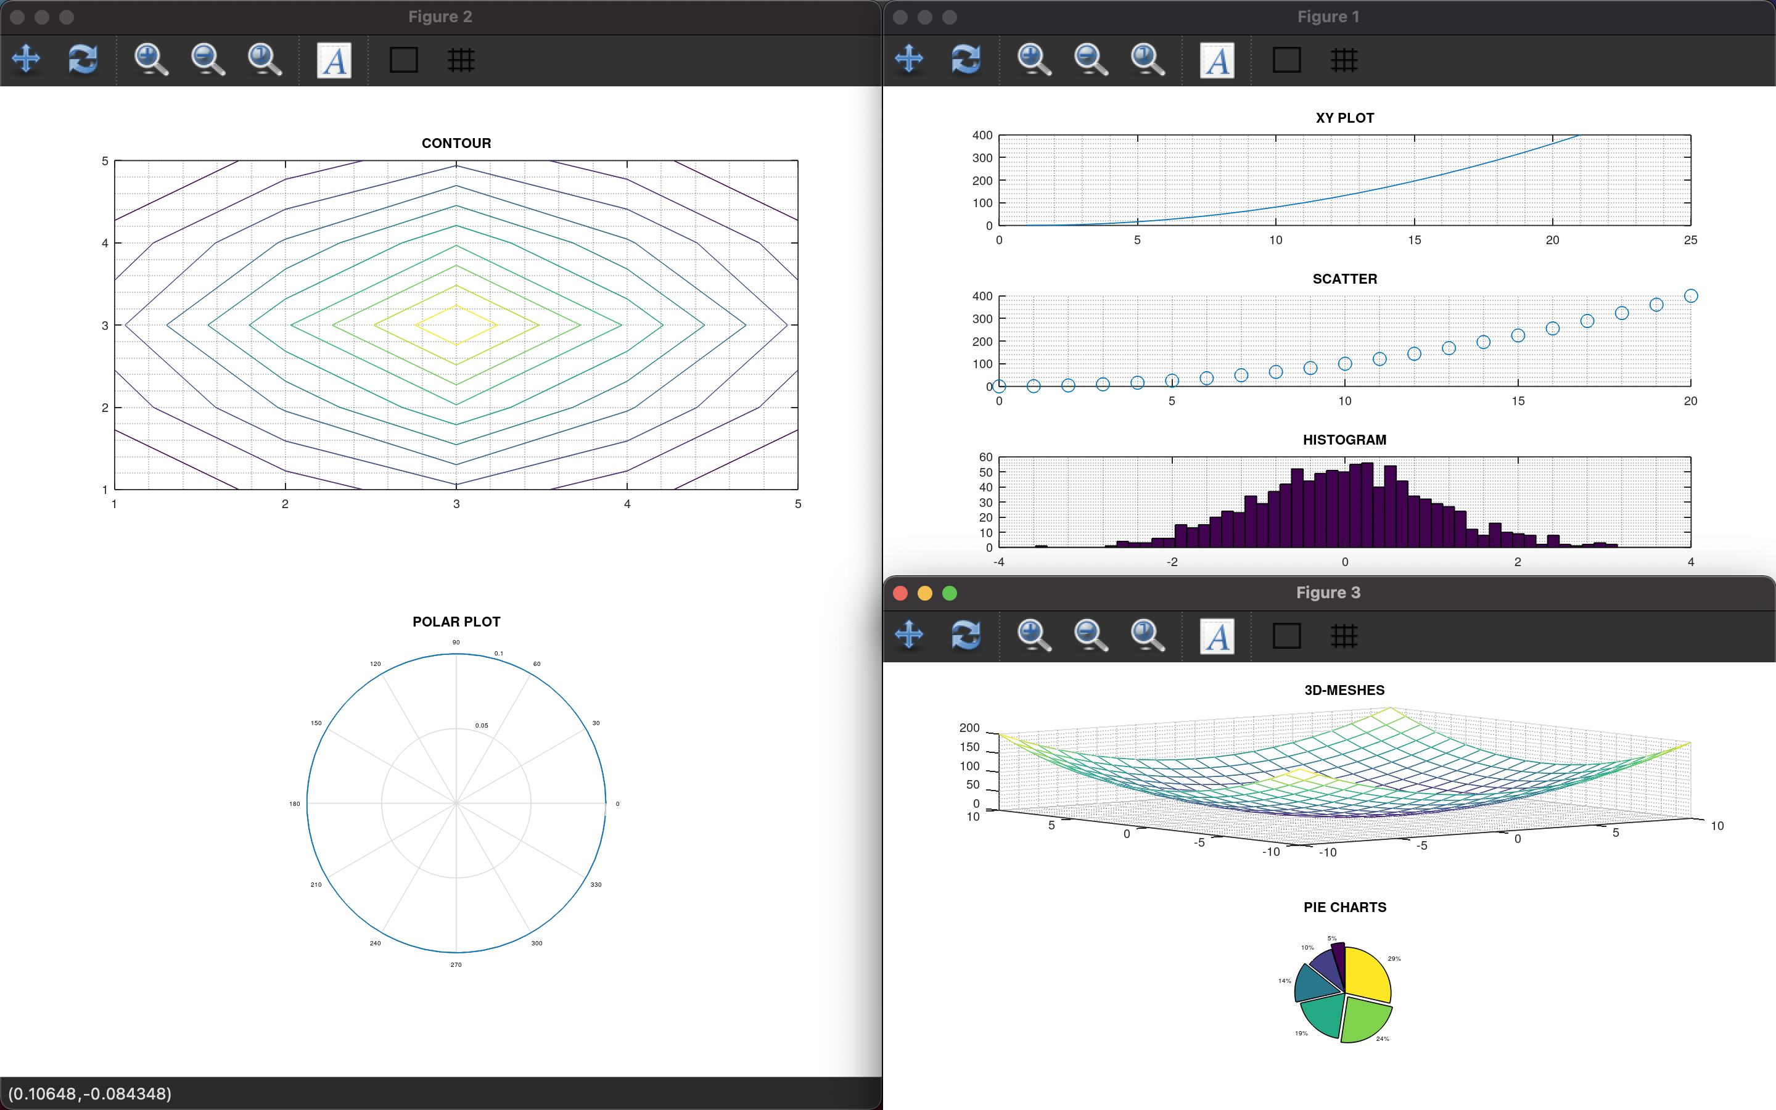

From the tutorial that I chose the description provided was, “This is tutorial looking at how to use the main graphing function Octave provides” Since most of the assignments we have went over in class went over plotting data I thought understanding the way Octave’s graphing functions worked was important. This tutorial went over how to use six main graphing functions, and these were XY PLOT, SCATTER, HISTOGRAM, 3D MESHES, PIE CHARTS, CONTOUR, and POLAR PLOT. I found it very helpful that before any coding began there was an informative slide on all six of the functions. One thing that really helped me was using and learning how to simply create figures, subplots, and appropriate labeling for graphs. When I really became comfortable with those skills, I was able to generate windows like you see above providing a more professional and simpler look. Some examples of that code looked like this.

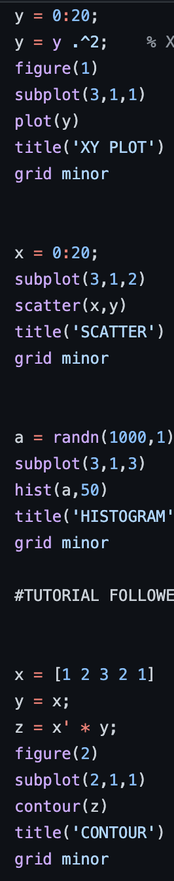 This code is what I meant when learning how to create a figure which would be a new window and by adding subplot you would be able to put 3 separate graphs on one window. Xlabel and Ylabel would be used to as you could probably imagine label the x and y axis. Title was used to create a header for whichever graph you were working with and however you decided to plot the data would come after. (This code on the LEFT is from the smoother/salter program in the same GitHub repository I just wanted to show how setting up figures worked.) With the code on the RIGHT, (this code is from the Octave Tutorial code which is what produced the output images above), you can tell it is a similar setup as the code on the left but with this code I was creating multiple figures throughout the tutorial. You can also visualize from the code that each graphing function used its own syntax for the graph to be created for example contour(z) was used to create a contour graph using the value of z. Also, hist (a, 50) which was used to create a histogram using the randn function to initialize ’a’ as a random number.