Salter Smoother Report Santino Celebre

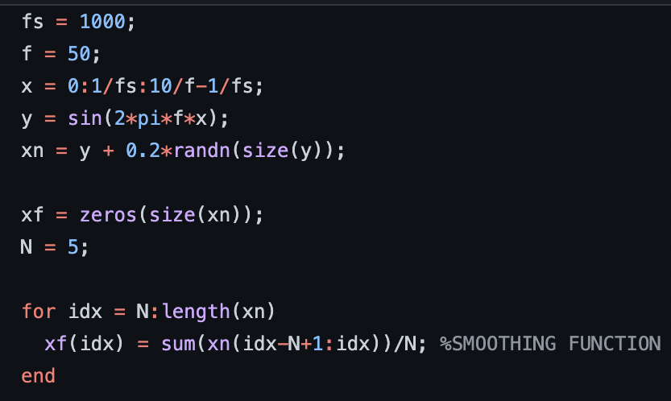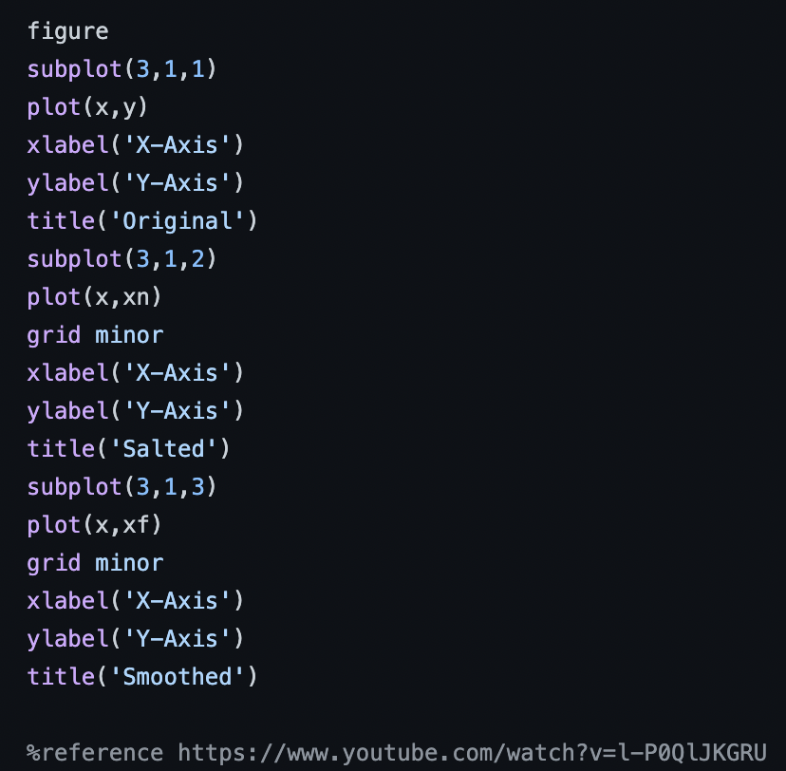

To start we had to initialize some variables to be able to plot some of this data and in total all the initializing was done in this segment of code. X and Y are used to plot regular data which down below is labeled “Original”. When salting the data xn = y + 0.2\*randn(size(y)) was used and when plotting that data, it was labeled “Salted” down below. Lastly, when salting the data, we initialized a new variable xf and after looping through the length of xn and doing some simple math we were able to come out with the output below labeled “Smoothed”. Similar to the Octave Tutorial I was able to use some of the skills learned from plotting data such as creating figures labels and subplots. And after going through this assignment, I was able to understand the for-loop application in Octave as well as how math functions worked in some equations.

