Bangmetric
Q1) difference between stack and heap memery ??
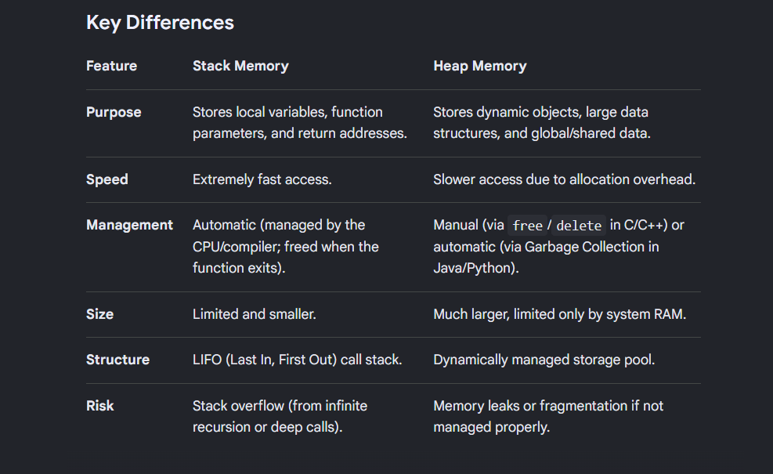

Q2)Types of Memory in cpp ?
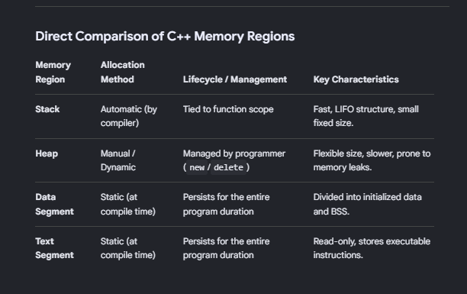

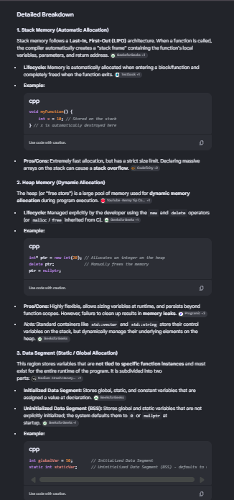
Q3)Struuct vs class
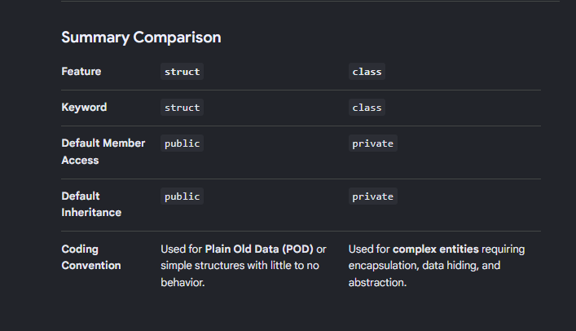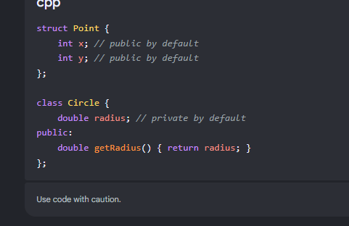

Q) what is virtual Function ?
A virtual function in C++ is a member function declared within a base class using the virtual keyword, which you expect to redefine (override) in derived classes. [1, 2]
Its primary purpose is to achieve runtime polymorphism (also called late binding or dynamic dispatch). It ensures that when you call a function using a base class pointer or reference, C++ executes the overridden version in the actual derived object rather than the base class version. [1, 2, 3]
Q)what is Pure Virtual Function ?
A pure virtual function (sometimes called an abstract function) in C++ is a virtual function that has no implementation in the base class and is assigned a value of 0 in its declaration.
Its primary purpose is to define an interface or a mandatory "blueprint" that all derived classes must implement.
class Base { public: virtual void draw() = 0; // Pure virtual function };

Main Differences: Virtual vs. Pure Virtual
Feature | Virtual Function | Pure Virtual Function
Declaration Syntax | virtual void func() {} | virtual void func() = 0;
Implementation | Has a body in the base class. It serves as a default fallback. | Has no body in the base class (with rare syntax exceptions).
Derived Class Duty | Overriding is optional. If skipped, the base version is used. | Overriding is mandatory to create a concrete object.
Impact on Base Class | Class can be instantiated normally. | Class becomes abstract and cannot be instantiated.
Note) Abstract class called if there is atleast one pure virtual function

Q)What is static and dynamic copy ?
A static copy occurs when you duplicate an object whose exact type is known at compile-time. C++ resolves the memory allocation and calls the copy constructor or copy assignment operator directly based on the static type declared in the code.
Stack or direct heap allocation: Typically used when cloning objects directly (e.g., Obj b = a;).
A dynamic copy occurs when you need to duplicate an object through a base class pointer or reference, where the true, derived type of the object is only known at runtime. Because C++ constructors cannot be virtual, you must use a virtual method (traditionally named clone()) to dynamically allocate and copy the exact runtime object.

Q14: Difference between static and non-static members?
The primary distinction lies in ownership—static members belong to the class, while non-static members belong to individual objects.
Feature | Static Members | Non-Static Members (Instance Members)
Ownership | Belong to the class as a whole. | Belong to a specific instance (object) of the class.
Memory Creation | Allocated once when the program starts. | Allocated every time a new object is instantiated.
Access Method | Can be accessed using the class name (ClassName::member). | Can only be accessed via an object (object.member).
The this Pointer | Do not have access to the implicit this pointer. | Have full access to the implicit this pointer.
Storage Area | Stored in the global/static memory segment. | Stored on the stack or heap (depending on how the object is made).

