The Secret Behind AI Learning Machines
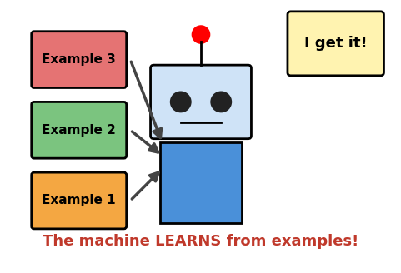
A machine learns by looking at many examples.

1. What is AI?
AI means Artificial Intelligence. 'Artificial' means made by people, not by nature. 'Intelligence' means the power to think, learn and solve problems.
So, AI is a computer or machine that can do smart things that humans normally do, like understanding speech, recognising pictures and answering questions.

Normal machine vs AI machine
Type | What it does
Normal machine | Follows fixed instructions and never gets smarter. Example: a calculator, a fan.
AI machine | Learns from examples and improves with practice. Example: a voice assistant, a photo app that finds faces.

Remember: AI is not magic and it has no feelings. It is a computer program that learns patterns.

2. The Big Secret: Learning from Examples
The secret behind AI learning machines is: they learn from MANY EXAMPLES, just like you do!
When you were small, you saw many cats and your family said, 'This is a cat.' After seeing lots of cats, you could spot a new cat even if you had never seen it before.
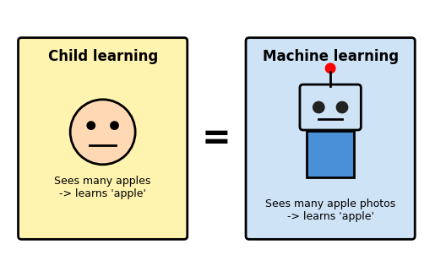
A child and a machine both learn by seeing many examples.
AI does the same. We show the machine thousands of cat photos and dog photos. It notices what is common in each group, like pointy ears or floppy ears. This is called a pattern.
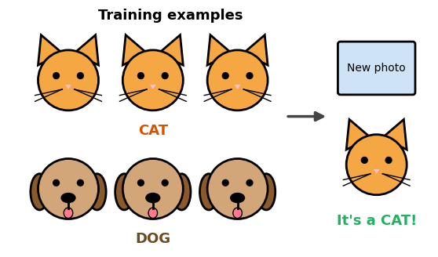
After training, the machine can name a new photo.

The 3 secret ingredients
- Data: the examples we give the machine (photos, words, sounds, numbers).
- Patterns: things that repeat in the data. The machine finds them by itself.
- Practice: the machine tries again and again and makes fewer mistakes each time.

Remember: More good examples make a smarter machine. This way of learning is called Machine Learning.

3. How a Machine Learns: 5 Easy Steps
Let us see how a machine learns to tell a cat from a dog.
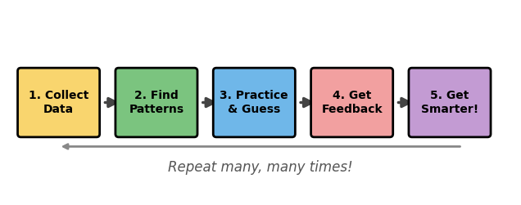
The five steps repeat many, many times.
- Step 1: Collect data. People collect many photos and write the correct name on each one (Cat or Dog). These names are called labels.
- Step 2: Find patterns. The machine looks at all the photos and finds clues like ear shape, nose, whiskers and size.
- Step 3: Practice and guess. The machine looks at a photo and makes a guess: 'I think this is a dog.'
- Step 4: Get feedback. We tell it whether the guess was right or wrong. If wrong, it fixes itself a little.
- Step 5: Get smarter. After doing this many, many times, the machine makes very few mistakes.

Remember: Learning = Guess, Check, Fix, Repeat. It is just like practising your maths sums!

4. The Machine's Brain: Neural Network
Your brain has billions of tiny cells called neurons. They pass messages to each other so you can think and learn.
Scientists copied this idea to make an artificial neural network: a computer program with many small 'artificial neurons' joined together in layers.
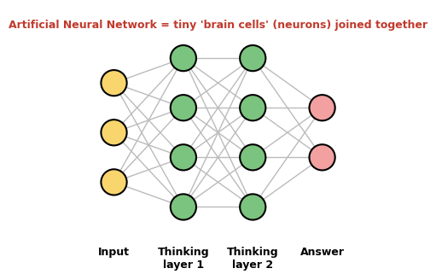
Information flows from the input to the answer.
- Input layer: takes in the information, for example a picture of an animal.
- Thinking layers: many neurons work together to look for clues and patterns.
- Output layer: gives the final answer, for example 'Cat'.
Each connection has a number called a weight. While learning, the machine keeps changing these weights a little so its answers become more correct. That is the real 'learning'!
Remember: A neural network is like a team of tiny helpers. Each one looks at a small clue, and together they find the answer.

5. Practice Makes Perfect
At the beginning, an AI machine makes many mistakes. After each round of practice, it gets a little better.
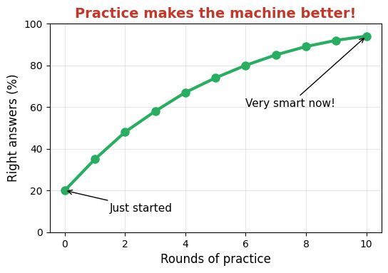
Example graph (made-up numbers to explain the idea).
Remember: The graph goes up because the machine learns from its mistakes.

6. AI in Real Life
You already use AI almost every day! Here are some places where machines have learned from lots of examples.
Where we see it | What the AI learned | How it helps us
Voice assistant | How people speak, from many voices. | Answers questions and plays songs.
Phone camera | What faces look like. | Focuses on faces and clears photos.
Video apps | What videos people like. | Suggests videos you may enjoy.
Google Maps | Patterns of traffic. | Shows the fastest road.
Language translator | From millions of sentences. | Changes words from one language to another.
Self-driving car | From many road pictures. | Spots signals, people and vehicles.
Doctor's helper | From many X-ray pictures. | Helps doctors find illness early.

Think: AI is a helper for humans. Humans decide how to use it. Always use AI in a safe and kind way.

7. Key Words
Word | Easy meaning
Artificial Intelligence | A machine that can do smart things like humans.
Machine Learning | Teaching a machine using many examples.
Data | Information such as photos, words, sounds or numbers.
Pattern | Something that repeats again and again.
Label | The correct name written on an example (like 'Cat').
Training | Showing examples to a machine so it can learn.
Prediction | The machine's guess or answer.
Feedback | Telling the machine if it was right or wrong.
Neuron | A tiny brain cell that passes messages.
Neural Network | Many artificial neurons joined together to learn.
Algorithm | A set of step-by-step instructions for a computer.

8. Quick Summary
- AI means Artificial Intelligence: machines that can do smart things.
- The secret of AI learning is learning from many examples.
- Machines find patterns in data and practise again and again.
- Feedback helps the machine fix its mistakes and get smarter.
- A neural network copies the idea of the human brain.

9. Quiz Time!
Circle the correct answer.
- AI stands for: A) Auto Internet B) Artificial Intelligence C) All Information
- What is the secret behind machine learning? A) Magic B) Learning from many examples C) Sleeping
- A 'pattern' is something that: A) repeats again and again B) is broken C) is very big
- The correct name written on a photo is called a: A) Label B) Pattern C) Weight
- Telling the machine if its guess was right or wrong is: A) Data B) Feedback C) Neuron
- A neural network is inspired by the human: A) Heart B) Brain C) Hand
- When a machine practises more, it usually becomes: A) Worse B) Smarter C) Slower
- Which one uses AI? A) A voice assistant B) A ceiling fan C) A pencil
Think and write in your notebook: Name two places where you have seen AI at home or school.

Answer key (for teachers/parents)
1-B, 2-B, 3-A, 4-A, 5-B, 6-B, 7-B, 8-A

Crack the Logic: Command to Creation
Communicating with AI | Class 5
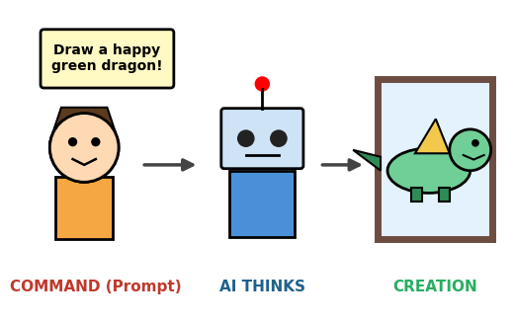
You give a command. The AI thinks. Then it creates something for you.

1. Talking to AI
When you talk to a friend, your friend understands your face, your voice and your feelings. An AI machine is different. It only understands the words that you type or say to it.
The words you give to AI are called a command or a prompt. What the AI makes for you is called the creation.
AI can help you to create many things: stories, poems, pictures, quiz questions, riddles and answers to your questions.

The simple logic
1. Command | 2. AI thinks | 3. Creation
You give a clear command (prompt). | AI looks at your words and finds patterns it has learned. | AI makes a story, picture, answer or idea for you.

Remember: Good command = good creation. You are the boss who tells the AI what to do!

2. AI Follows Words, Not Your Mind
AI cannot read your mind. It does exactly what your words say, in the order you say them. This is the logic of commands.
Think about making a sandwich. If the steps are in the wrong order, you get a mess! Computers follow steps one by one, so the order of your instructions matters.
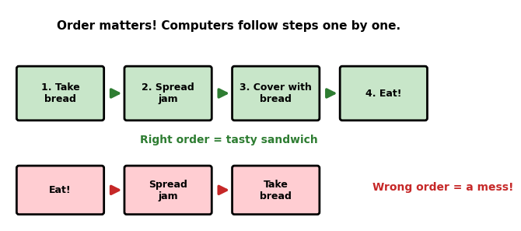
Right order gives the right result.

Unclear command vs clear command
If your command is too short or too vague, the AI has to guess. Look at the two examples below.
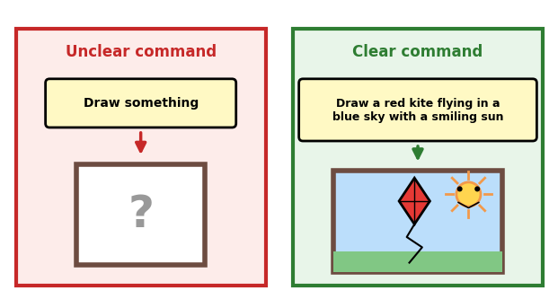
The clearer the command, the closer the creation is to your idea.
Unclear command | Clear command
Write a story. | Write a 5-line story about a brave mouse who saves a village.
Draw something. | Draw a red kite flying in a blue sky with a smiling sun.
Tell me about animals. | Tell me 3 interesting facts about elephants in simple words.

Remember: AI can only use what you tell it. Give clear details and the right order of steps.

3. The Command Recipe
A good command is like a recipe. It has 4 building blocks. You do not always need all four, but more blocks give a better creation.
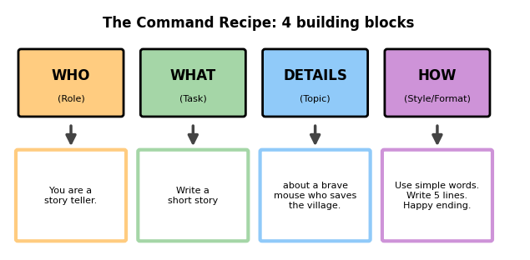
Mix the four blocks to make a powerful command.
- WHO: tell the AI what role to play, like a teacher, a story teller or a friend.
- WHAT: tell the AI the task, like write, draw, explain or make a quiz.
- DETAILS: give the topic, names, places and other important facts.
- HOW: tell the style and size, like simple words, 5 lines, funny, or a list.

Full example
Command: You are a story teller. Write a 5-line story about a brave mouse who saves a village. Use simple words and end with a happy ending.

Remember: WHO + WHAT + DETAILS + HOW = a clear command!

4. Try, Check, Improve
Your first command may not give a perfect result, and that is okay! Smart creators try, check the answer, and improve the command. This is called refining.
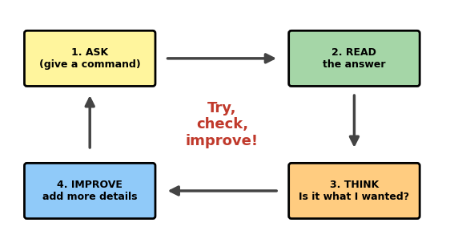
Keep improving your command until you are happy.

Example of improving
Try | Command
First try | Write a poem.
Better | Write a poem about rain.
Best | Write a funny 4-line poem about rain for 5th standard students. Use easy words.

Remember: If the answer is not what you wanted, do not give up. Change your command and ask again!

5. Use AI Safely and Wisely
AI is a great helper, but we must use it carefully. AI can also make mistakes, so we must always think and check.
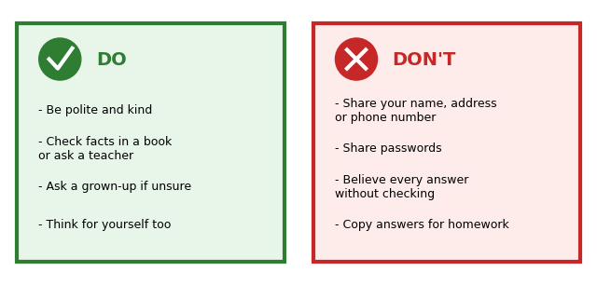
Safe AI habits.
- AI can be wrong. Check important facts in your textbook or ask your teacher.
- Keep private things private. Never type your address, phone number, passwords or school details.
- Be kind. Use polite words, and never use AI to hurt or tease anyone.
- Do your own thinking. Use AI to help you learn, not to copy your homework.
- Ask a grown-up if you are not sure about something.

Think: AI is a tool and you are the thinker. Your brain is the most important part!

6. Fun Commands to Try
Try these with the help of a teacher or a parent.
I want to... | Example command
Learn something | Explain how a rainbow is made in simple words for a 10-year-old.
Write a story | Write a funny 6-line story about a robot who is afraid of the dark.
Make a quiz | Make 5 easy multiple-choice questions about the solar system.
Get a picture idea | Describe a colourful picture of a village in the mountains at sunrise.
Solve a riddle | Give me 3 easy riddles about animals with their answers.
Check my work | Check my paragraph about my pet and tell me one thing to improve.

7. Key Words
Word | Easy meaning
Command / Prompt | The words you give to an AI to tell it what to do.
Creation | What the AI makes for you, like a story or picture.
Logic | Thinking step by step in the right order.
Instruction | A clear step that tells what to do.
Detail | Extra information that makes a command clearer.
Role | The part you ask AI to play, like a teacher.
Refine | To improve your command after checking the answer.
Fact-check | Making sure information is true by using books or teachers.
Privacy | Keeping your personal information safe.

8. Quick Summary
- A command (prompt) is the words you give to AI.
- AI follows your words in order, so be clear and give steps.
- Use the recipe: WHO + WHAT + DETAILS + HOW.
- Try, check and improve your command.
- Always check facts, stay safe and be kind.

9. Quiz Time!
Circle the correct answer.
- The words we give to AI are called a: A) Prompt B) Picture C) Plug
- What the AI makes for us is called the: A) Command B) Creation C) Computer
- Which command is clearer? A) Draw something B) Draw a red kite in a blue sky
- In the command recipe, 'WHO' means: A) The role AI plays B) The size of the answer C) The colour
- If the AI answer is not good, you should: A) Give up B) Improve your command C) Shout
- AI can make mistakes, so we should: A) Check important facts B) Believe everything C) Never use it
- Which should you NEVER type into an AI? A) Your favourite colour B) Your phone number and password C) A topic for a poem
- Why does the order of instructions matter? A) It does not matter B) Computers follow steps one by one C) AI likes numbers

Activity: Write your own command
Use the recipe to write a command in your notebook that asks AI to create a short poem about your school. Write WHO, WHAT, DETAILS and HOW.

Answer key (for teachers/parents)
1-A, 2-B, 3-B, 4-A, 5-B, 6-A, 7-B, 8-B

AI in the Classroom and AI in the Hospital
AI Applications | Class 5
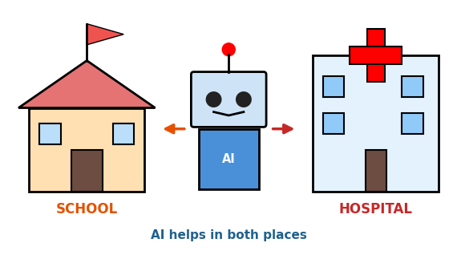
AI is a helper in many places, like schools and hospitals.

1. What is an AI Application?
An application means a use. An AI application is a real job that an AI machine does to help people.
In earlier notes we learned that AI learns from many examples and finds patterns. Now we will see how that learning is used in two important places: our classroom and the hospital.
Place | Who is helped? | What AI learned from
Classroom | Students and teachers | Many questions, answers, words and books
Hospital | Patients and doctors | Many X-ray pictures, health records and numbers

Remember: AI does not work alone. It is a helper that makes the work of teachers and doctors easier.

2. AI in the Classroom
A teacher has many students, and every student learns in a different way. Some learn fast and some need more time. AI can help each student learn in the way that suits them. This is called personalised learning.
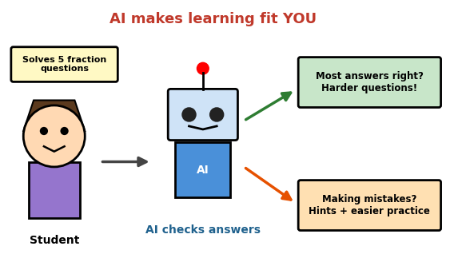
The AI checks answers and changes the questions to fit the student.
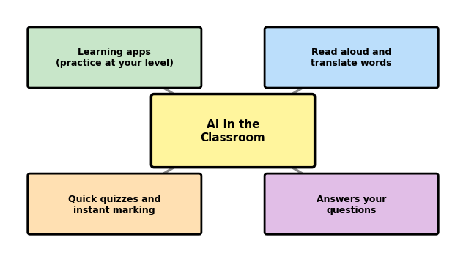
Ways AI helps in the classroom.
- Learning apps: give questions at your level. If you do well, they give harder ones. If you struggle, they give hints.
- Read aloud and translate: AI can read a lesson aloud or change words from one language to another.
- Quick quizzes: AI can mark answers in seconds, so the teacher has more time to teach.
- Answering questions: AI can explain a topic in simple words when you ask.

Remember: AI helps us learn, but the teacher is still the guide who understands you best.

3. AI in the Hospital
Doctors and nurses look after many patients and have to study many reports. AI can learn from thousands of past medical pictures and records. It helps doctors notice problems early.
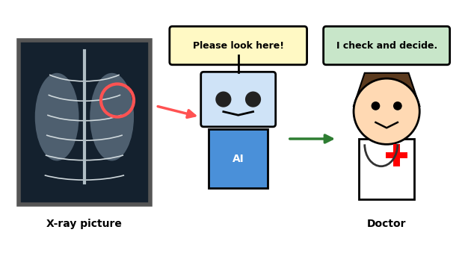
AI points to a place that needs a closer look. The doctor makes the final decision.
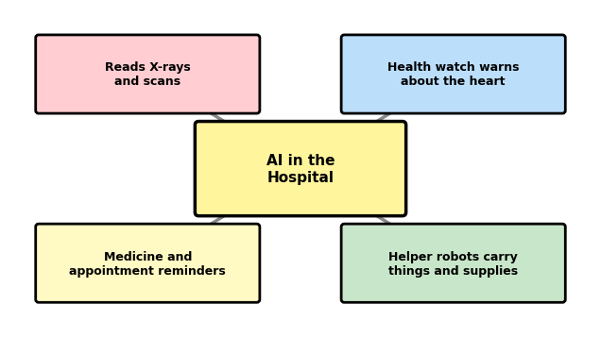
Ways AI helps in the hospital.
- Reading scans: AI can look at X-rays and notice tiny signs that are easy to miss.
- Health watches: they check the heartbeat and warn if something looks unusual.
- Reminders: AI can remind patients to take medicine and to visit the doctor.
- Helper robots: they carry supplies and medicines so nurses can spend more time with patients.

Remember: AI can suggest, but only the doctor decides. Doctors look at the whole patient, not just a picture.

4. Classroom vs Hospital
 | AI in the Classroom | AI in the Hospital
Main helper job | Helps students practise and learn | Helps doctors find and treat illness
Example | A maths app that changes questions | An AI that checks X-ray pictures
Learns from | Questions, answers, books | Scans, records, health numbers
Final decision by | Teacher | Doctor
Biggest benefit | Learning that fits each student | Finding problems early

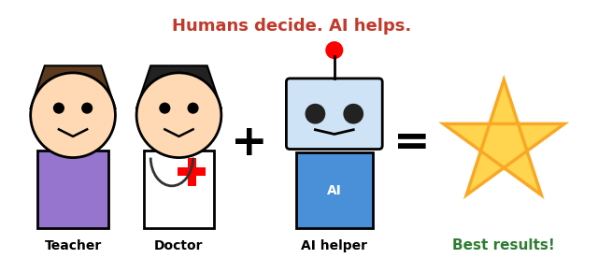
Humans and AI work best as a team.
Remember: AI + Teacher or Doctor = better results. AI does not replace caring people.

5. Using AI Safely and Fairly
When AI is used in schools and hospitals, we must be extra careful because it deals with important things in people's lives.
- AI can make mistakes. That is why a teacher or doctor must always check important results.
- Privacy matters. Students' marks and patients' health reports are private. They must be kept safe and never shared without permission.
- Be fair to everyone. AI should help all students and all patients equally, whatever their language, gender or background.
- Keep thinking. Use AI to learn better, not to copy answers or skip your own thinking.
- Humans care. A machine cannot give a hug or understand feelings the way a teacher, a nurse or a parent can.

Think and discuss
1. How would an AI helper change your learning at school?
2. Why should a doctor always check what the AI says?
3. Name one more place where AI could help people.
Think: AI is a powerful tool, and we must use it with care, kindness and honesty.

6. Key Words
Word | Easy meaning
Application | A use of something. An AI application is a job AI does to help people.
Personalised learning | Learning that is changed to fit each student.
Scan / X-ray | A medical picture of the inside of the body.
Patient | A person who is getting medical care.
Diagnosis | Finding out what illness a person has.
Health record | A file with a person's health information.
Privacy | Keeping personal information safe.
Fairness | Treating everyone equally.
Translate | To change words from one language to another.

7. Quick Summary
- An AI application is a real job that AI does to help people.
- In the classroom, AI gives personalised practice, reads aloud, translates and marks quizzes.
- In the hospital, AI helps read scans, watch the heart and send reminders.
- Teachers and doctors make the final decisions, and AI is the helper.
- We must keep data private, be fair and always check AI's results.

8. Quiz Time!
Circle the correct answer.
- An AI application is: A) A real job AI does to help people B) A type of fruit C) A school bag
- Learning that is changed to fit each student is called: A) Personalised learning B) Playing C) Copying
- In the classroom, AI can: A) Mark quizzes quickly B) Replace the school C) Eat lunch
- AI in hospitals can help doctors by: A) Cooking food B) Noticing signs in X-ray pictures C) Playing music
- Who makes the final decision about a patient's treatment? A) AI B) The doctor C) The computer mouse
- Why must students' marks and patients' reports be kept private? A) They are personal information B) They are boring C) They are heavy
- What happens when a student gets most answers right in a learning app? A) The app stops B) The app gives harder questions C) The app turns off
- AI works best when it: A) Works alone B) Works as a team with humans C) Is never checked

Activity: Draw and write
Draw a picture of an AI helper in your classroom. Write 3 lines on how it helps you and your teacher.

Answer key (for teachers/parents)
1-A, 2-A, 3-A, 4-B, 5-B, 6-A, 7-B, 8-B

My Future with AI: Skills of Tomorrow
AI and Careers | Class 5
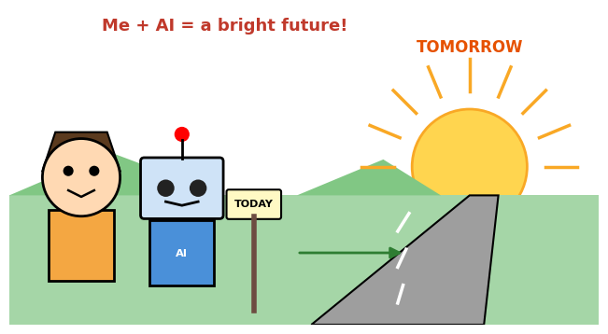
Today you learn. Tomorrow you create the future with AI as your helper.

1. The World is Changing
Long ago, people did not have phones, computers or the internet. Each new invention changed the way people lived and worked. Today, AI is one of those new inventions.
When you grow up, AI will probably be a part of almost every job, just like computers are today. Many things will be different, but the good news is that you have time to get ready.
Then | Now | Tomorrow
Searching books in a library | Searching on the internet | Asking AI helpers and checking the answers
Writing letters by hand | Sending messages on phones | Talking to smart helpers in many languages

Remember: The future is not something that just happens to us. We help to build it!

2. Jobs of Tomorrow
Will AI take away all jobs? No. Experts believe that AI will change many jobs. Some boring and repeated tasks may be done by machines, and many new kinds of jobs will be created. People who know how to work with AI will have a big advantage.
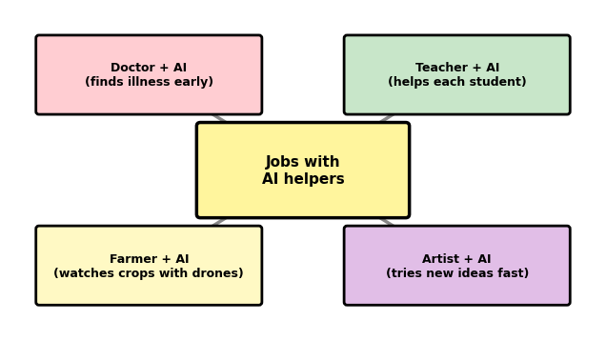
In the future, people will work together with AI helpers.
Job | How AI may help | Skill the person needs
Doctor | Checks scans and finds illness early | Caring, careful thinking
Teacher | Gives each student practice at their level | Patience, good communication
Farmer | Drones and sensors watch the crops | Understanding nature and technology
Artist | Gives quick ideas to try | Imagination and creativity
Engineer | Tests designs on a computer | Problem solving, maths

New jobs that may be common
- AI trainer: teaches AI by giving it good examples.
- Robot engineer: designs and repairs helpful robots.
- App designer: makes apps and games that people enjoy.
- Data scientist: finds useful patterns in lots of information.

Remember: Many jobs will change, and new ones will appear. Learning never stops!

3. Skills of Tomorrow
Whatever job you choose, these six skills will help you. Machines can do many tasks, but these skills make you special.
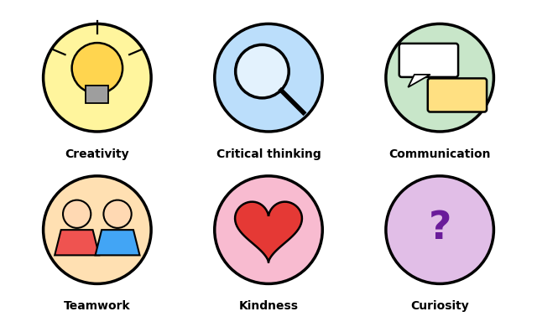
Six skills to practise from today.
- Creativity: thinking of new ideas, stories and ways to solve problems.
- Critical thinking: asking 'Is this true?' and checking before believing.
- Communication: explaining your ideas clearly and listening to others.
- Teamwork: working well with friends, even when you disagree.
- Kindness: caring for others' feelings. Machines cannot truly feel this.
- Curiosity: asking questions and wanting to learn new things.

Remember: Keep your heart kind and your mind curious!

4. What AI Does Best and What Humans Do Best
AI and humans are good at different things. When we understand this, we can work together as a great team.
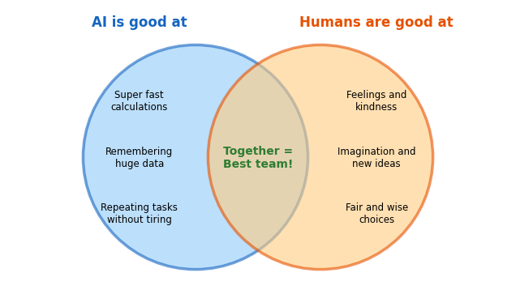
AI and humans are stronger together.
AI is good at | Humans are good at
Doing calculations very fast | Understanding feelings
Remembering lots of information | Imagining new things
Repeating the same task again and again | Making fair and wise choices
Finding patterns in large data | Caring for others

Remember: AI is a tool. Humans decide how to use it, so the human mind is the boss.

5. How to Grow Your Skills
You do not need to wait until you are grown up. You can start building skills of tomorrow today. Think of it as climbing a staircase, one step at a time.
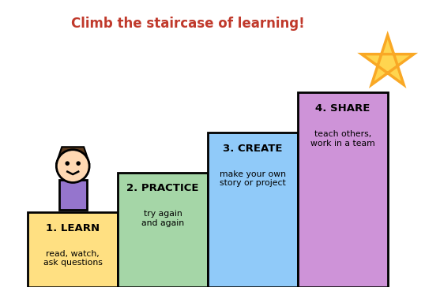
Learn, practise, create and share.

Good habits to start now
- Read every day: stories, science and news for children.
- Practise maths and logic puzzles: they train your thinking.
- Ask questions: 'Why?' and 'How?' are powerful words.
- Try making things: draw, write, build models or try simple coding games.
- Play and work in teams: sports, group projects and school events.
- Use AI wisely: with a teacher or parent, to learn, never to cheat.

Think: Small steps every day take you to big dreams!

6. Be a Responsible AI Citizen
A citizen is a member of a community. As AI becomes part of our community, we should use it in the right way.
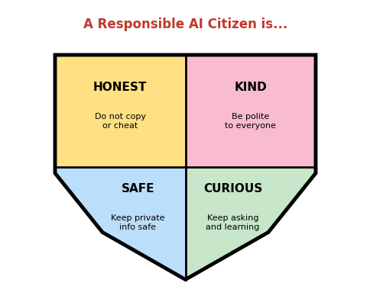
Four values that protect you and others.
- Honest: do your own work and give credit to your sources.
- Kind: never use AI to tease, trick or hurt anyone.
- Safe: do not share your name, address, school details or passwords.
- Curious: check facts, ask why and keep learning.

Think: With great tools comes great responsibility.

7. My Future Me
Fill in this table in your notebook or on this page. There are no wrong answers!
Question | My answer
My dream job is...
AI could help me in this job by...
Two skills I need are...
One thing I will do this week to grow my skills is...
A kind way I will use AI is...

Draw a picture of yourself at work in the future with your AI helper.

8. Key Words
Word | Easy meaning
Career | The work or job a person does for many years.
Skill | Something you can do well because you learned and practised.
Creativity | Thinking of new and original ideas.
Critical thinking | Checking and thinking carefully before believing something.
Teamwork | Working together to reach a goal.
Curiosity | A strong wish to learn and know more.
Technology | Tools and machines made by people to help us.
Citizen | A member of a community or country.
Responsible | Doing the right thing and caring about results.

9. Quick Summary
- AI will change many jobs and create new ones.
- Skills like creativity, critical thinking, communication, teamwork, kindness and curiosity will matter a lot.
- AI is good at speed and data. Humans are good at feelings and imagination.
- You can start growing skills today: learn, practise, create and share.
- Be an honest, kind, safe and curious AI citizen.

10. Quiz Time!
Circle the correct answer.
- Experts believe that AI will: A) Change many jobs and create new ones B) Stop all jobs C) Do nothing
- Which is a skill of tomorrow? A) Creativity B) Throwing stones C) Sleeping late
- Critical thinking means: A) Believing everything B) Checking and thinking carefully C) Being angry
- Which is a human strength? A) Understanding feelings B) Remembering huge data C) Never getting tired
- Which is an AI strength? A) Fair decisions B) Fast calculations C) Kindness
- A good way to grow your skills is to: A) Read and ask questions B) Avoid learning C) Copy others' work
- It is safe to share which information with AI? A) Your password B) A topic for a poem C) Your home address
- In the staircase of learning, what comes after 'Practice'? A) Create B) Learn C) Stop

Activity: My skill poster
Choose one skill of tomorrow. On a chart paper, draw a poster showing why this skill is important and how you can practise it.

Answer key (for teachers/parents)
1-A, 2-A, 3-B, 4-A, 5-B, 6-A, 7-B, 8-A

AI Study Buddy and AI Creative Corner
AI Tools | Class 5
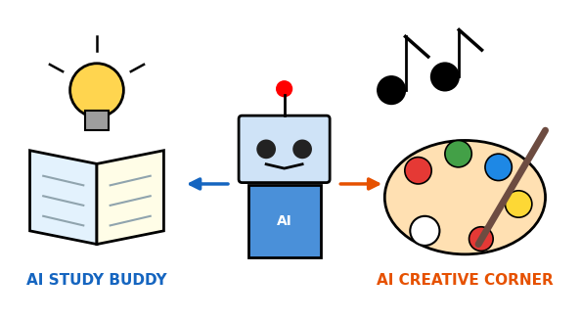
AI tools can help us learn and help us create.

1. What are AI Tools?
A tool is something that helps us do a job. A hammer is a tool for fixing things and a pencil is a tool for writing. An AI tool is a computer program that uses AI to help us do a job.
There are many kinds of AI tools. In these notes we will learn about two very useful kinds: the AI Study Buddy, which helps us learn, and the AI Creative Corner, which helps us create.
AI tool | What it does | Example
Chatbot | Talks with you and answers questions | Asking how a volcano works
Image helper | Gives picture ideas or makes pictures from words | Describing a dragon in a garden
Translator | Changes words from one language to another | Tamil to English
Spelling helper | Finds spelling mistakes while you type | Marking 'recieve' as wrong

Remember: An AI tool is a helper. You are the one who thinks, decides and learns.

2. AI Study Buddy
A study buddy is a friend who studies with you. An AI Study Buddy is an AI tool that helps you understand your lessons. It is always ready to answer your questions, even when you ask the same thing many times, and it never gets tired.
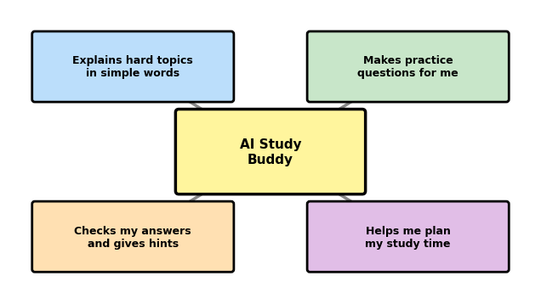
Ways an AI Study Buddy can help.
- Explains simply: if a topic is hard, ask for a simpler explanation or an example.
- Makes practice questions: you can test yourself before an exam.
- Checks answers and gives hints: you learn from your mistakes.
- Plans study time: it can help you make a timetable for the week.

Four steps to use it wisely
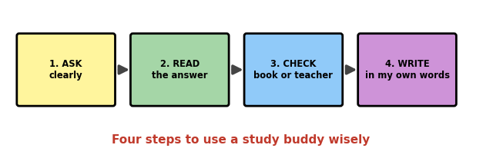
Ask, read, check and write.
I want to... | I can ask like this
Understand a topic | Explain photosynthesis in simple words with an example.
Practise | Give me 5 easy questions on fractions and check my answers.
Learn a word | What does 'habitat' mean? Use it in two sentences.
Plan my study | Help me make a 30-minute study plan for science and maths.

Remember: A study buddy helps you understand. It should never do your learning for you.

3. Smart Use and Not-Smart Use
An AI Study Buddy can make you smarter if you use it the right way. If you use it to skip your work, you learn nothing.
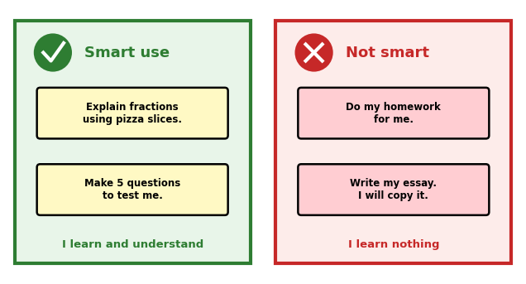
The same tool can help or harm learning, depending on how we use it.

Things to remember
- AI can be wrong. Always check important facts in your textbook or with your teacher.
- Write in your own words. Copying an answer is not learning, and it is not honest.
- Try first. Think about the question yourself before asking for help.
- Ask a grown-up. Use AI tools with the permission of your teacher or parents.

Think: Try first, ask second, check third.

4. AI Creative Corner
Creativity means making something new, like a story, a picture, a poem or a game. An AI Creative Corner is an AI tool that gives you ideas and helps you shape them. It is like a friend who says, 'Here are some more ideas. Which one do you like?'
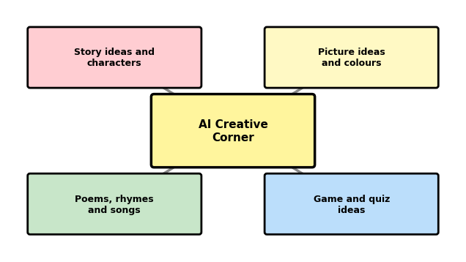
Ways an AI Creative Corner can help.
- Story ideas: characters, places and surprising endings.
- Picture ideas: colours, scenes and drawing suggestions.
- Poems and songs: rhyming words and rhythm.
- Games and quizzes: fun puzzles to share with friends.

Creating together
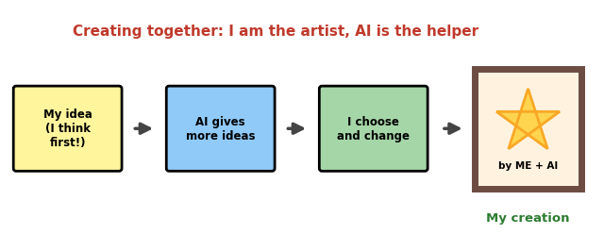
Your idea comes first. Then you choose and change what AI suggests.
I want to... | I can ask like this
Start a story | Give me 3 ideas for a story about a brave girl and a talking tree.
Draw something | Suggest a colourful scene for a village festival that I can draw.
Write a poem | Give me 10 words that rhyme with 'sun' for my poem.
Make a game | Give me 5 riddles about animals for my class game.

Remember: The best ideas are yours. Use AI to get more ideas, then make them your own.

5. Golden Rules for AI Tools
- Ask permission. Use AI tools only with a teacher or parent, and only the tools they approve.
- Keep private things private. Never type your full name, address, phone number, school details or passwords.
- Be honest. Say when you used AI help, and never pretend AI's work is only yours.
- Respect others. Do not make AI create unkind or untrue things about anyone.
- Respect other people's work. Do not copy pictures, stories or songs made by others and call them your own.
- Check before you believe. AI can sound sure and still be wrong.
- Keep a balance. Play outside, read books, and talk with family and friends too.

Think: AI tools are for learning and creating. A kind and honest user makes them better.

6. Try It: Two Missions
Do these with your teacher or parent.

Mission 1: Study Buddy
Step | What I did
The topic I want to learn about
The question I asked
What I understood in my own words
How I checked it (book or teacher)

Mission 2: Creative Corner
Step | What I did
My own idea first
Ideas AI gave me
What I chose and changed
My creation (title)

7. Key Words
Word | Easy meaning
Tool | Something that helps us do a job.
AI tool | A computer program that uses AI to help us.
Study buddy | A helper who studies with you.
Creative | Able to make new and original things.
Idea | A thought or plan.
Check | To make sure something is true or correct.
Honest | Telling the truth and not cheating.
Private | Personal information that should be kept safe.
Permission | Being allowed to do something.

8. Quick Summary
- AI tools are programs that use AI to help us do jobs.
- An AI Study Buddy explains, makes practice questions and checks answers.
- Use it smartly: try first, ask second, check third.
- An AI Creative Corner gives ideas for stories, pictures, poems and games.
- You are the artist. Make the ideas your own, and follow the golden rules.

9. Quiz Time!
Circle the correct answer.
- An AI tool is: A) A computer program that uses AI to help us B) A kind of hammer C) A school bag
- An AI Study Buddy helps you to: A) Understand lessons B) Skip your homework C) Copy answers
- Which is smart use of a study buddy? A) Do my homework for me B) Make 5 questions to test me C) Write my essay so I can copy it
- What should you do with important facts from AI? A) Check them in a book or with a teacher B) Believe them at once C) Ignore them
- An AI Creative Corner gives you: A) Ideas for stories and pictures B) Pocket money C) Marks
- In creating together, who has the idea first? A) The AI B) You C) Nobody
- Which information is safe to share with an AI tool? A) Your address B) Your password C) A topic for a poem
- The 'Try first, ask second, check third' rule means: A) Think yourself before asking AI B) Always ask AI first C) Never check answers

Activity: Make a poster
Make a poster called 'My 5 Golden Rules for Using AI Tools'. Draw one picture for each rule.

Answer key (for teachers/parents)
1-A, 2-A, 3-B, 4-A, 5-A, 6-B, 7-C, 8-A

Can AI Be Wrong? Be a Smart AI User
Responsible AI | Class 5
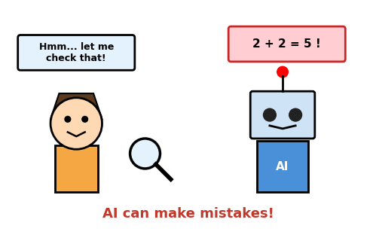
AI can sound very sure and still be wrong. Smart users check.

1. Can AI Be Wrong?
Yes! AI is clever, but it is not perfect. It can make mistakes, just like people do. The big problem is that AI often sounds very confident, even when its answer is wrong.
That is why we must not believe everything an AI says. We should think, check and then trust.

Some mistakes AI can make
Type of mistake | Example
Wrong fact | Saying a spider has 6 legs, when it really has 8.
Made-up answer | Giving the name of a book or a website that does not exist.
Old information | Not knowing about something that happened recently.
Misunderstanding | Giving a good answer to a different question than the one you asked.

Remember: AI can be wrong. Sounding sure does not mean being right.

2. Why Does AI Make Mistakes?
Remember that AI learns from examples. So its mistakes usually come from how it learned.
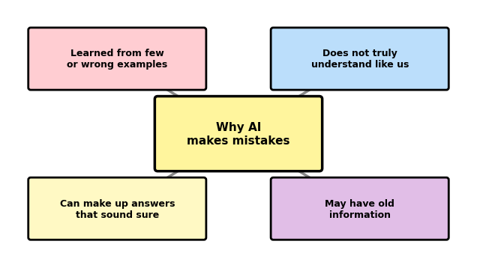
Four reasons why AI can be wrong.
- Few or wrong examples: if AI learned from poor or missing examples, its answers will be poor too.
- No real understanding: AI finds patterns in words and pictures. It does not think and feel like a person.
- Making things up: when AI does not know, it may still give an answer that sounds right but is invented.
- Old information: AI only knows what it learned before. The world keeps changing.

When examples are not fair
Look at the picture. This AI saw only orange cats while learning. When it saw a black cat, it said, 'Not a cat!' The AI was not bad. Its examples were not fair and complete.
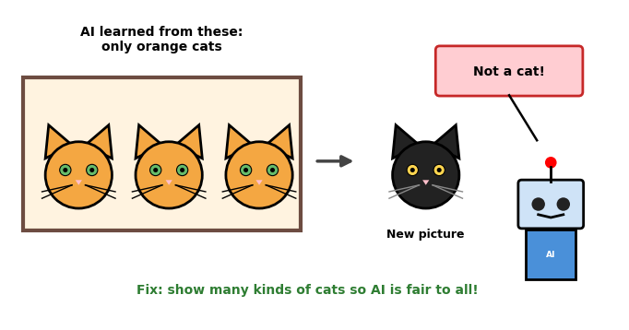
If AI does not see all kinds of examples, it can treat some people or things unfairly.
Remember: Fair examples make a fair AI. People must teach AI with many kinds of examples.

3. Check Before You Trust
When AI gives you an answer, use the traffic light rule: STOP, THINK, CHECK.
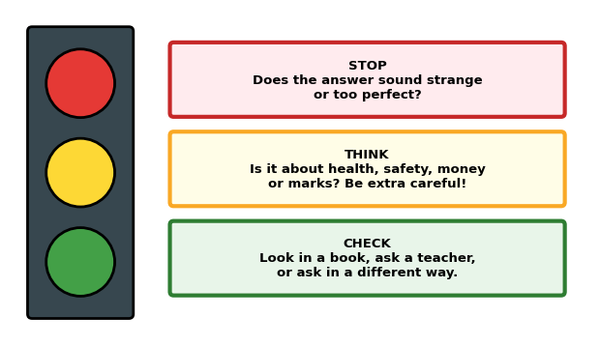
The traffic light helps us decide when to trust an answer.

Ways to check an answer
- Look in a book: your textbook or library book is a good source.
- Ask a teacher or a parent: they can tell you if it is right.
- Ask in another way: if the answers are very different, something is wrong.
- Use trusted sources: with an adult, look at a school or government website.

Think: Be extra careful with answers about health, safety, money and exam marks.

4. Be a SMART AI User
Use the word SMART to remember the five habits of a good AI user.
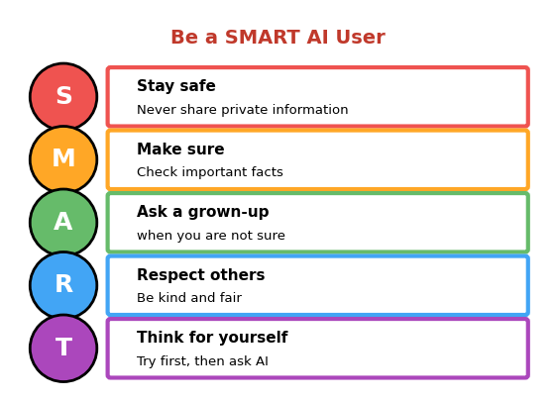
S-M-A-R-T: five habits for using AI well.
- Stay safe: never type your name, address, phone number, school details or passwords.
- Make sure: check the facts that matter before you use them.
- Ask a grown-up: if an answer feels strange, scary or unclear, talk to a teacher or parent.
- Respect others: never use AI to tease, trick or say untrue things about anyone.
- Think for yourself: try the question yourself first. Your brain gets stronger when you use it.

Remember: SMART users are Safe, Make sure, Ask, Respect and Think.

5. You Are the Captain
Responsible AI means using AI in a good and careful way. In every team of human and AI, the human is the captain who makes the final decisions.
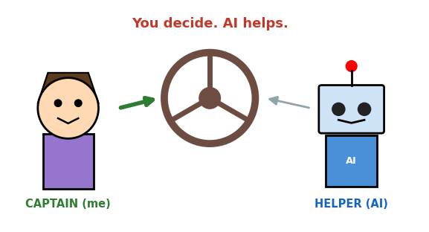
You steer. AI helps.
Value | What it means | Example
Fair | Treat everyone equally | AI should work well for all children
Safe | Protect people and their information | Do not share passwords
Honest | Tell the truth and give credit | Say when AI helped you
Kind | Never hurt anyone | No unkind messages or fake pictures
Human in control | People make the final choices | A doctor decides, not the AI

Think: AI is a powerful helper. A responsible user makes it a force for good.

6. Activity: Spot the Mistake
An AI helper gave these statements. Write R for right or W for wrong, and write how you will check each one. Ask your teacher for help.
AI's statement | R or W | How will I check?
The sun rises in the west.
Water boils at 100 degrees Celsius at sea level.
A spider has 6 legs.
The tiger is the national animal of India.
5 x 6 = 36

Answers are at the end of this document. Try first and check afterwards!

7. Key Words
Word | Easy meaning
Responsible | Doing the right thing and caring about the results.
Mistake | Something that is wrong or not correct.
Fair | Treating everyone equally.
Unfair | Not treating everyone equally.
Check | To make sure something is true or correct.
Trust | To believe that something is reliable.
Private information | Personal details like your address and passwords.
Honest | Telling the truth and not cheating.
Source | A place where information comes from.

8. Quick Summary
- AI can be wrong, even when it sounds sure.
- Mistakes happen because of poor examples, no real understanding, made-up answers and old information.
- Use STOP, THINK, CHECK before trusting an answer.
- Be a SMART user: Safe, Make sure, Ask, Respect, Think.
- Humans are the captains, and AI is the helper.

9. Quiz Time!
Circle the correct answer.
- Can AI be wrong? A) Yes, sometimes B) Never C) Only on Sundays
- AI often makes mistakes because it: A) Learned from poor examples B) Is tired C) Is hungry
- The AI said 'Not a cat!' for a black cat. This shows: A) Black cats are not cats B) Its examples were not complete C) Cats are rare
- In STOP, THINK, CHECK, what does CHECK mean? A) Look in a book or ask a teacher B) Believe the AI C) Close the computer
- Which information should you NEVER share with AI? A) Your favourite colour B) Your home address and passwords C) A topic for a story
- In SMART, the letter 'R' stands for: A) Run B) Respect others C) Repeat
- Who is the captain in a team of a person and AI? A) The AI B) The person C) Nobody
- If AI gives a very strange answer, you should: A) Check it and ask a grown-up B) Believe it C) Share it with everyone

Activity: My SMART pledge
Write one sentence for each letter of SMART about how you will use AI responsibly. Decorate it and put it on your notebook cover.

Answer key (for teachers/parents)
Quiz: 1-A, 2-A, 3-B, 4-A, 5-B, 6-B, 7-B, 8-A
Spot the mistake: 1-W (it rises in the east), 2-R, 3-W (spiders have 8 legs), 4-R, 5-W (5 x 6 = 30).

