**API Documentation Tax Calculator**

All response data will be JSON format

* View All Data

To display and calculate all data please refer to this url : <http://localhost:8080/tax_amount/get_all/>

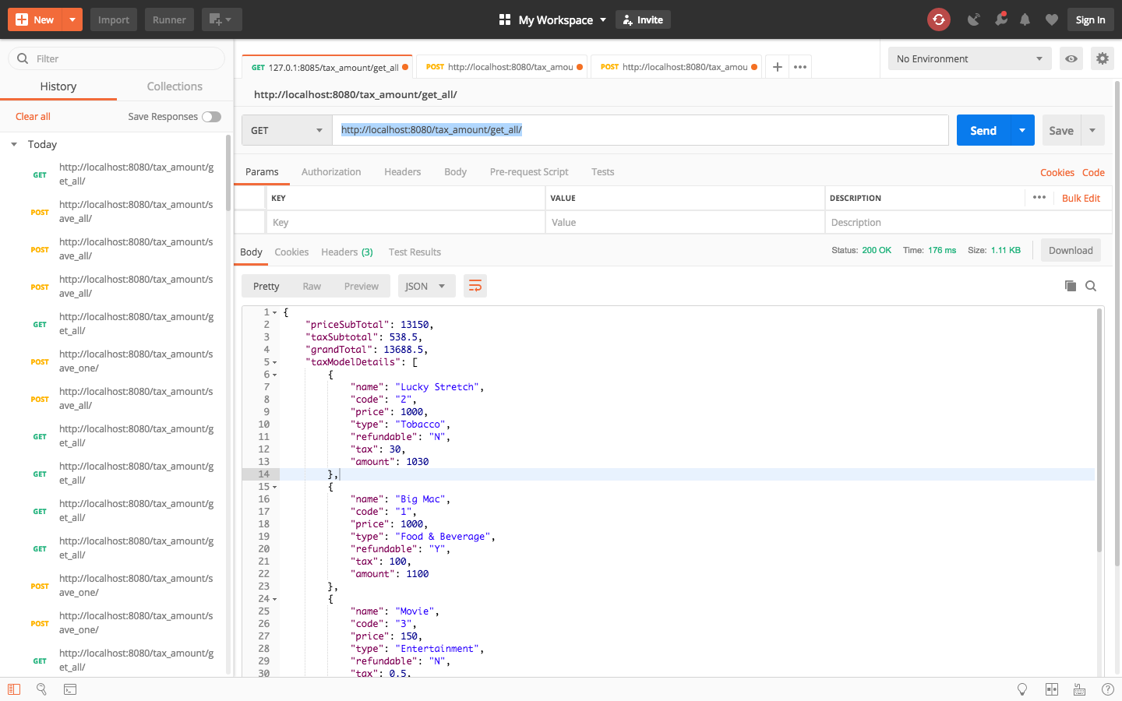

* Save one data

To save one data to database please refer to this url : <http://localhost:8080/tax_amount/save_one/>

*NB: Since “id” is not set to incremental please set it manually and should be different one to another.*

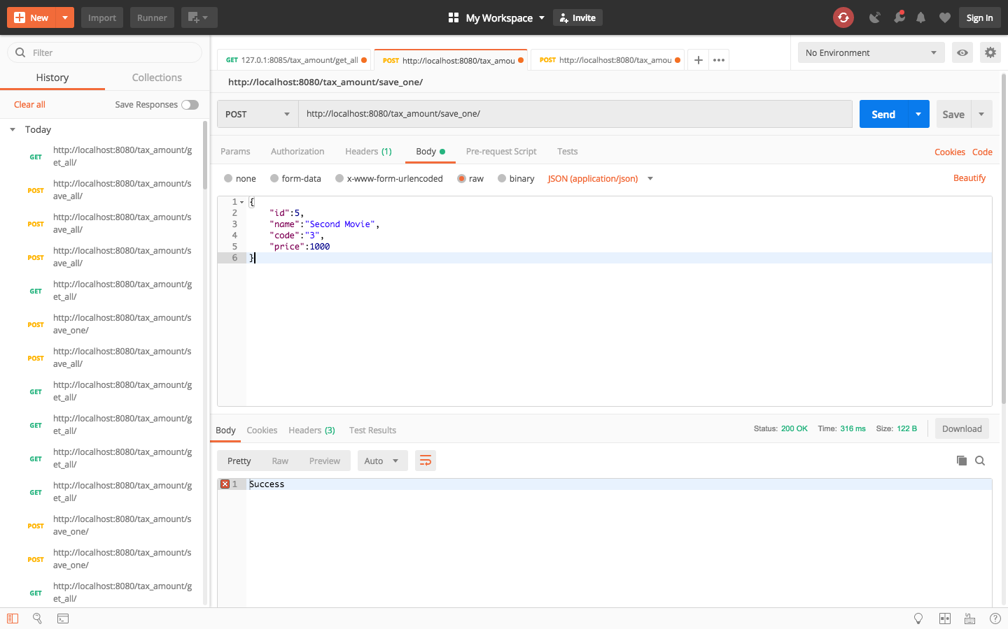

* Sava Multiple Data

To save multiple data to database please refer to this address : <http://localhost:8080/tax_amount/save_all/>

*NB: Since “id” is not set to incremental please set it manually and should be different one to another*

