Reproducible Research - Project 2

## Synopsis

# Data Processing

Include the code to import the csv file and transform the data so that it can be visualized.

library(ggplot2)

## Warning: package 'ggplot2' was built under R version 3.3.3

activity<-read.csv("activity.csv")  
#remove N/A steps  
hact<-activity[is.na(activity["steps"])==FALSE,]  
#Fix Date Field  
#hact[2]<-as.character.Date(hact[2])  
#aggregate the steps per date:  
ag<-aggregate(x=hact[1],by =list(hact$date),FUN="sum")  
names(ag)[1]="dt"  
ag[1]<-as.Date(ag$dt, format="%Y-%m-%d")  
  
#Now figure out the average number of steps for 5 minute intervals  
#per day  
fvmin<-aggregate(x=hact[1],by =list(hact$date),FUN="mean")  
names(fvmin)[1]="date"  
#now aggregate on interval  
intag<-aggregate(x=hact[1],by =list(hact$interval),FUN="mean")  
names(intag)[1]="interval"  
#find interval where the max is

## Including Plots

Histogram for total number of steps

plot(y=ag$steps,x=ag$dt,type="h", main = "Total Steps per Day", ylab = "Total Steps", xlab = "Date")

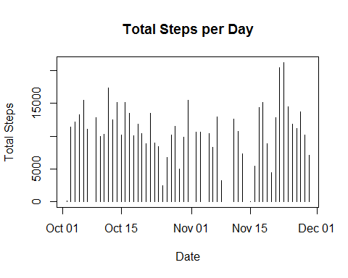

Mean and Median Steps per day

mn<-mean(ag$steps)  
md<-median(ag$steps)  
paste("The mean number of total steps per day is",mn)

## [1] "The mean number of total steps per day is 10766.1886792453"

paste("The median number of total steps per day is",md)

## [1] "The median number of total steps per day is 10765"

# Results

What is the average daily activity pattern?

plot(x=fvmin$date,y=fvmin$steps,type="l",main="Average Number of Steps Per Day",xlab="Date", ylab="Average Steps")  
lines(x=fvmin$date,y=fvmin$steps,type="l")

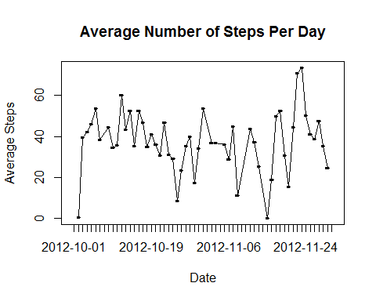

Which 5-minute interval, on average across all the days in the dataset, contains the maximum number of steps?

mx<-intag[intag$steps==max(intag$steps),1]  
  
paste("The maximum number of average steps was at interval",mx)

## [1] "The maximum number of average steps was at interval 835"

Imputing missing values

Note that there are a number of days/intervals where there are missing values (coded as NA). The presence of missing days may introduce bias into some calculations or summaries of the data.

# Calculate number of missing items in the dataset  
  
stepNA<-activity[is.na(activity["steps"])==TRUE,]  
totStepNA<-NROW(stepNA)  
dtNA<-activity[is.na(activity["date"])==TRUE,]  
totDtNa<-NROW(dtNA)  
intNA<-activity[is.na(activity["interval"])==TRUE,]  
totIntNa<-NROW(intNA)  
paste("There are",totStepNA, "records that are missing step counts.")

## [1] "There are 2304 records that are missing step counts."

paste("There are",totDtNa, "records that are missing dates.")

## [1] "There are 0 records that are missing dates."

paste("There are",totIntNa, "records that are missing intervals.")

## [1] "There are 0 records that are missing intervals."

#Fill in the missing data using the mean step count for the day and interval that the steps are missing  
  
library(dplyr)

## Warning: package 'dplyr' was built under R version 3.3.2

##   
## Attaching package: 'dplyr'

## The following objects are masked from 'package:stats':  
##   
## filter, lag

## The following objects are masked from 'package:base':  
##   
## intersect, setdiff, setequal, union

stepNA<-stepNA[order(stepNA$interval),]  
fillNA<-merge(stepNA,intag,by.x = "interval",by.y = "interval",all=TRUE)  
fillNA<-fillNA[c(4,3,1)]  
names(fillNA)[1]="steps"  
#Now combine with data set   
fillNAds<-rbind(hact,fillNA)  
#redo the aggregation with the new data set  
#aggregate the steps per date:  
ag<-aggregate(x=fillNAds[1],by =list(fillNAds$date),FUN="sum")  
names(ag)[1]="dt"  
ag[1]<-as.Date(ag$dt, format="%Y-%m-%d")  
  
#Now figure out the average number of steps for 5 minute intervals  
#per day  
fvmin<-aggregate(x=fillNAds[1],by =list(fillNAds$date),FUN="mean")  
names(fvmin)[1]="date"  
#now aggregate on interval  
intag<-aggregate(x=fillNAds[1],by =list(fillNAds$interval),FUN="mean")  
names(intag)[1]="interval"

New Histogram with missing data filled in

plot(y=ag$steps,x=ag$dt,type="h", main = "Total Steps per Day", ylab = "Total Steps", xlab = "Date")

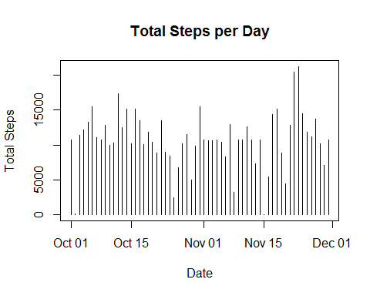

New interval chart with missing data filled in

plot(x=fvmin$date,y=fvmin$steps,type="l",main="Average Number of Steps Per Day",xlab="Date", ylab="Average Steps")  
lines(x=fvmin$date,y=fvmin$steps,type="l")

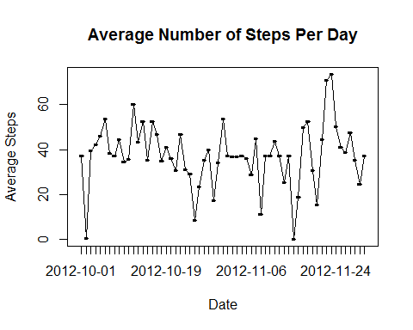

Conclussion - Filling in the missing data did not impact the overal view of the results

Are there differences in activity patterns between weekdays and weekends?

For this part the weekdays() function may be of some help here. Use the dataset with the filled-in missing values for this part.

#Add weekday column, it will be Y/N value  
#convert factor to date field  
fillNAds[2]<-as.Date(fillNAds$date, format="%Y-%m-%d")  
#get name of day for date  
fillNAds[4]<-weekdays(fillNAds$date)  
#identify weekdays vs weekends  
fillNAds[5]<-fillNAds[4]!="Saturday" & fillNAds[4]!="Sunday"   
names(fillNAds)[4:5]=c("Day","IsWD")  
wd<-fillNAds[fillNAds$IsWD==TRUE,]  
we<-fillNAds[fillNAds$IsWD==FALSE,]  
agwd<-aggregate(x=wd[1],by =list(wd$interval),FUN="mean")  
agwe<-aggregate(x=we[1],by =list(we$interval),FUN="mean")  
names(agwd)[1]="interval"  
names(agwe)[1]="interval"

Show average steps on weekdays

plot(x=agwd$interval,y=agwd$steps,type="l",main="Average Number of Steps - Weekday",xlab="interval", ylab="Average Steps")

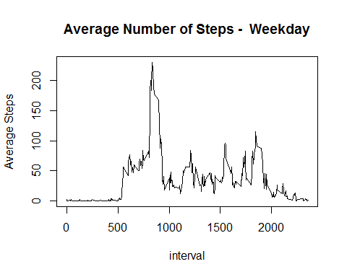

Show average steps on Weekends

plot(x=agwe$interval,y=agwe$steps,type="l",main="Average Number of Steps - Weekend",xlab="interval", ylab="Average Steps")

