* 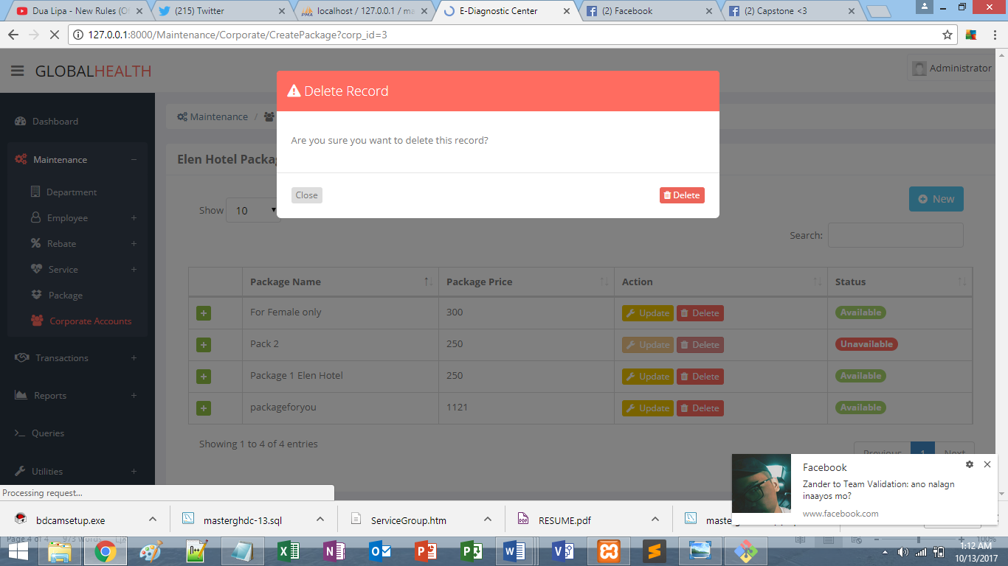

**-CORP ACCOUNTS, DINELETE KO UNG FOR FEMALE ONLY NA PACKAGE, ETO NEXT SCREEN NA LUMABAS**

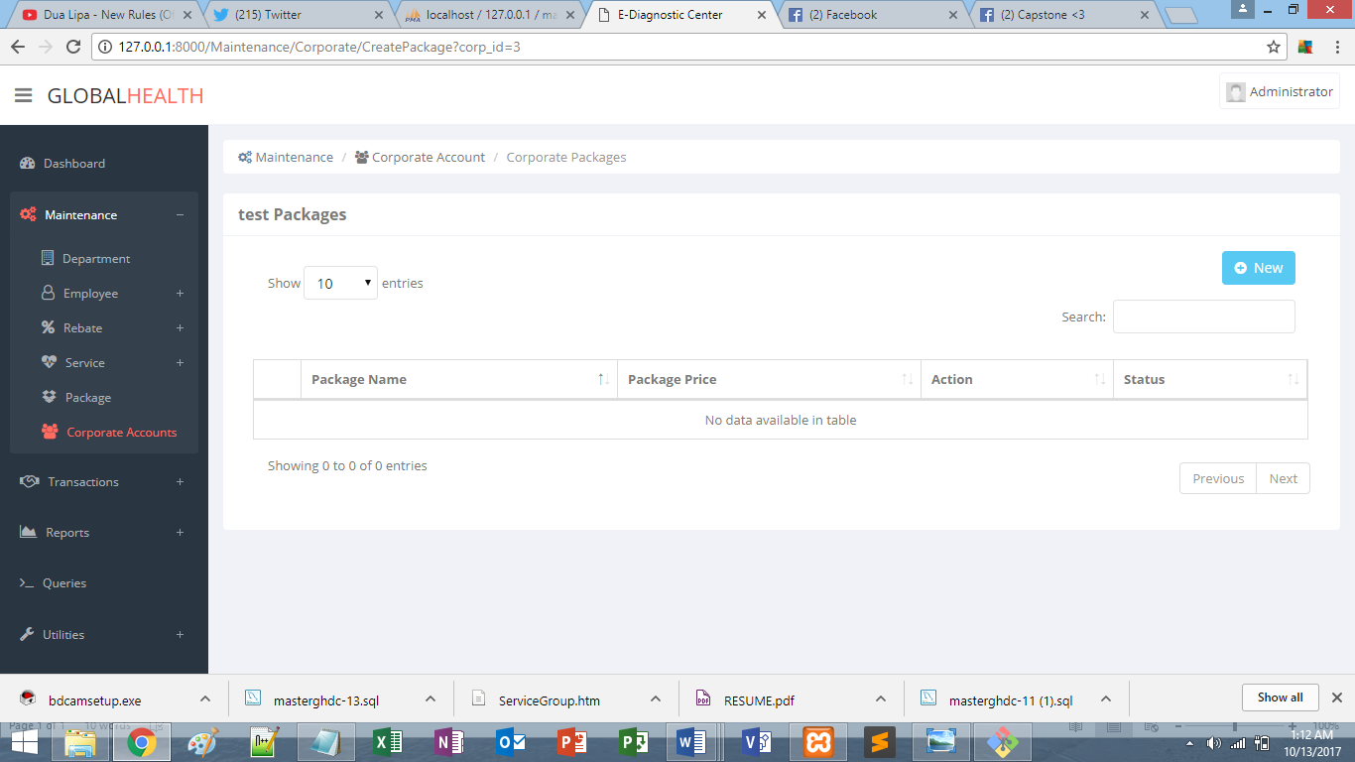

**????ISANG PACKAGE LANG NAMAN DINELETE KO?**

* 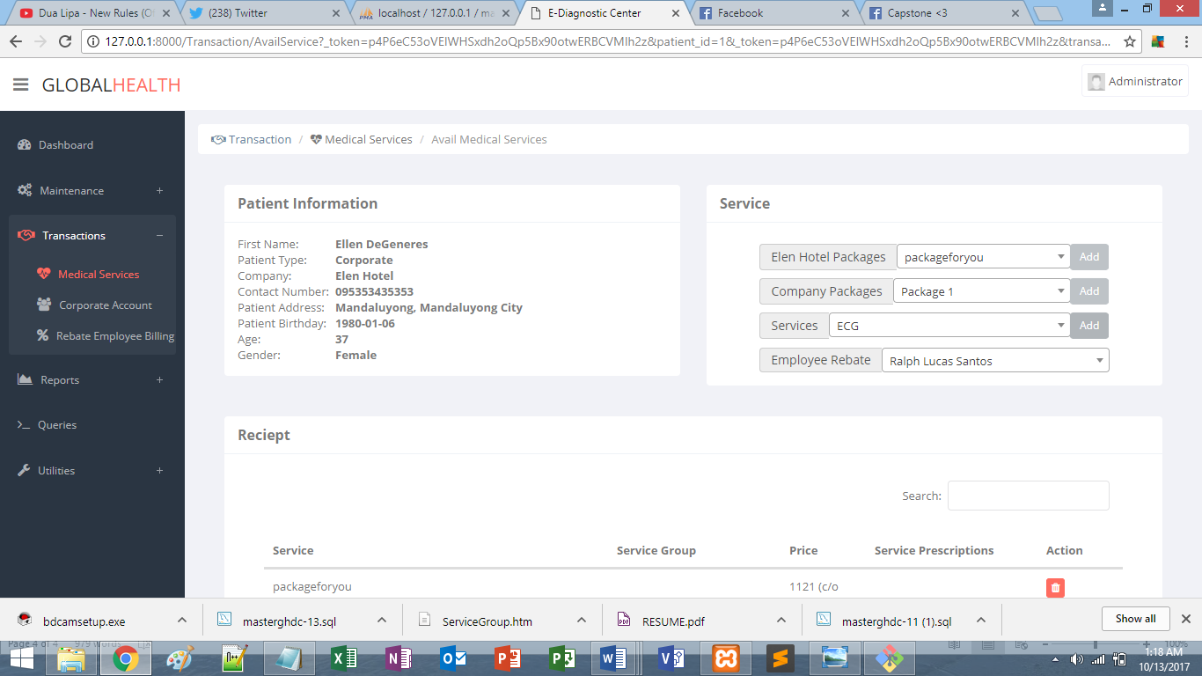

**DI GUMAGANA ADD BUTTON SA SERVICES**

* 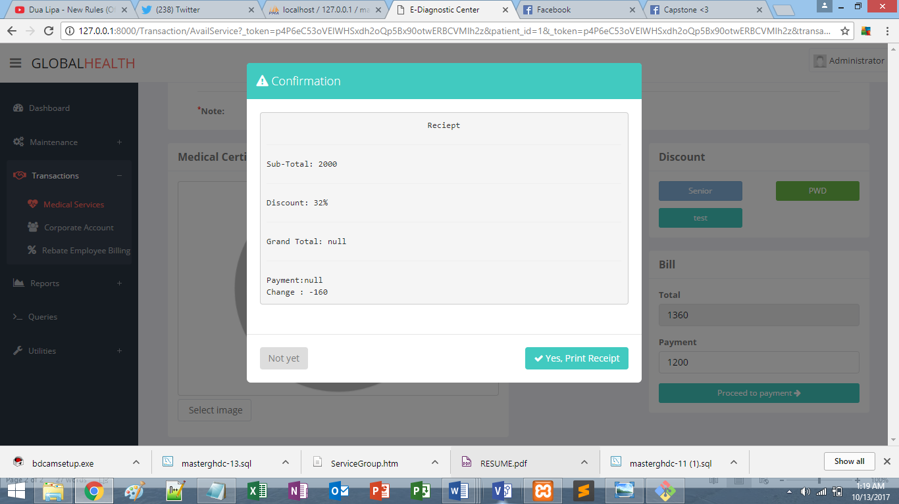

**INSUFFICIENT PAYMENT PERO NAGDIDIRECT SA RECEIPT? LUMALABAS UNG ERROR NA INSUFFICIENT PAYMENT PERO PAGKATAPOS LUMALABAS PA DIN UNG RECEIPT**

* 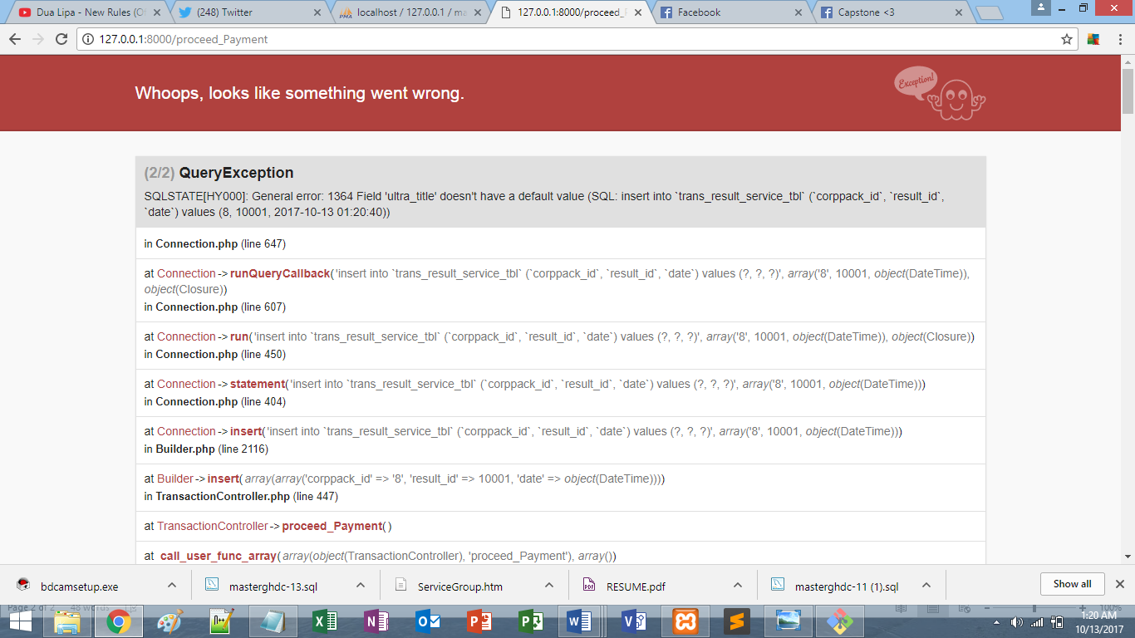

**PAG KINLICK UNG PRINT RECEIPT KAHIT NA INSUFFICIENT PAYMENT? AYAN NALABAS**

* 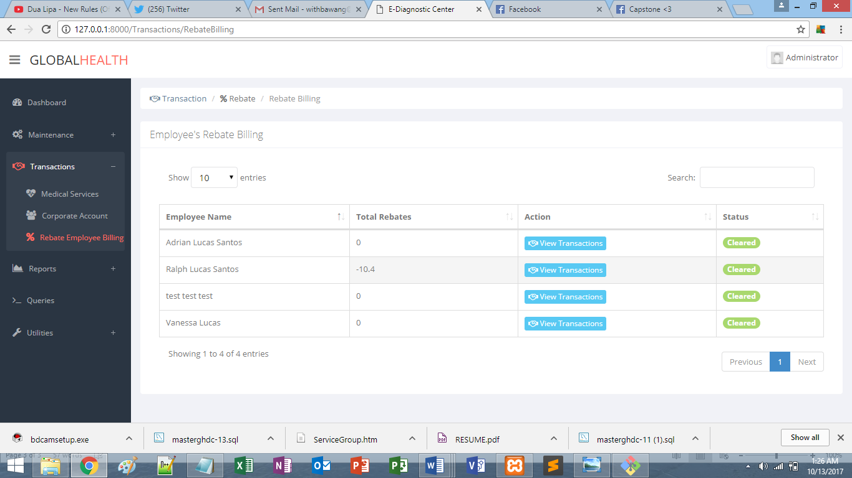

**DAPAT EXACT REBATE AMOUNT LANG UNG TINATANGGAP. 546 KASI REBATE NYA, 600 ININPUT KO, GANYAN LUMABAS**