**METHODS**

This study draws on balanced panel data over several indicators related to the collegiate board expertise from 1997 to 2018. The data set covers ten federal regulatory agencies: National Civil Aviation Agency (ANAC), National Film Agency (ANCINE), National Electrical Power Agency (ANEEL), National Telecommunications Agency (ANATEL), National Waterway Transportation Agency (ANTAQ), National Ground Transportation Agency (ANTT), National Health Surveillance Agency (ANVISA), National Health Agency (ANS), National Petroleum Agency (ANP), and National Water Agency (ANA). Because of its recent creation, the data do not cover the National Mining Agency (ANM), which replaced the previous National Department of Mineral Production (DNPM) in December 2017. The collegiate board from a federal regulatory agency consists of directors chosen by a specific process: the chief of the executive branch, i.e., Brazil’s president appoint them to Senate confirmation before taking over the office.

Our study sample is made up of tracking 117 directors’ occupational trajectories five years before and five years after composing the collegiate board and report yearly based information. The main source of data is the Federal Senate of Brazil that provides the curricula vitae for every director nominated to compose the collegiate board of a federal regulatory agency. These CVs highlight the academic training, level of education and experience of professionals. We investigated political affiliation in the Supreme Electoral Tribunal (TSE) database, which provides a list of affiliates per party in each state of the federation. We also extract data from the Annual Social Information Report (RAIS), an official registry of all formal workers in Brazil, to capture social characteristics, e.g., employer, occupation according to the Brazilian Classification of Occupations (CBO), compensation and work hours. Finally, we collected both governmental and non-governmental print (newspapers, magazines) and electronic (websites) media to cover information such as allegations of corruption, legal proceedings, and political scandals. Table 1 reports the individual variables and data sources considered in this article.

**Table 1** Definitions of Study Variables and Data Sources

|  |  |  |
| --- | --- | --- |
| Variables | Definitions | Data Sources |
| Gender | Man or Woman | RAIS |
| Political Afilliation | If one is found on the list of affiliates per party in each state of the federation and / or holds a legislative, administrative or judicial office (either appointed or elected) | TSE and Senate |
| Academia | If one has a Doctoral or Master of Science degree and / or holds a position in academia | Senate |
| Regulatory Agency | If one is a public servant on behalf of a regulatory agency | Senate |
| Public Service | If one is a public servant on behalf of any government department excluding regulatory agencies | Senate |
| Industry | If one works in the regulated industry | RAIS and Senate |
| Consultancy | If one works as a consultant that provides professional advice related to the regulated industry | RAIS and Senate |

We analyzed the data using the Optimal Matching Analysis(OMA), introduced in career analysis by Abbott and Hrycak (1990) and revised by Abbott and Tsay (2000), Aisenbrey and Fasang (2010), and Dlouhy and Biemann (2015). First, the technique defines the distance between sequences as the number of changes needed to transform one sequence into another. The lower this "cost," the more similar these sequences are. Second, the operations allowed to transform one sequence into another are the substitution, insertion, and elimination (indel operations, or indel operations) of a given state. The output of the comparison between the strings is a symmetric matrix that displays the distance from one sequence to all others. Finally, this matrix is used to cluster sequences that are more or less similar, even though they are not necessarily the same.

Thus, besides the coding of sequences and the time frame, there are two critical decisions in applying OMA: the deletion/insertion and replacement costs between the states, when applicable; and the criterion for grouping the sequences. The sequence of each professional *i* in each period *t* was defined according to

Simulations were conducted using the R statistical programming language. The TraMineR package from R 3.0.2 statistical software was used for the sequence analysis, as described by Gabadinho et al. (2011). The TraMineR algorithm is essentially that of Needleman and Wunsch, with standard optimizations (Gabadinho et al., 2011). The transition costs between states were based on transition probabilities. This choice has been a growing trend in the literature (Aisenbrey and Fasang, 2010; Dlouhy and Biemann, 2015). Mathematically, the transition cost from state *i* to state *j* (*i ≠ j*) is equal to 2 – *p(i|j) – p (j|i)*, where *p(i|j)* is the transition rate between states *i* and *j* in the sample. The rationale behind this approach is that the transitions observed more frequently are less costly than less frequent transitions. By definition, the probability of a transition from one state to itself is equal to one, which makes the transition cost zero.

The clustering method was Ward’s hierarchical cluster, a standard in the literature. The choice of the number of clusters involved the analysis of some measures available in the R cluster package of and visual dendrogram inspection. No definitive criterion to choose the number of clusters exists; some methods and indicators aid researchers in this decision, but they often do not point towards a single solution. In the end, the choice of this number is somehow subjective. Herein, we chose a four clusters solution based on three indicators, the dendrogram and the analytical power of such a solution compared to alternatives. All code used to conduct the simulations and generate plots, as well as the simulation results presented herein, are available upon request.

**RESULTS**

**CONVERSA 25/02/2019**

Arquivo - Análise preliminar - novos códigos sem mandato com chiquadrado.docx de 17/12/2018.

1ª Análise de strings mais frequentes para as carreiras – diretores ainda em exercício – não utilizaremos

Código T-1 com erro? Não nessa parte do documento.

# A análise começa na Página 15 - EXCETUANDO OS PROFISSIONAIS AINDA COM MANDATO

1H2N3N4N5S6N7N/5-1H2N3N4N5N6N7S/5 – o string mais frequente é Homem não político servidor e se torna consultor.

|  |  |  |
| --- | --- | --- |
| 1H2N3N4N5S6N7N/5-1H2N3N4N5N6S7N/5 | 4 | 3.4 |

String de servidor que vai para a indústria

Depois a análise pode agregar indústria e consultoria (6 e 7)

E Agregou servidor agência com servidor público em geral.

Faz mais sentido a análise exploratória de um quadro mais geral e depois para o mais detalhado. Começar o artigo com as categorias colapsadas. Análise mais descritiva das frequências.

Políticos não muda de carreira. Ser político não é um ganho pós mandato. Não atrapalha para conseguir um mandato, mas não assegura nenhuma posição pós agência. Pode ser uma

Não há diferença relevante detectável de gênero (há poucas mulheres). A parte acadêmica não agrega também.

Arquivo Análise preliminar - novos códigos sem mandato redux2.docx de 24/01/2019

Junção político

2Npub/5-2Npriv/5

2N/2S – politico ou não

Pub – servidor

Priv – privado

2Npub/5-2Npriv/5 subiu para freq 25 juntar 2Spub/5-2Spriv/5 freq 10 – para evidenciar que o servidor público muda de setor.

Análise por agência fica mais simplificada com essa agregação. Fazer essa análise. Pode aparecer uma tendência em agência de infraestrutura. Ex. ANEEL, ANATEL, ANS, onde tem mercados competitivos que o servidor sai do setor público e vai para o setor regulado.

Controlar por idade para confirmar se o servidor pediu exoneração ou se aposentou. Ideia prorrogada.

Metodologia – a consulta à base da RAIS para confirmar se o servidor pediu exoneração e está na indústria para ganhar salários maiores.

Teoria clássica de captura (pois serviu aos interesses do privado) vs. Teoria de expertise (tem valor de mercado).

O político não consegue fazer essa transição pois ele não era conhecido pela sua expertise. Cria-se essa rejeição. Nunca chegará como diretor reconhecido com mérito próprio.

Validar a terminologia: Terms – mandatos; Private Sector – não Industry.

Análise dos clusters página 7: Cluster 1 – 60%

Não utilizaremos o gráfico mosaico da página 8. Pegaremos as seguintes sequências:

|  |
| --- |
| 2Npub/5-2Npriv/5 |
| 2Npub/10 |
| 2Spub/10 |
| 2Npriv/10 |
| 2Spub/5-2Spriv/5 |

Classificar como são e colocar as outras categorias em “OUTROS”.

Rodar os chi-quadrados novamente. BRUNO 26/2 manhã.

Agora esperamos confirmar o que o modelo probit indicou (página 11): “Agora, pode-se rejeitar a hipótese nula de que os setores antes e depois são independentes, pelo menos a 10% de significância. Isso quer dizer que há uma proporção maior de servidores migrando para um pós-agência no setor privado do que seria esperado aleatoriamente.”

A politização atrapalha? Fazer classificação mais dura (5 categorias e OUTROS).

Stability of the strings is also noticeable. In fact, when career changes happen, almost all of them take place after boarding. As a result, although there are 128 possible states (27), in practice there are only 40 different states. Moreover, the 10 most common sequences correspond to 40% of the total.

**Table 1 – 10 most common sequences**

|  |  |  |  |
| --- | --- | --- | --- |
| 5 years before | 5 years after | Freq | Percent |
| Male, public servant | Male, consultant | 11 | 9.4 |
| Male, public servant, politically affiliated | Male, public servant, politically affiliated | 6 | 5.1 |
| Male, public servant | Male, public servant | 5 | 4.3 |
| Male, public servant, politically affiliated | Male, public servant, politically affiliated | 5 | 4.3 |
| Male, from the regulated sector | Male, from the regulated sector | 4 | 3.4 |
| Male, public servant | Male, from the regulated sector | 4 | 3.4 |
| Female, public servant | Female, public servant | 4 | 3.4 |
| Male, professor or scholar, public servant | Male, professor or scholar, public servant | 3 | 2.6 |
| Male, professor or scholar, public servant | Male, professor or scholar, consultant | 3 | 2.6 |
| Male, from the regulated sector | Male, consultant | 2 | 1.7 |

Source: own elaboration

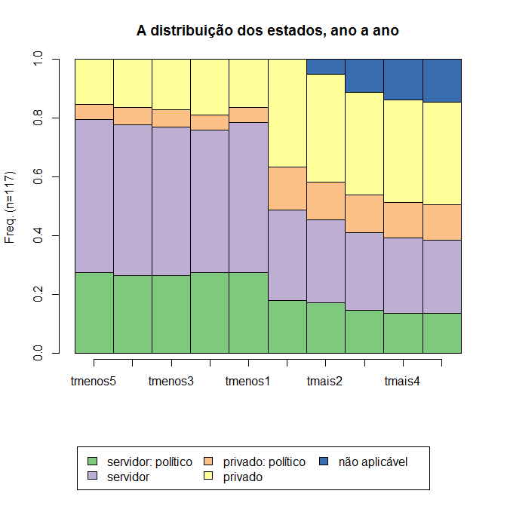*’*

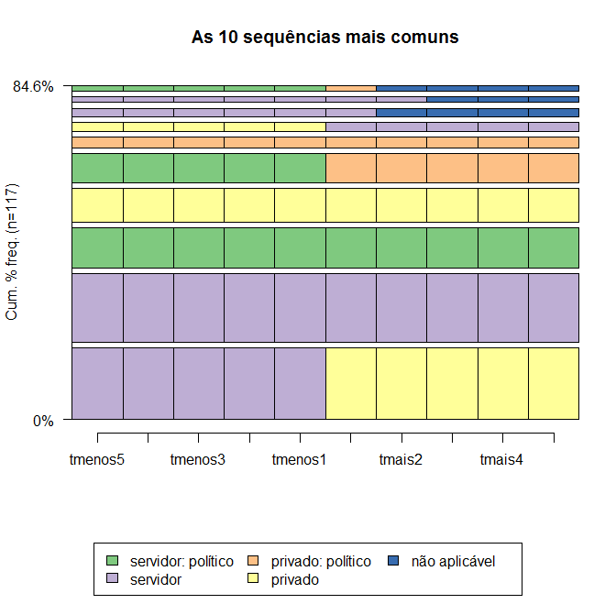

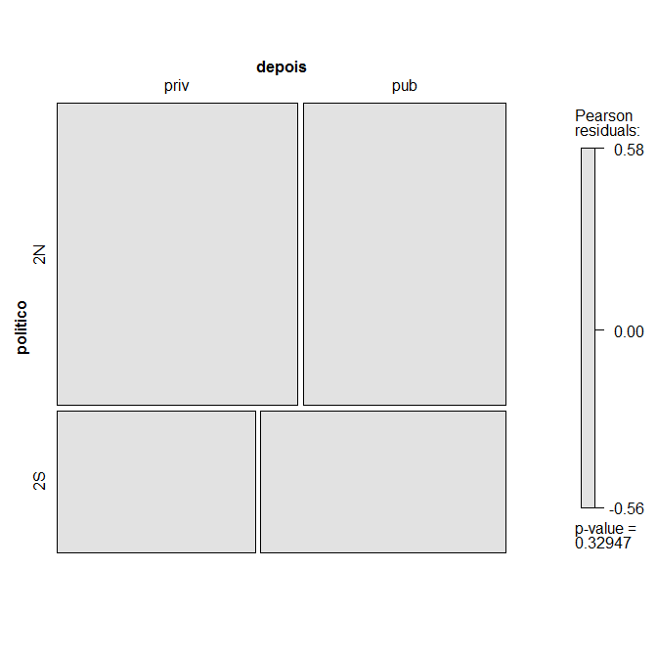

|  |  |  |
| --- | --- | --- |
|  | depois |  |
| politico | priv | pub |
| 2N | 0.9751744 | -0.9751744 |
| 2S | -0.9751744 | 0.9751744 |

Com p-valor de 0,32, não podemos rejeitar a hipótese nula de que a politização não afeta a distribuição entre setor público e privado. Preciso reportar

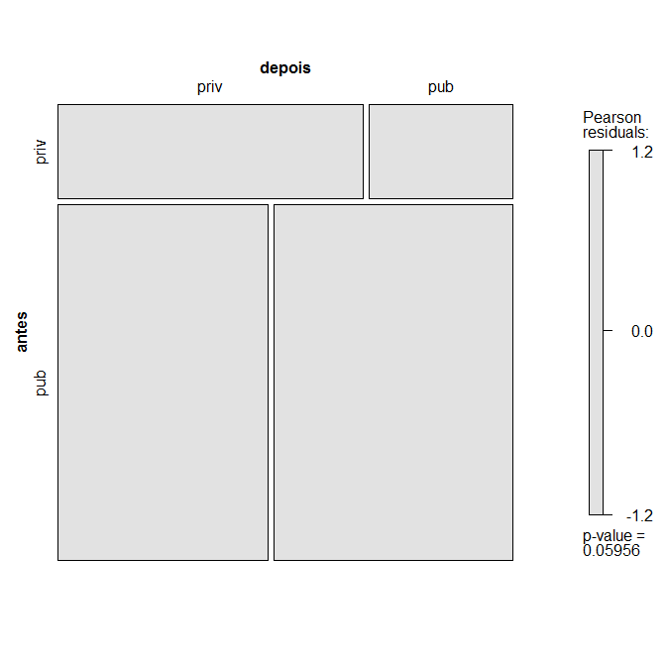

|  |  |  |
| --- | --- | --- |
|  | depois |  |
| antes | priv | pub |
| priv | 1.884.039 | -1.884.039 |
| pub | -1.884.039 | 1.884.039 |

Agora, pode-se rejeitar a hipótese nula de que os setores antes e depois são independentes, pelo menos a 10% de significância. Isso quer dizer que há uma proporção maior de servidores migrando para um pós-agência no setor privado do que seria esperado aleatoriamente.

Outra forma de analisar isso é a partir de um modelo probit:

glm(formula = depois ~ antes + politico, family = binomial(link = "probit"),

data = seqregclass)

Deviance Residuals:

Min 1Q Median 3Q Max

-1.3271 -1.1847 -0.8484 1.1701 1.5469

Coefficients:

Estimate Std. Error z value Pr(>|z|)

(Intercept) -0.5179 0.2687 -1.928 0.0539 .

antespub 0.5287 0.2924 1.808 0.0706 .

politico2S 0.2051 0.2496 0.822 0.4113

---

Signif. codes: 0 ‘***’ 0.001 ‘**’ 0.01 ‘*’ 0.05 ‘.’ 0.1 ‘ ’ 1

(Dispersion parameter for binomial family taken to be 1)

Null deviance: 164.89 on 118 degrees of freedom

Residual deviance: 160.60 on 116 degrees of freedom

AIC: 166.6

Number of Fisher Scoring iterations: 4

Ou seja, reforça o resultado anterior: vários servidores fazem a migração do setor público para o privado, ou seja, dentre aqueles que estão no setor privado no pós-agência, ter sido servidor conta favoravelmente.

Contudo, condicionalmente, a ser do setor público, a politização parece não ter influência. Mas podemos rodar um modelo em amostra reduzida:

Deviance Residuals:

Min 1Q Median 3Q Max

-1.342 -1.177 1.021 1.177 1.177

Coefficients:

Estimate Std. Error z value Pr(>|z|)

(Intercept) 1.872e-16 1.592e-01 0.000 1.000

politico2S 2.372e-01 2.747e-01 0.864 0.388

(Dispersion parameter for binomial family taken to be 1)

Null deviance: 129.93 on 93 degrees of freedom

Residual deviance: 129.18 on 92 degrees of freedom

AIC: 133.18

Number of Fisher Scoring iterations: 3

Conclusão: não se pode rejeitar a hipótese nula de que a politização não influi na carreira no setor privado no pós-agência.