Resultados

Cristiano

1 de maio de 2017

# mecnost

## Modelos estruturais de componentes não obserados para séries temporais

This package provides functions used in the Project

## Installation

The package can then be installed using devtools::install_github('santoscs/mecnost').

## Data visualiation

Os dados são PIB trimestral dos setores extraídos das contas nacionais do IBGE no período de 1996Q1 a 2016Q3.

As séries temporais são mostradas na figuras seguir:

devtools::load_all()

## Loading mecnost

g1 <- tsplot(log(pibsetor[,1:7]))  
g2 <- tsplot(log(pibsetor[,8:14]))  
multiplot(g1, g2, cols = 2)

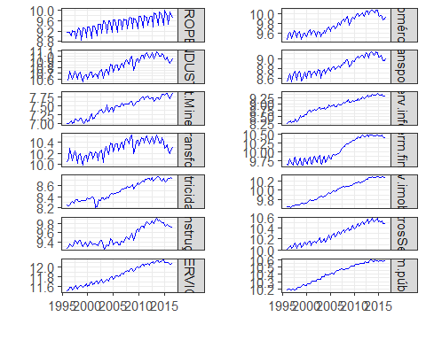

Log do PIB setorial

## Estimando os modelos

Estima os modelos por MCMC

# lpib <- as.list(log(pibsetor))  
# models <- purrr::map(lpib, btcmodel,  
# a.theta = 1, b.theta = 1000, n.sample = 2050,  
# thin = 1, save.states = TRUE)  
#   
  
# save(models, file = "data-raw/estimacoes.RData")  
load(file = "data-raw/estimacoes.RData")  
y <- as.list(names(models))  
plots <- purrr::map2(models, y, autoplot.btcmodel, burnin=0.05)  
tabs <- purrr::map(models, tab.btcmodel, burnin=0.2)

## Mostra o gráfico dos componentes estimados

multiplot(plotlist=plots[1:4], cols = 2)

## Warning: Removed 168 rows containing missing values (geom_path).  
  
## Warning: Removed 168 rows containing missing values (geom_path).  
  
## Warning: Removed 168 rows containing missing values (geom_path).  
  
## Warning: Removed 168 rows containing missing values (geom_path).

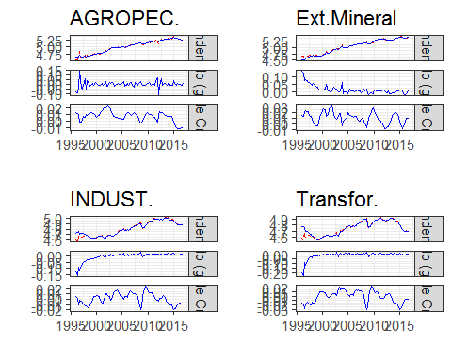

Componentes estimados

multiplot(plotlist = plots[5:8], cols = 2)

## Warning: Removed 168 rows containing missing values (geom_path).  
  
## Warning: Removed 168 rows containing missing values (geom_path).  
  
## Warning: Removed 168 rows containing missing values (geom_path).  
  
## Warning: Removed 168 rows containing missing values (geom_path).

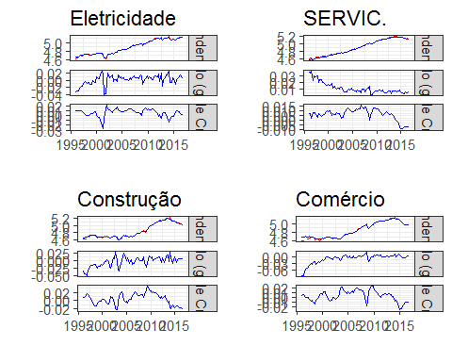

Componentes estimados

multiplot(plotlist = plots[9:12], cols = 2)

## Warning: Removed 168 rows containing missing values (geom_path).  
  
## Warning: Removed 168 rows containing missing values (geom_path).  
  
## Warning: Removed 168 rows containing missing values (geom_path).  
  
## Warning: Removed 168 rows containing missing values (geom_path).

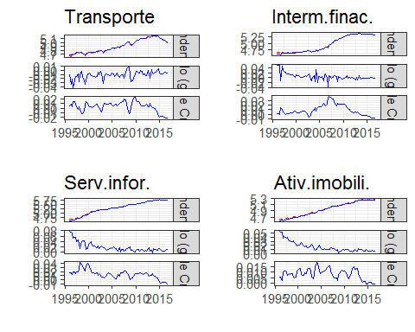

Componentes estimados

multiplot(plotlist = plots[13:14], cols = 2)

## Warning: Removed 168 rows containing missing values (geom_path).  
  
## Warning: Removed 168 rows containing missing values (geom_path).

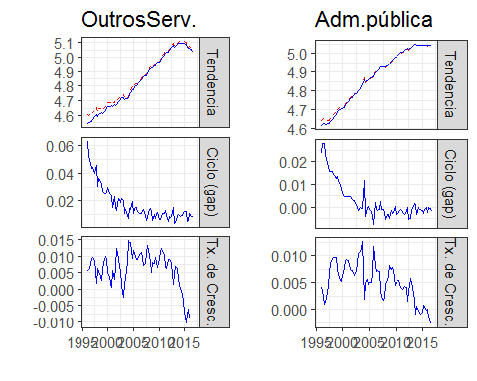

Componentes estimados