Resultados

Cristiano Santos

20 de abril de 2018

## Resultados

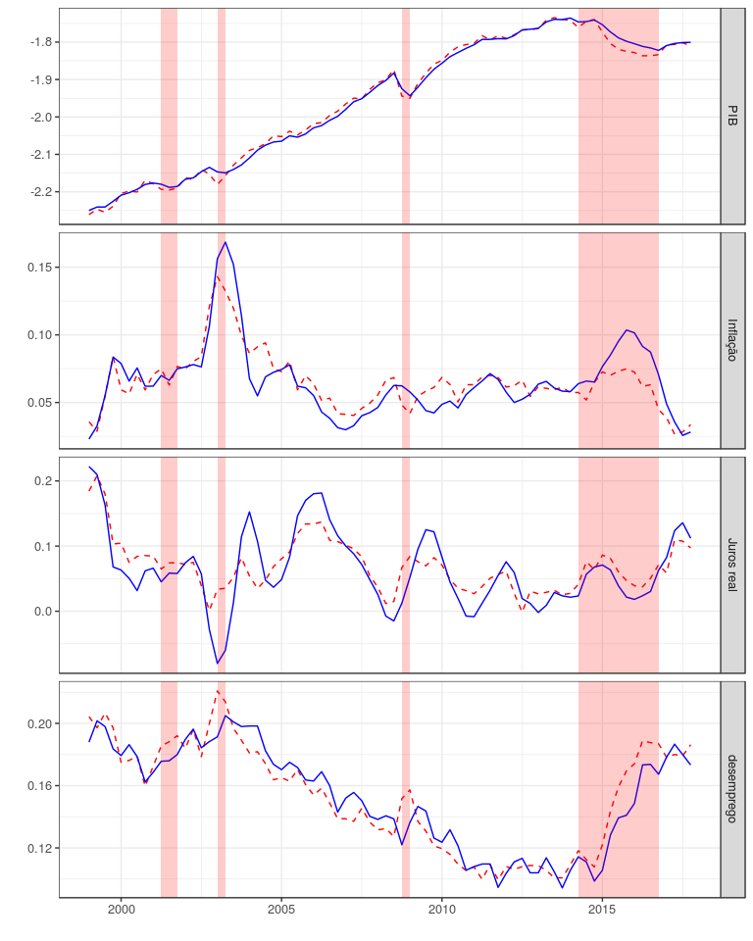

Fig. 1 Actual and natural rates. The solid line is the actual rate; the dashed line is the natural rate. The shaded areas indicate the NBER recessions

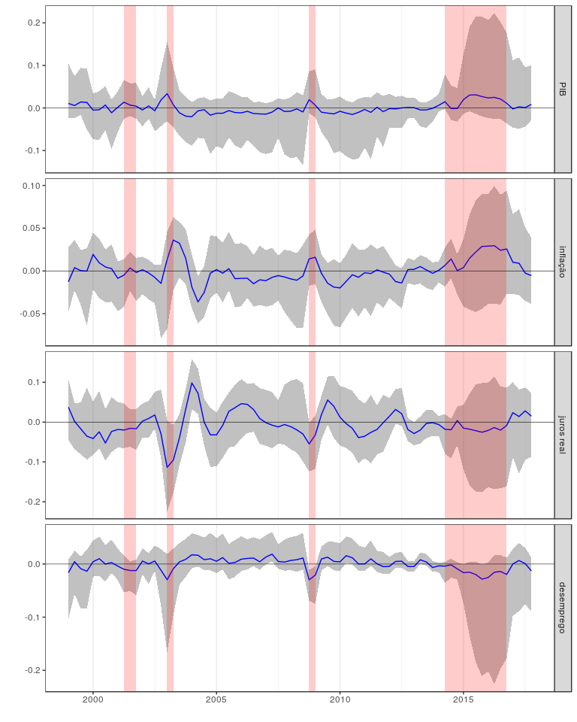

Fig. 2 Gaps. The dashed lines are the 0.025- and 0.975-quantiles. The shaded areas indicate the NBER recessions

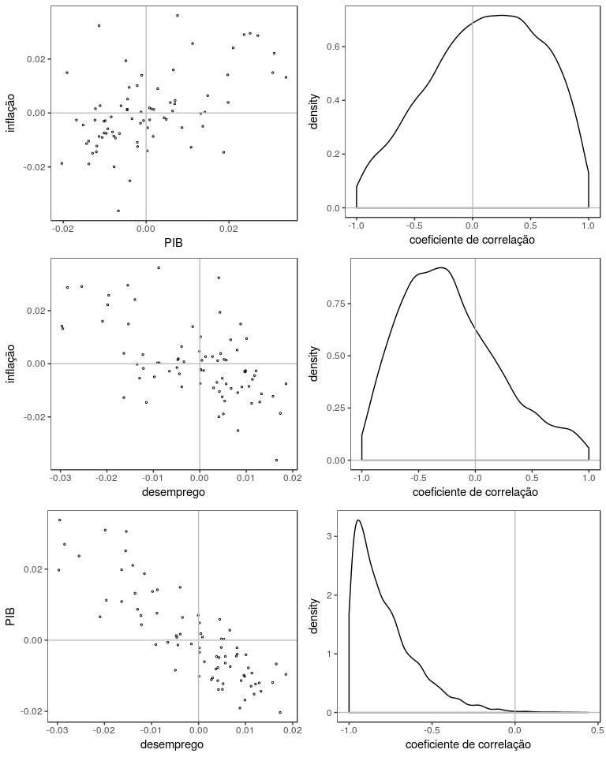

Fig. 3 Phillips curve andOkun’s law.The left panels are the scatter plots of the simulated posteriormedians of the gaps in each quarter; the right panels are the simulated posterior pdfs of the correlation coefficients between the gaps

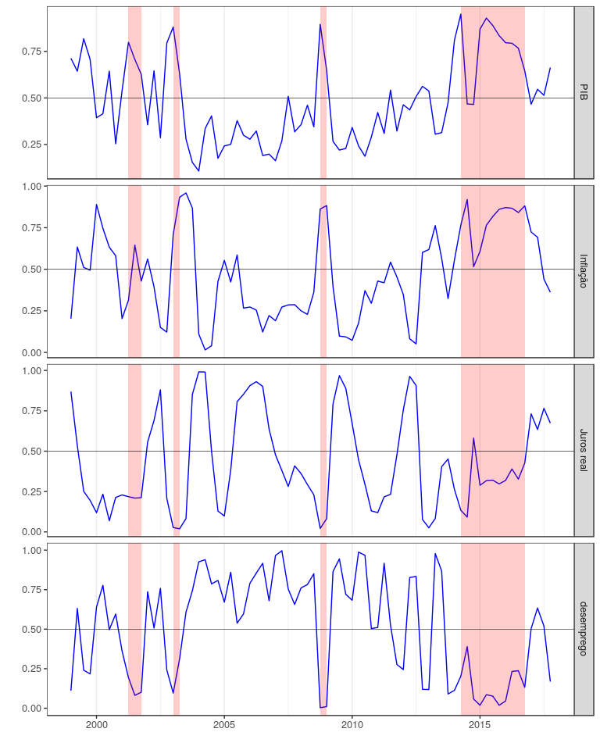

Fig. 4 Posterior probability of positive gap. The shaded areas indicate the NBER recessions

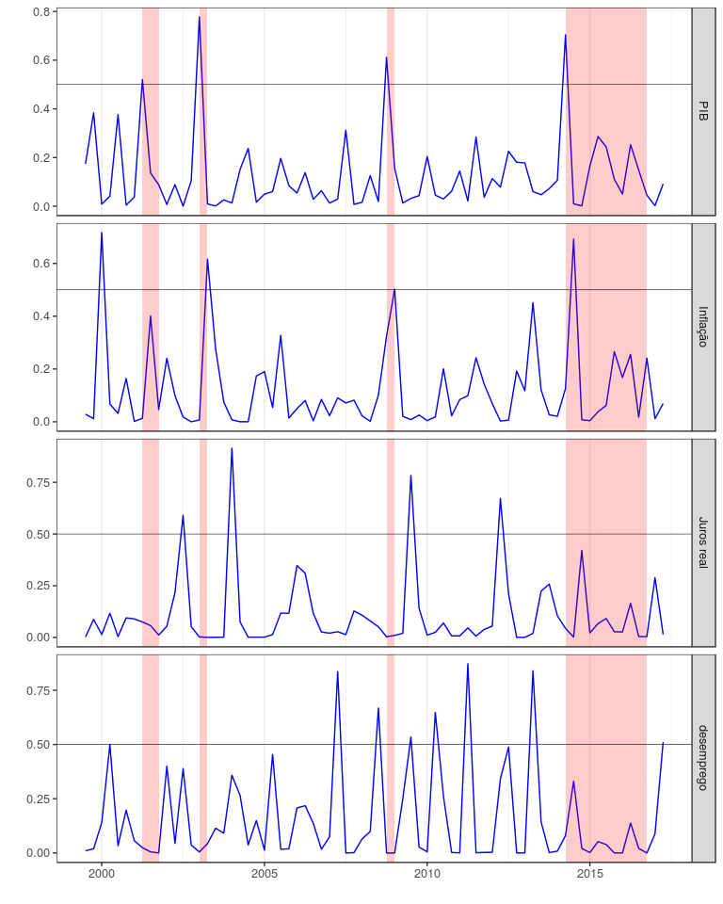

Fig. 5 Posterior probability of recession. The shaded areas indicate the NBER recessions

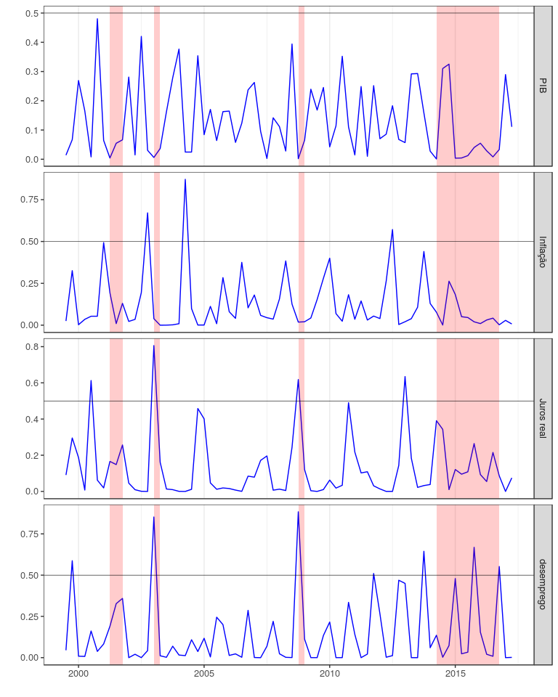

Fig. 6 Posterior probability of revival. The shaded areas indicate the NBER recessions