resultados e dicussoes

## Descrição dos dados

Antes de aplicar o modelo de componentes não observados é necessário saber se a hipótese de raiz unitária I(1) é atendida pelas séries inseridas no modelo.

A tabela a seguir apresenta os teste de

devtools::load_all()

## Loading nimcno

tsmz <- macro95[, c('ipca', 'selicr')]  
tab <- tab.stationary(tsmz)  
knitr::kable(tab)

|  |  |  |  |  |
| --- | --- | --- | --- | --- |
| Variavel | tendencia | ADF.lag | ADF | KPSS |
| ipca | sim | 13 | -4,252*** | 0,180** |
| selicr | sim | 2 | -6,052*** | 0,165** |
| diff.ipca | nao | 12 | -5,714*** | 0,046 |
| diff.selicr | nao | 8 | -7,014*** | 0,023 |

## Gráficos das séries

x <- macro95[, c('ipca', 'selicr', 'ipca.ex2', "ipca.ex")]  
colnames(x) <- c("IPCA", "SELIC", "IPCA-EX2", "IPCA-EX")  
tsplot(x)

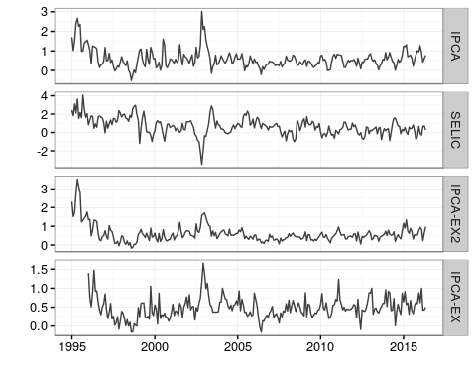

x <- macro95[, c('ipca.ma', 'ipca.mas', 'ipca.dp', "ipc.br.core")]  
colnames(x) <- c("IPCA-MA", "IPCA-MAS", "IPCA-DP", "IPC-BR")  
tsplot(x)

## Warning: Removed 72 rows containing missing values (geom_path).

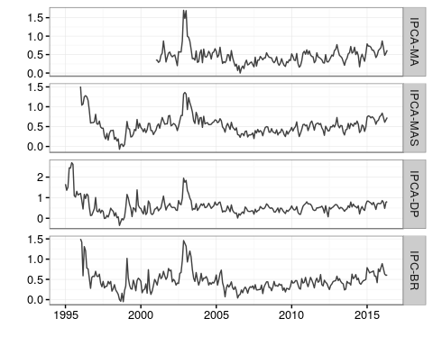

## Tabela cointegração

tab <- tab.cointeg(tsmz)  
knitr::kable(tab)

|  |  |  |  |
| --- | --- | --- | --- |
|  | Posto | Traco | Lambda.max |
| r = 0 | | 0 | 60,230*** | 36,999*** |
| r <= 1 | | 1 | 23,230*** | 23,230*** |

## Tabela resultados da estimacao

bn.ipca <- ucmodel(x = macro95[,"ipca"], l = 2,  
 init = c(rep(c(2, 0.2), 1),# ar pars  
 c(-0.7), # var arima  
 c(-1.2), # var level  
 rep(0.001, 1) # cov arima level  
 ))  
tab <- pars.ucmodel(bn.ipca)  
knitr::kable(tab$tab, caption = "BN univariado")

BN univariado

|  |  |  |
| --- | --- | --- |
|  | level | arima |
| level | 0,007 | 1,000 |
| arima | + | 0,058 |

knitr::kable(tab$ar, caption = "BN univariado")

BN univariado

|  |  |
| --- | --- |
| arima1 | 0,698 |
| arima2 | -0,151 |

knitr::kable(tab$mu, caption = "BN univariado")

BN univariado

|  |
| --- |
| -0,003 |

bn2 <- ucmodel(x = macro95[,c('ipca', 'selicr')], l=2,   
 init=c(c(2, 0.2),  
 c(2, 0.2),  
 c(-0.5, -0.5), # var arima  
 c(-1.2, -1.2), # var level  
 0.001, # cov level   
 0.01, # cov arima  
 rep(0.001, 4) # cov level arima  
 ), corre = TRUE)  
  
tab <- pars.ucmodel(bn2)  
knitr::kable(tab$tab, caption = "BN multivariado")

BN multivariado

|  |  |  |  |  |
| --- | --- | --- | --- | --- |
|  | level.ipca | level.selicr | arima.ipca | arima.selicr |
| level.ipca | 0,007 | 1,000 | -0,390 | -0,752 |
| level.selicr | + | 0,001 | -0,391 | -0,751 |
| level.ipca | - | - | 0,109 | -0,234 |
| level.selicr | - | - | + | 0,407 |

knitr::kable(tab$ar, caption = "BN multivariado")

BN multivariado

|  |  |  |
| --- | --- | --- |
| arima1.ipca | 0,541 | 0,652 |
| arima2.ipca | 0,017 | 0,050 |

knitr::kable(tab$mu, caption = "BN multivariado")

BN multivariado

|  |  |  |
| --- | --- | --- |
|  | slope.ipca | slope.selicr |
| [257,] | -0,005 | -0,005 |

## Grafico dos componentes

# componentes permanentes   
x <- cbind(bn.ipca$out$alphahat[,"level"],  
 bn2$out$alphahat[,"level.ipca"],  
 bn2$out$alphahat[,"level.selicr"])  
# series observadas  
y <- cbind(bn.ipca$out$model$y,  
 bn2$out$model$y)  
# desvio padrao dos componentes  
dp <- cbind(ic.ucmodel(bn.ipca, state = "level")$v,  
 ic.ucmodel(bn2, state = "level")$v)  
# intervalo de confianca 95%   
ic <- ic(x, dp = dp, nc = 0.95)  
# nome dos componentes  
colnames(x) <- c("IPCA-CP1", "IPCA-CP2", "SELIC-CP2")  
  
#plot  
biplot(x, y, upper = ic$upper, lower = ic$lower)

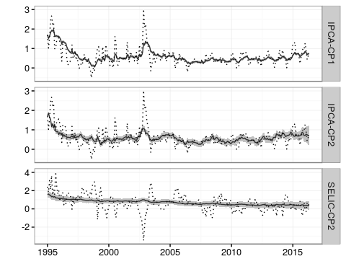

## Grafico dos núcleos

core.cp1 <- bn.ipca$out$alphahat[,'level']  
core.cp2 <- bn2$out$alphahat[,'level.ipca']  
core <- macro95[,c('ipca.ex2', "ipca.ex", 'ipca.ma', 'ipca.mas', 'ipca.dp', "ipc.br.core")]  
core <- cbind(core, core.cp1, core.cp2)  
x <- acum(core)  
y <- acum(macro95[,'ipca'])  
colnames(x) <- c("IPCA-EX2", "IPCA-EX", "IPCA-MA", "IPCA-MAS", "IPCA-DP", "IPC-BR", "IPCA-CP1", "IPCA-CP2")  
tsplot(x[,1:4], y)

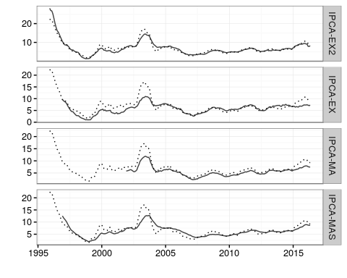

tsplot(x[,5:8], y)

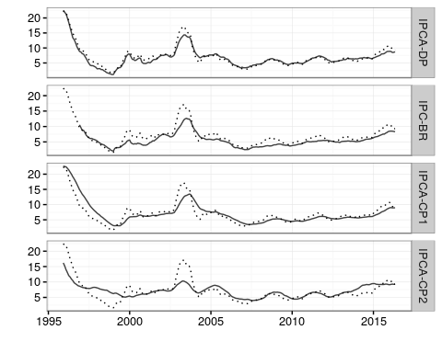

## Tabela estacionaridade dos nucleos

tab <- tab.stationary(core, d = FALSE)  
knitr::kable(tab)

|  |  |  |  |  |
| --- | --- | --- | --- | --- |
| Variavel | tendencia | ADF.lag | ADF | KPSS |
| core.ipca.ex2 | sim | 15 | -3,547** | 0,228*** |
| core.ipca.ex | sim | 14 | -3,222* | 0,092 |
| core.ipca.ma | sim | 8 | -2,775 | 0,314*** |
| core.ipca.mas | sim | 13 | -2,994 | 0,168** |
| core.ipca.dp | sim | 14 | -3,512** | 0,175** |
| core.ipc.br.core | sim | 13 | -2,728 | 0,204** |
| core.cp1 | sim | 13 | -4,165*** | 0,326*** |
| core.cp2 | sim | 9 | -3,500** | 0,386*** |

## Tabela estacionaridade dos componente transitorio

tab <- tab.stationary(core - macro95[,"ipca"], d = FALSE)  
knitr::kable(tab)

|  |  |  |  |  |
| --- | --- | --- | --- | --- |
| Variavel | tendencia | ADF.lag | ADF | KPSS |
| core.core.ipca.ex2 | sim | 6 | -7,121*** | 0,130* |
| core.core.ipca.ex | sim | 13 | -3,819** | 0,149** |
| core.core.ipca.ma | sim | 2 | -5,656*** | 0,117 |
| core.core.ipca.mas | sim | 13 | -4,600*** | 0,063 |
| core.core.ipca.dp | sim | 13 | -3,791** | 0,106 |
| core.core.ipc.br.core | sim | 7 | -6,408*** | 0,056 |
| core.core.cp1 | sim | 13 | -4,144*** | 0,068 |
| core.core.cp2 | sim | 13 | -4,270*** | 0,050 |

## Tabela UCM

tab <- tab.ucmodel(bn2)  
knitr::kable(tab)

|  |  |
| --- | --- |
| parametro | valor |
| $σ_{η_{1}}$ | 0,007 |
| $σ_{η_{2}}$ | 0,001 |
| $σ_{ε_{1}}$ | 0,109 |
| $σ_{ε_{2}}$ | 0,407 |
| $μ_{1}$ | -0,005 |
| $μ_{2}$ | -0,005 |
| $ϕ_{1_{1}}$ | 0,541 |
| $ϕ_{2_{1}}$ | 0,017 |
| $ϕ_{1_{2}}$ | 0,652 |
| $ϕ_{2_{2}}$ | 0,050 |
| log verossimilhanca | -299,635 |
| Correlacoes |  |
| $ρ_{η_{1}η_{2}}$ | 1,000 |
| $ρ_{η_{1}ε_{1}}$ | -0,390 |
| $ρ_{η_{1}ε_{2}}$ | -0,752 |
| $ρ_{η_{2}ε_{1}}$ | -0,391 |
| $ρ_{η_{2}ε_{2}}$ | -0,751 |
| $ρ_{ε_{1}ε_{2}}$ | -0,234 |

## Tabela condicoes de Marques

tab <- tab.marques(y = macro95[,'ipca'], x = core)  
knitr::kable(tab)

|  |  |  |  |  |  |
| --- | --- | --- | --- | --- | --- |
| nucleos | ADF | t.alpha | t.gamma | t.lambda | F.thetas |
| core.ipca.ex2 | -7,157*** | 0,189 | 0,012 | 0,311 | 0,003 |
| core.ipca.ex | -3,453** | 0,103 | 0,009 | 0,368 | 0,000 |
| core.ipca.ma | -5,630*** | 0,003 | 0,012 | 0,454 | 0,010 |
| core.ipca.mas | -4,610*** | 0,244 | 0,003 | 0,566 | 0,000 |
| core.ipca.dp | -3,585*** | 0,185 | 0,009 | 0,182 | 0,581 |
| core.ipc.br.core | -6,410*** | 0,000 | 0,000 | 0,196 | 0,012 |
| core.cp1 | -3,769*** | 0,765 | 0,000 | 0,000 | 0,000 |
| core.cp2 | -4,369*** | 0,624 | 0,000 | 0,550 | 0,034 |

tab <- tab.marques(y = acum(macro95[,'ipca']), x = acum(core))  
knitr::kable(tab)

|  |  |  |  |  |  |
| --- | --- | --- | --- | --- | --- |
| nucleos | ADF | t.alpha | t.gamma | t.lambda | F.thetas |
| core.ipca.ex2 | -3,228** | 0,163 | 0,079 | 0,518 | 0,013 |
| core.ipca.ex | -1,646 | 0,315 | 0,408 | 0,169 | 0,001 |
| core.ipca.ma | -4,071*** | 0,006 | 0,003 | 0,115 | 0,023 |
| core.ipca.mas | -2,645* | 0,219 | 0,134 | 0,242 | 0,000 |
| core.ipca.dp | -2,173 | 0,363 | 0,419 | 0,990 | 0,090 |
| core.ipc.br.core | -3,149** | 0,003 | 0,000 | 0,201 | 0,033 |
| core.cp1 | -2,831* | 0,491 | 0,000 | 0,001 | 0,000 |
| core.cp2 | -3,731*** | 0,488 | 0,000 | 0,795 | 0,090 |