IT Job Market Analysis
Project Documentation
Python | SQL Server | Excel | Power BI
Based on a simulated dataset of 26,500 IT job postings
Author: Santosh Chaurasia
M.Sc. Data Science, University of Mumbai
Project type: Personal data analytics portfolio project

Table of Contents
1. Project Overview
2. Objectives
3. Tools and Technologies
4. Dataset Description
5. Methodology and Workflow
6. SQL Analysis
7. Python Analysis
8. Excel Workbook
9. Power BI Dashboard
10. Key Findings
11. Limitations
12. Conclusion
13. Future Scope

1. Project Overview
This project analyzes IT hiring in India across job roles, cities, experience levels, salaries and required skills. It covers the complete analytics workflow: generating a relational dataset with Python, normalizing skills for SQL, answering business questions with SQL Server queries, exploring the data in Python, and presenting results in an Excel workbook and a Power BI dashboard.

Important: the data is simulated
The dataset was generated with Python using rules defined by the author (role mix by year, salary ranges by experience level, fixed skill sets per role). It is not real hiring data. The project demonstrates the analytics workflow and tools; the findings describe the simulated data and must not be read as claims about the real job market.

2. Objectives
- Create a realistic, relational IT jobs dataset (a jobs table and a normalized skills table).
- Use SQL to answer business questions on skill demand, salary by city, salary tiers, experience vs pay, and hiring companies.
- Explore salary and location patterns with Python.
- Build an Excel dashboard using pivot tables, pivot charts and a slicer.
- Build an interactive Power BI dashboard with KPI cards, charts and a slicer.

3. Tools and Technologies
Tool | Purpose in this project
Python (Pandas) | Data generation, inspection, skill normalization
Plotly | Charts in the EDA notebook (average salary by title, jobs by city)
SQL Server (T-SQL) | Eight analytical queries using JOIN, GROUP BY, CASE, CAST and a subquery
Microsoft Excel | 3 pivot tables, 3 charts, slicer and a dashboard sheet
Power BI | Dashboard with 2 KPI cards, 3 charts and an Experience Level slicer

4. Dataset Description

4.1 Files
File | Rows | Description
simulated_it_jobs.csv | 26,500 | Main jobs table with 8 columns
Normalized_Job_Skills.csv | 127,180 | One row per job-skill pair (Job_ID, Skill)
IT_Job_Market_Clean.csv | 26,500 | 4-column extract (Location, Job_Title, Experience_Level, Salary_INR) used for Excel, Power BI and the EDA notebook

4.2 Columns of the main table
Column | Description
Job_ID | Unique ID, JOB_100000 to JOB_126499
Company_Name | 12 companies: TCS, Infosys, Wipro, Cognizant, Accenture, Tech Mahindra, Capgemini, JPMorgan, Amazon India, Allied Digital, eClerx, Parascadd
Job_Title | AI / ML Engineer, Data Analyst, Data Engineer, Java Developer, Python Developer, UI Developer, Manual Tester, System Administrator
Skills_Required | Comma-separated skills fixed per role (4 or 5 skills)
Experience_Level | Entry-Level, Mid-Level, Senior
Salary_INR | Annual salary in INR
Location | Bengaluru, Navi Mumbai, Mumbai, Pune, Hyderabad, Noida, Chennai
Posted_Year | 2024, 2025, 2026

4.3 Data generation logic
The generator in Data_Generation_&_Cleaning.ipynb loops 26,500 times and builds each row from these rules:
- Random attributes: company, city, experience level and posting year are chosen uniformly at random.
- Market shift: AI/Data roles (Data Analyst, AI / ML Engineer, Data Engineer) make up 30% of postings in 2024, 50% in 2025 and 70% in 2026. The rest are traditional roles.
- Salary bands: each experience level has a salary range, higher for AI/Data roles. Entry: 3.5-6 LPA (AI/Data) vs 2.4-4 LPA (traditional). Mid: 7-12 LPA vs 5-8.5 LPA. Senior: 14-22 LPA vs 9.5-15 LPA.
- 2026 uplift: AI/Data salaries get a 15% increase in 2026.
- Skills: each role has a fixed skill set, for example Data Analyst = SQL, Python, Power BI, Advanced Excel, Data Analysis.
Because of these rules, some patterns in the results (equal city and company shares, balanced experience levels, ties in skill counts) are artifacts of random generation.

5. Methodology and Workflow
Step | Stage | What was done
1 | Data generation | Generated 26,500 job rows with Pandas and saved simulated_it_jobs.csv
2 | Inspection | Checked head, shape, info and salary summary; no missing values or duplicates (Job_ID is unique)
3 | Normalization | Split Skills_Required into one skill per row and saved Normalized_Job_Skills.csv (127,180 rows) for SQL joins
4 | SQL analysis | Loaded both tables in SQL Server (it_jobs_main, job_skills_normalized) and ran 8 queries
5 | Clean extract | Selected Location, Job_Title, Experience_Level and Salary_INR into IT_Job_Market_Clean.csv for BI tools
6 | EDA in Python | Plotted average salary by job title and job count by location
7 | Excel dashboard | Built pivot tables, charts and an Experience Level slicer
8 | Power BI dashboard | Built KPI cards, charts and a slicer on the clean table

6. SQL Analysis
All queries run on the database IT_Job_Market_DB (SQL Server) using the tables it_jobs_main and job_skills_normalized. Results below were verified against the CSV files.

Query 1: Top 10 Skills in Demand
Objective: Find the most frequently required skills across all job postings.
Result: Python (15,861) and SQL (14,042) lead by a wide margin; each appears in four of the eight role skill sets. Machine Learning, LLM, Prompt Engineering and NLP follow at 4,469 each.
Skill | Demand count
Python | 15,861
SQL | 14,042
Machine Learning / LLM / Prompt Engineering / NLP | 4,469 each
Power BI / Advanced Excel / Data Analysis | 4,381 each
AWS | 4,306

Query 2: Joining Both Tables: Top Skills for Data Analysts
Objective: Join jobs and skills to list the top 5 skills for Data Analyst roles.
Result: SQL, Python, Power BI, Advanced Excel and Data Analysis all have the same count (4,381), because every Data Analyst posting has the same fixed skill set. The ranking is therefore a tie.

Query 3: City-wise Salary Analysis
Objective: Compare Data Analyst openings and average salary across cities.
Result: Mumbai has the highest average (₹11.69 LPA) and Navi Mumbai the lowest (₹11.13 LPA), a gap of only about 5%.
City | Data Analyst openings | Average salary (₹)
Mumbai | 635 | 11,69,145
Hyderabad | 653 | 11,56,400
Bengaluru | 598 | 11,52,401
Chennai | 586 | 11,34,159
Noida | 635 | 11,33,879
Pune | 618 | 11,29,127
Navi Mumbai | 656 | 11,13,025

Query 4: Salary Categories
Objective: Segment all jobs into salary tiers using CASE.
Result: About 36% of jobs pay below 6 LPA, 37% pay 6-12 LPA and 28% pay above 12 LPA.
Salary tier | Total jobs | Average salary (₹)
Mid Pay (6 - 12 LPA) | 9,754 | 8,90,316
Entry Pay (< 6 LPA) | 9,388 | 4,15,935
High Pay (> 12 LPA) | 7,358 | 16,79,933

Query 5: Experience Level vs Average Salary
Objective: Measure how pay grows with experience.
Result: Senior roles pay about 3.8 times Entry-Level roles on average.
Experience level | Total jobs | Average salary (₹)
Senior | 8,744 | 15,67,538
Mid-Level | 8,974 | 8,48,152
Entry-Level | 8,782 | 4,13,576

Query 6: Top 10 Hiring Companies
Objective: Rank companies by number of openings.
Result: Cognizant (2,273), Infosys (2,267) and TCS (2,256) are first, but all 12 companies lie between 2,134 and 2,273 postings, so there is no real leader (companies were assigned randomly).

Query 7: Most In-Demand Skills for Python Developer
Objective: List the top 5 skills for Python Developer roles.
Result: Python, Django, Flask, SQL and REST APIs each appear 2,705 times: a tie, because the skill set is fixed per role.

Query 8: Job Openings Density by City (Market Share %)
Objective: Calculate each city's share of total openings using a subquery.
Result: Bengaluru has the largest share (14.60%) and Pune the smallest (14.00%); the spread is small.
City | Total jobs | Market share %
Bengaluru | 3,869 | 14.60
Navi Mumbai | 3,834 | 14.47
Noida | 3,833 | 14.46
Hyderabad | 3,757 | 14.18
Chennai | 3,752 | 14.16
Mumbai | 3,744 | 14.13
Pune | 3,711 | 14.00

Supporting query
Query IT_Job_Market_Clean.csv.sql selects Location, Job_Title, Experience_Level and Salary_INR from it_jobs_main. Its output is the clean 4-column file used in Excel, Power BI and the EDA notebook.

7. Python Analysis

7.1 Data_Generation_&_Cleaning.ipynb
- Generates the 26,500-row dataset using the rules in section 4.3.
- Inspects the data with head(), shape, info() and describe(): salary ranges from ₹2.40 LPA to ₹25.29 LPA, mean ₹9.42 LPA, median ₹8.09 LPA.
- Transforms the comma-separated skills into a normalized table with one skill per row (127,180 rows) so SQL can join and count skills.

7.2 IT_Job_Market_Analysis.ipynb
- Loads IT_Job_Market_Clean.csv.
- Horizontal bar chart of average salary by job title (top 10).
- Bar chart of total job openings by location.

8. Excel Workbook
IT_Job_Market_Workbook.xlsx has three sheets:
- IT_Job_Market_Data: the 26,500-row clean table.
- Pivot Tables: job count by location, average salary by job title (overall average ₹9,41,505), and job count by experience level (Entry 8,782 / Mid 8,974 / Senior 8,744).
- Dashboard: three charts (two bar charts and a pie chart) driven by the pivots, with a slicer, titled as simulated data.

9. Power BI Dashboard
The Power BI file (IT Job Market Analysis Dashboard.pbix) is built on the clean table and contains:
- KPI cards: Total Jobs (26.5K, shown as 27K) and Average Salary (941.51K).
- Column chart: total jobs by location.
- Pie chart: total jobs by experience level (Mid 33.86%, Entry 33.14%, Senior 33.00%).
- Horizontal bar chart: average salary by job title.
- Tile slicer for Experience Level that filters the whole page.

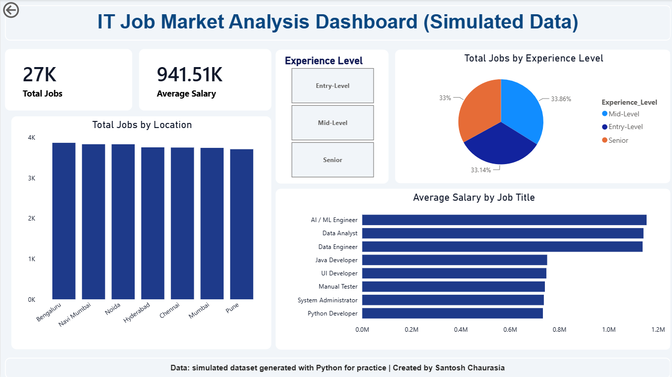
Figure 1: Power BI dashboard (simulated data)

10. Key Findings
These findings describe the simulated dataset; several are direct results of the generation rules.
Area | Finding
Overall | 26,500 jobs; average salary ₹9.42 LPA, median ₹8.09 LPA
Role type | AI/Data roles average ₹11.44 LPA vs ₹7.42 LPA for other roles (about 54% higher)
Top-paid roles | AI / ML Engineer (₹11.54 LPA), Data Analyst (₹11.41 LPA), Data Engineer (₹11.38 LPA)
Experience | Entry ₹4.14 LPA, Mid ₹8.48 LPA, Senior ₹15.68 LPA; Senior is about 3.8x Entry
Trend over time | AI/Data share of postings rises 30.2% (2024), 49.5% (2025), 69.5% (2026) while total postings stay flat at about 8,800-8,900 per year; average AI/Data salary is ₹12.34 LPA in 2026
Skills | Python and SQL are the most required skills overall
Location and company | Jobs are spread almost evenly across 7 cities (14.0-14.6%) and 12 companies; this is a result of random assignment

11. Limitations
- The data is simulated; uniform city, company and experience distributions are artifacts and carry no market meaning.
- Fixed skill sets per role produce ties in the skill queries (Queries 2 and 7).
- The dashboard uses only the 4-column clean table, so it does not show company, skills or year trends.
- Salary is a single annual figure with no bonus or variable pay.
- The generator has no random seed, so re-running it produces a slightly different dataset.

12. Conclusion
The project delivers a complete analytics pipeline: data generation and normalization in Python, eight SQL Server queries, EDA, an Excel workbook and a Power BI dashboard. It shows practical skills in relational data preparation, SQL joins and aggregation, and dashboard design. Since the data is simulated, the next step is to apply the same pipeline to real job-posting data.

13. Future Scope
- Run the same analysis on real job-posting data and compare it with this simulated baseline.
- Add year-wise trend and skills pages to the Power BI dashboard.
- Add a random seed to the generator for full reproducibility.
- Build a salary prediction model once real data is available.

