AMAZONE –WEB SCRAPPING

PRODUCT  
Redmi Note 8 (Neptune Blue, 4GB RAM, 64GB Storage)

WORD-CLOUD

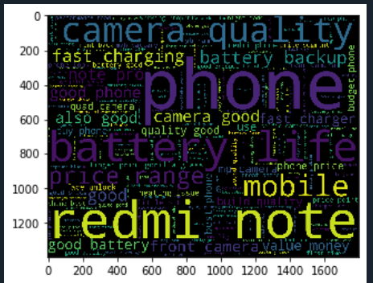

NEGATIVE-WORD CLOUD

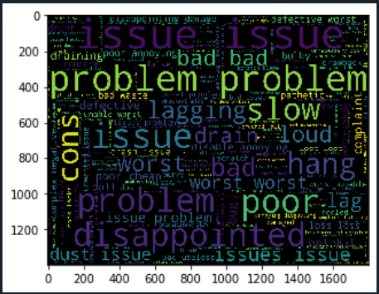

POSITIVE-WORD CLOUD

