SNEAPDEAL –WEB SCRAPPING

PRODUCT  
Karbonn Jumbo K9 Black & Red & Black

WORD-CLOUD

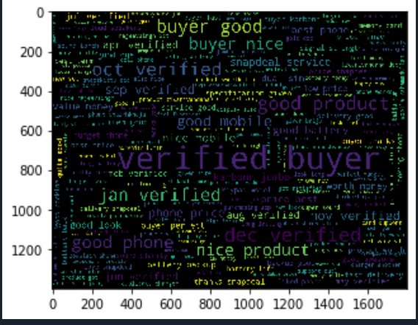

NEGATIVE-WORD CLOUD

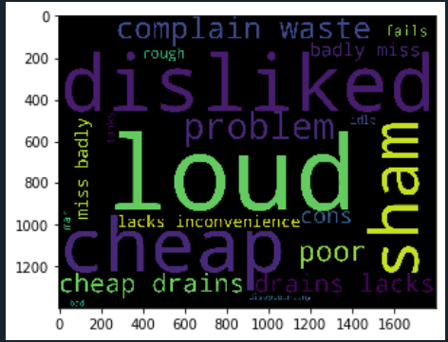

POSITIVE-WORD CLOUD

