BUSSINESS PROBLEM:

A cloth manufacturing company is interested to know about the segment or attributes contributing to high sale.

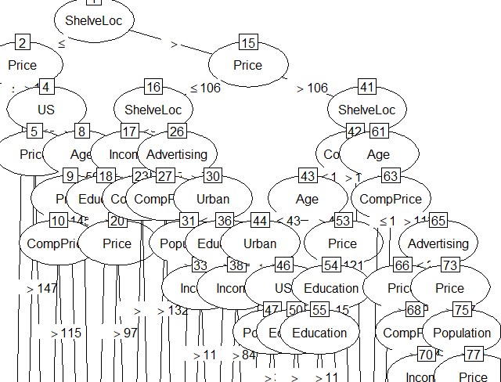

|  |  |  |
| --- | --- | --- |
| TEST ACCUTACY | TRAIN ACCURACY | MODEL |
| 0.9 | 0.9 | RIGHT FIT MODEL |