Problem Statement:

Use Decision Trees to prepare a model on fraud data, treating those who have taxable_income <= 30000 as "Risky" and others are "Good"

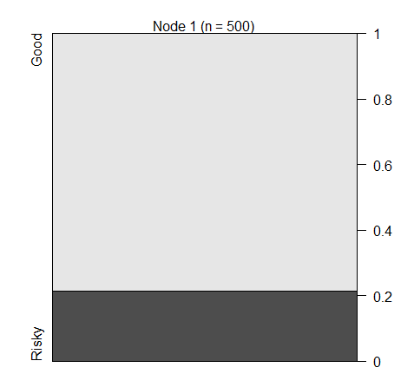

|  |  |  |  |
| --- | --- | --- | --- |
| MODEL | TEST ACC | TRAIN ACC |  |
| Model1 | 0.83 | 0.76 | OVER FIT MODEL |
| Pruning model | 0.74 | 0.74 | RIGHT FIT MODEL |