Perform Clustering for the crime data and identify the number of clusters formed and draw inferences.

Problem:-To draw inference from east west airline data

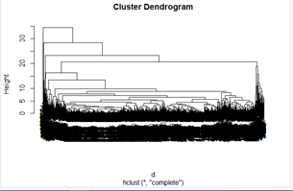

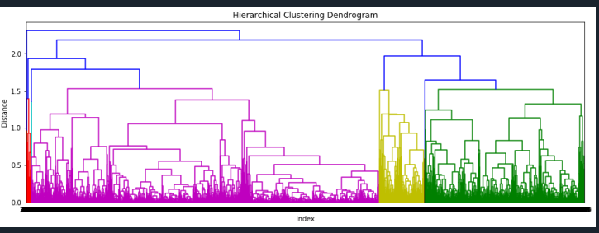

INFERENCE:

|  |
| --- |
| Records with similar properties are clustered together with different clusters. |
|  |