AIRLINES DATA

Perform clustering (Both hierarchical and K means clustering) for the airlines data to obtain optimum number of clusters.

Draw the inferences from the clusters obtained.

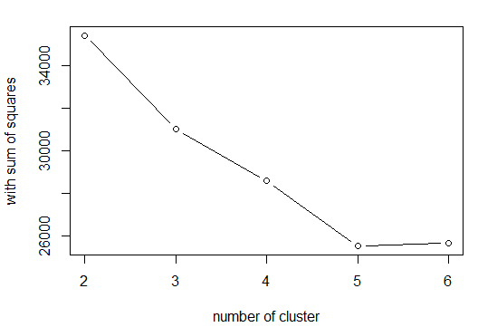

|  |  |  |  |
| --- | --- | --- | --- |
| K-VALUE | TWSS | TBSS | TSS |
| k=3 | 31001 | 12977 | 43978 |
| K=4 | 29035 | 14943 | 43978 |
| K=5 | 27494 | 16484 | 43978 |
| K=6 | 25695 | 18283 | 43978 |

|  |
| --- |
| INFERENCE:  when k=6 TOTAL WITHIN SUM OF SQUARE IS LESS AND TOTAL BETWEEN SUM OF SQUARE IS MORE..HENCE K=6 WOULD BE OPTIMIAL K VALUE |