INSURANCE DATA

Analyze the information given in the following ‘Insurance Policy dataset’ to create clusters of persons falling in the same type

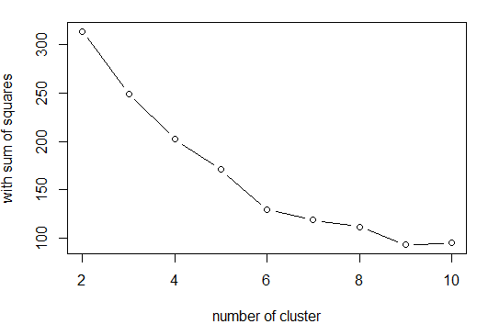

|  |  |  |  |
| --- | --- | --- | --- |
| K-VALUE | TWSS | TBSS | TSS |
| k=3 | 250 | 245 | 495 |
| K=4 | 201 | 294 | 495 |
| K=5 | 156 | 339 | 495 |
| K=6 | 129 | 366 | 495 |

|  |
| --- |
| INFERENCE:  when k=6 TOTAL WITHIN SUM OF SQUARE IS LESS AND TOTAL BETWEEN SUM OF SQUARE IS MORE..HENCE K=6 WOULD BE OPTIMIAL K VALUE |