BUSSINESS PROBLEM: Implement a KNN model to classify the animals in to categories.

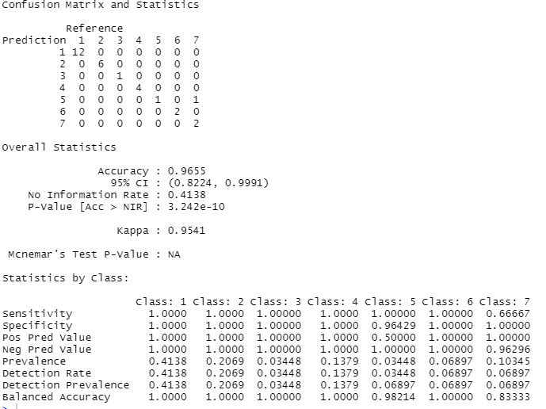

CrossTable(x = test$type, y = predicted.type,

prop.chisq=FALSE)

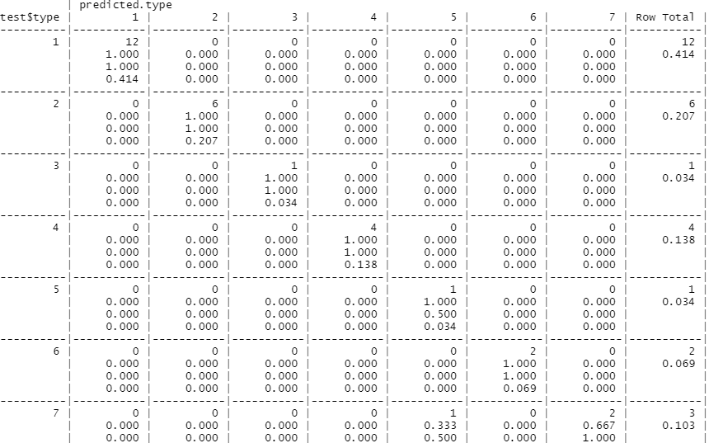

Python code:

import pandas as pd

import numpy as np

animals=pd.read_csv("C:/Users/USER/Desktop/KNN-TECHNIQUE/knn-assignment/Zoo.csv")

animals1=animals.drop(["animal name"],axis='columns')

from sklearn.model_selection import train_test_split

train,test = train_test_split(animals1,test_size = 0.2)

from sklearn.neighbors import KNeighborsClassifier as KNC

neigh = KNC(n_neighbors= 2)

animals1.shape

neigh.fit(train.iloc[:,0:16],train.iloc[:,16])

train_acc = np.mean(neigh.predict(train.iloc[:,0:16])==train.iloc[:,16])

test_acc = np.mean(neigh.predict(test.iloc[:,0:16])==test.iloc[:,16])

for i in range(3,50,2):

neigh = KNC(n_neighbors=i)

neigh.fit(train.iloc[:,0:4],train.iloc[:,4])

train_acc = np.mean(neigh.predict(train.iloc[:,0:4])==train.iloc[:,4])

test_acc = np.mean(neigh.predict(test.iloc[:,0:4])==test.iloc[:,4])

acc.append([train_acc,test_acc])

import matplotlib.pyplot as plt # library to do visualizations

# train accuracy plot

plt.plot(np.arange(3,50,2),[i[0] for i in acc],"ro-")

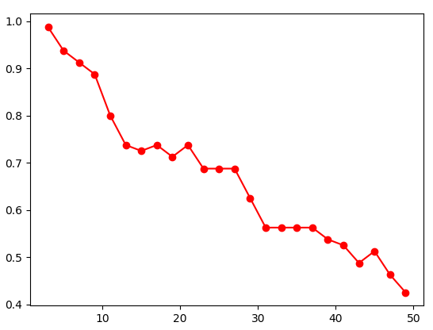

# test accuracy plot

plt.plot(np.arange(3,50,2),[i[1] for i in acc],"bo-")

