BUSSINESS PROBLEM: Prepare a model for glass classification using KNN

RCODE

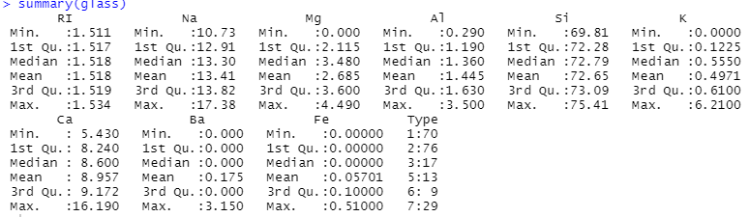

After scaling

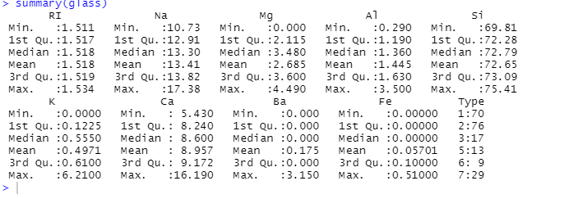

corrplot(cor(data))

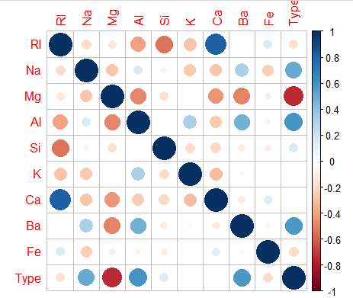

K=1

predicted.type <- knn(train[1:9],test[1:9],train$Type,k=1)

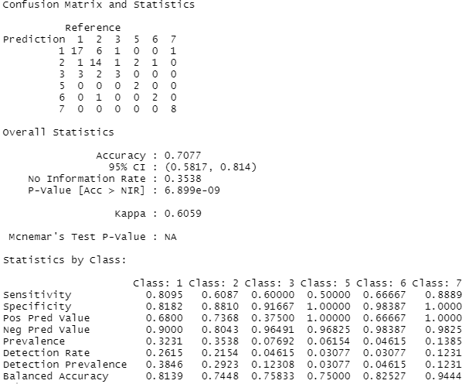

Accuracy=70

Cross table

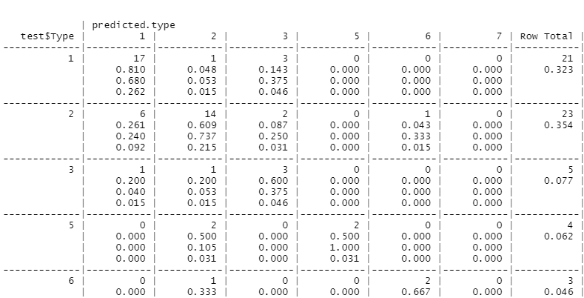

Python code

import pandas as pd

import seaborn as sns

import numpy as np

glass=pd.read_csv("C:/Users/USER/Desktop/KNN-TECHNIQUE/knn-assignment/glass.csv")

from sklearn.model_selection import train_test_split

train,test = train_test_split(glass,test_size = 0.2)

from sklearn.neighbors import KNeighborsClassifier as KNC

neigh = KNC(n_neighbors= 2)

neigh.fit(train.iloc[:,0:9],train.iloc[:,9])

train_acc = np.mean(neigh.predict(train.iloc[:,0:9])==train.iloc[:,9])

# test accuracy

test_acc = np.mean(neigh.predict(test.iloc[:,0:9])==test.iloc[:,9])

acc = []

for i in range(3,50,2):

neigh = KNC(n_neighbors=i)

neigh.fit(train.iloc[:,0:9],train.iloc[:,9])

train_acc = np.mean(neigh.predict(train.iloc[:,0:9])==train.iloc[:,9])

test_acc = np.mean(neigh.predict(test.iloc[:,0:9])==test.iloc[:,9])

acc.append([train_acc,test_acc])

import matplotlib.pyplot as plt # library to do visualizations

# train accuracy plot

plt.plot(np.arange(3,50,2),[i[0] for i in acc],"ro-")

# test accuracy plot

plt.plot(np.arange(3,50,2),[i[1] for i in acc],"bo-")

plt.legend(["train","test"])